Final System Design & Integration & Functional Verification
Zeyad Khaled Abd Elhamid El Razek

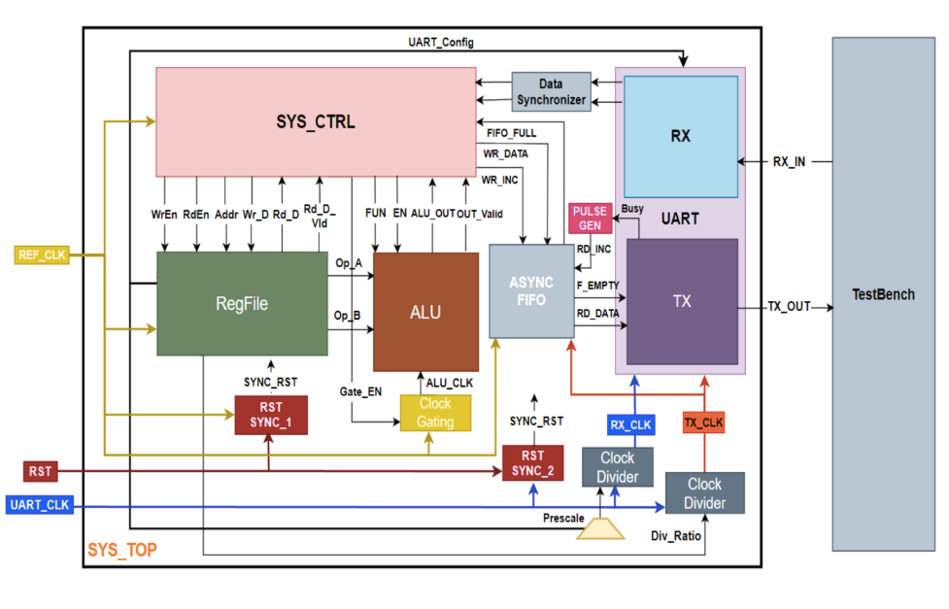
First lets go through the most important Tasks in the TB

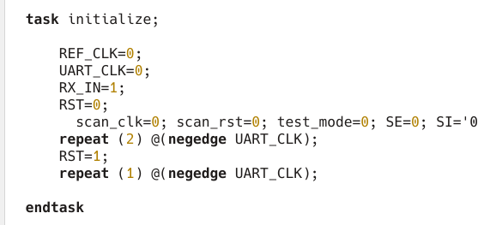

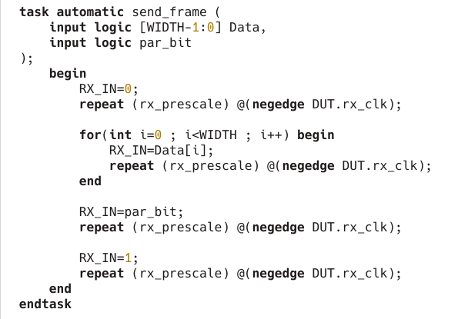
The Send Frame Sends data in serially acting like the sending tx for the RX to receive any frame must start with 0 to be a valid frame , followed by the data or command , followed by the par_bit then stop bit

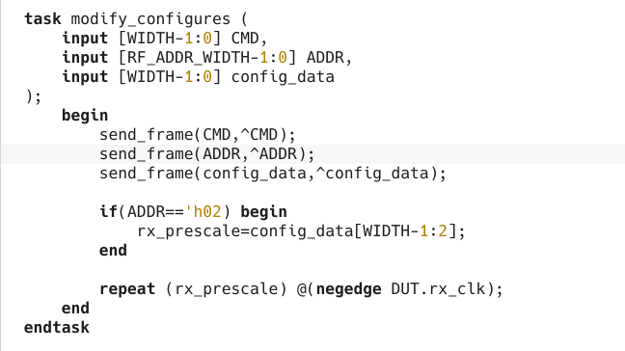
Sends frames to modify the REG signals at the start of the simultation
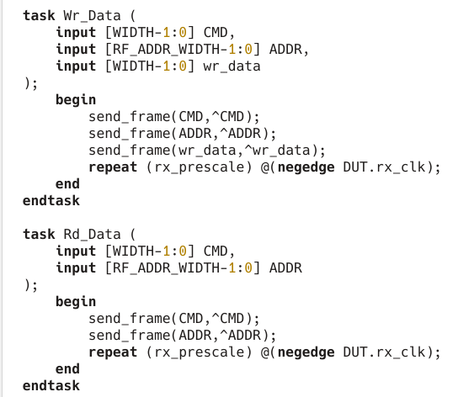
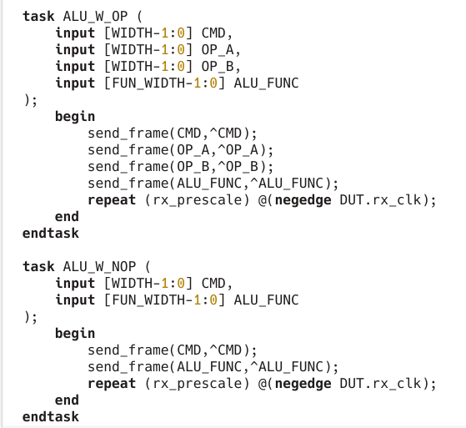

TB TEST CASES :
initial begin
initialize;
repeat (10) @(negedge DUT.rx_clk);
modify_configures('hAA,'h02,'h41);
modify_configures('hAA,'h03,'h20);

1st
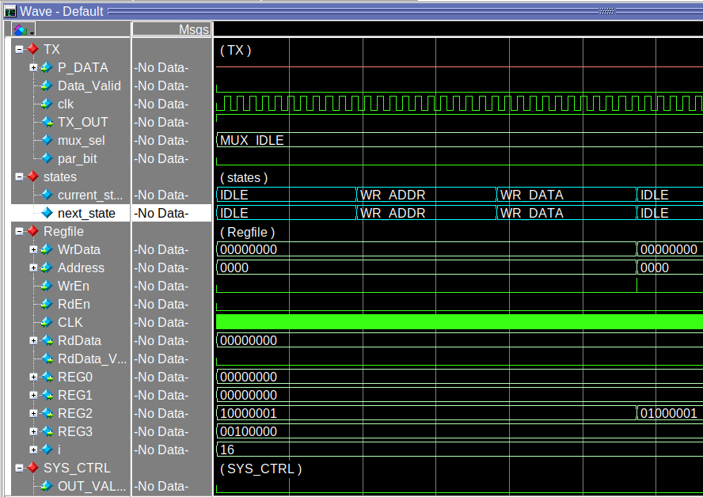
Modifying REG2 by using WR_CMD
originally RX Prescale = 32 the highest clk freq we will modify it to 16
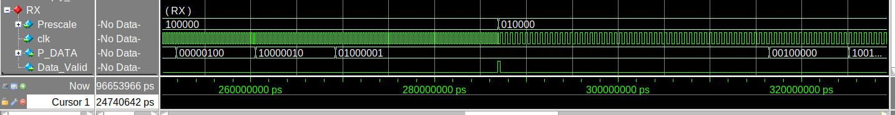
RESULT :
RX CLK Freq is /2 or 2* period

Case 2 : reg3 is kept at its 32 value
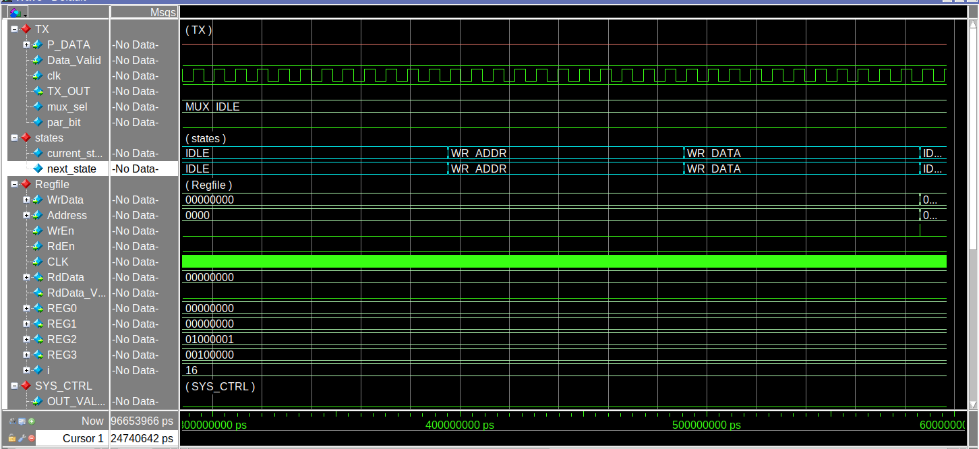

Test Case 3

Wr_Data('hAA,'h05,'b111);
Wr_Data('hAA,'h09,'b011);
WR_CMD,ADDR,DATA
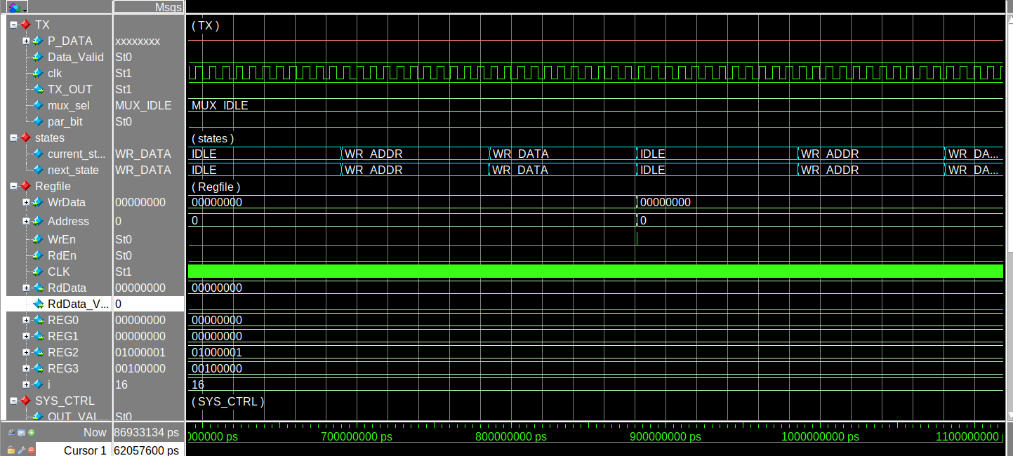

Now Do Rd_Data to check they were written successfully

Case 4 : Rd Data
Rd_Data('hBB,'h05);
Rd_Data('hBB,'h09);
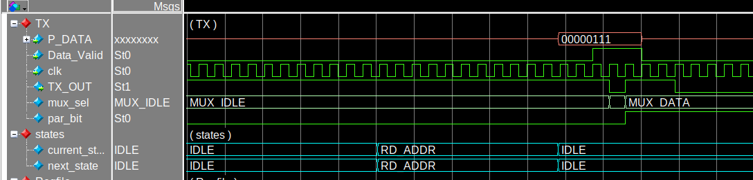
States were sucessful
The TX P_data Sucessfully receieved the Rd_Data from the Regfile
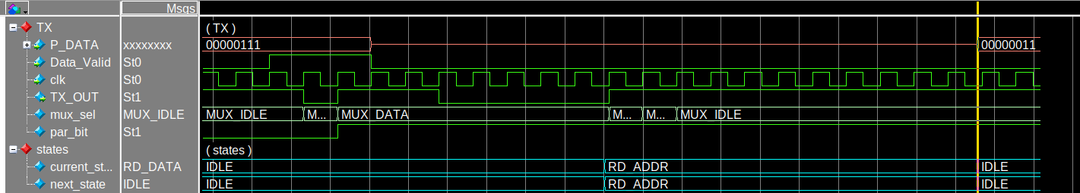
successfully captured 011 data

Case 5 : ALU WITH OPERANDS
ALU_W_OP('hCC,3,4,'h0000);

1.

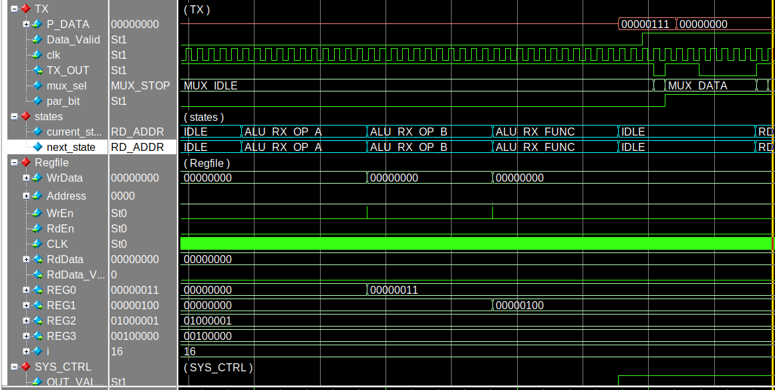
first REG 0 = 3 , REG1 = 4 , ALU_FUN = 0000
P_DATA Sucesfully recieved frame 1 Result 7 and frame 2 result = 0

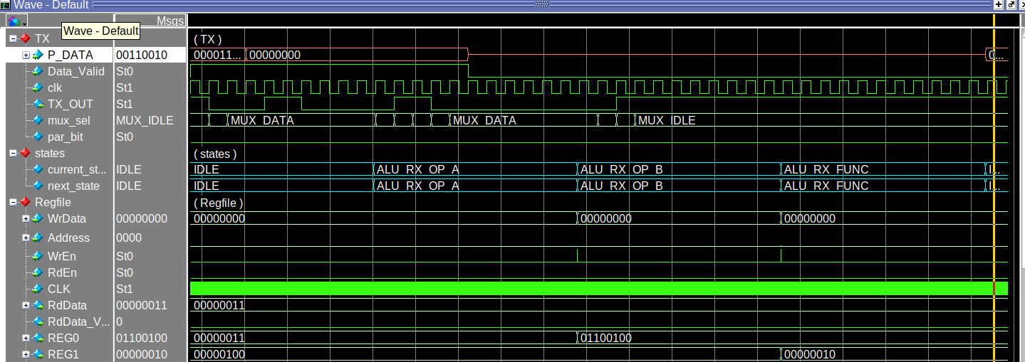
ALU_W_OP('hCC,100,2,'b0011);
A=100 , B= 2 , ALU_FUNC =Divide
P_DATA = 00110010 →50

ALU_W_OP('hCC,8'b11111111,8'b11111111,'h0000);
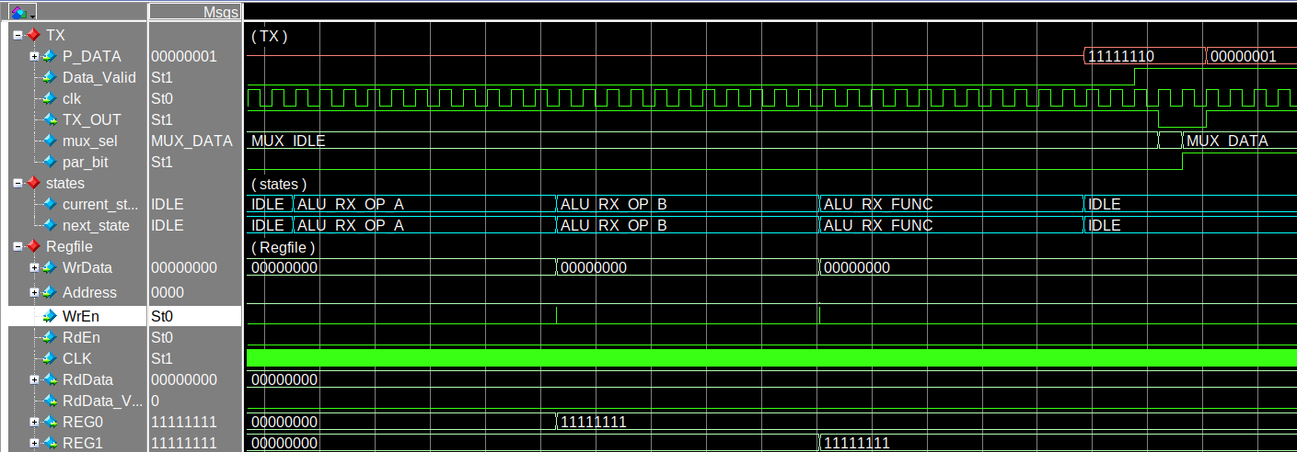
Multiplying 256 * 256 = 65025
The output is sent on two frames
P_DATA = 11111110_00000001 → 65025
Correct
Test Case 6 No Operands :
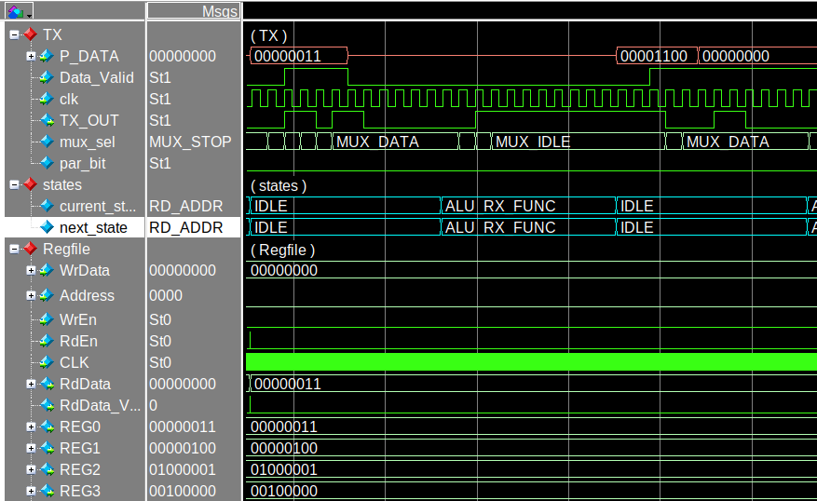
ALU_W_NOP('hDD,'b0010);
now we test No operands ALU_ Operation for the same A and B Values;
ALU_FUNC = 0010 → Multiply
P_DATA Sucessfully captures 3 * 4 = 1100→ 12

