CSE336 – Design Patterns

Software Requirements Specification
MissionOS: Non-Profit Management System
03/11/2026


Submitted to:
Dr. Raghda
Submitted by:
Zeyad Ahmed Hamdy – 23P0082
Youssef Wael Youssef – 23P0283
Ahmad Wail – 23P0335

Document Control
Item | Details
Document | Software Requirements Specification (SRS)
System | MissionOS: Non-Profit Management System
Course | CSE336, Design Patterns
Submitted to | Dr. Raghda
Version | 1.0
Date | 03/11/2026
Scope of this version | Phase 1 (up to the mid-term)
Team members | Zeyad Ahmed Hamdy (23P0082), Youssef Wael Youssef (23P0283), Ahmad Wail (23P0335)

Table of Contents
1. Introduction 2
1.1 Purpose 2
1.2 Scope 2
1.3 Definitions, acronyms and abbreviations 2
1.4 References 2
1.5 Overview of this document 3
2. Overall Description 3
2.1 Product perspective 3
2.2 Product functions 3
2.3 User classes and characteristics 4
2.4 Operating environment 4
2.5 Design and implementation constraints 4
2.6 Assumptions and dependencies 4
2.7 Requirements postponed to Phase 2 4
3. Specific Requirements 5
3.1 External interface requirements 5
3.2 Functional requirements 5
3.3 Non-functional requirements 8
3.4 Design pattern requirements 9
3.5 Data requirements 9
4. System Models 10
4.1 Use cases 10
4.2 Class diagrams 11
4.3 Sequence diagram: making a donation 14
4.4 Database 14
5. Requirements Traceability 14
5.1 Assessment brief 14
5.2 Client requirements 15
6. Verification 15
6.1 Automated tests 15
6.2 Acceptance checks 16
Appendix A. Questions to confirm with the client 16

1. Introduction

1.1 Purpose
This document specifies the requirements of MissionOS, a management system for non-profit organisations. It describes what the system must do and the limits it works within, so that the team, the instructor and future maintainers share the same understanding of Phase 1.
The intended readers are the course instructor (Dr. Raghda), the three team members, and anyone who later extends the system in Phase 2.

1.2 Scope
MissionOS helps a non-profit organisation run its daily work from one desktop application. In Phase 1 it covers five areas:
- Donations: donors, donations of different types, optional add-ons (Gift Aid, matching fund, recurring pledges) and an automatic receipt.
- Volunteers: contact details, skills, availability and matching to events.
- Events: creating events, assigning volunteers, registration, tickets and attendance.
- Beneficiaries: who receives help and what kind of help they need.
- Communication: messages to donors, volunteers and beneficiaries through email, SMS or social media.
The system also provides a dashboard, editable lookup tables (skills, event types, donation types and need types), and user sign-in. Data is stored in a Supabase project (PostgreSQL with built-in authentication).
Out of scope for Phase 1: online payment, tax documents and year-end statements, volunteer hours and certificates, tracking of distributed resources and impact, administrator roles and reports, and real email, SMS or social media gateways. These are listed in section 2.7.

1.3 Definitions, acronyms and abbreviations
Term | Meaning
SRS | Software Requirements Specification, this document.
CRUD | Create, read, update and delete.
MVC | Model-View-Controller, the way the code is divided into data, screens and control logic.
Gift Aid | A UK scheme that lets a charity claim 25% extra on a donation from a UK taxpayer.
Matching fund | A company doubles the amount its employee donates.
In-kind donation | A donation of goods or services instead of money.
Lookup table | A short list of allowed values (for example skills or event types) that staff can edit.
Supabase | The hosted service that provides the PostgreSQL database and the sign-in service.
RLS | Row Level Security, a database feature that decides which signed-in users may read or write rows.
Anon key | The public key of a Supabase project. It is safe to place in a desktop application.
Strategy, Observer, Decorator, Factory, Singleton | Design patterns used in the system (see section 3.4).

1.4 References
- Major Assessment Task, CSE336 Design Patterns (assessment brief, Phase 1 and Phase 2 criteria).
- IEEE Std 830-1998, Recommended Practice for Software Requirements Specifications (structure of this document).
- E. Gamma, R. Helm, R. Johnson, J. Vlissides, Design Patterns: Elements of Reusable Object-Oriented Software, Addison-Wesley, 1994.
- MissionOS project files: source code, database/supabase-schema.sql, docs/client-requirements.md, docs/crud-matrix.md, docs/diagrams/.

1.5 Overview of this document
Section 2 describes the product in general terms. Section 3 lists the specific requirements: interfaces, functions, quality attributes, design patterns and data. Section 4 shows the system models (use cases, architecture, class diagrams, a sequence diagram and the database). Section 5 traces the requirements back to the assessment brief and to the client requirements. Section 6 explains how the requirements are verified.

2. Overall Description

2.1 Product perspective
MissionOS is a stand-alone Java desktop application. It is a client of a Supabase project: it signs users in through the Supabase Auth service and stores all data in PostgreSQL through the Supabase REST interface over HTTPS. There is no separate server of our own.
Inside the application the code follows the MVC idea and is split into layers, as shown in Figure 1. Screens call controllers, controllers call services, and services reach the database only through one object, the DataStore singleton.
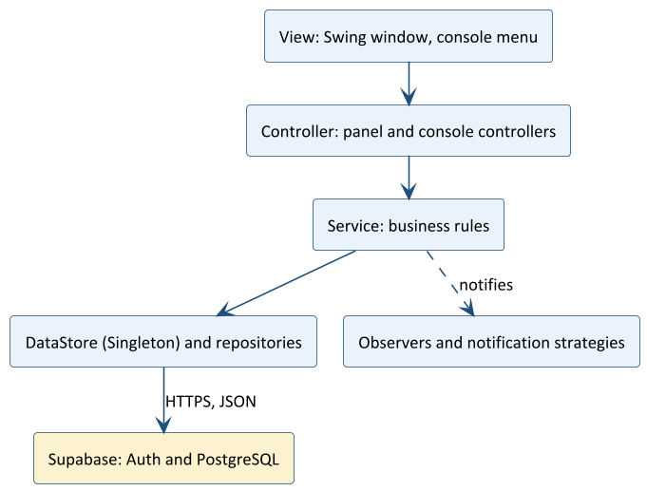
Figure 1. Layers of MissionOS

2.2 Product functions
Area | Main functions
Sign-in | Sign in, create an account, sign out. All data screens need a signed-in user.
Dashboard | Totals for donors, money donated, volunteers, events and beneficiaries; latest donations and events.
Donations | Manage donors; record online, check and in-kind donations; apply Gift Aid, matching fund and recurring add-ons; send a receipt.
Volunteers | Manage volunteers, their skills and available days; find volunteers by skill or by day.
Events | Manage events; assign volunteers; suggest volunteers by skill; register volunteers; issue tickets; check people in.
Beneficiaries | Manage beneficiaries and the type of help each one needs.
Notifications | Send a message to one recipient or to all donors, volunteers or beneficiaries, choosing email, SMS or social media.
Lookup tables | Edit the allowed skills, event types, donation types and need types.

2.3 User classes and characteristics
User class | Description
Staff user | An employee or volunteer coordinator of the organisation who has an account. Needs no programming knowledge. In Phase 1 every signed-in user may use every function.
Project administrator | Creates the Supabase project, runs the database script and creates the first accounts. Works in the Supabase dashboard, not in MissionOS.
Donors, volunteers, beneficiaries | They do not use the application. They are records in it and they receive messages from it.

2.4 Operating environment
- Any operating system that runs Java 11 or newer (developed and tested on Windows 11).
- A graphical desktop for the window interface. A text-menu mode exists for terminals.
- An internet connection to reach the Supabase project.
- Apache Maven 3.9 or newer to build and start the application.

2.5 Design and implementation constraints
- The language is Java 11. The window interface uses Swing with the FlatLaf theme; JSON is handled with Gson.
- The assessment brief requires the Factory, Observer, Strategy and Decorator patterns, plus Singleton and MVC in Phase 1.
- The application may only use the public anon key. A service-role key must be refused.
- Settings are read from a .env file or from environment variables. The file is not committed to version control.
- There is no in-memory fallback. If Supabase is unreachable, the application reports the error instead of storing data elsewhere.

2.6 Assumptions and dependencies
- A Supabase project exists and database/supabase-schema.sql has been run in it.
- Staff accounts are created in the Supabase dashboard, or by the sign-up option if the project allows it. Supabase may require email confirmation, and its built-in mail sender is limited to a few emails per hour.
- Email, SMS and social media messages are simulated in Phase 1: the text is produced and shown, but nothing is sent to an external gateway.
- The organisation will confirm its own privacy, retention and access rules before real use (see Appendix A).

2.7 Requirements postponed to Phase 2
Item | Reason
Online payment module | Phase 2 criterion of the brief.
Donation tax documents and year-end statements | Needs the Template Method pattern and report design.
Volunteer hours tracking and certificates | The hours field exists, but there is no screen to record hours yet.
Distribution of resources and impact monitoring for beneficiaries | Needs additional data and reports.
Administrator pages and roles | Phase 1 gives every signed-in user the same rights.
Real email, SMS and social media gateways | To be added behind the Adapter pattern.
Event lifecycle (planned, open, ongoing, completed, cancelled) | To be modelled with the State pattern.
Command, Facade, Iterator and Proxy patterns | Phase 2 criteria of the brief.

3. Specific Requirements

3.1 External interface requirements

3.1.1 User interfaces
- UI-1. A sign-in window with email and password fields, a show-password button, a switch to "Create an account", and error messages shown inside the window.
- UI-2. A main window with a header (product name, dark or light mode button, sign-out button) and seven tabs: Dashboard, Donations, Volunteers, Events, Beneficiaries, Notifications and Lookup Tables.
- UI-3. Every list is a table with sortable columns and a search box. The main action of a screen is highlighted.
- UI-4. Data entry happens in dialogs with labelled fields. Deleting asks for confirmation.
- UI-5. A text-menu interface offers the same functions for use in a terminal.

3.1.2 Software interfaces
Interface | Use
Supabase Auth (REST) | Sign in with email and password, sign up, refresh the session, sign out.
Supabase PostgREST (REST, JSON) | Read, insert, update and delete rows in the nine application tables.
Gson 2.11 | Converts entities to and from the JSON stored in the database.
FlatLaf 3.5 | Look and feel of the Swing windows.

3.1.3 Communication interfaces
All traffic uses HTTPS and JSON. Plain HTTP is accepted only for a project on the same computer (localhost). Each request times out after 15 seconds.

3.2 Functional requirements
Priority Must means the function is needed for Phase 1; Should means it improves the system but could be dropped. Source Brief is the assessment brief; R1 to R18 are the client requirements in docs/client-requirements.md.

3.2.1 Sign-in
ID | Requirement | Source | Priority
FR-AUTH-01 | The system shall let a user sign in with an email address and a password. | Brief | Must
FR-AUTH-02 | The system shall let a new user create an account. If email confirmation is required, it shall say so and return to the sign-in screen. | Brief | Must
FR-AUTH-03 | The system shall show the error returned by the sign-in service (for example an invalid email address or a wrong password). | Brief | Must
FR-AUTH-04 | The system shall let the user sign out and return to the sign-in window. | Brief | Must
FR-AUTH-05 | The system shall refresh an expired session once, using the refresh token, before reporting an error. | Brief | Should
FR-AUTH-06 | The system shall not open any data screen until a user is signed in. | Brief | Must

3.2.2 Donations
ID | Requirement | Source | Priority
FR-DON-01 | The system shall let staff add a donor with a name (required), email, phone and the channel used for receipts (email, SMS or social). Choosing SMS requires a phone number. | Brief, R14 | Must
FR-DON-02 | The system shall let staff edit and delete a donor. A donor who has donations cannot be deleted. | Brief | Must
FR-DON-03 | The system shall list donors and donations, with search and sorting. | Brief | Must
FR-DON-04 | The system shall record a donation for a donor with a type, an amount greater than zero and, for in-kind donations, an item description. The date is set to today. | Brief | Must
FR-DON-05 | The system shall accept only the donation types found in the DONATION_TYPE lookup table, and shall reject any other type with a clear message. | Brief, R5 | Must
FR-DON-06 | The system shall create the right kind of donation (online, check or in-kind) from the chosen type. | Brief | Must
FR-DON-07 | The system shall let staff add any combination of Gift Aid (+25%), matching fund (x2) and recurring monthly pledge (amount x number of months). The stored amount shall be the final amount and the description shall name the add-ons. | R2, R3, R4 | Must
FR-DON-08 | The system shall send a receipt to the donor after a donation is saved, through the donor's chosen channel, showing the final amount. | Brief, R1 | Must
FR-DON-09 | The system shall let staff delete a donation after confirmation. | Brief | Should

3.2.3 Volunteers
ID | Requirement | Source | Priority
FR-VOL-01 | The system shall let staff add a volunteer with a name (required), an email and an optional first skill. | Brief | Must
FR-VOL-02 | The system shall let staff edit a volunteer's name and email and delete a volunteer. | Brief | Must
FR-VOL-03 | The system shall let staff add skills to a volunteer. A skill already held is not added twice. | Brief | Must
FR-VOL-04 | The system shall let staff set the days a volunteer is available. | Brief, R7 | Must
FR-VOL-05 | The system shall find volunteers who have a given skill. | Brief, R8 | Must
FR-VOL-06 | The system shall find volunteers who are available on a given day (text-menu interface and service layer). | Brief, R7 | Should
FR-VOL-07 | The system shall list volunteers with their skills, availability and hours, with search and sorting. | Brief | Must

3.2.4 Events
ID | Requirement | Source | Priority
FR-EVT-01 | The system shall let staff create an event with a name (required), date, location, an event type chosen from the lookup table and a list of required skills. | Brief | Must
FR-EVT-02 | The system shall let staff edit the name, date and location of an event, and delete an event. Deleting an event also removes its registrations and tickets. | Brief | Must
FR-EVT-03 | The system shall let staff assign a volunteer to an event. The same volunteer cannot be assigned twice. | Brief | Must
FR-EVT-04 | The system shall suggest the volunteers who have at least one of the skills the event requires. | Brief, R8 | Must
FR-EVT-05 | The system shall let staff register a volunteer for an event. A volunteer cannot register twice for the same event. | Brief, R10 | Must
FR-EVT-06 | The system shall list the registrations of an event. | Brief | Must
FR-EVT-07 | The system shall issue a ticket only to a registered volunteer, once per event. Ticket numbers (TKT-1001, TKT-1002, ...) shall be unique, also after the application is restarted. | Brief, R10 | Must
FR-EVT-08 | The system shall list the tickets of an event. | Brief | Must
FR-EVT-09 | The system shall check a ticket in to record attendance. A ticket can be checked in once. | Brief, R11 | Must
FR-EVT-10 | The system shall tell every volunteer about a new event, and shall tell the assigned volunteers when an event is updated. | Brief, R12 | Must

3.2.5 Beneficiaries
ID | Requirement | Source | Priority
FR-BEN-01 | The system shall let staff add a beneficiary with a name (required), contact details and a need chosen from the NEED_TYPE lookup table. | Brief, R15 | Must
FR-BEN-02 | The system shall let staff edit and delete a beneficiary. Edits shall be saved to the database. | Brief | Must
FR-BEN-03 | The system shall list beneficiaries with search and sorting. | Brief | Must

3.2.6 Communication
ID | Requirement | Source | Priority
FR-COM-01 | The system shall support three delivery channels: email, SMS and social media. Each channel is a separate, interchangeable strategy. | Brief, R13 | Must
FR-COM-02 | The system shall let the user choose the channel when sending a message, and shall use the chosen channel at that moment. | R14 | Must
FR-COM-03 | The system shall send a message to a custom recipient, to all donors, to all volunteers or to all beneficiaries. | Brief | Must
FR-COM-04 | The system shall use the phone number for SMS and the email address for the other channels, and shall skip recipients who have no suitable contact detail. | Brief | Must
FR-COM-05 | The system shall require a message text and at least one recipient, and shall otherwise show a clear error. | Brief | Must
FR-COM-06 | The system shall show a log of the messages sent in the current session. | Brief | Should

3.2.7 Lookup tables
ID | Requirement | Source | Priority
FR-LKP-01 | The system shall keep four lookup tables: SKILL, EVENT_TYPE, DONATION_TYPE and NEED_TYPE. | Brief, R16 | Must
FR-LKP-02 | The system shall let staff add, list, rename and delete entries of any lookup table. | Brief, R16 | Must
FR-LKP-03 | The system shall not allow two entries with the same name (ignoring capital letters) in one lookup table. | Brief | Should
FR-LKP-04 | The database script shall provide starting values for each lookup table. | Brief | Should

3.2.8 Dashboard and general behaviour
ID | Requirement | Source | Priority
FR-UI-01 | The dashboard shall show the number of donors, the total amount donated, and the number of volunteers, events and beneficiaries. | R17 | Must
FR-UI-02 | The dashboard shall list the latest donations and the events. | R17 | Should
FR-UI-03 | Each tab shall show current data when it is opened. | R17 | Should
FR-UI-04 | The user shall be able to switch between a light and a dark appearance. | R17 | Should
FR-UI-05 | A failed request shall show an error message and leave the application running. | Brief | Must

3.3 Non-functional requirements

3.3.1 Security
ID | Requirement
NFR-SEC-01 | The application shall use only the public anon key. It shall refuse to start with a service-role or secret key.
NFR-SEC-02 | Row Level Security shall be enabled on every table, and only signed-in users shall be allowed to read or change rows.
NFR-SEC-03 | Passwords shall not be stored or logged. Password fields shall be cleared after use. The session token shall be kept in memory only.
NFR-SEC-04 | Connections shall use HTTPS, except to a project on localhost.
NFR-SEC-05 | The .env file with the project settings shall be excluded from version control.

3.3.2 Reliability and data integrity
ID | Requirement
NFR-REL-01 | Foreign keys shall link donations to donors and registrations, tickets and assignments to events and volunteers.
NFR-REL-02 | The database shall reject duplicate ticket numbers, duplicate event assignments, duplicate registrations and duplicate lookup entries.
NFR-REL-03 | A network or database error shall produce a readable message and shall not close the application or corrupt data.

3.3.3 Performance
ID | Requirement
NFR-PERF-01 | Target: a list screen shall load in under 3 seconds for up to 1,000 records on a normal broadband connection. This target has not been measured yet.
NFR-PERF-02 | Every request to Supabase shall time out after 15 seconds.

3.3.4 Usability
ID | Requirement
NFR-USE-01 | All tabs shall follow the same layout: table on top, buttons below, dialogs for data entry.
NFR-USE-02 | Error messages shall be in plain language and say what to do next.
NFR-USE-03 | A user with basic computer skills shall be able to add a donor and record a donation without training.

3.3.5 Maintainability, extensibility and portability
ID | Requirement
NFR-MNT-01 | The code shall be divided into model, view, controller, service, repository, observer and communication packages. Controllers and views shall contain no business rules.
NFR-MNT-02 | A new donation type, notification channel or donation add-on shall be added by writing one new class and registering it in one place (a factory or the service).
NFR-MNT-03 | Core behaviour shall be covered by automated tests that run with mvn clean package.
NFR-POR-01 | The application shall run on any operating system with Java 11 or newer.

3.4 Design pattern requirements
The assessment brief asks for specific design patterns. This table states where each Phase 1 pattern is used and the problem it solves.
Pattern | Where | Problem it solves
Factory | DonationFactory, NotificationFactory | Creates the right donation class or delivery strategy from a name, so the rest of the code does not use new on concrete classes.
Observer | Subject, Observer, DonationService, EventService, DonationReceiptObserver, EventUpdateObserver | Lets the services announce that a donation was received or an event changed, without knowing who reacts.
Strategy | NotificationStrategy with EmailStrategy, SmsStrategy, SocialMediaStrategy; context Notifier | Lets the delivery channel be swapped at run time.
Decorator | DonationInfo, DonationDecorator, GiftAidDecorator, MatchingFundDecorator, RecurringDecorator | Adds Gift Aid, matching and recurring behaviour to a donation in any combination.
Singleton | DataStore | Gives the whole application one access point to the repositories.
MVC | views, controllers, services | Keeps screens, control logic and business rules apart.

3.5 Data requirements
The system stores the following entities. Each has a numeric identifier created by the database.
Entity | Attributes | Rules
Donor | name, email, phone, notification channel | Cannot be deleted while it has donations.
Donation | donor, amount, date, type, item (in-kind), add-on description | Type is online, check or in-kind. Amount greater than zero.
Volunteer | name, email, skills, availability, hours | Skills and days are lists of text.
Event | name, date, location, event type, status, required skills, assigned volunteers | Status starts as PLANNED.
Registration | volunteer, event, registration date | One per volunteer and event.
Ticket | ticket number, volunteer, event, checked in | One per volunteer and event; unique number.
Beneficiary | name, contact, need | Need comes from the NEED_TYPE lookup.
Lookup item | name, category | Category is SKILL, EVENT_TYPE, DONATION_TYPE or NEED_TYPE. Unique name per category.

4. System Models

4.1 Use cases
Figure 2 shows what a staff user can do. Recording a donation always sends a receipt, and can be extended with add-ons. Creating an event always notifies the volunteers.
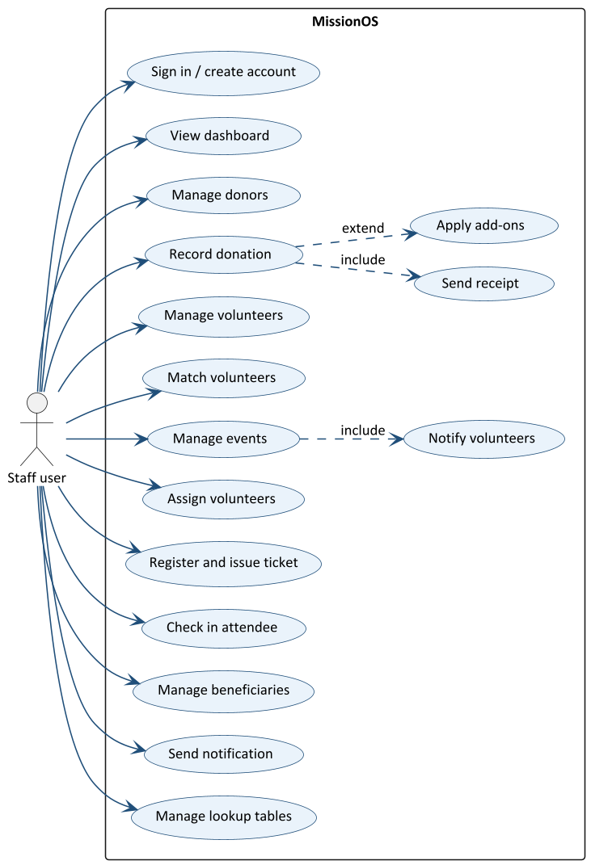
Figure 2. Use case diagram

Main use case: record a donation
Item | Description
Actor | Staff user
Precondition | The user is signed in and at least one donor exists.
Main flow | 1. The user opens the Donations tab and chooses Make Donation. 2. The user selects the donor and the type, enters the amount and, if needed, the item and the add-ons. 3. The system validates the input, saves the donation and applies the add-ons. 4. The system sends the receipt through the donor's channel. 5. The system shows the saved donation.
Alternative flows | The amount is not a positive number, or the type is not in the lookup table: the system shows an error and nothing is saved. The database cannot be reached: the system shows the error message.
Postcondition | The donation is stored with its final amount and the donor has received the receipt.

4.2 Class diagrams
Figures 3 to 5 show the Phase 1 classes in three parts: the domain model, the design patterns, and the layers with persistence. The complete diagram with every class is in docs/diagrams/class-diagram-full.puml.
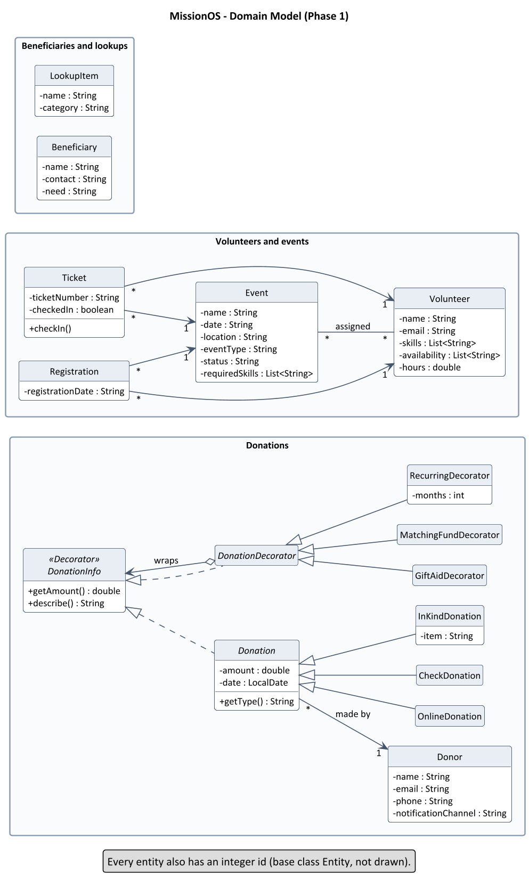
Figure 3. Domain model: entities, Factory-created donations and Decorator add-ons
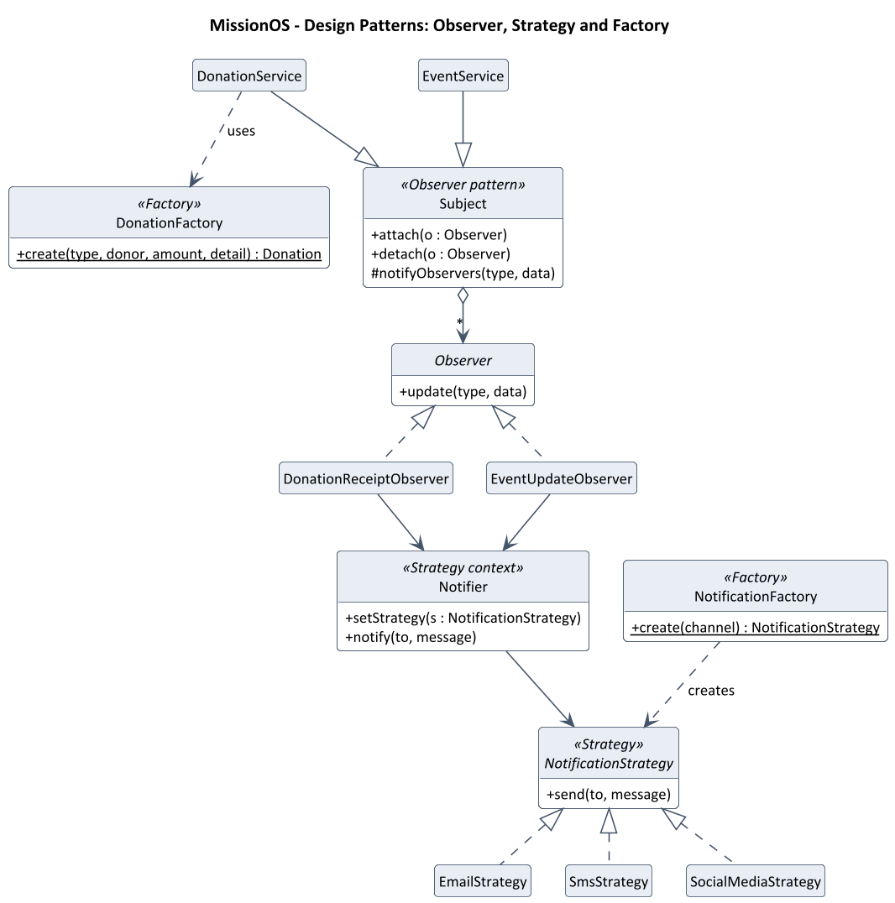
Figure 4. Observer, Strategy and Factory patterns
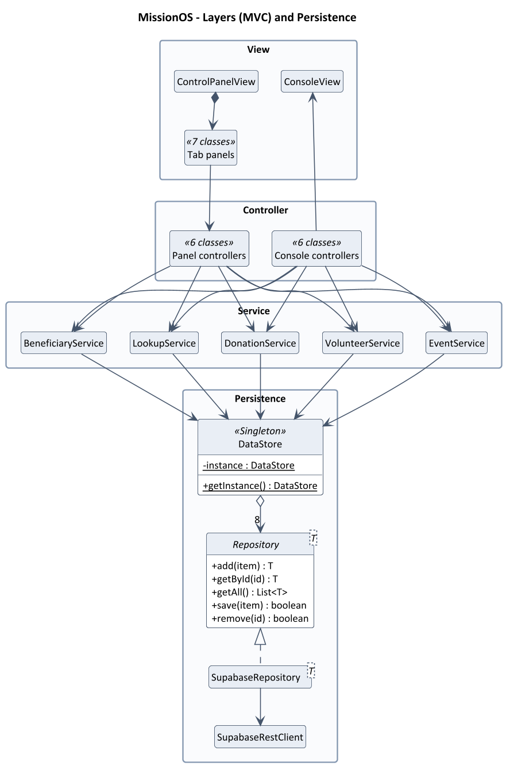
Figure 5. Layers (MVC) and persistence with the Singleton DataStore

4.3 Sequence diagram: making a donation
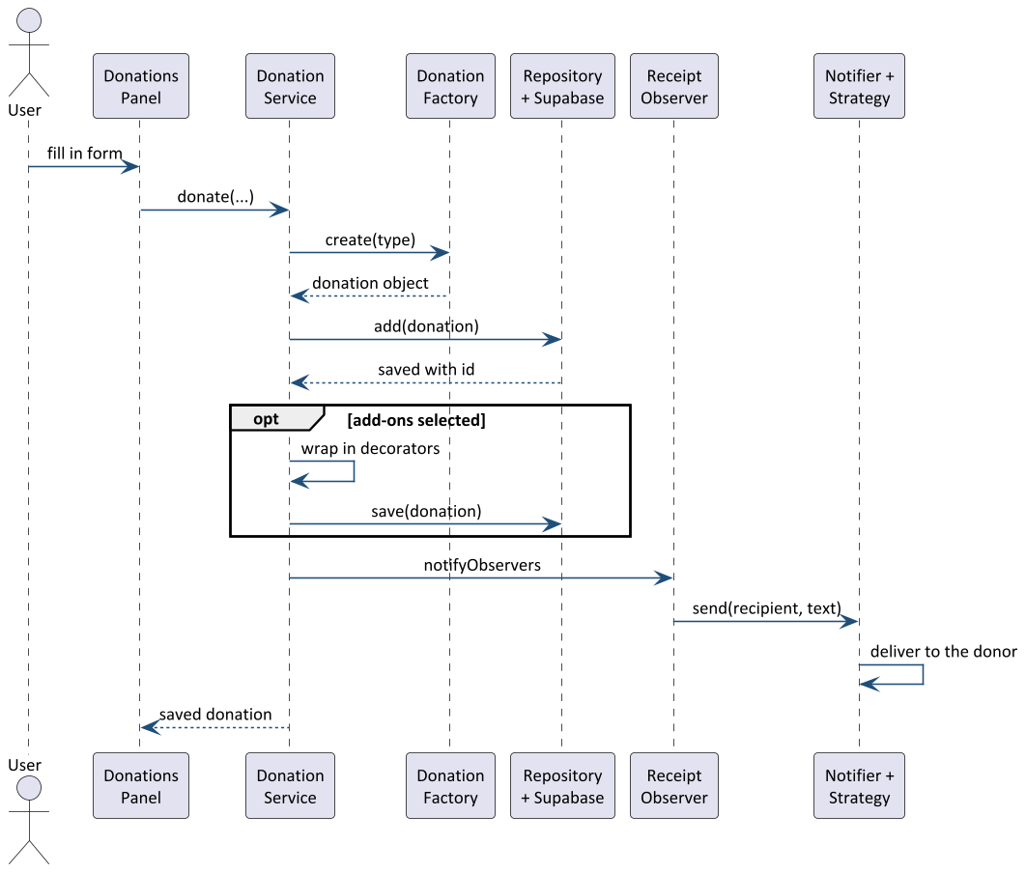
Figure 6. Sequence of recording a donation

4.4 Database
Each table has an integer identifier. Entity attributes are stored as JSON in a data column; relationships are real columns protected by foreign keys. Row Level Security allows access only to signed-in users.
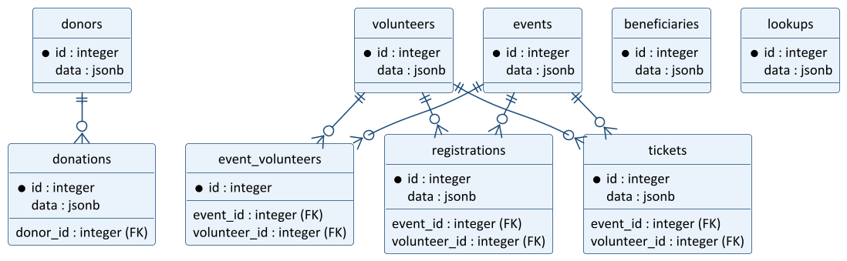
Figure 7. Database tables and their relationships

5. Requirements Traceability

5.1 Assessment brief
Status is Done when Phase 1 implements the requirement, Partial when only a part is implemented, and Phase 2 when it is planned for later.
Requirement in the brief | Status | Requirements
Donations: track donor information, amounts and types | Done | FR-DON-01 to 06
Donations: generate receipts | Partial | FR-DON-08 (message receipt; no document yet)
Donations: tax-related documents | Phase 2 | Section 2.7
Donations: several donation methods (online, check, in-kind) | Done | FR-DON-04 to 06
Volunteers: information, skills, availability | Done | FR-VOL-01 to 07
Volunteers: assign to events by qualifications | Done | FR-EVT-03, FR-EVT-04
Volunteers: track hours, certificates | Phase 2 | Section 2.7
Events: create, manage and track | Done | FR-EVT-01, 02
Events: registration, ticketing, attendance | Done | FR-EVT-05 to 09
Events: reminders and communications | Partial | FR-EVT-10 (no scheduled reminders yet)
Beneficiaries: store information and needs | Done | FR-BEN-01 to 03
Beneficiaries: distribution and impact | Phase 2 | Section 2.7
Communication: email, SMS and other channels | Done (simulated) | FR-COM-01 to 06
Communication: social media integration | Partial | FR-COM-01 (simulated post)
Patterns: Factory, Observer, Strategy, Decorator, Singleton, MVC | Done | Section 3.4

5.2 Client requirements
Client requirement | Status | Requirements
R1 Automatic receipt after a donation | Done | FR-DON-08
R2 Gift Aid for UK donors | Done | FR-DON-07
R3 Corporate matching fund | Done | FR-DON-07
R4 Recurring monthly donations | Done | FR-DON-07
R5 Configurable donation types | Done | FR-DON-05, FR-LKP-01
R6 Year-end tax document | Phase 2 | Section 2.7
R7 Volunteers state available days | Done | FR-VOL-04, 06
R8 Match volunteers to events by skill | Done | FR-VOL-05, FR-EVT-04
R9 Volunteer hours for certificates | Phase 2 | Section 2.7
R10 Registration with tickets | Done | FR-EVT-05, 07
R11 Check-in at the event | Done | FR-EVT-09
R12 Notify volunteers about events | Done | FR-EVT-10
R13 Several notification channels | Done | FR-COM-01
R14 User chooses the channel | Done | FR-COM-02, FR-DON-01
R15 Record the help each beneficiary needs | Done | FR-BEN-01
R16 Manage lookup tables | Done | FR-LKP-01 to 04
R17 Graphical interface | Done | FR-UI-01 to 04, UI-1 to UI-4
R18 Resource distribution tracking | Phase 2 | Section 2.7

6. Verification

6.1 Automated tests
The project has 17 automated tests (JUnit 5) that run with mvn clean package.
Test class | Tests | What it checks
DonationDecoratorTest | 2 | Gift Aid adds 25%; add-ons stack and are all named in the description (FR-DON-07).
DonationReceiptObserverTest | 1 | The receipt goes through the donor's chosen channel (FR-DON-08).
EntityJsonCodecTest | 2 | Entities are converted to and from the stored JSON.
SupabaseConfigTest | 4 | Settings are read from the .env file, environment variables win, missing values are reported.
SupabaseIntegrationTest | 8 | Requests to a local test server: session refresh, refusal of service-role keys and non-local HTTP, donation and event persistence (NFR-SEC-01, NFR-SEC-04).

6.2 Acceptance checks
These checks are done by hand against a Supabase project:
- Add a donor with the SMS channel and no phone number: the system refuses (FR-DON-01).
- Record a 1,000 donation with Gift Aid and a matching fund: the stored amount is 2,500 and the receipt shows 2,500 (FR-DON-07, FR-DON-08).
- Create an event, assign the same volunteer twice: the second attempt is refused (FR-EVT-03).
- Register a volunteer, issue a ticket, restart the application, issue another: the numbers differ (FR-EVT-07).
- Send a message to all donors by SMS when one donor has no phone number: that donor is skipped (FR-COM-04).

Appendix A. Questions to confirm with the client
- Which staff members may see or change donor and beneficiary personal data? (Phase 1 gives every signed-in user full access.)
- How long may personal data be kept, and how is consent recorded and withdrawn?
- Which extra notification channels or delivery records does the organisation need?
- Which reports and year-end documents are required?
- Does a volunteer need approval before being assigned to an event?

