**React Native To-Do List App Report**

**1. Introduction**

This report provides an overview of the **React Native To-Do List App**, covering its design, colors, fonts, components, styling, and logic. The app allows users to add, edit, and delete goals dynamically. It is built using React Native and Expo, with a focus on simplicity and usability.

**2. Screenshots of the App**

**3. Colors & Fonts Used**

**🎨 Colors:**

| **Component** | **Color Code** | **Description** |
| --- | --- | --- |
| Background | #ecf0f1 | Light Gray |
| Header | #3498db | Blue |
| Button | #3498db | Blue |
| Input Border | #3498db | Blue |
| Input BG | #ecf0f1 | Light Gray |
| Goal Item BG | #3498db | Blue |

**📝 Fonts:**

* Default React Native fonts used.
* fontWeight: 'bold' for important text elements.

**4. Code Breakdown**

**📌 App Component (App.js)**

The App.js file contains the main logic and structure of the app. Key features include:

* State Management:
  + goal: Stores the current input value.
  + goals: Stores the list of goals.
  + editingIndex: Tracks the index of the goal being edited.
* Functions:
  + addGoal: Adds a new goal or updates an existing one.
  + deleteGoal: Removes a goal from the list.
  + startEditing: Populates the input field with the goal to be edited.
* Components:
  + TextInput: For entering goals.
  + TouchableOpacity: For buttons (Add/Update, Edit, Delete).
  + FlatList: For rendering the list of goals.

5. Features

Core Features:

1. Add Goal:
   * Users can enter a goal in the input field and click "ADD GOAL" to add it to the list.
2. Edit Goal:
   * Users can click the "Edit" button next to a goal to populate the input field with the goal's text.
   * Clicking "UPDATE GOAL" updates the goal in the list.
3. Delete Goal:
   * Users can click the "Delete" button next to a goal to remove it from the list.

**🎨 Styling (styles object)**

The StyleSheet object defines the app's visual design. Key styles include:

* Container: Centers the app content and sets the background color.
* Header: Styles the app title with a blue background and white text.
* Input Container: Arranges the input field and button horizontally.
* Goal Item: Styles each goal item with a blue background and white text.
* Buttons: Styles for the Edit (green) and Delete (red) buttons.

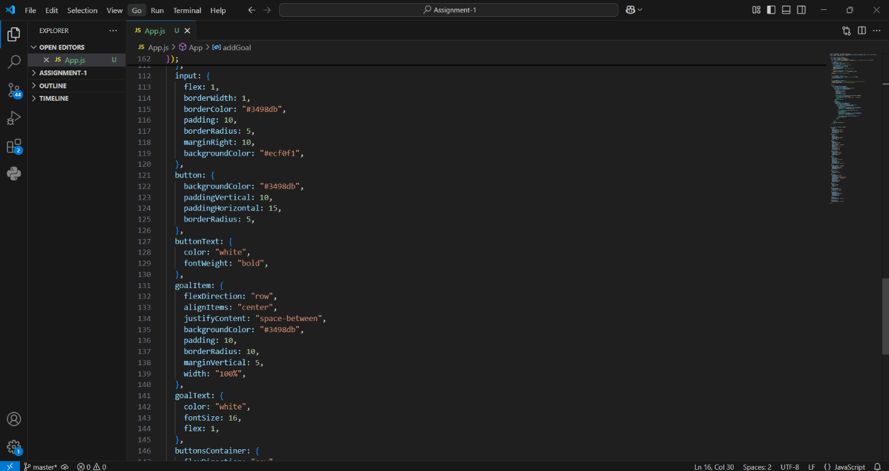

**5. Conclusion**

The **React Native To-Do List App** is a simple yet powerful tool for managing tasks. It demonstrates the use of React Native components, state management, and styling to create a clean and functional user interface. With the addition of **Edit** and **Delete** functionality, the app provides a more complete user experience. Future enhancements, such as local storage and animations, could further improve the app's usability and appeal.