Department | Engineering Mathematics and Physics
Division | ----------
Academic Year | 2019-2020 Preparatory
Course name | Computer
Course code | ECE001
Title: -
Artificial intelligence
By:
 | Name | Edu mail | B.N
1 | Zeyad ezat Mohamed fekry | zeyad195408@feng.bu.edu.eg | 369

Approved by:

Examiners committee | Signature
Dr.Ahmed Bayoumi
Dr.Shady Elmashad
Dr. Abdelhamid Attaby

AI or artificial intelligence is the simulation of human intelligence processes by machines, especially computer systems. These processes include learning, reasoning and self-correction. Some of the applications of AI include expert systems, speech recognition and machine vision. Artificial Intelligence is advancing dramatically. It is already transforming our world socially, economically and politically.
AI was coined by John McCarthy, an American computer scientist, in 1956 at The Dartmouth Conference where the discipline was born. Today, it is an umbrella term that encompasses everything from robotic process automation to actual robotics. AI can perform tasks such as identifying patterns in the data more efficiently than humans, enabling businesses to gain more insight out of their data. With the help from AI, massive amounts of data can be analyzed to map poverty and climate change, automate agricultural practices and irrigation, individualize healthcare and learning, predict consumption patterns, and streamline energy-usage and waste-management.

Applications:

- Siri
Everyone is familiar with Apple's personal assistant, Siri. She's the friendly voice-activated computer that we interact with on a daily basis. She helps us find information, gives us directions, add events to our calendars, and helps us send messages and so on.

- Alexa
When Amazon first introduced Alexa, it took much of the world by storm. However, its usefulness and its uncanny ability to decipher speech from anywhere in the room has made it a revolutionary product that can help us scour the web for information, shop, schedule appointments, set alarms and a million other things, but also help power our smart homes and be a conduit for those that might have limited mobility.

- Tesla
This is quite possibly one of the best cars ever made. Not only for the fact that it's received so many accolades, but because of its predictive capabilities, self-driving features and sheer technological "coolness.".

Screenshots:
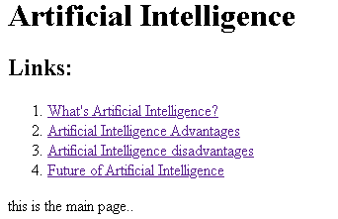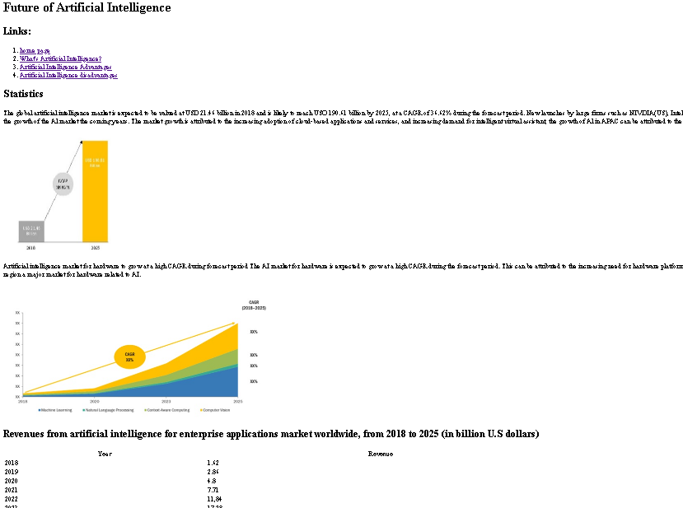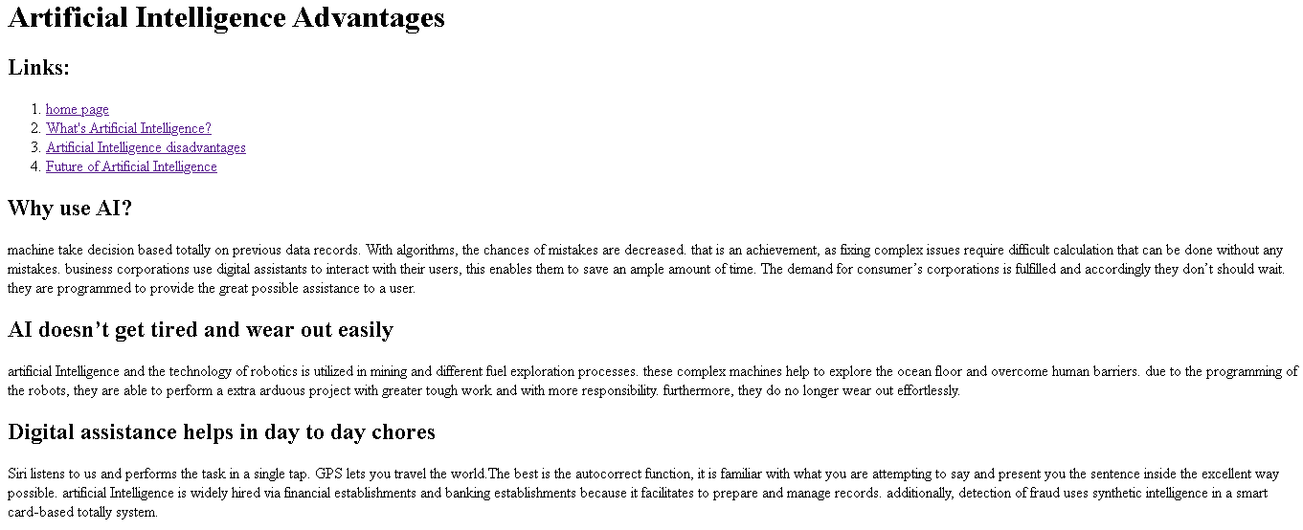
Source code: 