A1 Equivalence Class Partitioning

Test ID | Req ID | class | Representative Input | Expected Outcome
TID-1 | FR-01 | Valid credit hours: current 0-18, new 1-4, sum ≤ 18 | check_credit_limit(11, 3) | True
TID-2 | FR-01 | Valid credit hours: current 0-18, new 1-4, sum > 18 | check_credit_limit(17, 3) | False
TID-3 | FR-02 | Invalid credit hours: current < 0 | check_credit_limit( -17, 3) | Invalid Course Credit
TID-4 | FR-03 | Valid: Required is Empty | prerequisites_satisfied({"CS101"}, set() ) | True
TID-5 | FR-03 | Invalid: Required one is not Empty and it is not is Complete | prerequisites_satisfied( set() , {"CS101"} ) | False
TID-6 | FR-03 | Valid: Required one is in complete | prerequisites_satisfied( {"CS101"} , {"CS101"} ) | True
TID-7 | FR-04 | Valid: dues = 0 | Decision with S1.outstanding_dues = 0 | REGISTERED
TID-8 | FR-15 | Invalid: dues < 0 | Decision with S1.outstanding_dues = -100 | Invalid dues

ECP explanation
Equivalence Class Partitioning divides the input domain into classes expected to behave a like then selects a representative from each class. The classes used here include valid invalid credit values capacity states. The expected result for each representative is derived from the requirements not from the current program behavior.

A2. Boundary Value Analysis

Test ID | Req ID | Boundary Focus | Input | Expected Output
TID-1 | FR-01 | Current credits = 0 (lower boundary, valid)  new credits = 1 (lower boundary, valid) | check_credit_limit(0, 1) | True
TID-2 | FR-01 | New credits = 4 (upper boundary, valid);  combined total = 18 (exactly at limit) | check_credit_limit(14, 4) | True
TID-3 | FR-01 | Current credits = 18 (upper boundary, valid)  combined total = 19 (just above limit) | check_credit_limit(18, 1) | False
TID-4 | FR-02 | Current credits = -1 (just below lower boundary) | check_credit_limit(-1, 1) | Invalid Course Credit
TID-5 | FR-02 | New credits = 0 (just below lower boundary) | check_credit_limit(10, 0) | Invalid Course Credit
TID-6 | FR-02 | New credits = 5 (just above upper boundary) | check_credit_limit(10, 5) | Invalid Course Credit
TID-7 | FR-04 | Dues = 0 (boundary, valid) | Decision with S1.outstanding_dues = 0 | REGISTERED
TID-8 | FR-04 | Dues = 1 (just above zero) | Decision with S1.outstanding_dues = 1 | DUES_BLOCK
TID-9 | FR-08 | Enrolled = 30 = capacity (upper boundary, valid) | Decision with C1.capacity = 30, C1.enrolled = 30 | WAITLISTED
TID-10 | FR-15 | Enrolled = 31 (just above capacity) | Decision with C1.capacity = 30, C1.enrolled = 31 | Invalid capacity or enrollment
BVA explanation
Boundary Value Analysis concentrates tests at valid limits and immediately outside them where errors are common. The credit total boundary is inclusive exactly 18 is allowed. Course capacity is valid through enrolled == capacity; that exact full boundary. A value above capacity is invalid input under FR-15, not a valid waitlist case.

A3. Decision Table Testing and Optimization
Conditions are evaluated in the FR-09 priority order:
1. Negative dues are invalid input positive dues block registration.
2. Student is already registered in the course.
3. Prerequisites are missing.
4. Credit limit would be exceeded.
5. Course is full otherwise register.

Test ID | Req ID | C1 Dues | C2 Already | C3 Prereq | C4 Credit | C5 Full | Executable Input | Expected Output
DT-01 | FR-04 | Y | N | N | N | N | S1.outstanding_dues = 1 | DUES_BLOCK
DT-02 | FR-05 | N | Y | N | N | N | S1.registered_courses = {“C1”} | ALREADY_REGISTERED
DT-03 | FR-06 | N | N | Y | N | N | C1.prerequisites = {“CS101”}, S1.completed = {} | PREREQUISITES_MISSING
DT-04 | FR-07 | N | N | N | Y | N | S1.current_credits = 16 | CREDIT_LIMIT
DT-05 | FR-08 | N | N | N | N | Y | C1.capacity = 30, C1.enrolled = 30 | WAITLISTED
DT-06 | FR-08 | N | N | N | N | N | Baseline fixture | REGISTERED
DT-07 | FR-09 | Y | Y | Y | Y | Y | All five setups applied together | DUES_BLOCK
DT-08 | FR-09 | Y | N | N | N | Y | S1.outstanding_dues = 1, C1.enrolled = 30 | DUES_BLOCK
DT-09 | FR-09 | N | Y | Y | Y | Y | Setups C2, C3, C4, C5 applied together | ALREADY_REGISTERED
DT-10 | FR-09 | N | N | Y | Y | Y | Setups C3, C4, C5 applied together | PREREQUISITES_MISSING
DT-11 | FR-09 | N | N | N | Y | Y | S1.current_credits = 16, C1.enrolled = 30 | CREDIT_LIMIT

B1. CFG and Cyclomatic Complexity
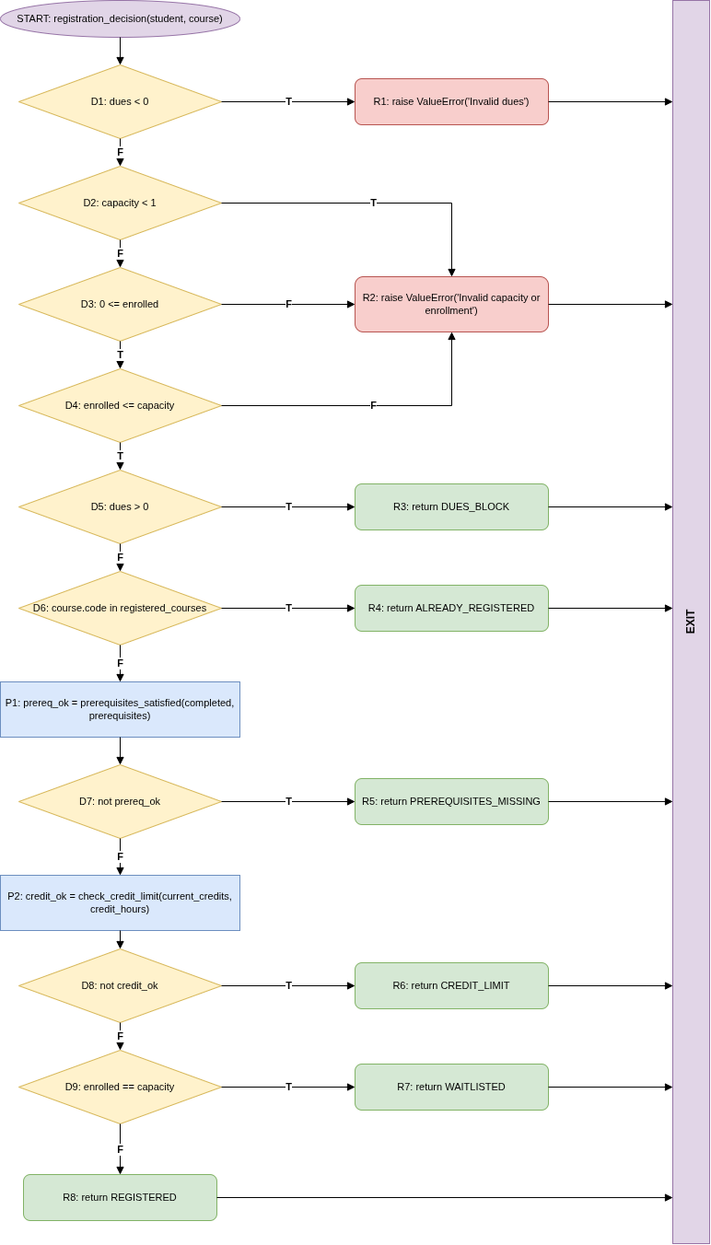

V(G) = E − N + 2
29 − 21 + 2 = 10

Decision nodes + 1
9 + 1 = 10

Path | Flipped decision | Test input | Expected | Covered by existing suite?
BP-01 | none (baseline) | baseline fixture | REGISTERED | Yes (A1-TID-7, A2-TID-7, DT-06)
BP-02 | D1 true | dues = -100 | Invalid dues | Yes (A1-TID-8)
BP-03 | D2 true | capacity = 0, enrolled = 0 | Invalid capacity or enrollment | No
BP-04 | D3 false | capacity = 30, enrolled = -1 | Invalid capacity or enrollment | No
BP-05 | D4 false | capacity = 30, enrolled = 31 | Invalid capacity or enrollment | Yes (A2-TID-10)
BP-06 | D5 true | dues = 1 | DUES_BLOCK | Yes (A2-TID-8, DT-01)
BP-07 | D6 true | registered = {“C1”} | ALREADY_REGISTERED | Yes (DT-02)
BP-08 | D7 true | prerequisites = {“CS101”}, completed = {} | PREREQUISITES_MISSING | Yes (DT-03)
BP-09 | D8 true | current_credits = 16 | CREDIT_LIMIT | Yes (DT-04)
BP-10 | D9 true | capacity = 30, enrolled = 30 | WAITLISTED | Yes (A2-TID-9, DT-05)

B2. Statement and Branch Coverage
Initially

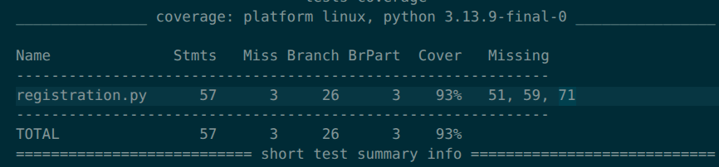

Added structural tests
Test ID | Targets | Input | Expected (from SRS)
WB-01 | BP-03, capacity < 1 alone | capacity 0, enrolled 0 | Invalid capacity or enrollment
WB-02 | BP-04, enrolled < 0 alone | capacity 30, enrolled -1 | Invalid capacity or enrollment
Coverage before and after the white-box additions

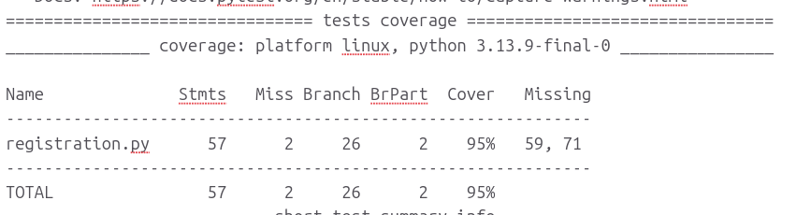

Initial run:
python -m pytest tests/test_blackbox.py --cov=registration --cov-branch --cov-report=term-missing
Result: 27 passed, 8 failed; 93% combined coverage. Missed statements: registration.py lines 51, 59, 71. Partial branches: 3.
White-box-added full run:
python -m pytest tests/ --cov=registration --cov-branch --cov-report=term-missing
Result: 33 passed, 10 failed; 95% combined coverage. Missed statements: registration.py lines 59, 71. Partial branches: 2.
The white-box suite adds eight tests. It exercises the validation path for dues and capacity and adds structural checks, increasing statement and branch coverage by one each. The two additional failed tests expose existing prerequisite and waitlist defects, so the overall failure count rises from eight to ten because white-box tests were added. The remaining uncovered waitlist and withdrawal statements reflect defects or unreachable code, not proof that those requirements are correct.

B3. Condition Coverage and MC/DC

1. Atomic conditions

Decision | Expression | Atomic conditions
D1 | dues < 0 | a1: dues < 0
D2 to D4 (compound) | capacity < 1 or not 0 <= enrolled <= capacity | A: capacity < 1, B: 0 <= enrolled, C: enrolled <= capacity
D5 | dues > 0 | dues > 0
D6 | code in registered_courses | membership test
D7 | not prerequisites_satisfied(...) | one call result
D8 | not check_credit_limit(...) | one call result
D9 | enrolled == capacity | enrolled == capacity
check_credit_limit (compound) | not 0 <= current <= 18, not 1 <= new <= 4 | 0 <= current, current <= 18, 1 <= new, new <= 4

2. Truth table

Row | A | B | C | D (raise) | Feasible with real inputs?
1 | T | N/E | N/E | T | Yes (capacity 0, enrolled 0)
2 | F | F | N/E | T | Yes (capacity 30, enrolled -1)
3 | F | T | F | T | Yes (capacity 30, enrolled 31)
4 | F | T | T | F | Yes (capacity 30, enrolled 10)

3. MC/DC test set

Test | Input (capacity, enrolled) | A | B | C | D | Outcome
MC-1 (T1) | 30, 10 | F | T | T | F | continues, no raise
MC-2 (T2) | 0, 0 | T | N/E (true) | N/E (true) | T | ValueError
MC-3 (T3) | 30, -1 | F | F | N/E (true) | T | ValueError
MC-4 (T4) | 30, 31 | F | T | F | T | ValueError

4. Manual calculation

Metric | Final | Calculation
Decision coverage | 100% | unchanged
Condition coverage | 100% | 6 of 6 outcomes
MC/DC | 100% | 3 of 3 conditions have independence pairs

5. Independence pairs for the capacity/enrollment decision
Decision: raise if A or not B or not C, using the condition labels in the tables above. Masking MC/DC is used (N/E means not evaluated because of short-circuiting).
Condition | Compared tests | Shows
A (capacity < 1) | MC-1 vs MC-2 | A alone changes the outcome from no raise to raise
B (0 <= enrolled) | MC-1 vs MC-3 | B alone changes the outcome from no raise to raise
C (enrolled <= capacity) | MC-1 vs MC-4 | C alone changes the outcome from no raise to raise
6. Credit argument validation in check_credit_limit
Decision | Atomic condition | MC/DC pair (valid -> invalid)
Current-credit range | A: 0 <= current | 10 -> -1 (B stays true)
 | B: current <= 18 | 10 -> 19 (A stays true)
Course-credit range | C: 1 <= new | 3 -> 0 (D stays true)
 | D: new <= 4 | 3 -> 5 (C stays true)

C1. Defects, GitHub Issues, and Fix Status
Issue | Requirement / observed defect | Status
#1 | FR-01: exact total of 18 credits returns False; implementation uses a strict less-than comparison. | OPEN; not fixed
#2 | FR-03: completing only some required prerequisites returns True; implementation checks any intersection. | OPEN; not fixed
#3 | FR-04: dues of Rs. 1 do not block; implementation blocks only when dues exceed Rs. 1000. | OPEN; not fixed
#4 | FR-08: course at capacity returns REGISTERED; later waitlist branch checks > capacity, which is rejected earlier by FR-15 input validation. | OPEN; not fixed
#5 | FR-13: withdrawal removes course and credits but does not decrement course.enrolled. | OPEN; not fixed
All five issues are open in the repository at the time of this report. The test reports record 8 black-box failures and 10 full-suite failures. No merged pull request fixes these defects. PR #6 explicitly adds structural waitlist tests and says the related defect is not fixed. PR #7 adds CI, coverage evidence and documentation and also says it does not fix the reported defects.
Issue references:
#1 https://github.com/Zeyam-Hussain/SQE_Assignment2_Registration_Student/issues/1
#2 https://github.com/Zeyam-Hussain/SQE_Assignment2_Registration_Student/issues/2
#3 https://github.com/Zeyam-Hussain/SQE_Assignment2_Registration_Student/issues/3
#4 https://github.com/Zeyam-Hussain/SQE_Assignment2_Registration_Student/issues/4
#5 https://github.com/Zeyam-Hussain/SQE_Assignment2_Registration_Student/issues/5

C2. Repository, Pull Requests, and Contributions
GitHub repository:
https://github.com/Zeyam-Hussain/SQE_Assignment2_Registration_Student
Pull request | Status | Contribution
#6 | Merged | Added structural tests for waitlist update behavior and preserved full-suite coverage evidence. Related to Issue #4; it does not fix the defect.
#7 | Merged | Added pytest/coverage GitHub Actions, trace marker and issue/PR templates; organized testing files in docs; added the black-box and decision-table workbooks, CFG image, PDF report, and README updates. It does not fix the reported defects.
PR references:
#6 https://github.com/Zeyam-Hussain/SQE_Assignment2_Registration_Student/pull/6
#7 https://github.com/Zeyam-Hussain/SQE_Assignment2_Registration_Student/pull/7
Contributor | Verified contribution
Zeyam Hussain (Zeyam-Hussain / zynex) | The only contributor returned by the repository contributors endpoint and the author of the project commits. Work includes the black-box test suite and test-suite optimization, initial/final white-box test and coverage evidence, white-box branch tests, GitHub issue reports, CI, and testing documentation.
Copilot is listed as a co-author in the metadata for PR commits, not as a student team member. No other repository contributor or submitted PR review was found in the repository records checked for this report. The PR review checklists request review by a different team member; no review entries were present in the PR review records.

C3. Repository Artifacts and Reproduction
Test sources:
tests/test_blackbox.py
tests/test_whitebox.py
Related evidence:
docs/blackbox_test_design.xlsx
docs/decision_table.xlsx
docs/cfg.png
docs/coverage_initial.txt
docs/coverage_final.txt
docs/final_whitebox_report.txt
docs/test_evidence.txt
docs/testing_report.pdf
Reproduce the initial black-box run:
python -m pytest tests/test_blackbox.py --cov=registration --cov-branch --cov-report=term-missing
Reproduce the full black-box and white-box run:
python -m pytest tests/ --cov=registration --cov-branch --cov-report=term-missing
The expected result is a non-zero test-run status while the five reported defects remain in the supplied implementation. The failing assertions and their requirement-based expected results are kept unchanged until the defects are fixed and regression-tested.

