Name:

PART A- Tableau Question - In order to use data, go to blackboard and select the number written in the right corner for Superstore data. Do your question in different worksheet and submit the tableau public links as one file to Blackboard. Make sure that the links provided by you is working. If the link does not work, you will get 0 from that question.Check format for your submission based on question A5.

A1). The graph below shows monthly sales data with minimum and maximum sales data for the chosen year. Create the following graph using Superstore data. You need to create a filter for years so that if you choose a different year, this plot changes accordingly as well. (10 points)

Hint: You will use WINDOW_MIN and WINDOW_MAX functions to get minimum and maximum values.

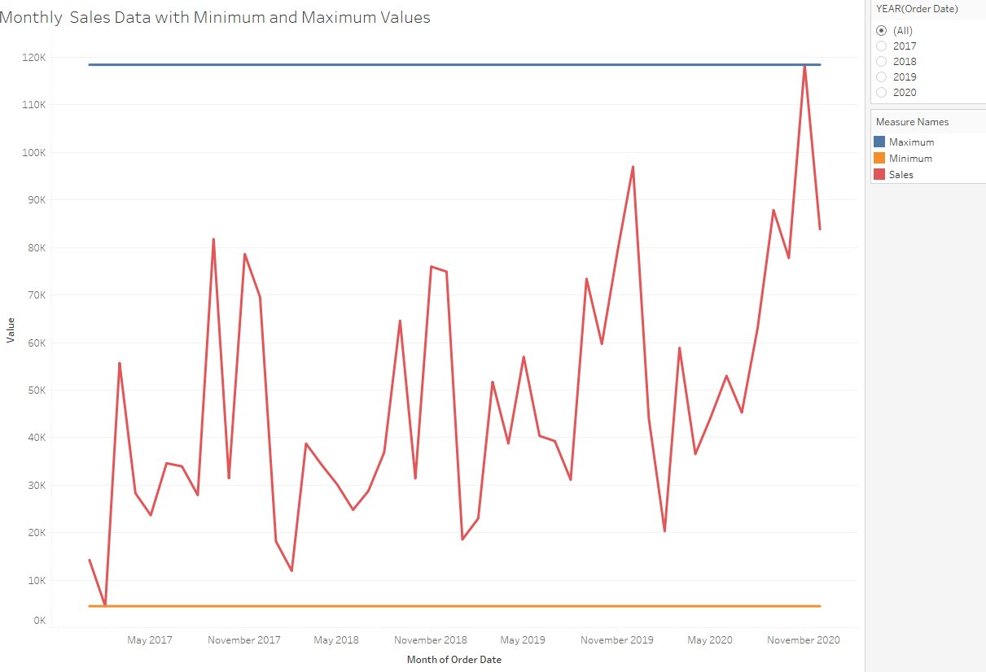

A2) In this question, you will create the following dashboard using Superstore data. The view below groups customers by the year of their first purchase to compare sales contributions annually. In order to find the first purchase date, you will get minimum of order date. In the second graph, you will create the percentage of sales based on the first graph. You also need to create filter for segment and once you choose different segment, these plots should change accordingly as well. (14 points)

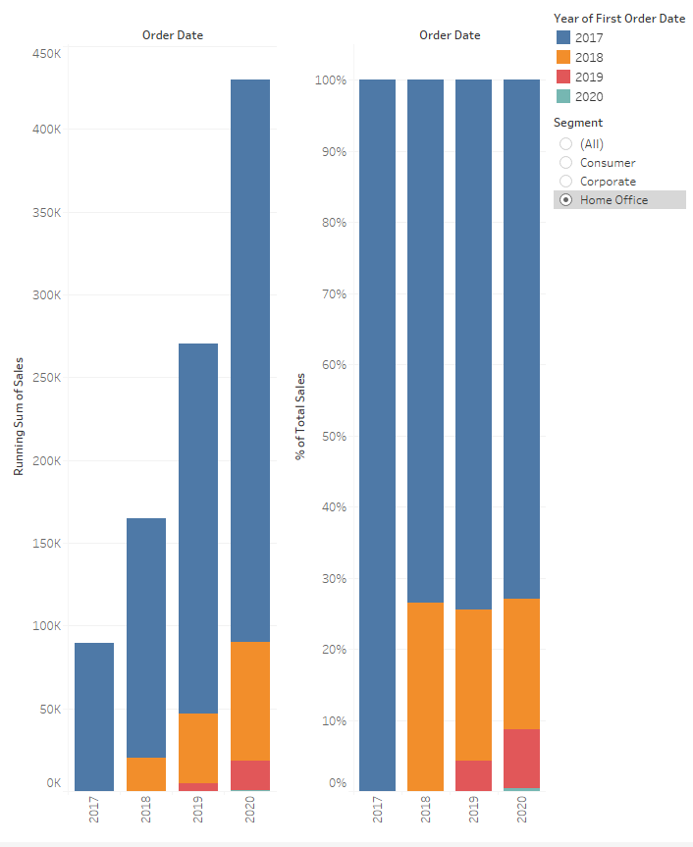

A3) The graph below shows tree map chart of sales data for each region for given year. If sales are high (low) in that region, larger (smaller) boxes represent that region in tree map chart. Create a similar graph using Superstore data. You need to create filter for year so that if you choose different year, this plot change accordingly as well. (10 points)

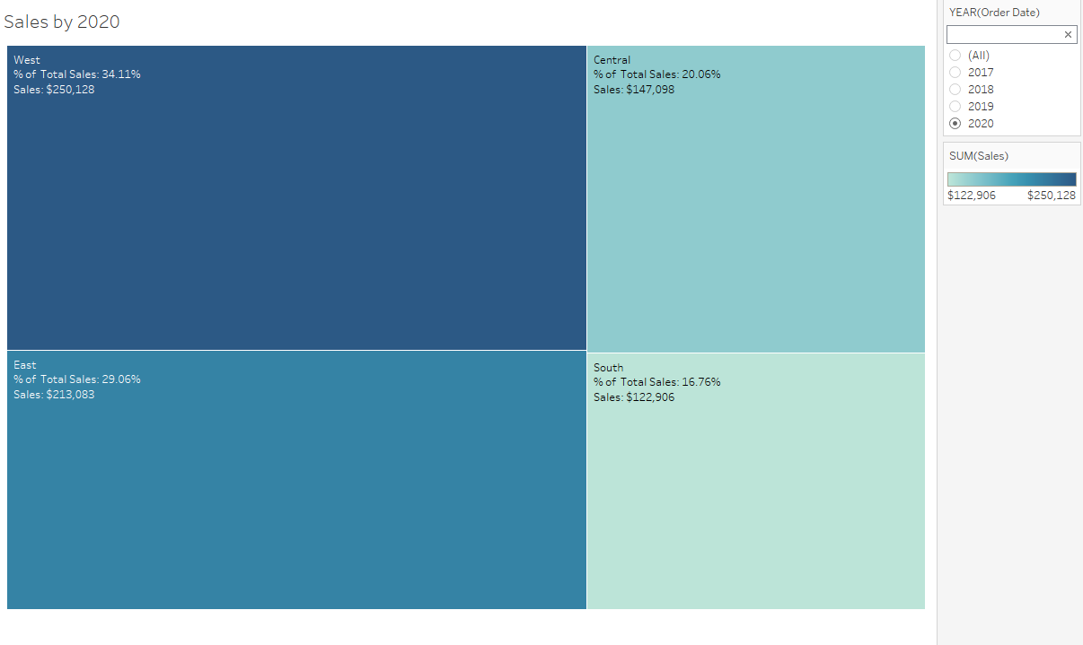

A4) Sales for each region, total sales amount and percentage of sales compared to total sales are given for each region in the table below. Using Superstore data, create similar tables. (10 points)

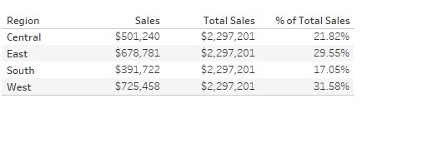

A5) Take a screenshot of each of your answer for 4 questions and put it into word file. Put link of each question into this file as well and submit through blackboard. (1 points