You can get maximum 100 points.

Name/ID/Number:

Part A-Tableau Question -Each Question worth 12 points. Total points from Part A and B can be maximum 100 points. Superstore data is given the link below for question A1,A2,A3 and A4. In order to use data, clcikdownload icon. Do your question in different worksheet and submit as one file to Blackboard as twbx file. Alternatively, post your answer to Tableau public and provide link for each question in a word file. Get the screenshoot of your answer and put into word file as well.

<https://github.com/ogut77/BA/blob/main/Midterm1.csv>

A1) Using Superstore data, create Monthly Profit by Segment graph in the following format. (12 points)

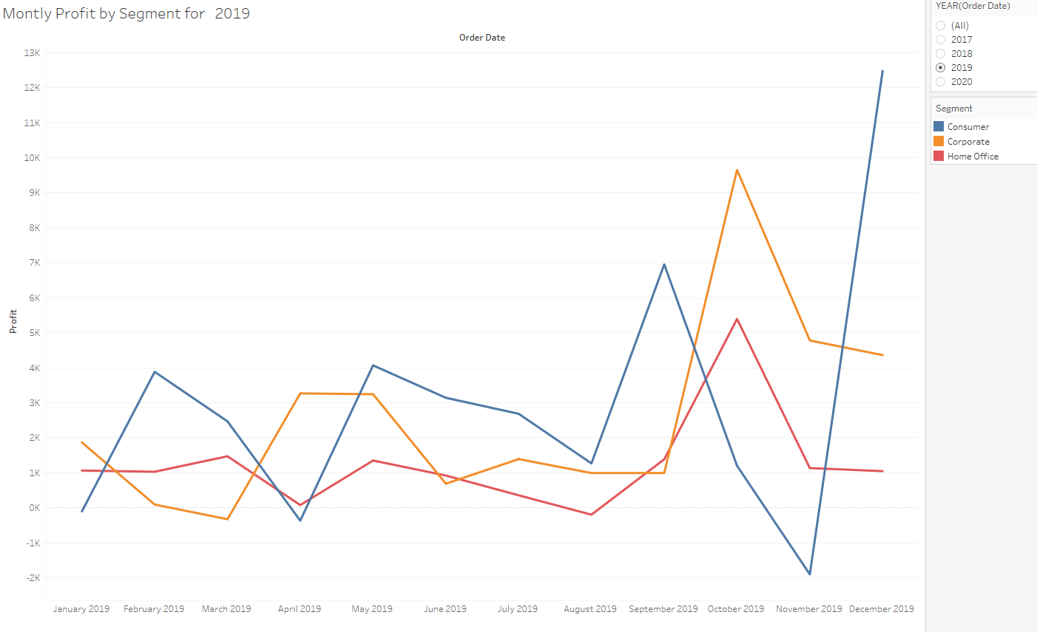

A2) Using Superstore data, create Monthly Sales & Profit by Segment Report in following format.

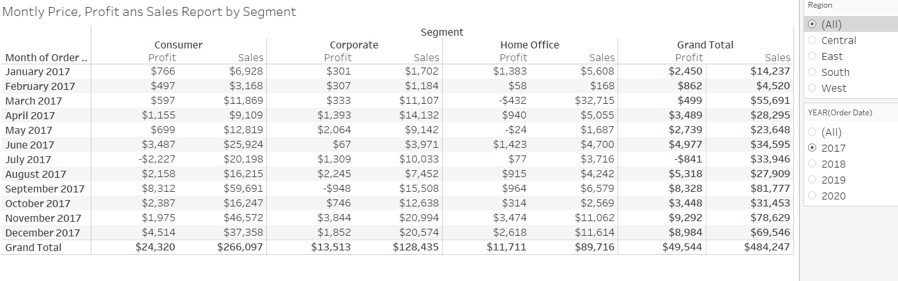

A3) Using Superstore data, answer following questions creating report in following format.

How many distinct sub- categories are there in each category in 2017? What is the profit, sales and average price for each category in 2017? (Hint: Price=Profit/Quantity)

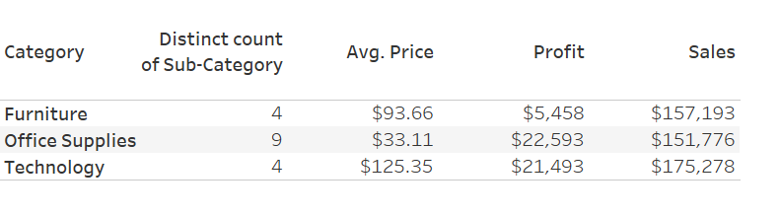

A4) Using Superstore data, create the graph below in the following format.

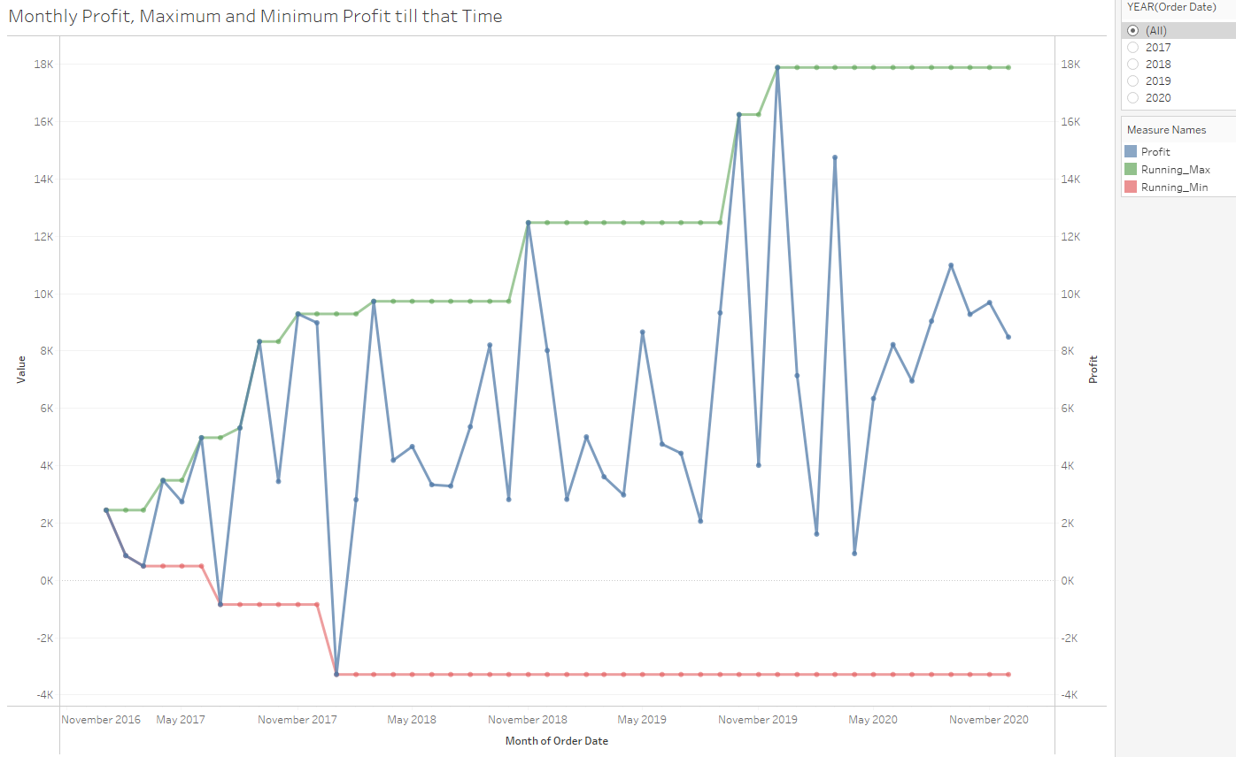

A5) Using the dataset given in the following URL, create average life expectancy by years for the country chosen from single dropdown list similar to the graph below. In order to use data, right clcik and save as

<https://github.com/ogut77/BA/blob/main/Midterm2.csv>

