Using Order Data, create following

1)Create Following Table

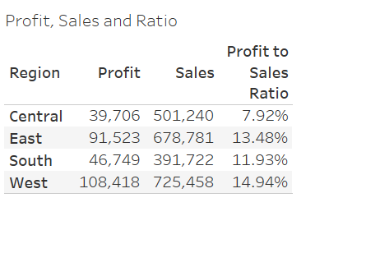

2)Create Following 2 Graph Using Dashboard (Hint: You will create two worksheets and combine into dashboard)

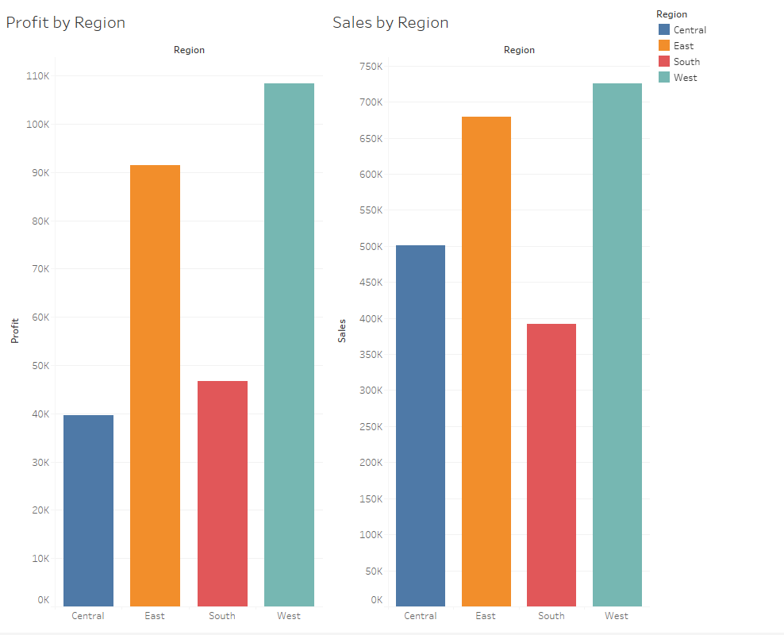

3)Create The Following Sales and Profit by Region Tables

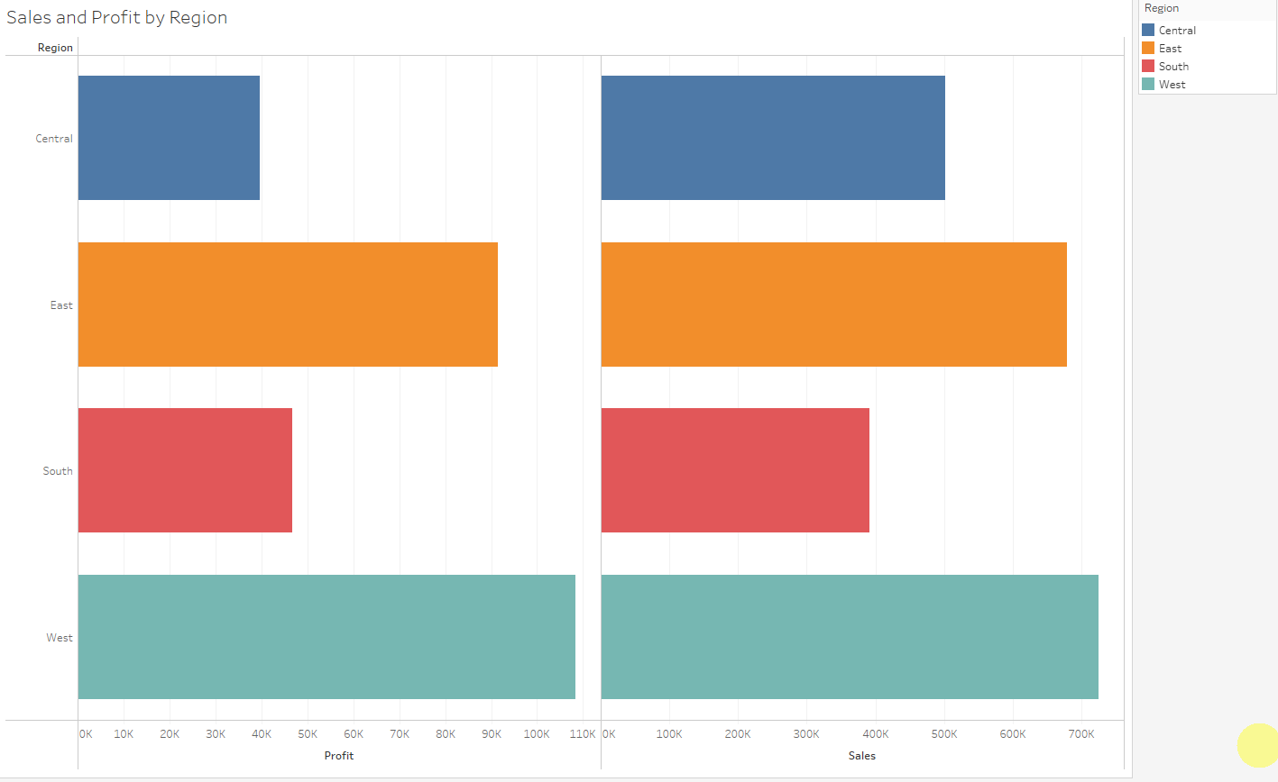

4)Create Following Monthly Sales by Region Tables for Specific Year (such as 2017 or 2016)

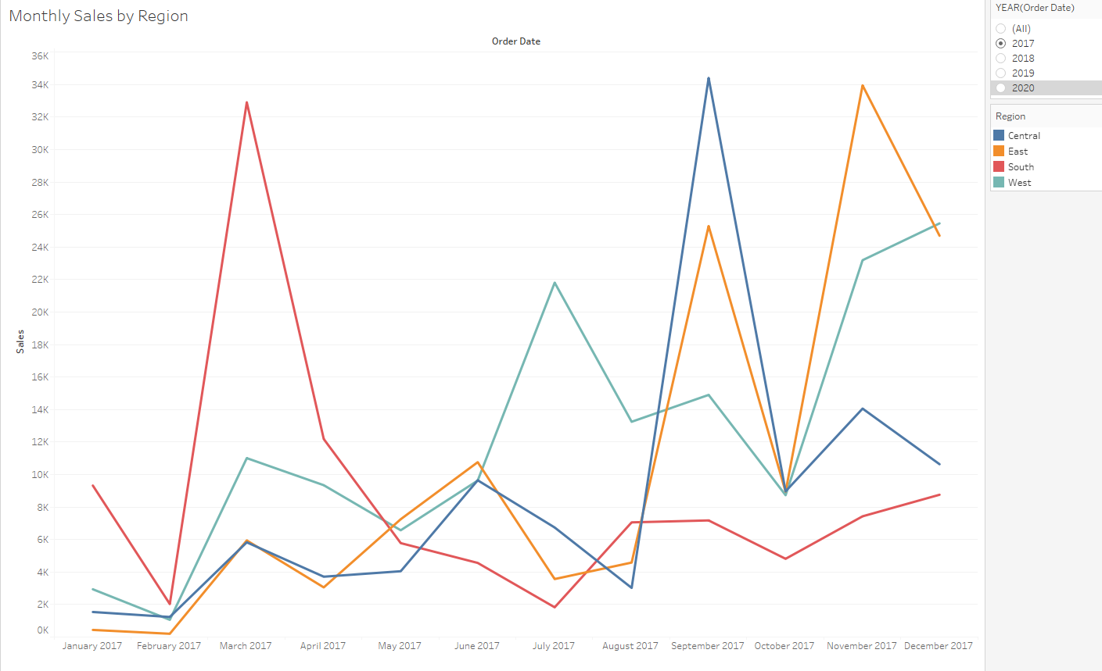

5)Create the following Monthly Sales Profit by Region Report

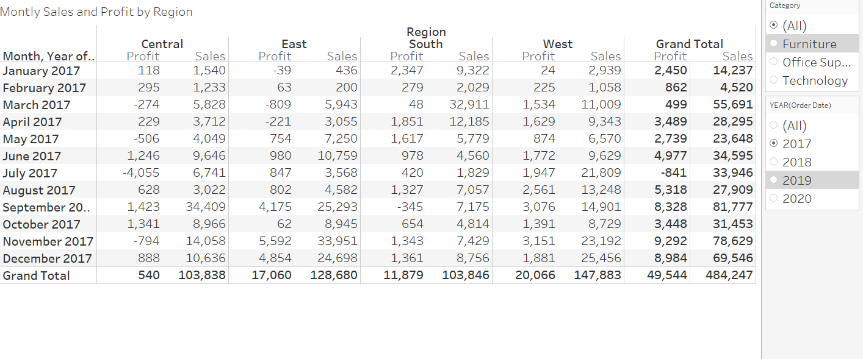

6)Create the following Individual Customer Sales Report (Note: You will get Price by creating Calculated Field Sales/Quantity)

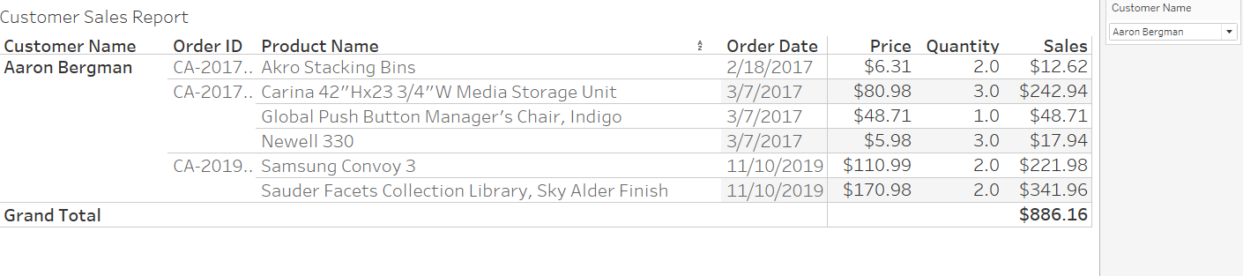

7) Homework 4- Using the Order Database Table

<https://github.com/ogut77/BA/blob/main/OrderDB.xls>

First, you need to join tables using Tableau. Then, create two reports similar to below.

<https://public.tableau.com/app/profile/hulisi.ogut/viz/CustomerOrderReport_16651320735140/CustomerReport>

<https://public.tableau.com/app/profile/hulisi.ogut/viz/CusitmerProductOrderReport/Product>

8-(Similar to Homework 5 but you will do this using Tableau Desktop)

https://github.com/ogut77/BA/blob/main/OrderDB.xls

Using the Order Database Table from above link and Tableau Desktop get the following two output files. (Hint: You will join required tables and get this output by aggregate. You need to create calculated field for Total Value as well.

a) Find each order's total amount and how many different products are there in each order

b) Find total sales and quantity sold for each product. What is the total quantity sold for each product? How many times has this product ordered?

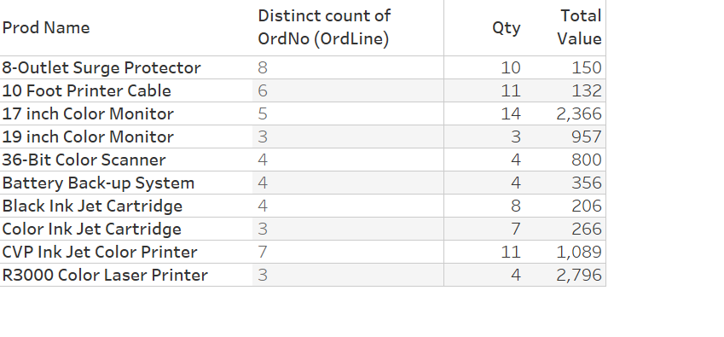

9)-Homework 6

Using the files below, Create total value of open transaction graphs similar to below. Note: There are two sheets in this file. In addition to main sheet (Transaction), you can find dates for January in Dates sheet <https://github.com/ogut77/BA/blob/main/Hw6Q2.xlsx>

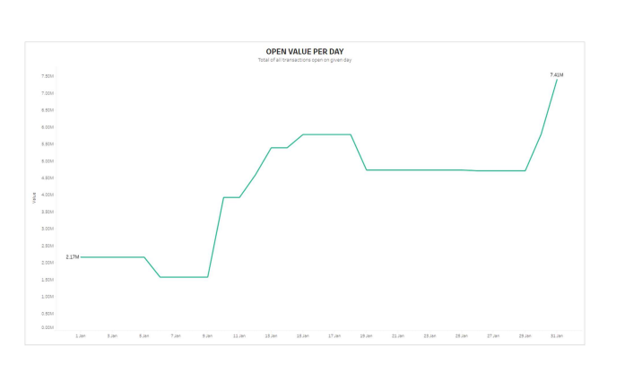

10) Using

<https://github.com/ogut77/BA/blob/main/population_total.csv>

Generate the following two graphs/map

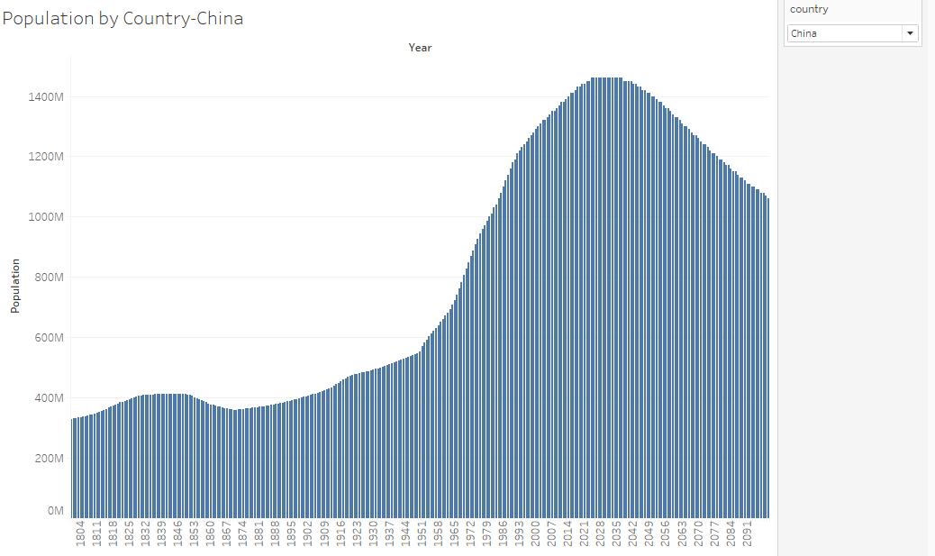

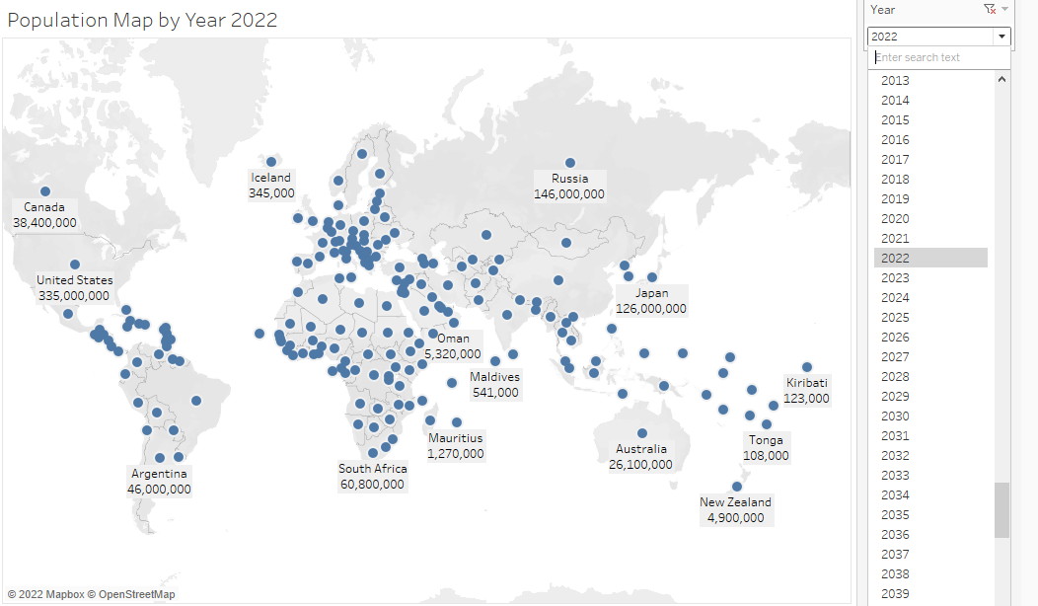

11) Chapter 4

<https://public.tableau.com/app/profile/hulisi.ogut/viz/Chapter4_16663464482850/Patients-Scaffolding>

Blend-ShirtPants

Blend-HM

Patient-Pivot

Patient-GantChart

Patient-Scaffolding

12)Chapter 5-Worksheet form Chapter 5

<https://public.tableau.com/app/profile/hulisi.ogut/viz/Chapter5ClassSolution/DirectionalNon-Directional?publish=yes>

Chapter 7 is not included in the Midterm Exam