Gebze Technical University
Computer Engineering

CSE 222 - 2018 Spring

HOMEWORK 7 REPORT

ZEYNEB AKDOĞAN
181041038

Course Assistant: Fatma Nur Esirci

Q1

Problem Solution Approach
Listgraph, Vertexlerden oluşan ArrayList ve edges lerden oluşan List tanımlandı.

Test Cases
List of Edges
from Source 0
0 - 1 w: 74.0
0 - 2 w: 45.0
0 - 4 w: 45.0
0 - 6 w: 84.0

from Source 1
1 - 2 w: 65.0
1 - 4 w: 86.0
1 - 5 w: 2.0

from Source 2
2 - 4 w: 65.0
2 - 6 w: 90.0
2 - 5 w: 48.0

from Source 3
3 - 5 w: 1.0
3 - 9 w: 68.0

from Source 4
4 - 6 w: 100.0
4 - 8 w: 38.0

from Source 5
5 - 6 w: 83.0
5 - 9 w: 87.0

from Source 6
6 - 7 w: 31.0
6 - 8 w: 96.0

from Source 7
7 - 8 w: 26.0

from Source 8
8 - 9 w: 28.0

from Source 9

Show that this func results ->
- plot_graph:

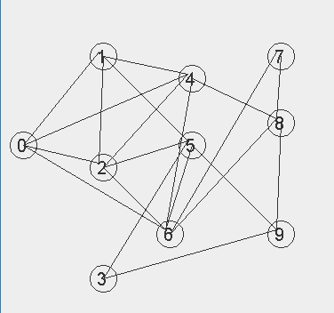

- is_undirected: Graph is directed (okları yapamadım)
- is_acyclic_graph: Graph is acyclic
- shortest_path (use least 3 different label pair):
Shortest PAth from 0 to 9
- (0 , 4) w: 45.0
- (4 , 8) w: 38.0
- (8 , 9) w: 28.0
- Shortest PAth from 3 to 9
- (3 , 9) w: 68.0
- Shortest PAth from 3 to 8
- (3 , 5) w: 1.0
- (5 , 6) w: 83.0
- (6 , 7) w: 31.0
- (7 , 8) w: 26.0

Q2

Problem Solution Approach

Test Cases
List of Edges
from Source 0
0 - 1 w: 1.0
0 - 2 w: 1.0
0 - 4 w: 1.0
0 - 6 w: 1.0

from Source 1
1 - 0 w: 1.0
1 - 3 w: 1.0
1 - 5 w: 1.0
1 - 5 w: 1.0

from Source 2
2 - 0 w: 1.0
2 - 7 w: 1.0
2 - 9 w: 1.0

from Source 3
3 - 1 w: 1.0

from Source 4
4 - 0 w: 1.0
4 - 10 w: 1.0
4 - 11 w: 1.0

from Source 5
5 - 1 w: 1.0
5 - 1 w: 1.0
5 - 13 w: 1.0

from Source 6
6 - 0 w: 1.0

from Source 7
7 - 2 w: 1.0

from Source 8

from Source 9
9 - 2 w: 1.0

from Source 10
10 - 4 w: 1.0
10 - 12 w: 1.0

from Source 11
11 - 4 w: 1.0

from Source 12
12 - 10 w: 1.0
12 - 14 w: 1.0

from Source 13
13 - 5 w: 1.0

from Source 14
14 - 12 w: 1.0

Show that this func results ->

- plot_graph:

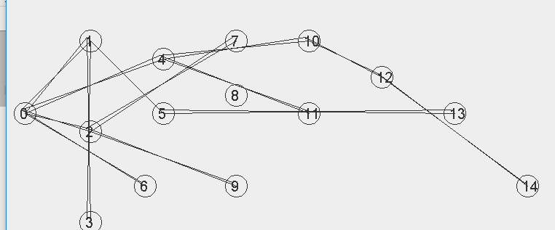

- is_undirected: Graph is undirected
- is_acyclic_graph: Graph is acyclic
- is_connected function (use least 3 different label pair)

Q3
This part about Question3 in HW7

Problem Solution Approach

Test Cases
List of Edges
from Source 0
0 - 1 w: 1.0
0 - 2 w: 1.0
0 - 4 w: 1.0
0 - 6 w: 1.0

from Source 1
1 - 0 w: 1.0
1 - 2 w: 1.0
1 - 4 w: 1.0
1 - 5 w: 1.0

from Source 2
2 - 0 w: 1.0
2 - 1 w: 1.0
2 - 4 w: 1.0
2 - 6 w: 1.0
2 - 5 w: 1.0

from Source 3
3 - 5 w: 1.0
3 - 9 w: 1.0

from Source 4
4 - 0 w: 1.0
4 - 1 w: 1.0
4 - 2 w: 1.0
4 - 6 w: 1.0
4 - 8 w: 1.0

from Source 5
5 - 1 w: 1.0
5 - 2 w: 1.0
5 - 3 w: 1.0
5 - 6 w: 1.0
5 - 9 w: 1.0

from Source 6
6 - 0 w: 1.0
6 - 2 w: 1.0
6 - 4 w: 1.0
6 - 5 w: 1.0
6 - 7 w: 1.0
6 - 8 w: 1.0

from Source 7
7 - 6 w: 1.0
7 - 8 w: 1.0

from Source 8
8 - 4 w: 1.0
8 - 6 w: 1.0
8 - 7 w: 1.0
8 - 9 w: 1.0
8 - 10 w: 1.0
8 - 11 w: 1.0

from Source 9
9 - 3 w: 1.0
9 - 5 w: 1.0
9 - 8 w: 1.0
9 - 12 w: 1.0
9 - 13 w: 1.0

from Source 10
10 - 8 w: 1.0

from Source 11
11 - 8 w: 1.0
11 - 14 w: 1.0
11 - 13 w: 1.0
11 - 12 w: 1.0

from Source 12
12 - 9 w: 1.0
12 - 11 w: 1.0
12 - 14 w: 1.0
12 - 13 w: 1.0

from Source 13
13 - 9 w: 1.0
13 - 11 w: 1.0
13 - 12 w: 1.0
13 - 14 w: 1.0

from Source 14
14 - 11 w: 1.0
14 - 12 w: 1.0
14 - 13 w: 1.0
Show that this func results ->
- plot_grap:
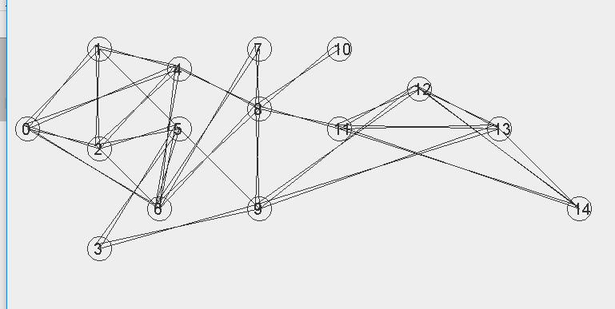

- is_undirected: Graph is undirected
- is_acyclic_graph: Graph is cyclic
- DepthFirstSearch (Show that spanning tree) gösteremedim.
- BreathFirstSearch (Show that spanning tree) gösteremedim.

Q4
If you used the handwriting, add this part 1 page pdf include answer of Q4.



