**Step-by-Step PB&J Preparation**

A Peanut butter and jelly sandwich is an American delicacy, which is loved and enjoyed by children and adults. You can have this delicacy for breakfast, lunch, or even dinner. It is also practical to prepare; so, in five minutes or less you will have a meal ready to eat. In this paper, I am going to explain a step-by-step procedure to help you make your own peanut butter and jelly sandwich.

Let’s start with the ingredients.

**Ingredients**

1. Your favorite brand of peanut butter (For one sandwich, we will need two tablespoons of peanut butter. If you are a real peanut butter lover, then you can use more peanut butter).

This part is tricky; if you are not familiar with peanut butter, then I can suggest some of my favorite brands. Skippy and Jif are my favorite brands; however, there are many other brands that are available in a local grocery store. If you are a careful consumer, another important part of selecting a jar of peanut butter is selecting the kind in terms of texture. The two main types that are available are creamy (totally processed creamy texture) and chunky (with chunks of peanut pieces inside, rather than being completely creamy).

2. A bag of pre-sliced white bread (For one sandwich, we will need two slices of bread).

Again, there are many kinds and brands of breads available in grocery stores. You can choose your favorite brand. For this assignment I used white, pre-sliced “Wonder” brand bread. In addition, you can use your bread either toasted or untoasted. I will leave mine untoasted.

3. A jar of grape jelly (For one sandwich, we will need one tablespoon of jelly. If you like more jelly, then you can use more jelly).

I use my favorite brand “Smucker’s” concord grape jelly. However, you can use any brand and any kind of jelly or jam. If you like crushed fruit pieces in your sandwich then use jam instead of jelly.

Optional: If you do not like any type of jelly or jam, then you can use banana slices instead to add fruit flavor to your peanut butter sandwich (For one sandwich we will use half of a regular banana or one whole baby banana, sliced).

**Materials:**

1. Several cleaning wipes.

2. A wooden or plastic cutting board (If you do not have a cutting board, then you can use a dinner plate or a napkin).

3. A butter knife (If you do not have a butter knife, any kind of a kitchen knife or a spoon will do).

4. A tablespoon.

**Procedure (Assumes all ingredients and tools are readily available):**

1. Inspect the counter top for cleanness.
2. If the counter top is not clean, clean it with a cleaning wipe.
3. Once you conclude that the counter top is clean, place the following ingredients and tools on it: a bag of white bread, a jar of crunchy (or creamy) peanut butter, a jar of concord grape jelly (or any other kind of jam/jelly), a butter knife, a tablespoon, and a wooden cutting board.
4. Open your bag of white bread.
5. Take out two bread slices.
6. On the wooden cutting board place the two slices of white bread side-by-side.
7. Take the lid off your peanut butter jar.
8. Scoop one tablespoon of peanut butter.
9. Spread the peanut butter on one of the bread slices.
10. Is there enough peanut butter on the bread slice?
11. If not, then scoop another tablespoon of peanut butter and spread it on the slice of bread.
12. When there is enough peanut butter on the bread slice, spread the peanut butter evenly on the bread slice.
13. Take the lid off your grape jelly jar.
14. Scoop one tablespoon of jelly.
15. Spread the jelly on top of the bread slice with peanut butter on it.
16. Is there enough jelly on the bread slice?
17. If not, scoop another tablespoon of jelly and spread it on the slice of bread.
18. When there is enough jelly on the bread slice, spread the jelly evenly on the bread slice.
19. Put the other bread slice on top of the slice which has peanut butter and jelly on it.
20. Enjoy your delicious peanut butter and jelly sandwich.

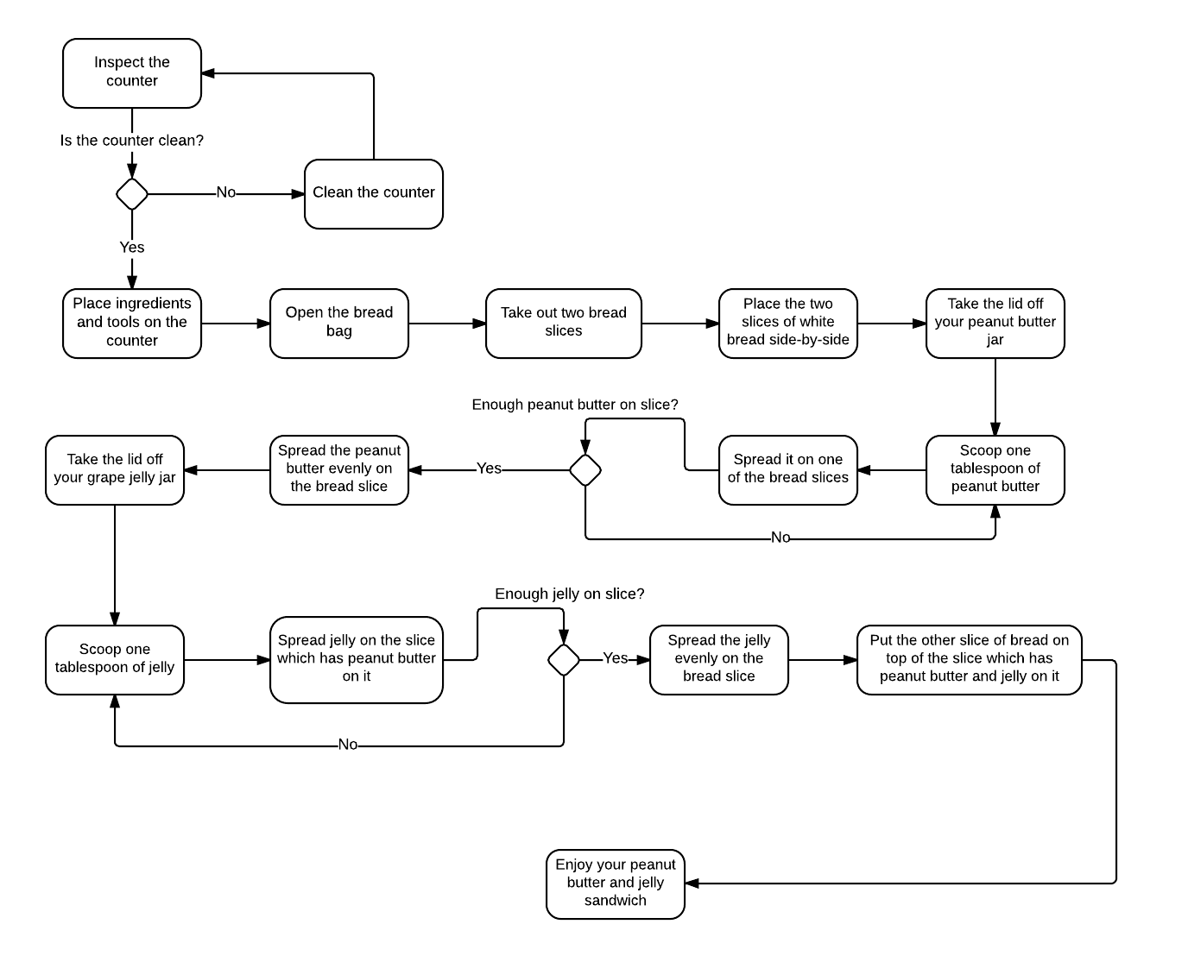

Word count: 722 (Excluding text in the figure above).