**Work Plan for Team MEZ**

**Project on Nutrition, Physical Activity, and Obesity Data**

**Reference**

Nutrition, Physical Activity, and Obesity - Behavioral Risk Factor Surveillance System. (2017, July 14). Retrieved September 10, 2017, from <https://catalog.data.gov/dataset/nutrition-physical-activity-and-obesity-behavioral-risk-factor-surveillance-system>.

**Planned Timeline for Completing the Project**

|  |  |  |  |  |
| --- | --- | --- | --- | --- |
| **Assignment** | **Due** | **Due Date** | **Lead** | **Estimated Hours** |
| Work Plan | Week 6 | 10/3/2017 | MEZ | 4 |
| Data preparation | Week 10 | 10/31/2017 | Elif | 9 |
| Progress Meeting | Week 10 | 10/31/2017 | MEZ | 2 |
| Draft R Script | Week 12 | 11/14/2017 | Michelle | 10 |
| Draft R Plot | Week 13 | 11/21/2017 | Zeynep | 10 |
| Project Presentation | Week 15 | 12/5/2017 | Michelle | 7 |
| Git Repository | Finals | TBD | Zeynep | 2 |

We assigned a “Lead” for each step in the project who will be responsible for scheduling meetings, keeping the team on task, and submitting the assignment. However, we will all work on all parts of the project for the sake of learning and hands-on experience. For example, in the Data Preparation piece, Elif will take the lead in scheduling our initial meeting and our discussion to determine the best format. Then each of us will take one region to prepare its data - MD, VA, or DC. In reality it would be much more efficient if the same person did all three, but we want to ensure we all gain experience with each part of the project.

See Gantt chart below for a visual representation of the project timeline. We will update subcategories of major project steps as the project moves forward and our classes better inform us on the necessary steps, such as how to use the R program. The online Gantt chart tool includes assignments and estimated hours. We will update this throughout our project.

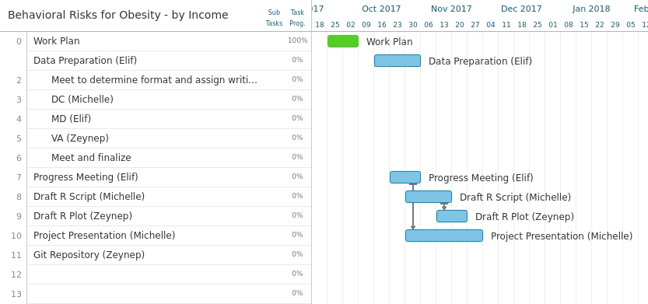

**Research Questions**

Our research questions ask the relationship between obesity and income, the behavioral habits associated with higher rates of obesity, and how this can inform programs aimed at reducing obesity. How does weight status correlate with income? Does obesity decrease as income level increases? The dataset divided the income levels as: Less than $15,000; $15,000 - $24,999; $25,000 - $34,999; $35,000 - $49,999; $50,000 - $74,999 and $75,000 or greater. We expect to find that as the income level decreases, the percentage of obese or overweight population increases. If data is consistent with our theory, we will ask which habits of the overweight or obese population differ the most widely compared to those with weight status other than overweight or obese? Then we can look more into details for what factors and habits correlate to obesity.

**Target Audience**

Health expenditures constitute a large part of the government budget through programs such as Medicaid and Medicare, and many health problems are due to or exacerbated by obesity. Private businesses also have difficulty remaining competitive if health expenditures, health related absentia, and health insurance premiums increase. This dataset includes national and state specific data on adults aged 18 years or older who are considered obese or overweight, and behavioral data such as the percentage of adults who report consuming fruits or vegetables less than once a day or engage in muscle-strengthening activities on a regular basis.

The analyses of this project can help health government agencies such as U.S. Department of Health and Human Services, National Institute of Health, Food and Drug Administration in their effort to promote healthy behaviors. Lower-income families face additional barriers to healthy habits like food costs, food deserts, and less leisure time for physical activity. Several government programs attempt to address this, like food stamps and WIC. This analysis will help us understand behavioral changes needed to reduce obesity, and better inform the focus of programs with this goal.

Word Count (excluding reference and Word Count): 579