**Summary**

**Audience & Analysis Targets**

Our audience includes decision makers for programs that serve low-income communities, including government agencies and private foundations. For example our persona is a Program Officer in the Aetna Foundation, which awards grants to nonprofits working with underserved populations on various social determinants of health (Hartford 2017). Health expenditures overall constitute an important part of the government budget through programs such as Medicaid and Medicare which tend to increase with obesity. Private businesses also have difficulty remaining competitive if health expenditures, health related absentia, and health insurance premia increase.

1. Obesity is getting worse for all income groups.
2. Obesity disproportionately affects the poor.
3. The gap in obesity between high and low income groups is increasing, and is much worse in some states than other. This indicates a larger part of the problem is access to resources instead of cultural or other reasons.

**Source Data & Processing**

The dataset is Nutrition, Physical Activity, and Obesity - Behavioral Risk Factor Surveillance System, from the Centers for Disease Control and Prevention of the US Department of Health and Human Services. It includes national and state specific annual data between 2011 to 2015 on adults aged 18 years or older. Subcategories are age, gender, race, education and income. Dataset reports the rates of obesity, overweight status, and behavioral questions. Raw data has 48,772 observations (rows) and 33 variables (columns). Unit of observation is state (not individual responses).

Dataset is aggregated by various demographic variables, as opposed to each row being one individual’s response. For each demographic category we have a set of panel data. Therefore, our panel data has more than one cross sectional dimension. This causes an aggregation problem and information loss which occurs in the substitution of aggregate, or macro level, data for individual data, or micro level data.

Nutrition, Physical Activity, and Obesity - Behavioral Risk Factor Surveillance System. (2017,

October 13). Retrieved October 30, 2017, from https://chronicdata.cdc.gov/api/views/hn4x-zwk7/rows.csv?accessType=DOWNLOAD.

**Plot & Interpretation**

Our final plot shows the obesity rates of the lowest income group and the gap between the obesity rates of the lowest income group and the highest income group. This is the key plot of our analysis, emphasizing that programs addressing obesity in underserved communities should prioritize locations where not only obesity is high, but more importantly, where the gap is large. This implies that obesity in these states is more strongly related to access to resources.

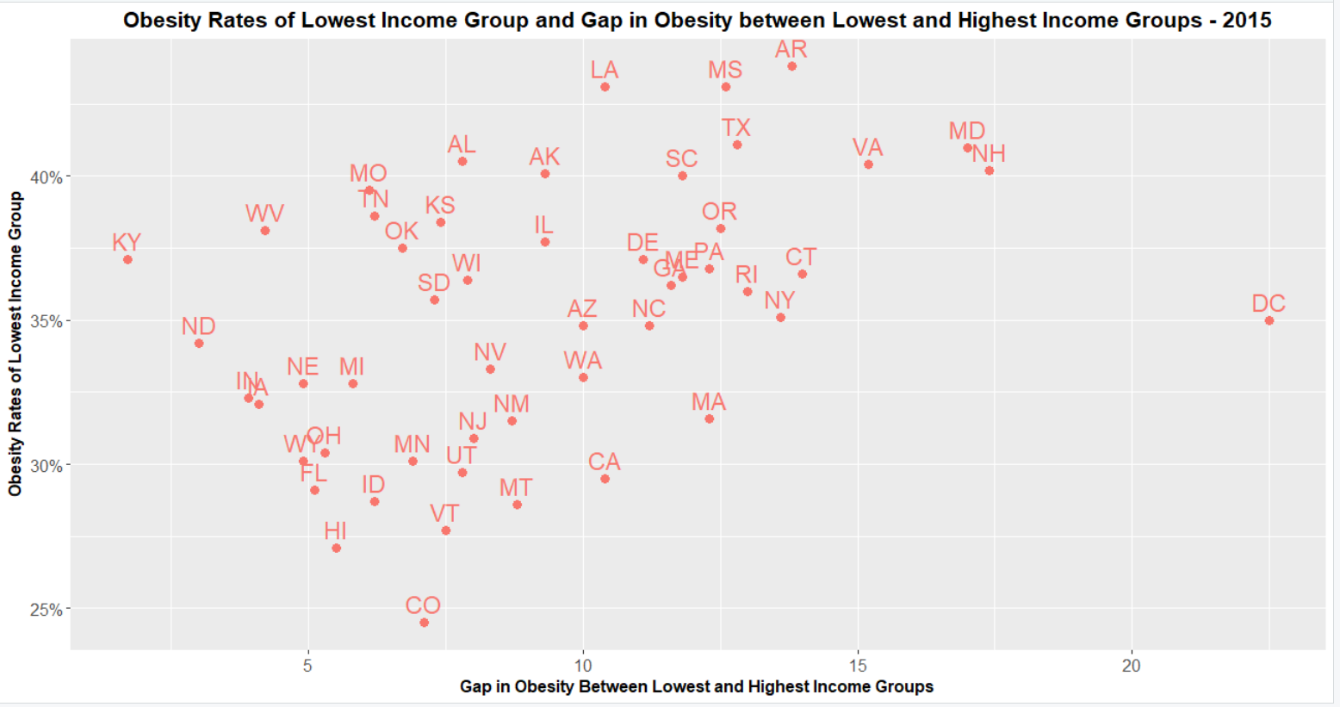

**Argument for Audience Decision**

Aetna Foundation should strengthen its focus on programs that address obesity. This is in line with Aetna Foundation’s mission to help underserved communities because obesity disproportionately affects low income groups, and the gap in obesity between high and low income is increasing.  
  
Aetna Foundation should look for and support programs where obesity gap is largest such as DC, New Hampshire, Maryland, Virginia, Arkansas, and Connecticut. In these states, the large gap indicates that the problem is not simply regional or cultural differences, but a lack of access to resources which can be more effectively addressed by programs serving low-income communities.

**Sources**

Hartford. (2017, March 16). Aetna Foundation Opens Call for Local Nonprofits to Cultivate Healthier Communities Through $2 Million Grant Program. Retrieved 2017, March 16 from

<http://news.aetnafoundation.org/press-release/foundation/aetna-foundation-opens-call-local-nonprofits-cultivate-healthier-communitie>

Word Count (excluding sources): 481