1) Can ordered and unordered lists nested within each other?

Yes, we can nest the two types of lists within each other. Just like we can nest an unordered or an ordered list within another list of their own type, we can also nest an unordered list within an ordered list, or an ordered list within an unordered list. Below is an example page showing possible combinations:

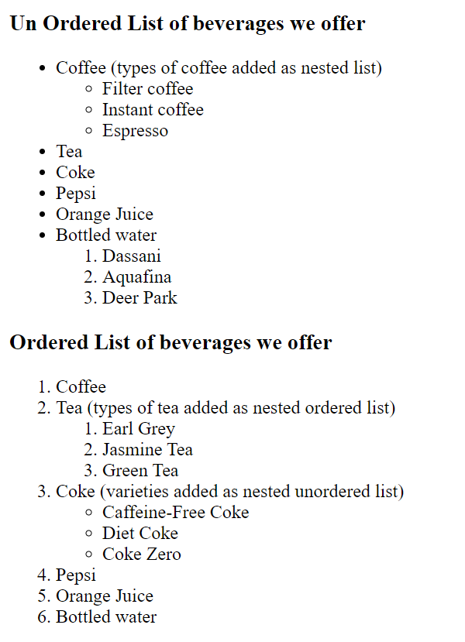

2) Is it possible to nest an ordered list within an unordered list or vice versa?

Yes, it is possible to nest an ordered list within an ordered list, or an unordered list within an ordered list. The example above shows the possible combinations. For the code, see the submitted HTML file (W2-Quiz-Q1-Q2_Zeynep_Diker.html)

3) Give example showing customizing of ordered and unordered list?

We can customize the bullets of an unordered or an ordered list by using either CSS, or the “type” attribute of the <ul> or the <ol> tag. Some common unordered list bullets we can use are type=“square”, type=“disc”, and type=“circle”. Some common ordered list bullets we can use are type=“a” (lowercase letters: a, b, c, d, etc.), type=“A” (uppercase letters: A, B, C, D, etc.), type=“i” (lowercase roman numerals: i, ii, iii, iv, etc.), and type=“I” (uppercase roman numerals: I, II, III, IV, etc.). Please see example page below, and for the code, see the submitted HTML file (W2-Quiz-Q3_Zeynep_Diker.html)

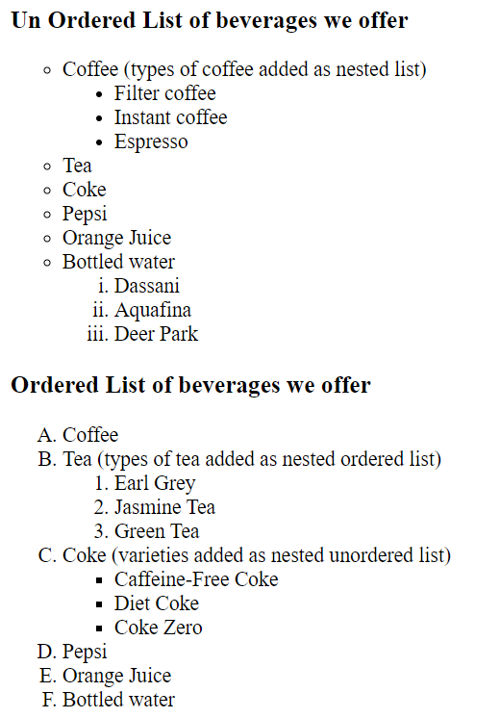

4) Describe basic parts of a table and tags used to identify them?

A table in HTML is made up of rows, which are made up of cells. The main pair of tags for declaring a table are <table></table>. All of the rows and cells go inside those two tags. The tag pair for declaring a row are <tr></tr> (‘tr’ = table row). The cells are nested within rows, and are declared using the tag pair <td></td> (‘td’ = table data, since each cell holds a piece of data that makes up the table). Then there are <thead></thead>, <tfoot></tfoot>, and <tbody></tbody> tag pairs, which define the three main parts of a table: header, footer, and body. These last three pairs are optional and can be omitted while building a table. If they are used, the rows and cells should be nested under each one of those parts appropriately. Rows are listed as <th> under <thead> and <tfoot>, (not <tr>). For sample code, see the submitted HTML file (W2-Quiz-Q4 _Zeynep_Diker.html)

5) How do you create cells that span more than one column or row?

We can create cells that span more than one column by using the ‘colspan’ attribute within a <tr> tag, and cells that span more than one row by using the ‘rowspan’ attribute within a <tr> tag.

6) Create a nested table that contains 4 rows and 5 columns. Create a second table that contains 3 rows and 2 columns inside 3rd row and 4th col of parent table.

Please see the submitted HTML file (W2-Quiz-Q6_Zeynep_Diker.html)

7) Write down styling attributes you can use while creating table and explain what they do.

The following are some of the most commonly used table styling attributes:

align: specifies horizontal alignment of text in cells, (such as left, center, right)

background-color: specifies the background color of cells in words (“red”), or RGB numbers (“FF0000”)

border: defines whether the table will have a border, and how think the border will be

border-spacing: defines border spacing between cells; a higher value means cells are further apart

colspan: defines how many columns the given cell will cover

padding: specifies the amount of margin added to the cells

rowspan: defines how many rows the given cell will cover

valing: specifies vertical alignment of text in cells, (such as top, middle, bottom)

width: specifies how wide the table, or a given cell or column will be, either in pixels or percentage