1. STM32’nin voltajını ölçmek istersek:

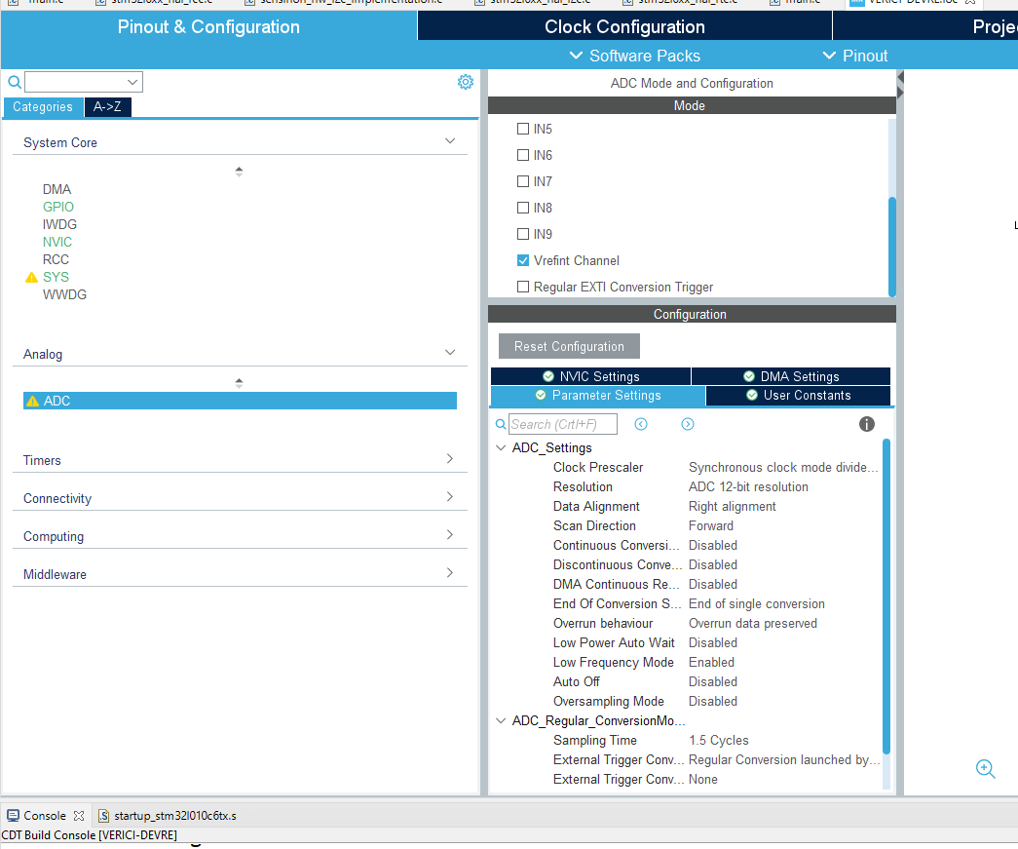
ADC Kısmından→ Vrefint enable et

/* USER CODE BEGIN PD */
//Bu değer işlemcinin datasheet’inden bak
#define VREFINT_CAL_ADDR 0x1FF80078
#define VREFINT_CAL ((uint16_t*) VREFINT_CAL_ADDR)
/* USER CODE END PD */

/* USER CODE BEGIN 2 */
//1 defalığına doğru ölçüm yapabilmek için kalibre ayarı yapıyoruz
HAL_ADCEx_Calibration_Start(&hadc,ADC_SINGLE_ENDED);
/* USER CODE END 2 */

while (1)
{
/* USER CODE END WHILE */

/* USER CODE BEGIN 3 */
HAL_ADC_Start(&hadc);
HAL_ADC_PollForConversion(&hadc, 100);
uint16_t VREFINTADC = HAL_ADC_GetValue(&hadc);
HAL_ADC_Stop(&hadc);
float VDD=3000.0*(*VREFINT_CAL/ (float)VREFINTADC);

}
/* USER CODE END 3 */

2. kodları biçimlendirmek istersen istediğin dosyaya sağ tıkla → source->format

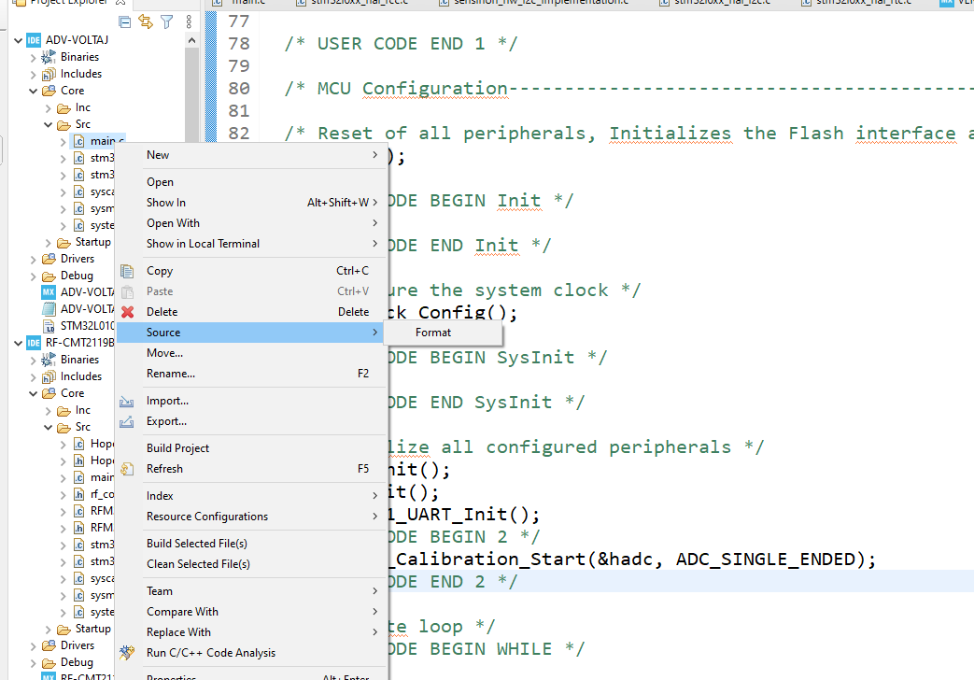

3. HAL_UART_TRANSMIT Fonksiyonu yerine
/* USER CODE BEGIN Includes */
#include <string.h>
#include <stdio.h>
#define printf(...) HAL_UART_Transmit((UART_HandleTypeDef *)&hlpuart1, (uint8_t *)u_buf,\
sprintf((char*)u_buf,__VA_ARGS__), 0xFFFF);
uint8_t u_buf[256];
/* USER CODE END Includes */
kodunu kullan örneğin:

printf("basladi\r\n");
printf("Time--%d:%d:%d\r\n",nTime.Hours,nTime.Minutes,nTime.Seconds); //Output time
printf("buffer toplam: %s\r\n",buffer);

4. RTC İle Standby kodu
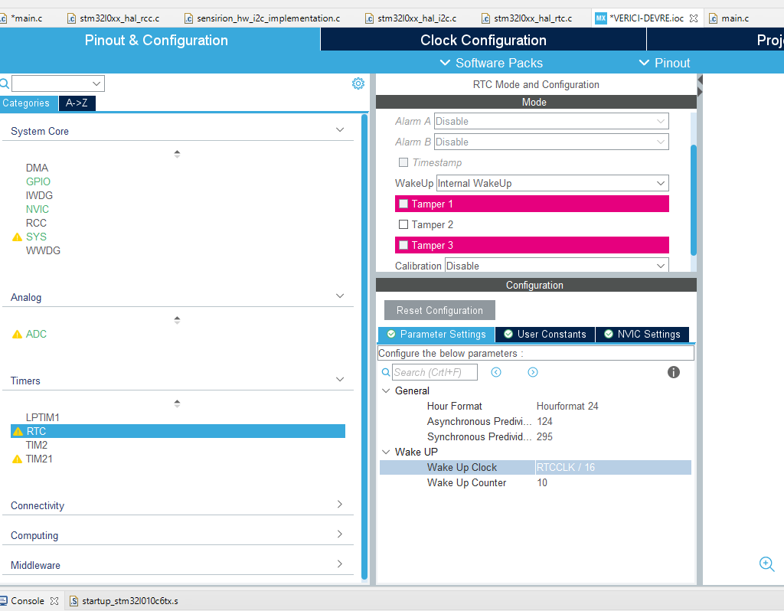

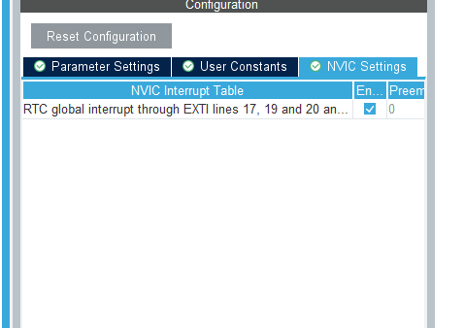

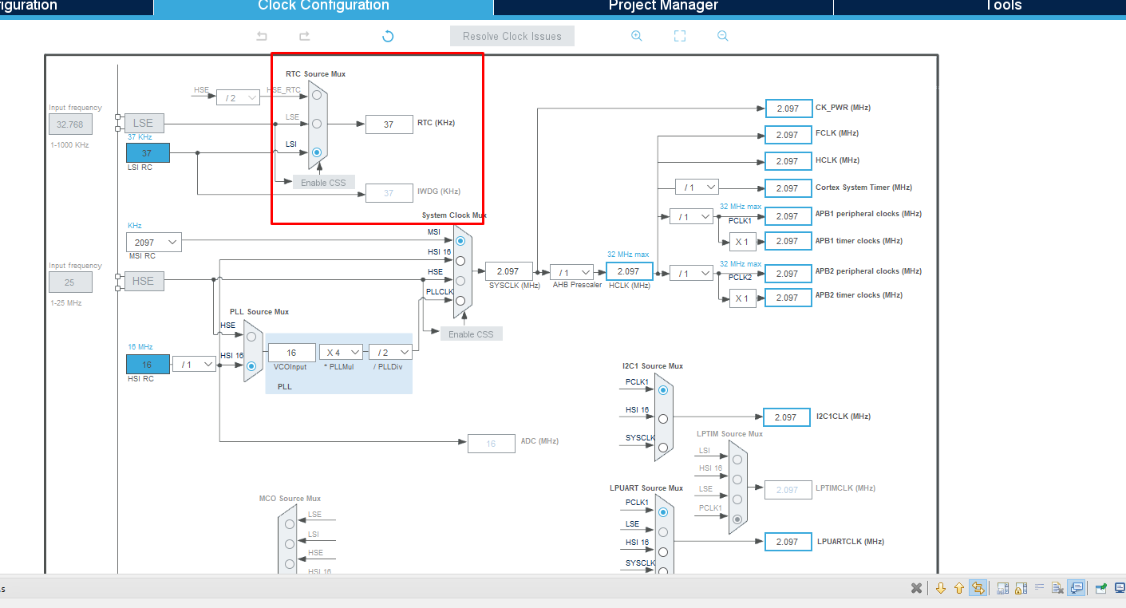
WakeUpCounter buradaki değere göre hesaplanır.
Örneğin 10 saniye olmasını istiyoruz:

To configure the wake up timer to 4s the WakeUpCounter is set to 0x1FFF:
RTC_WAKEUPCLOCK_RTCCLK_DIV = RTCCLK_Div16 = 16
Wakeup Time Base = 16 /(~37.000kHz) = ~0,432 ms
Wakeup Time = 10s = 0,432 ms * WakeUpCounter
==> WakeUpCounter = ~10s/0,432 ms = 23125 = 0x5A55

https://controllerstech.com/low-power-modes-in-stm32/#:~:text=The%20Standby%20mode%20allows%20to,oscillator%20are%20also%20switched%20off.

int main ()
{
..............
.............
if (__HAL_PWR_GET_FLAG(PWR_FLAG_SB) != RESET)
{
__HAL_PWR_CLEAR_FLAG(PWR_FLAG_SB); // clear the flag

/** display the string **/
char *str = "Wakeup from the STANDBY MODE\n\n";
HAL_UART_Transmit(&huart2, (uint8_t *)str, strlen (str), HAL_MAX_DELAY);

/** Blink the LED **/
for (int i=0; i<20; i++)
{
HAL_GPIO_TogglePin(GPIOA, GPIO_PIN_5);
HAL_Delay(200);
}

/** Disable the WWAKEUP PIN **/
HAL_PWR_DisableWakeUpPin(PWR_WAKEUP_PIN1); // disable PA0

/** Deactivate the RTC wakeup **/
HAL_RTCEx_DeactivateWakeUpTimer(&hrtc);
}

/** Now enter the standby mode **/
/* Clear the WU FLAG */
__HAL_PWR_CLEAR_FLAG(PWR_FLAG_WU);

/* clear the RTC Wake UP (WU) flag */
__HAL_RTC_WAKEUPTIMER_CLEAR_FLAG(&hrtc, RTC_FLAG_WUTF);

/* Display the string */
char *str = "About to enter the STANDBY MODE\n\n";
HAL_UART_Transmit(&huart2, (uint8_t *)str, strlen (str), HAL_MAX_DELAY);

/* Blink the LED */
for (int i=0; i<5; i++)
{
HAL_GPIO_TogglePin(GPIOA, GPIO_PIN_5);
HAL_Delay(750);
}

/* Enable the WAKEUP PIN */
HAL_PWR_EnableWakeUpPin(PWR_WAKEUP_PIN1);

/* enable the RTC Wakeup */
/* RTC Wake-up Interrupt Generation:
Wake-up Time Base = (RTC_WAKEUPCLOCK_RTCCLK_DIV /(LSI))
==> WakeUpCounter = Wake-up Time / Wake-up Time Base

To configure the wake up timer to 5s the WakeUpCounter is set to 0x2710:
RTC_WAKEUPCLOCK_RTCCLK_DIV = RTCCLK_Div16 = 16
Wake-up Time Base = 16 /(32KHz) = 0.0005 seconds
==> WakeUpCounter = ~5s/0.0005s = 20000 = 0x2710
*/
if (HAL_RTCEx_SetWakeUpTimer_IT(&hrtc, 0x2710, RTC_WAKEUPCLOCK_RTCCLK_DIV16) != HAL_OK)
{
Error_Handler();
}

/* one last string to be sure */
char *str2 = "STANDBY MODE is ON\n\n";
HAL_UART_Transmit(&huart2, (uint8_t *)str2, strlen (str2), HAL_MAX_DELAY);

/* Finally enter the standby mode */
HAL_PWR_EnterSTANDBYMode();

/* USER CODE END 2 */

/* Infinite loop */
/* USER CODE BEGIN WHILE */
while (1)
{
/* USER CODE END WHILE */

/* USER CODE BEGIN 3 */
}
/* USER CODE END 3 */
}

5. input outuput yapma modu
"HopeDuino_SPI3.c" içine

void InputSDIO(void)
{

GPIO_InitTypeDef GPIO_InitStruct = {0};

/* GPIO Ports Clock Enable */
__HAL_RCC_GPIOH_CLK_ENABLE();
__HAL_RCC_GPIOA_CLK_ENABLE();

/*Configure GPIO pin : GPO3_Pin */
GPIO_InitStruct.Pin = SDIO_Pin;
GPIO_InitStruct.Mode = GPIO_MODE_INPUT;
GPIO_InitStruct.Pull = GPIO_NOPULL;
HAL_GPIO_Init(SDIO_GPIO_Port, &GPIO_InitStruct);
}
void OutputSDIO(){
GPIO_InitTypeDef GPIO_InitStruct = {0};

/* GPIO Ports Clock Enable */
__HAL_RCC_GPIOH_CLK_ENABLE();
__HAL_RCC_GPIOA_CLK_ENABLE();

/*Configure GPIO pin Output Level */
HAL_GPIO_WritePin(SDIO_GPIO_Port, SDIO_Pin, GPIO_PIN_RESET);

/*Configure GPIO pins : CSB_Pin FCSB_Pin SCLK_Pin SDIO_Pin */
GPIO_InitStruct.Pin = SDIO_Pin;
GPIO_InitStruct.Mode = GPIO_MODE_OUTPUT_PP;
GPIO_InitStruct.Pull = GPIO_NOPULL;
GPIO_InitStruct.Speed = GPIO_SPEED_FREQ_LOW;
HAL_GPIO_Init(GPIOA, &GPIO_InitStruct);

}

"HopeDuino_SPI3.h" içinde

void InputSDIO(void);
void OutputSDIO(void);
……………………………………………………………………………………………….

#define SDIO_H() (HAL_GPIO_ReadPin(SDIO_GPIO_Port, SDIO_Pin) == 1)
#define SDIO_L() (HAL_GPIO_ReadPin(SDIO_GPIO_Port, SDIO_Pin) == 0)
#define SetSDIO() (HAL_GPIO_WritePin(SDIO_GPIO_Port, SDIO_Pin, 1))
#define ClrSDIO() (HAL_GPIO_WritePin(SDIO_GPIO_Port, SDIO_Pin, 0))

