Project report

Name (UID), Zeyu Liao(zeyu9)

In this project, we based on "Deep learning for hand gesture recognition on skeletal data" implement a hand gesture recognition model and several applications based on it.

**Motivation and impact:**

Human action recognition is a challenging but essential task in computer vision, with a wide range of potential applications, such as health care and military applications. Within the field, we focus on hand gesture recognition this specific area. Deep neural networks have shown promising results in this field and combining them with computational photography techniques can lead to exciting new possibilities. We chose this topic, to learn and implement natural human gesture recognition so that we can utilize it in the online e-commerce industry. How the project work. We hope to learn how computational photography techniques that we learned in CS445 can create values combined with deep neural networks.

**Approach:**

Our project could be split into three main part, pre-process, training model, and application. We tried two dataset mentioned in the paper and choose the better performance one. The paper uses two model, Kera and PyTorch. We implement Pytorch based on the paper. We have referenced part of paper’s code, but we did not fully copy from the paper.

**Results:**

Our model achieves about same accuracy on the training and test sets compare with the paper’s result (Figure 1).

Unfortunately, our real word hand gesture detection does not work very well. Our results indicate that our implementation of hand gesture is not very accurate. Our model will give several prediction results. Results include the correct result, but the correct result is not the most common one (see Figure 3).

Implementation details:

In this project, we use Jupyter Notebook and use following packages: sklearn, glob, numpy, pickle, ndimage, train_test_split, itertools, torch, sklearn.utils, time, math, PIL, torchvision.transforms, and tensorboardX. For the dataset, we pre-processed DHG-14/28 Dataset and the SHREC’17 Track Dataset, but we end up with using SHREC’17 Track Dataset for the model.

Datasets Citation: Dynamic Hand Gesture Recognition using Skeleton-based Features ,Quentin De Smedt, Hazem Wannous and Jean-Philippe Vandeborre, 2016 IEEE Conference on Computer Vision and Pattern Recognition Workshops (CVPRW). Download from http://www-rech.telecom-lille.fr/DHGdataset/ and unzip into ./415-finalproject/dataset_dhg1428

**Challenge / innovation:**

Describe what you think was challenging or innovative about your project. Explain the effort required to interpret unclear steps to a paper’s implementation or get a proposed new idea to work. Write and justify how many points you expect to receive for the challenge/innovation component of grading

**Demo Video:**

Link1:

Figure 1: Model accuracy

Figure 2: Evaluation of the model

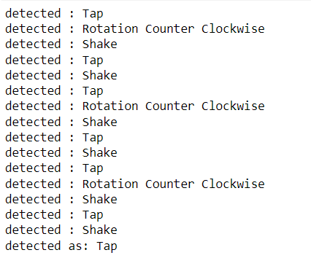

Figure 3: Real world image detection result

(detected as indicate the most common detect result)

**Citation:**

Devineau, Guillaume, Fabien Moutarde, Wang Xi, and Jie Yang. "Deep learning for hand gesture recognition on skeletal data." In 2018 13th IEEE International Conference on Automatic Face & Gesture Recognition (FG 2018), pp. 106-113. IEEE, 2018.