Butterworth_IIR_LP_DF_impinvar



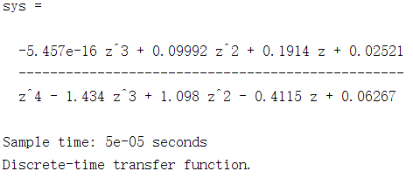

Butterworth_IIR_LP_DF_bilinear



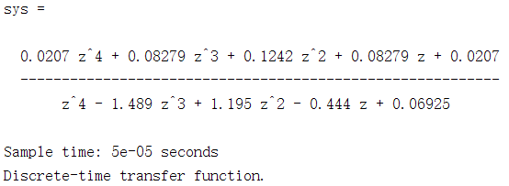

Ellipse_IIR_LP_DF_impinvar



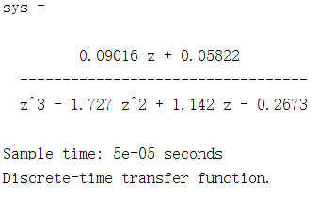

Ellipse_IIR_LP_DF_bilinear



