Financial instruments
Session 2 – 22/02/2019

Please write a synthetical report of your work.
Your report must professional and good-looking: print pretty charts, bring some valuable analysis, and be straightforward
Your file must be renamed like this: name1_name2.pdf (PDF only) and uploaded on box.com (folder Session2) before MIN(time at which the FIRST GROUP has submitted the file + 15 minutes ; 17h30).

Any file that does not meet the requirement in red won’t be evaluated.
dropBox.com : Login sergewerle@gmail.com , pwd ensiie

What you’ll learn. Understanding equity derivatives (price evolution, delta, time value…) + option combinations.

This exercise is very hard. Don’t waste your time.

1/ Intrinsic value, time value of a call option OVER TIME

Open the pricer.xlsx file.
This is a basic, very basic call option: the call price is on column F, depending on the value of the 5 main parameters of the same line.
You’ll have the price of 3 call options for underlying having different strikes. Of course you can modify the input parameters freely and see the impact on the call price. Just for fun at this stage.

Columns K and L you’ll have the historical data of a given virtual underlying (for 1Y). You can print the chart to have a look. Every time you press F9 the underlying will change. That will allow you to test your derivatives on various underlying behaviors.

In this exercise you’ll always parameterize your pricer with an underlying volatility of 20%, and a risk-free rate of 1%. But other parameters may vary (spot price, strike, remaining maturity).

Let’s say we’re on the 01/01/2019 on you want to buy an ATM call option on the underlying, with a maturity of 1Y. What’s the buying price of such option?

Now, be smart and adapt your Excel file so as to be able to compute the call price evolution, every day from 1/1/2019 to 31/12/2019, depending on the new spot value of the Underlying. So every day the spot price moves, but be aware that’s not the only input parameter that will vary over time.

Once that’s done, split the call option price into “intrinsic value” and “time value”.

Print a smart chart to show your results: Underlying price over time + call price over time + split intrinsic/time values.

Now, compute, day after day, the delta of your call option. Print them on a separate chart.

Press F9 to see different possibilities of evolution for the Underlying. Pick some nice ones (3 different at least). And give great analyses on them.

2/ Let’s step up with a call-spread now
A call spread (K1/K2) is the combination of :
- Buying a call option of strike K1
- Selling a call option of strike K2 with K2>K1, on the same underlying of course

First of all, print the classical chart of (payoff at maturity) = f [S(T)] for a given call spread. You can do it on Paint to do it quickly.

What’s the advantage of a call spread over a classical call option? In what kind of case should I buy a call spread instead of a simple call?

So here we’ll consider a (1000/1100) call spread on our Underlying.

Then, make what’s necessary so as to rerun the exercise 1 with the present call spread, so compute:
- Price over time
- Split of price between intrinsic and time value
- Delta of your call spread (when the Underlying rises by 1€, what is the sensitivity of my call spread? This is the delta)

Again, select a few interesting Underlying evolutions by pressing F9 and analyze them.

3/ Intrinsic value, time value of a call option AT DIFFERENT POINTS OF TIME

Consider a 2Y-call option (T=2), on a given underlying, with a strike K=1000.
Use the pricer for different points in time (t=0,…t=2Y) and with different hypothetical values of St (900,910,…) to replicate (more or less) the following chart. And show me you understood it.

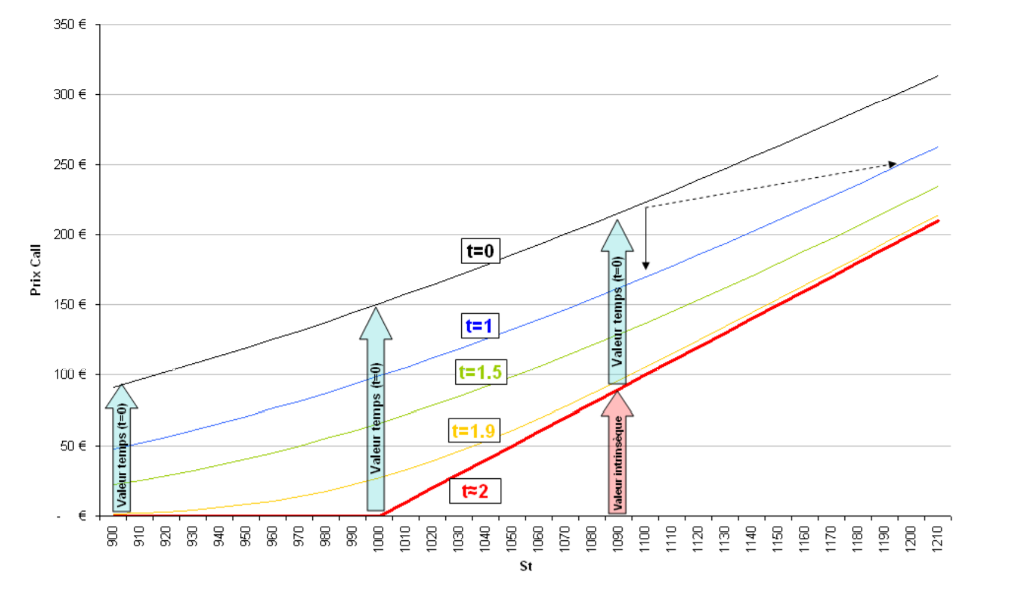

4/ Delta chart
The delta of a call is between 0 and 1.

Consider the following call option:
Underlying volatility = 20%
Strike=1000€
Risk-free rate = 1%
(Initial remaining) Maturity = 1Y

Print the chart of Delta = f[S(t)] for a given time t, let’s say 1 year before maturity (so at time 0).
So, you’ll make the computation of Call option Delta for some hypothetical values of S(t) (let’s say 10 values ranging between 800€ and 1200€). Remember: the Call strike is always at 1000€.
Basically the chart will tell you, at inception, depending on the Underlying spot value, what would be the Delta of a 1000€-strike call option on it.

Analyze your chart of course

Then, print the same chart of Delta = f[S(t)] but for t=0.5Y (so the remaining maturity is 0.5Y)

And then, print the same chart of Delta = f[S(t)] for t~=1Y so a few minutes before maturity, (so the remaining maturity is 0.01Y).

How can you explain the evolution of the Delta curve?

