Debrief Meeting Protocol

This document covers the steps that the experimenter must take to complete a successful introduction meeting. It covers the following:

1. Setting up the Laptop for the meeting
2. Downloading data from the Shimmer device
3. Interviewing the Participant
4. Compensating the Participant.
5. Checking the Post Analysis Checklist

Notes:

1. The Shimmer device may not behave as expected all the time, but it is possible to troubleshoot the device and retrieve the data from the device.
2. The text suggests what to say to a participant. Feel free to talk in your own words and have a natural conversation.

# Setup

This example will use Participant ID P2187 throughout the document. **Participant ID’s must start with a capital P, followed by the number 2.** It is important that no mistakes are made when typing in the Participant ID.

Setup the Laptop for the survey

1. Switch on the laptop and use the password “clemson” to login.
2. Sign in to the wifi
   1. Click on the Network ID on the laptop in the bottom right. Click connect to EDUROAM.
   2. Use your Clemson email id ending in clemson.edu (Not g.clemson.edu). eg: [spsharm@clemson.edu](mailto:spsharm@clemson.edu)
   3. Use your Clemson password
3. Launch the Debrief Survey icon on the Desktop
4. Maximise the Screen

## Welcome the participant

1. Ask the participant for their device and Participant Handout card.
   1. The card should have the Participant ID on it. It is alright if they do not have their participant handout card, you can find the ID from the Shimmer device.
2. If the participant has their ID, ask them to complete the exit survey on their laptop. Otherwise wait till Step 4 of “Downloading data from the device” to find this out.

## Download the data from the Device

**On the laptop connected to the dock:**

1. Remove any Shimmers with a battery level greater than 75% from the dock and put them in the “Available” box. This is not a required step but speeds up the process.
2. Start Consensys if it is not started already
   1. Click Manage Device when asked.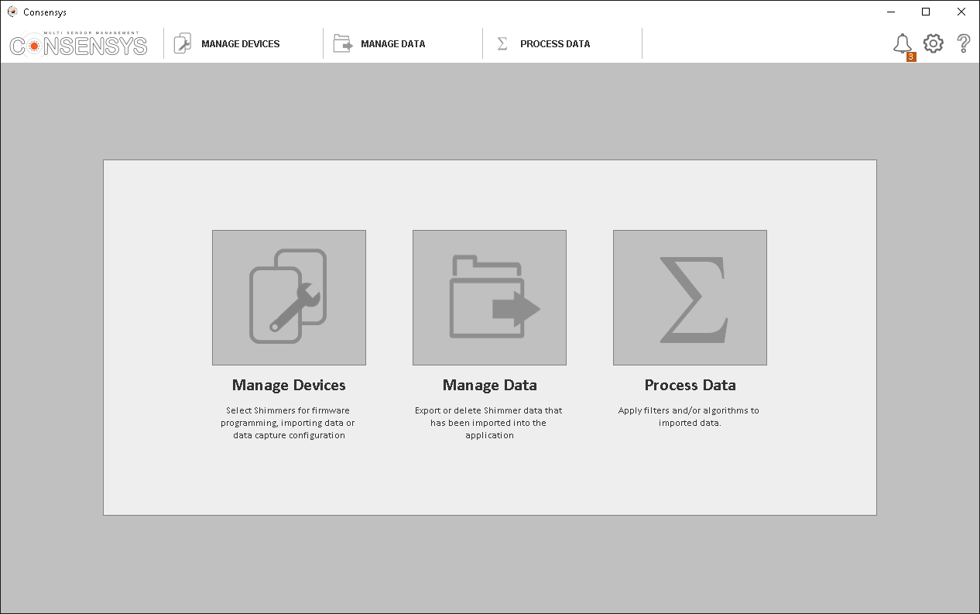
3. Connect the participants Shimmer to the Dock.
4. Find this device on the device list in Consensys. Wait for the device to stop showing “Pending”.
   1. It is okay if the device shows 0% battery.
   2. If the device status shows “Pending” or “Unknown” for more than 60 seconds, unplug the device, switch the device off and on using the switch to the side as shown below, then plug it back into the dock.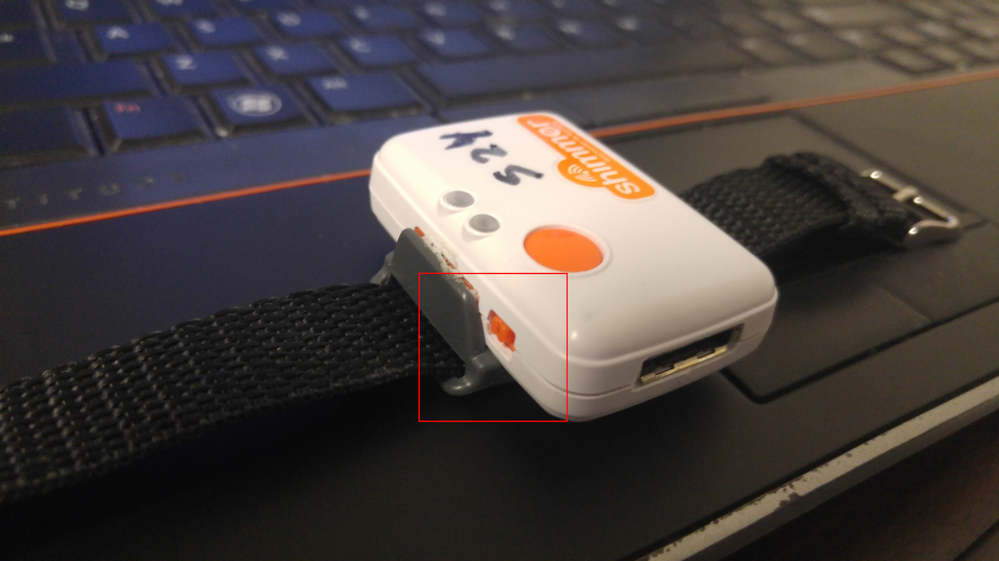
   3. If you cannot get the device showing its battery % after repeating the previous step, this device has a hardware error. Try troubleshooting Consensys if other Shimmer devices show similar errors. If nothing works, you can move on to compensate the participant.
5. Copy the Raw data from the device
   1. Right Click the device and click Open SD. This will open a Windows Explorer window with the Shimmer device contents.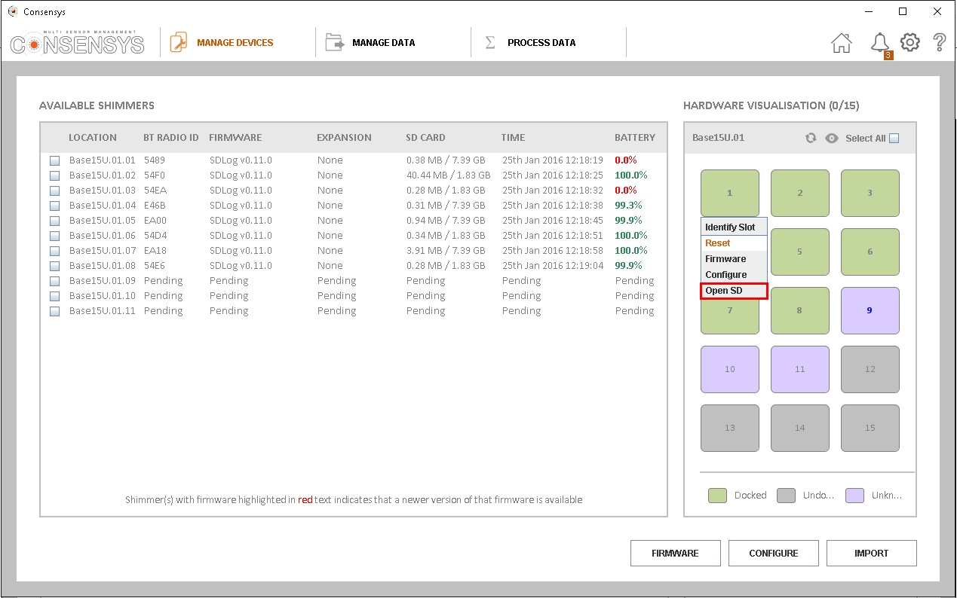
      1. If you do not have the participant ID, open the SDLOG file in the folder, and read the ID from the first line in this file. This line looks like “experimentid=P2187”. Provide this ID to the participant and ask them to complete their debrief survey.
   2. Create a folder on the Desktop with the same name as the Participant ID. For this example, create the folder P2187.
   3. Drag the “data” folder from the device to the folder created on the desktop.
   4. Close the explorer window.
6. Import the data
   1. In Consensys, click the refresh icon.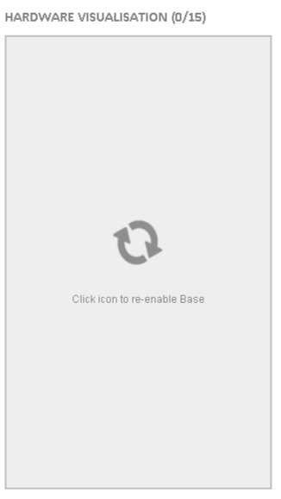
   2. Find the device, and click the check mark next to it.Then click “Import”.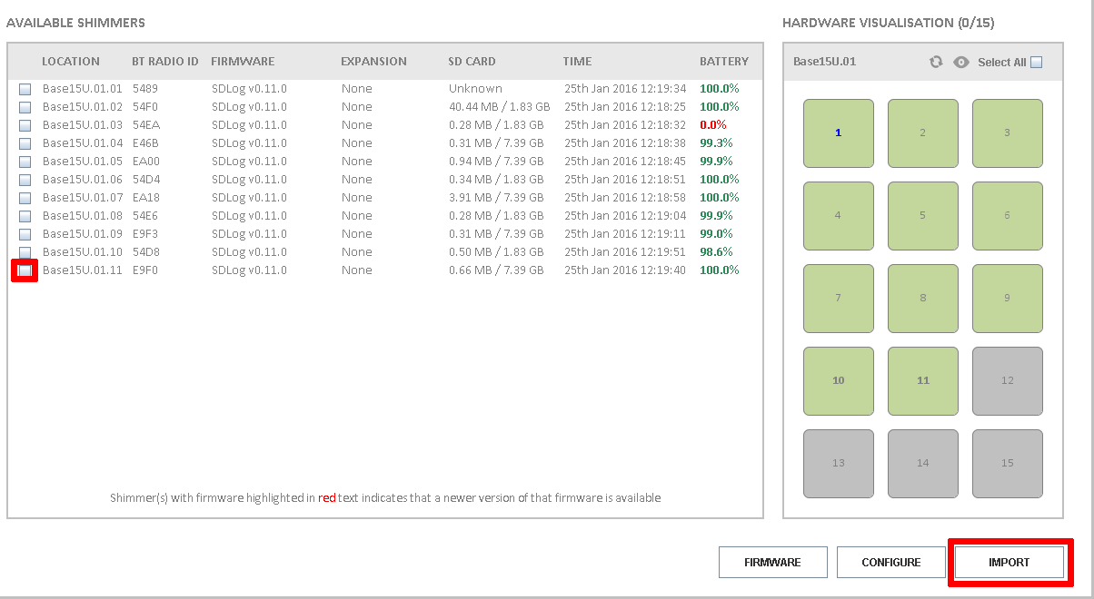
   3. Click Next after Consensys finishes scanning the device.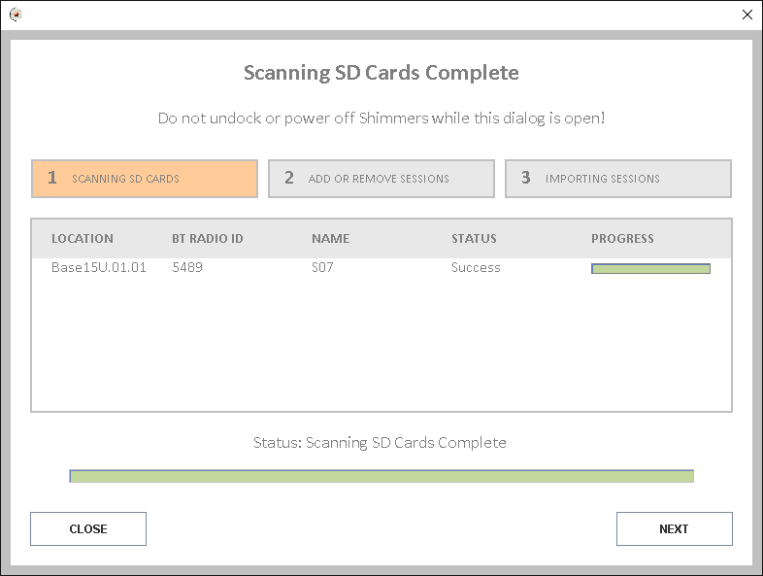
   4. You will see a list of sessions recorded on the device.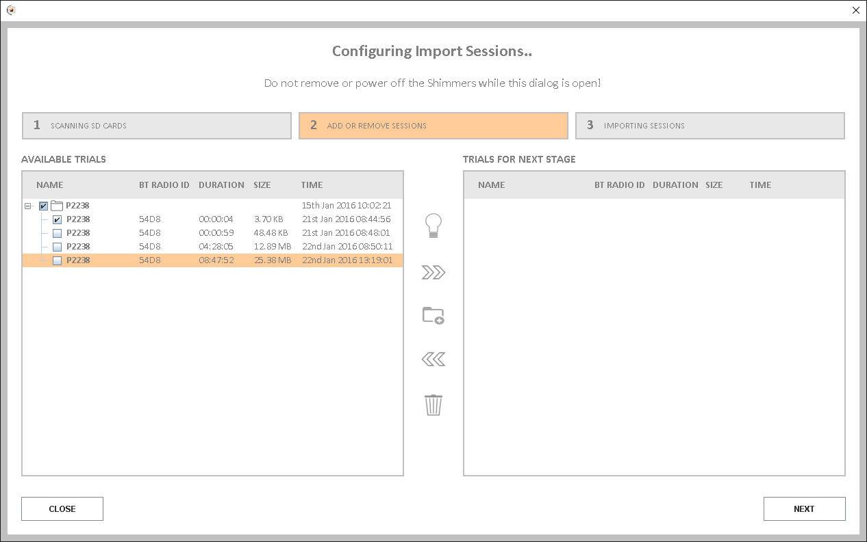
   5. Uncheck all boxes in the left pane.
   6. If the Device shows the year as 1969 or 1970, the device has a time sync error. You can move on to compensate the participant. Indicate a hardware error when you fill in the Post Analysis Checklist. Add a comment indicating a time sync error and your name.
   7. Identify the sessions starting on the day the participant recorded data. These can be multiple sessions.
   8. Select these sessions, then click the >> button in the middle of the window.
   9. Select all the other sessions not belonging to the day or the participant, and click delete.
   10. The result will look something like the figure below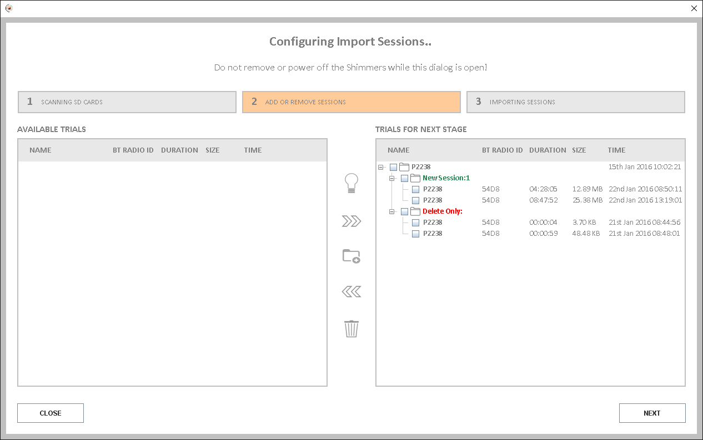
   11. Click Next and import the data.
7. Export the data
   1. In Consensys, click the Manage Data tab
   2. Find the correct participant ID, and click the checkmark next to it.
   3. Click the Export button in the bottom right.
   4. Find the Participant folder in the computer.
      1. The fastest way to do this is find the Desktop, then find the participant's folder inside it.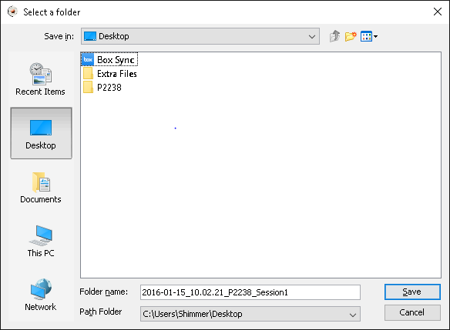
   5. Open the participant folder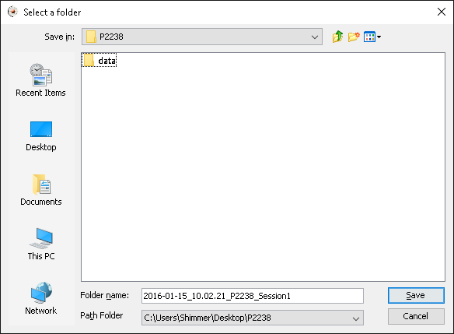
   6. Click save.
   7. Wait for Consensys to finish exporting data.
8. Inform the participant that you have some more questions about their meals from the previous day, and ask them to sit on the chair next to you.
9. Process the data
   1. Start MarkerParser using the icon on the desktop.
   2. Click “Select Input File”.
   3. Find the file exported by Consensys.
   4. This file should be inside the folder created for the participant.
   5. Click Read Data. **Wait for this process to complete.**
      1. If interview data already exists, the application will ask you if you want to delete the previous data. Make sure you have selected the correct participant ID before confirming to delete this data.
   6. The application will show you a form like the one shown in the figure below. You will need the participant to complete their survey before proceeding.
10. Interview the participant
11. You need to gather information for all the meals that a participant has marked.
    1. You can interview the participant in your own word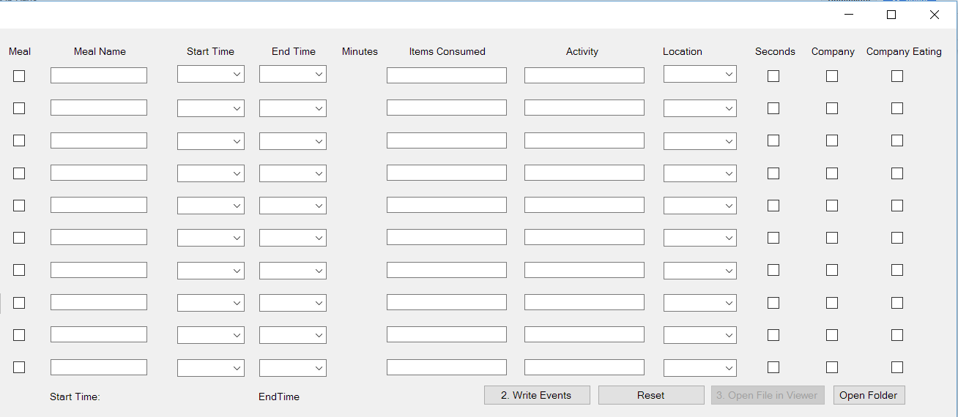s once you understand this process.
    2. We need to mark all the meals with meal names. **These meal names have to be single words without spaces.** The most common meal names will be Breakfast, Lunch, Dinner, Coffee, Snack, AfternoonSnack, Dinner2, Lunch2, etc.
    3. If the participant forgets to press the button at the end or start of a meal, please ask them to guess when they started or ended a meal, and enter this in the appropriate box next to a meal. Also put a * after the Meal Name, for example, if the Meal Name was Breakfast, the new name would become Breakfast*.
    4. The device might have turned off if the participant pressed the button too many times. Other times, participants press the buttons multiple times because they forget if they had pressed the button. Use discretion and ask questions if you see multiple repeated times in the list, or multiple times close to each other.
    5. If a participant has marked more than 10 meals, use your discretion and ignore meals that you deem unimportant. This can be events like drinking water at the gym.
12. Ask questions to fill in this form.
    1. Click on the arrow next to the first Start Time box, and read the first time in the list. Ask the participant if this is when they started eating. If they say yes, select this time, otherwise repeat this question for the next time in the list.
    2. From the End Time list, ask the participant which of the available times was when they ended the meal.
    3. Ask if this was Breakfast, Lunch or Dinner, and use that as a meal name.
       1. In some cases you might have participants mark drinking coffee in the morning. You can mark this as Coffee.
       2. Participants might mark the appetizers, entree and dessert of a meal separately. You can mark each of these separately as such.
    4. The software indicates how long the meal was in minutes. Confirm that the meal was approximately as long as this number.
    5. Ask what the participant what they ate during this meal, and enter this in the Items Consumed box for the meal.
    6. Ask if this was a sit down meal. Ask if they were doing anything else while eating this meal for example, “Were you doing anything else while eating? Talking to someone, watching TV, using the phone or computer?”
    7. Enter this information as briefly as possible in the Activity box. Examples: “Driving car to office”, “Just sitting”, “Talking to friend”, “Using the computer”, “Watching TV”, “Read a book”.
    8. Ask where this meal was consumed (Home / Restaurant / Work / Other).
       1. Dining Halls are considered Restaurants
       2. Classrooms are considered Work
    9. Ask if this meal was consumed in company with someone else and mark this with a checkbox.
       1. If the answer is no, skip the next question.
    10. Ask if the person in company was also eating, and mark this with a checkbox.
    11. Once all the information for this meal is collected, click the checkbox in the first column, “Meal”.
13. Repeat Step 13 to collect information for each meal.
14. Click “Write Events” once you have completed this process, and all meals have been checked.
15. The application will indicate the time data is available before the first meal, and the time data is available after the last meal. Check if either of these numbers are less than 10 minutes.
16. Click “Open File in Viewer” to open this file in Shimmerview and look at it. The data should look like in the figure below.
    1. The green line indicates current position, with the current time indicated next to it.
    2. The value at the bottom of the line is the value of the data as shown below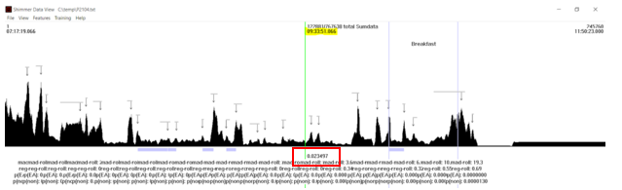
17. Close Shimmerview.
18. At this point, if everything looks good, open the Participant Folder on the desktop, and delete the folder inside it. This folder name will be similar to “2015-10-27_08.49.15_P104_10_27_Session1/”.
19. On the desktop, select the participants folder. Right click this folder and click “Cut”.
20. Open the folder “Box” on the Desktop, and open the “BiteCounting” folder inside it.
21. Right click an empty spot, and click Paste.

### Compensation

1. Ask the participant if they have any question for you.
   1. If the participant asks what we do with the data, tell them that the device they wore records wrist motion data throughout the day, and we will be using this data to create a wristwatch like device that automatically detects eating.
   2. If the participant asks about the two week study, let them know that someone will contact them if they qualify for it based on their responses to our surveys.
2. Hand compensation sign off form to participant
3. Have them print name, sign name, and date
4. Give participant their compensation
5. Thank them for participating, wish them well, and excuse them from the laboratory.

### If the battery level of the Shimmer is greater than 70%, unplug the Shimmer from the dock, and place it in the “Available” box on the table.

# Post Analysis Checklist

1. Open the Post Analysis Checklist on the Samsung Tablet and answer the questions.
2. Question 2: Hardware Error
   1. Answer this as Yes if you could not import the data
   2. Answer this as Yes if the data showed it was collected in the year 1969 or 1970.
   3. Answer No otherwise.
3. Question 3: “Within the folder created for the participant, is there a sub folder called data?”
   1. Answer no if the folder “data” does not exist in the participant folder (eg folder “P2187”) like in the image below.
   2. Answer yes if the folder exists
4. Question 4: “If you answered no to the previous question, does the participant folder contain a sub folder with a csv file in it?”
   1. Answer no if there is no folder with a CSV (excel) file in it. This folder name is similar to “2015-10-29_13.30.24_P2021_10_30_Session1/”
   2. Answer yes if the folder exists
5. Question 5: “Within the folder created for the participant, are there three files: P2021.txt, P2021-events.txt and P2021-markers.txt”
   1. Answer yes if the three files exist.
   2. Answer no if these files are missing.
6. Question 6: Is there at least 10 minutes of data before the first meal?
   1. Answer yes if MarkerParser indicated this is true.
7. Question 7: Is there at least 10 minutes of data after the last meal?
   1. Answer yes if MarkerParser indicated this is true.
8. Answer the question “Does the data look good visually in ShimmerView?”
   1. Use the ‘a’ and ‘g’ keys on the keyboard to move forward and backward in Shimmerview.
   2. If you see long plateaus (longer than 10 minutes) with values of 0.035 or higher (as shown in the figure below), you will reject this data and indicate in the next step. If you do not see anything, indicate the data looks good visually.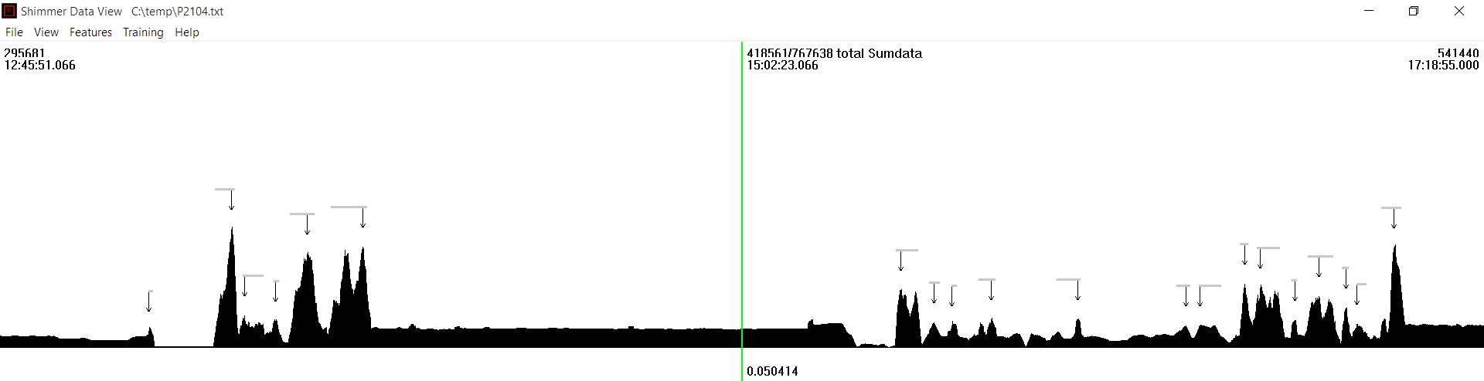
9. Answer the question: Has the file been moved to the "Bite Counting" folder in Box?
10. Enter any comments about the participant or data collection in the last box, then submit the forms. Add your name if there is a hardware error and you could not import data. If you ask questions about the meals, add this information here.
11. Examples:
    1. Device had a hardware error, could not import data.
    2. Device did not sync time, shows 1970.
    3. Participant recorded more than 10 meals
    4. Participant turned device off after lunch
    5. Participant did not wear device between meals
    6. Participant pressed marker too many times, and could not recall button presses correctly