**Instruction:**

for the file location:

Step 1. Please put the whole file 'CRUD' to 'D:’ or in any desired location.

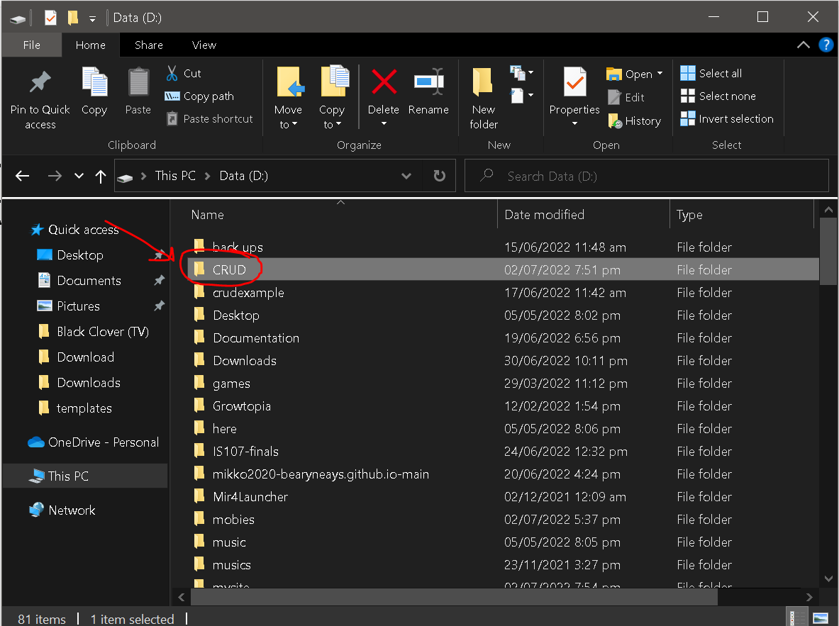

As for the database,

-please create a database named ‘djangodb’ in mysql.

To run the web app:

in CMD:

Step 1. type cd\

Step 2. type D:

Step 3. type python -m venv tutorial-env

Step 4. type tutorial-env\Scripts\activate.bat

Step 5. type cd CRUD

Step 6. download the mysqlclient. Please type pip install mysqlclient

Step 7. After that please type python manage.py makemigrations

Step 8. Then please type python manage.py migrate

Step 9. Type python manage.py runserver

Step 10. Go to your browser and type <http://localhost:8000/show>

If haven’t installed Django, please type this in cmd python -m pip install Django