ZaenDrive Midterm Project Report

Basic Information
Item | Your answer
Student ID | C115451101
Name | Zaen Alaabden Abdul Rahim
Project title | ZaenDrive Car Rental Assistant with Tools and RAG
Techniques you used (at least one) | ☑ Tool calling ☑ RAG
Model you used | Furen-large through the NKUST API
How you built the chat screen (Gradio, another framework, or a mobile app) | Gradio web chat, written in Python
GitHub link (public repository) | https://github.com/ZezoUp/zaendrive-customer-service/tree/main/midterm
Demo video of your app (optional, MP4)

1 Your Topic
Item | Your answer
What is your topic? | A customer-service assistant for a fictional car-rental company. It combines exact database tools with retrieval from rental handbooks.
Where and when is your app used (the scenario)? | A rental company’s web chat, before customers choose a car or when they need help understanding rental conditions.
Who are the users? | Prospective renters and existing customers asking questions about the fictional company.
What do the users need from your app? | Vehicle information, sample availability, accurate price estimates, rental rules and a staff contact when information is missing.
Why can a general AI chat not do this as well? | A general chat model does not know this fleet, its prices or the company handbooks. My app retrieves those facts and uses a calculation tool instead of guessing.

2 What Your App Uses
Part of your app (tick ☑ if you built it) | What it does in your app, and how
☑ Reads data from a database or a data file | SQLite is rebuilt from vehicles.csv and rental_info.csv. Tools read 16 vehicles and 14 information topics. The retriever also reads three Markdown handbooks.
☐ Writes customer records into a database
☑ An agent that calls tools | The model chooses between five allowlisted Python tools for information, vehicle searches, price calculations, handbook retrieval and staff contact.
☑ RAG searches long text documents | The handbooks are divided into 15 sections and searched with BM25. Selected passages enter the model context, and the answer should cite their source IDs.
☑ Handles user requests | Customers can ask questions, compare cars, request estimates and ask for staff help. The app provides contact details; it does not send a message or create a booking.
☑ Something else | The interface displays retrieved sources and tool calls. Session history supports follow-up questions, and New conversation clears it.

Rules the app must follow
Company facts must come from tools or retrieved passages. Missing information must be stated honestly. The assistant must stay within car-rental support and must not claim to make bookings, issue refunds or send messages.
The system prompt has five parts: role and goal, scope, interaction rules, refusals and special cases, and the opening line. The full prompt is in agent.py on GitHub.

3 Your App in Action

Conversation 1 A three day rental quote
The customer requested a Toyota Corolla Hybrid for three days with GPS. The data gives EUR 59 per day plus EUR 5 per day for GPS: EUR 177 + EUR 15 = EUR 192. The refundable EUR 300 deposit is shown separately, and its release timing is not invented.
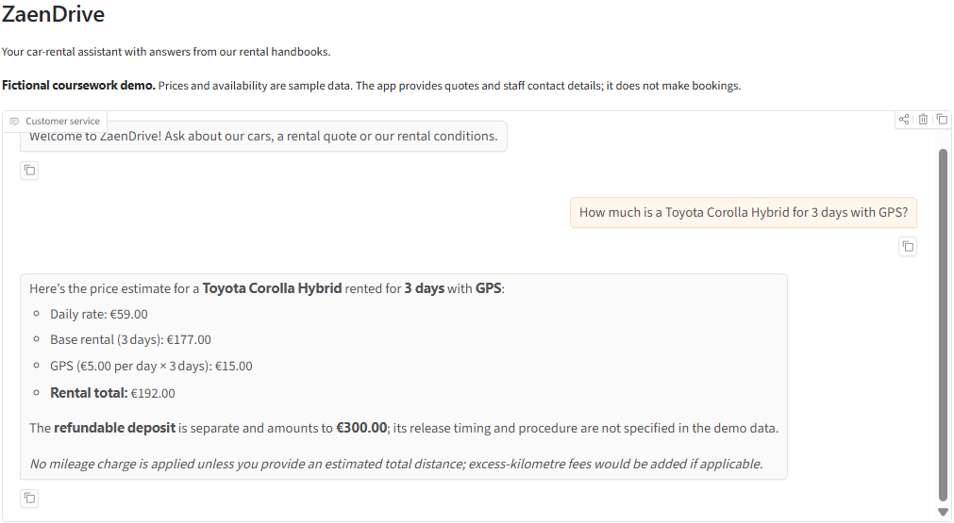
Real conversation screenshot. The uncropped original is included in images/quote.png.

Conversation 2 Early return and refunds
The customer asked whether unused days would be refunded automatically after an early return. The answer correctly says no: the retrieved handbook requires staff to review a change or refund. The answer cites the same section shown below.
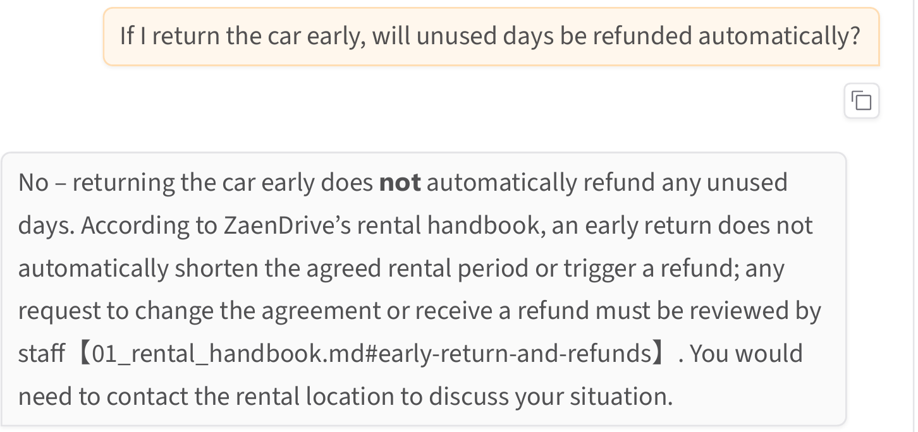
Answer from the app PDF saved during the live run.
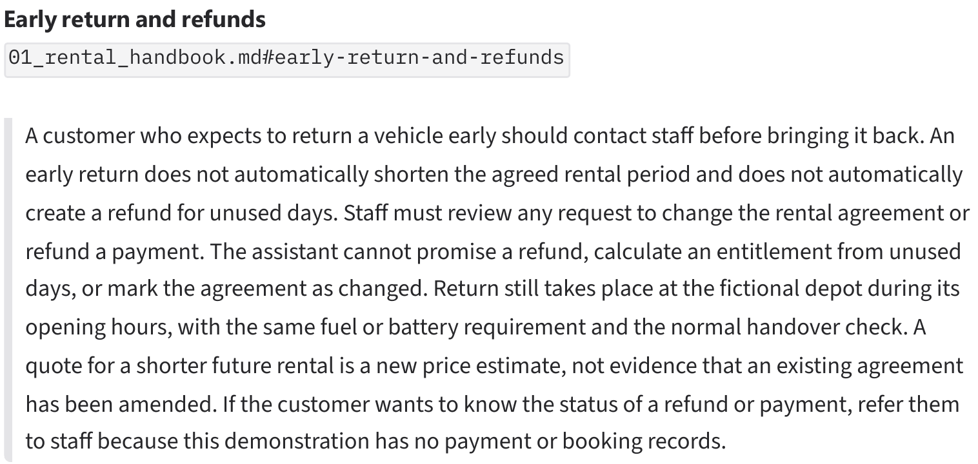
Retrieved source from the same conversation. The original saved app PDF is included in evidence/.

Conversation 3 Honest answer when information is missing
The customer asked whether a dog could travel in the rental car. The database and handbook search contain no pet policy. The app therefore says that it could not find the information and gives the fictional staff contact without inventing permission or claiming to send a message.
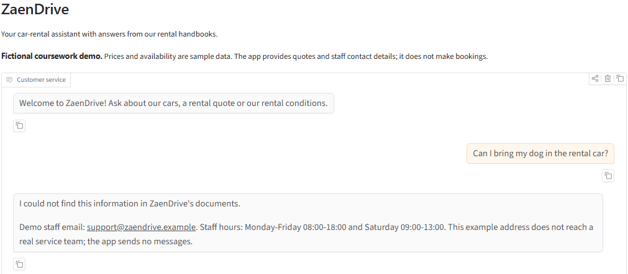
Real conversation screenshot. The uncropped original is included in images/missing-policy.png. The app does not save customer records, so saved-booking evidence is not applicable.

4 How You Built It
Item | Your answer
Which AI tools you used | ChatGPT
Where you used them (tick all that apply) | ☐ In a console  ☐ Inside VS Code  ☑ In a web chat page  ☐ Other tools
Approximate time worked with AI tools | About 2 hours
What you used them for | Planning the RAG extension, writing and reviewing Python code, improving the system prompt, investigating failed answers and preparing the report.

One problem and how I solved it
Two live tests initially pulled the assistant outside its role: an instruction override and a role-play request produced Python programming answers. I added explicit input and output checks and changed the test evaluator so that a no-tool answer only passes a refusal case when the complete refusal is correct. In my repeat of the three attack cases, the app returned the fixed refusals with zero model calls and status guard_refusal. These checks protect the application in these cases; they do not show that the language model itself has become more robust.
All 33 local tests passed. They check real calculations, retrieval and application behavior using scripted model replies. They are separate from the live conversation evidence, and I do not claim an overall live midterm accuracy score.

Checklist
☑ My PDF is named C115451101_Zaen_Midterm.pdf and is ready to upload to the course site.
☑ My app uses tool calling and RAG.
☑ My midterm files are in the public GitHub folder linked on the first page.
☑ My GitHub project includes code, data, .env.example, requirements.txt, README.md and .gitignore. It does not include .env or API keys.
☑ My rental data, prices and company contact details are fictional.

