

**E-COMMERCE GAS SHOP**

**Software Requirement Specification**

**Version 3.0.0**

**<1/7/2023>**

**Nguyễn Thái Thịnh**

**Lead Software Engineer**

– Hanoi, Summer 2023 –

# Revision History

|  |  |  |  |
| --- | --- | --- | --- |
| **Date** | **Description** | **Author** | **Comments** |
| 8/01/2023 | Version 1 | Nguyễn Thái Thinh, Cát Bá Lân, Nguyễn Quang Minh, Trần Sỹ Cao Thiên, Nguyễn Xuân Thắng | First version |
| 21/6/2023 | Version 2 | Nguyễn Thái Thinh, Cát Bá Lân, Nguyễn Quang Minh, Trần Sỹ Cao Thiên, Nguyễn Xuân Thắng | Update and correct errors to standardize the document |
| 1/7/2023 | Version 3 | Nguyễn Thái Thinh, Cát Bá Lân, Nguyễn Quang Minh, Trần Sỹ Cao Thiên, Nguyễn Xuân Thắng | Minor bug fixes |
| 20/7/2023 | Version 4 | Nguyễn Thái Thinh, Cát Bá Lân, Nguyễn Quang Minh, Trần Sỹ Cao Thiên, Nguyễn Xuân Thắng | Format fix |

# Document Approval

The following Software Requirements Specification has been accepted and approved by the following:

|  |  |  |  |
| --- | --- | --- | --- |
| **Signature** | **Printed Name** | **Title** | **Date** |
|  | Nguyễn Thái Thịnh | Leader |  |
|  | Nguyễn Thành Ý | Instructor, SWP 391 |  |

# Table of Content

Contents

Revision History 2

Document Approval 2

Table of Content 3

1 Introdution. 5

1.1 Overview 5

1.2 Purpose 5

1.3 Scope 6

1.4 Definitions, Acronyms, and Abbreviations 6

2 General Description 6

2.1 Product Perspective 6

2.2 Product Functions 6

2.3 User characteristic 7

2.4 General Constraints 7

3 Specific Requirements 7

3.1 External Interface Requirements 7

3.1.1 User Interfaces 7

3.1.2 Hardware Interfaces 7

3.1.3 Software Interfaces 7

3.2 User Case 8

3.2.1 Use case Overview 8

3.2.2 Use Case Admin 9

3.2.3 Use Case Employee 9

3.2.4 Use Case Customer 10

3.2.5 Use Case Guest 10

3.3 Function Requirement 11

3.3.1 System Functional Overview 11

1. Screens Flow 11

2. Screen Descriptions 12

1. Admin application 12

2. Client application 14

3. Screen Authorization 15

3.3.2 Entity Relationship Diagram 17

3.3.3 Enitity Description 18

3.3.4 Sale Management 18

4. View Recent Sales 18

5. View All Sales 19

6. View Sales Details 20

7. View Today Sales 22

8. View Montly Sales 23

9. View Last Year Sales 24

10. View Yearly Sales 25

11. View fix History list 26

12. View fix History details 27

3.3.5 Login Management 29

13. Login 29

14. Login bằng tài khoản google 29

15. Log out 31

16. Forgot password 31

17. Register 32

3.3.6 Customers Management 33

18. View Customer List 33

19. Search name customer in Customer List 34

20. Sort customer in Customer List 35

21. Delete customer in Customer List 36

22. Update customer in Customer List 37

3.3.7 News Management 38

23. View List News 38

24. Modify News 39

25. Delete News 40

26. Create News 41

3.3.8 Product Management 43

27. View Product List 43

28. Search Product in Product List with Category 44

29. Add new Product 45

30. View Product Detail 46

31. View Product Comment 48

32. Customer Register site 49

3.3.9 Coupon Management 50

33. Create Coupon 50

34. Change status of coupon 51

35. Search Coupon 52

3.3.10 Employee Management 53

36. Display Employee List 53

37. Manage Employee Access Authority 54

3.3.11 Order Management 55

38. Add to Cart 56

39. Manage Cart 57

40. Check out 58

3.4 Non-Functional Requirements 60

3.4.1 Security 60

3.5 Design Constraints 60

A. Appendices 60

A.1 Business Rule 60

A.2 References 60

# Introdution.

## Overview

The e-commerce gas shop software system aims to provide a user-friendly online platform for customers to purchase gas products conveniently. It serves as a digital marketplace connecting gas suppliers with end-users, facilitating seamless transactions and efficient order management. The software system will be developed to support the operations of a gas shop, offering a wide range of gas products, secure payment processing, and inventory management capabilities.

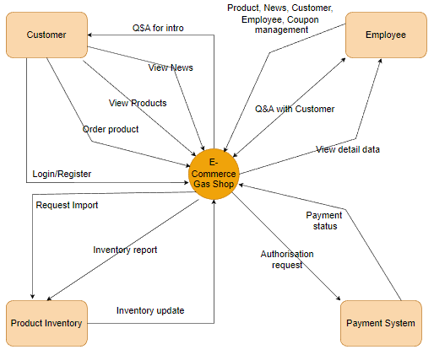

Fig: Context Diagram

## Purpose

* Project of a website to sell gas products, gas cylinders, and equipment associated with the product, built with the aim of providing customers with high quality products. and full of convenient features, helping customers easily search, compare, choose and buy the necessary products for themselves.

## Scope

* The scope of this gas sale web will be executed on the local host of the current server ie this computer. Currently the scope is reduced in this class, but if it can be implemented into a real electronic network, then the scope of this gas selling website will be implemented firstly within the city and provinces. Nearby cities, the website will sell gas to people nationwide later.

## Definitions, Acronyms, and Abbreviations

|  |  |
| --- | --- |
| SRS | Software Requirements Specifications |
| BR | Business Rule |
| UI | User Interface |
| N/A | Not applicate, not available |
| User Case(s) | Diagram describe system requirements |

# General Description

## Product Perspective

The e-commerce gas shop software system is designed to operate as an independent web-based application, functioning as a standalone platform for customers to browse and purchase gas products.

## Product Functions

* Client site:
  + List news by day
  + List product by category
  + Sort product, news
  + Update profile
  + Update cart
  + Order product
* Admin site:
* Customer management
* Product management
* News management
* Orders management
* Coupon management
* Client web management
* Employee management

## User characteristic

The system consists of agents who are Guest, Customer, Employee and Administrator.

* Guests: This is a user who visits the website and performs activities on the website, but has not registered for an account. Guest can view product information, prices and policies of the online store.
* Customer: This is a user who has registered an account on the website and can log in to use the website's functions such as placing orders, viewing order history, managing personal information and registering to receive news. instant, promotion from online store. The customer's role is to be the consumer of the online store's products and services. Customers can bring the product to warranty when the product has a fault.
* Administrator: This is the person who manages and runs the entire operation of the online store, including tasks such as product management, order management, customer information management, Store activity statistics. The administrator's role is to ensure that the operations of the online store are carried out efficiently, that the customer needs are met, and that the store's business goals are achieved. Will evaluate the product when the product is brought to the warranty beyond the specified.
* Employee: This is the person who performs parts of an administrator role. The employee’s role is to keep track of the online store and perform tasks based on the administrator requirements.

## General Constraints

The e-commerce gas shop software system is subject to various constraints that will impact the design and development process. These constraints include corporate policies, regulatory requirements, hardware limitations, interfaces, technologies, security considerations, and design conventions. It is essential to consider these constraints during system development.

# Specific Requirements

## External Interface Requirements

### User Interfaces

Ul-1: The website header will include the website's logo, address, phone number, and main categories: The middle of the page displays the products, the bottom of the page is divided into newsgroups (warranty policy, promotions.

Ul-2: The interface is suitable for display on computers and phones

U-3: Use icons to provide more detail to users.

U-4: The main color of the website is green

### Hardware Interfaces

No hardware interfaces have been identified

### Software Interfaces

Combine payment with API, VNPAY

## User Case

|  |  |  |
| --- | --- | --- |
| **#** | **Actor** | **Description** |
| 1 | Admin | The one who manage the whole system. This actor can manage the other role, also the client site and admin site |
| 2 | Customer | The one who interact with client site, view and add product, view customer info, view news, and order |
| 3 | Guests | The one who interact with client site, view product, view news |
| 4 | Employee | The one who is assigned with specific roles given by admin |

### Use case Overview

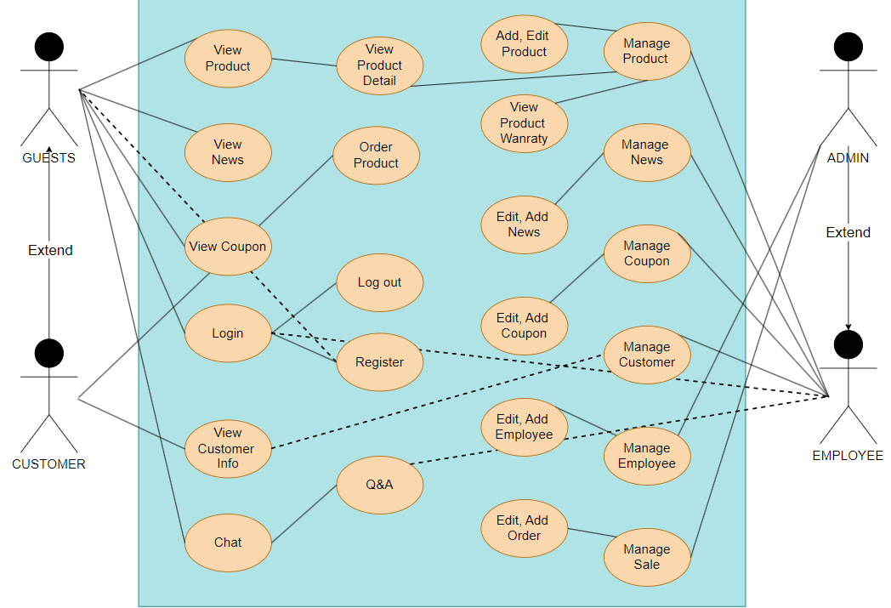

### Use Case Admin

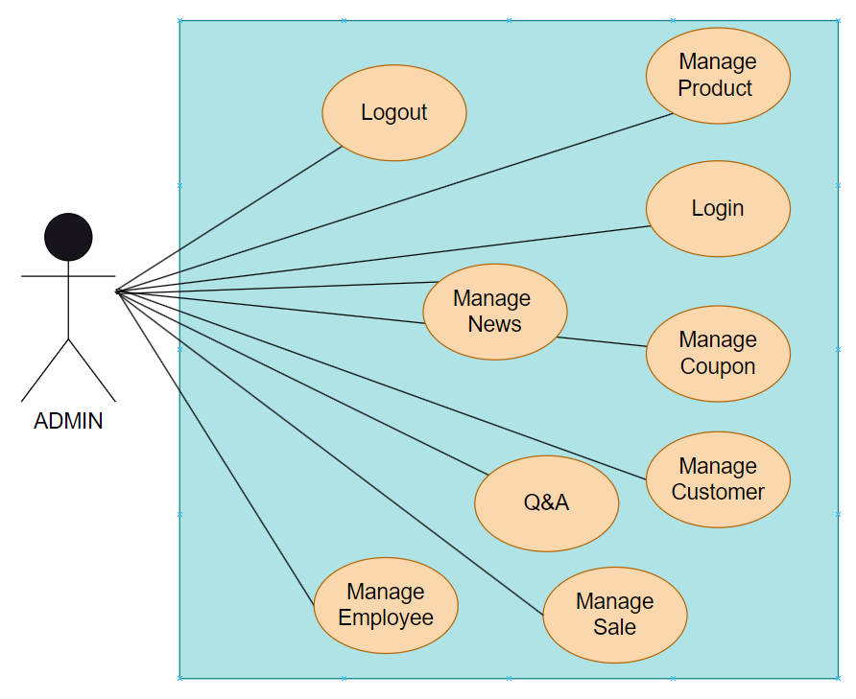

### Use Case Employee

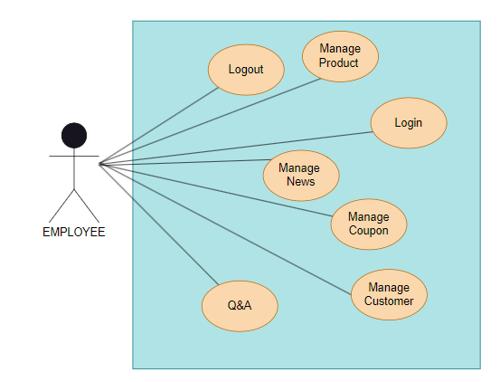

### Use Case Customer

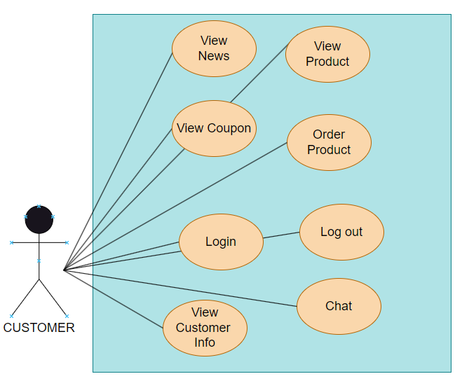

### Use Case Guest

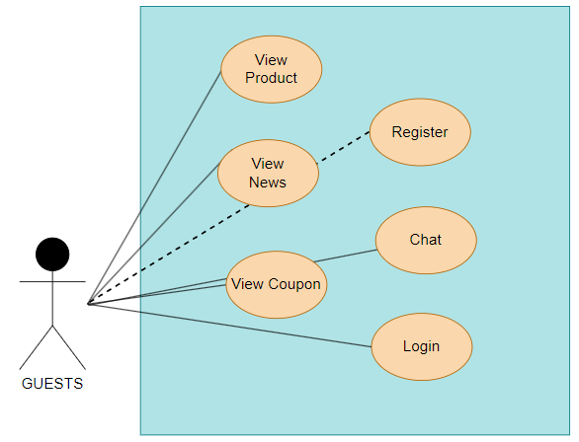

3.2 1 Overview use Case

## Function Requirement

### System Functional Overview

#### Screens Flow

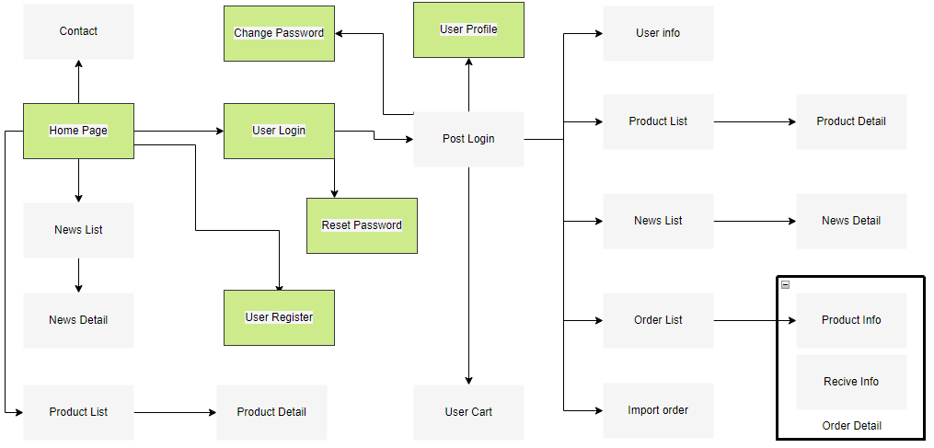

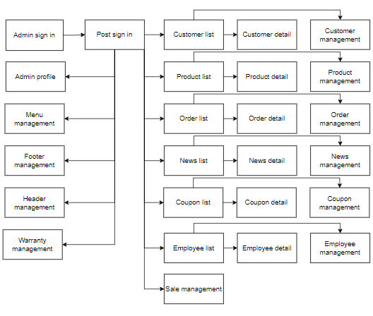

#### Screen Descriptions

###### Admin application

|  |  |  |  |
| --- | --- | --- | --- |
|  | **Feature** | **Screen** | **Description** |
| 1 | **Customer**  **Management** | View Customer | View Customer list |
| Update Customer | Change the information of a Customer |
| Delete Customer | Remove the Customer from the Customer list |
| Search News Group | Search the Customer from the Customer list |
| 2 | **Order Management** | Create Order | Add new Order to the Order list |
| Update Order | Change the information of a Order |
| Delete Order | Remove the Order from the Order list |
| Search Order | Search the Order from the Order list |
| 3 | **News**  **Management** | Create News | Add new News to the News list |
| Update News | Change the information of a News |
| Delete News | Remove the News from the News list |
| Search Order | Search the News from the News list |
| 4 | **Sale**  **Management** | Order Management | Manage the status of the order and manage the orders in the history |
| Warranty Management | Manage the warranty information of the products |
| Product Fixing Management | Manage the products have been applied for maintainance |
| Invoice Management | Manage the orders in the form of invoice |
| Sale Management | Display the sale of the business by day, month and year |
| 5 | **Product Management** | Create Product | Add new Product to the Product list |
| Update Product | Change the information of a Product |
| Delete Product | Remove the Product from the Product list |
| Search Product | Search the Product from the Product list |
| 6 | **Coupon Management** | Create Coupon | Add new Coupon to the Coupon list |
| Update Coupon | Change the information of a Coupon |
| Delete Coupon | Remove the Coupon from the Coupon list |
| Search Coupon | Search the Coupon from the Coupon list |
| 7 | **Employee Management** | Create Employee | Add new Employee to the Employee list |
| Update Employee | Change the information of a Employee |
| Delete Employee | Remove the Employee from the Employee list |
| Search Employee | Search the Employee from the Employee list |

###### Client application

|  |  |  |  |
| --- | --- | --- | --- |
| **#** | **Feature** | **Screen** | **Description** |
| 1 | View Category | Home page | View products category |
| 2 | Sign up | User Register | User create account with customer’s information |
| 3 | Login | User Login | Access to the website as customer role |
| 4 | Update user | User detail | Update latest information of user profile |
| 5 | View News | News List | View the list of news |
| 6 | View news detail | News detail | View detail information of a specific news |
| 7 | View products | Product List | View list all of products or group of products |
| 8 | View product detail | Product detail | View detail information of a specific product |
| 9 | View order history | Order detail  (History Purchase) | View the list of orders have been ordered of the customer |
| 10 | Add to Cart | User Cart | View the cart, add, delete or update products in the cart |
| 11 | Checkout the order | Checkout | Fill in the information to check out the cart |
| 12 | View order detail | Order detail | View a specific order of user (They can export it to a pdf file) |
| 13 | Contact | Contact | User give questions, comments related to products, news, order… of the website to the admin |
| 14 | Chage password | Change Password | User request to change his password |
| 15 | Reset Password | Reset Password | User forgot his password, so he will request to reset his password and the system will confirm his request by sending an email. |

#### Screen Authorization

|  |  |  |  |  |
| --- | --- | --- | --- | --- |
| **Screen** | **Admin** | **Employee** | **Customer** | **Guest** |
| **Home Page** | X | X | X | X |
| **Product List** | X | X | X | X |
| **Product Details** | X | X | X | X |
| **Active/Deactive an Employee** | X |  |  |  |
| **View his/her orders** |  |  | X |  |
| **Employee Edit** | X | X |  |  |
| **News List** | X | X | X | X |
| **Add News** | X | X |  |  |
| **News Details** | X | X | X | X |
| **Edit News information** | X | X |  |  |
| **Coupon List** | X | X |  |  |
| **Coupon Details** | X | X | X | X |
| **Add new Coupon** | X | X |  |  |
| **Update Coupon** |  | X |  |  |
| **User Login** | X | X | X | X |
| **User Register** | X | X | X | X |
| **Forgot Password** | X | X | X | X |
| **Change Password** | X | X | X | X |
| **User Profile** | X | X | X |  |
| **Accounts List** | X |  |  |  |
| **Account Details** | X |  |  |  |
| **Customers List** |  | X |  |  |
| **Customers Details** |  | X |  |  |
| **Settings List** | X |  |  |  |
| **Setting Details** | X |  |  |  |

### 

### Entity Relationship Diagram

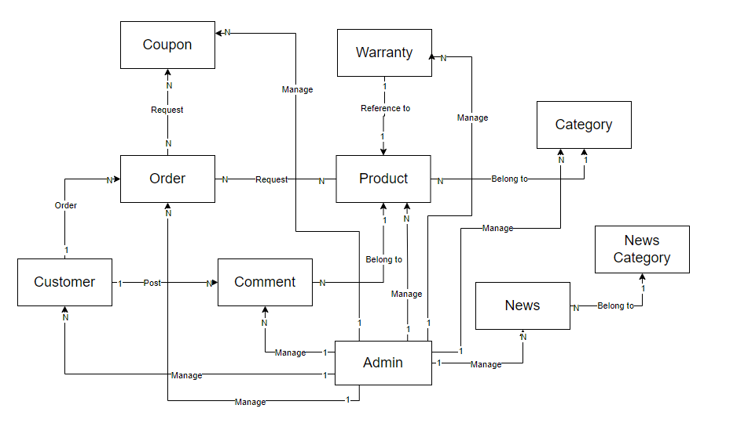

### Enitity Description

|  |  |  |
| --- | --- | --- |
| **#** | **Entity** | **Description** |
| 1 | Admin | Containing username, password and other information of admins of admin page |
| 2 | Customer | Containing username, password and other information of users of client page |
| 3 | Product | Containing information about a product |
| 4 | News | Containing news of a website, such as product evaluation, discount, … |
| 5 | Order | Containing information of user and products bought and other related information as orderdate, … |
| 6 | Warranty | Containing information about problems of products bought, then the summary of quality of product |
| 7 | Comment | Contain information about comment of customer to that Product |
| 8 | Coupon | Contain information related to discount codes for products or conditional orders |
| 9 | Category | Contains information about product types |
| 10 | News Category | Contains information of all kinds of news |

### Sale Management

#### View Sales

|  |  |  |  |
| --- | --- | --- | --- |
| Name: | View Sale | | |
| Created By: | Minhnq | **Date Created:** | 16-5-2023 |
| Primary Actor: | Admin | **Secondary Actors:** | Employee |
| Description: | User access general page and system display sales according to the user needs. | | |
| Trigger: | Actor logins to the system, and click on general navigation | | |
| Preconditions: | PRE-1. User must login into the system  PRE-2. User have permission to access the General Page | | |
| Postconditions: | POST-1. System displays sales list | | |
| Normal Flow: | **1.0 View recent sales**   1. User click on “General” navigation button 2. The system would display the list of recent sales along with the total income of the day, month, last year and this year. Additionally, there will be a “Show All” button at the right corner of the table.   **1.1 View all sales**   1. User click on “Show All” button 2. The system would display the list of all sales along with the total income of the day, month, last year and this year. Additionally, there will be a “Details” button next to every order displayed.   **1.2 View sales among a period of time**   1. User click on “Today Sale” (Monthly Sale or Yearly Sale) button 2. The system displays the list of today’s (monthly or yearly) sale as well as the total income of the day, month, last year and this year. Additionally, there is a “Details” button next to every order displayed.   **1.3 View sale detail**   1. User click on “Detail” button 2. The system displays details of the order in the form of a bill corresponding to the chosen order 3. (Optional) User click on “Print” button 4. System display print option and ask for directory location then printed the sale detail in form of a bill as a pdf | | |
| Alternative Flows: | N/A | | |
| Exceptions: | N/A | | |
| Priority: | High | | |
| Frequency of Use: | High | | |
| Business Rules: |  | | |
| Other Information: | N/A | | |
| Assumptions: | N/A | | |

#### View fix History list

|  |  |  |  |
| --- | --- | --- | --- |
| Name: | Display Fix History | | |
| Created By: | Minhnq | **Date Created:** | 16-5-2023 |
| Primary Actor: | Admin | **Secondary Actors:** | Employee |
| Description: | Actor can see the list of all the order items that have been taken to the shop for warranty, maintenance. | | |
| Trigger: | Actor clicks on the “Fix History List” button at the general page | | |
| Preconditions: | PRE-1. User must login into the system  PRE-2. User have permission to access the General Page | | |
| Postconditions: | POST-1. System display list of items has been taken to the shop for warranty, maintenance. | | |
| Normal Flow: | **1.0 View fix history list**   1. Actor clicks on the “Fix History List” button at the general page 2. The system display the information on the list of order that has been brought to the store for maintenance/warranty.    1. **View detail of a fix history** 3. Actor clicks on the “Details” button at the Product Fix History page (AF_1) 4. System display the detail of the order in which has been brought to the store for warranty, maintenance. | | |
| Alternative Flows: | 1. Actor clicks on the “Fix History” button at the Invoice page    1. Return step 2 of 1.1 in Normal Flow | | |
| Exceptions: | N/A | | |
| Priority: | Medium | | |
| Frequency of Use: | Medium | | |
| Business Rules: |  | | |
| Other Information: | N/A | | |
| Assumptions: | N/A | | |

### Login Management

#### Login

|  |  |  |  |
| --- | --- | --- | --- |
| Name: | Login | | |
| Created By: | Minhnq | **Date Created:** | 17-5-2023 |
| Primary Actor: | Admin | **Secondary Actors:** | Employee |
| Description: | Step for actor to access to the system | | |
| Trigger: | Actor starts the program | | |
| Preconditions: | N/A | | |
| Postconditions: | Actor gain access to the program and the system display the general page | | |
| Normal Flow: | 1. Actor enter the information for entrance 2. The system would go through the database to check whether the inputted information is valid 3. If valid, the system would go through the database again to check the role of the actor and create 3 session parameters being the admin’s id, name and role 4. Based on the admin’s role saved in the session, the page would be redirected accordingly | | |
| Alternative Flows: | N/A | | |
| Exceptions: | N/A | | |
| Priority: | High | | |
| Frequency of Use: | High | | |
| Business Rules: | BR-1, BR-3, BR-4, BR-5, BR-6, BR-7 | | |
| Other Information: | N/A | | |
| Assumptions: | N/A | | |

#### Login bằng tài khoản google

|  |  |  |  |
| --- | --- | --- | --- |
| Name: | Login bằng tài khoản google | | |
| Created By: | ThinhNT | **Date Created:** | 16-5-2023 |
| Primary Actor: | Customer | **Secondary Actors:** | Guest |
| Description: | Project will request Google API to get information of server then login with that account | | |
| Trigger: | Customer click Google login button | | |
| Preconditions: | PRE-1. The system has connected to Google service | | |
| Postconditions: | POST-1. System display home page | | |
| Normal Flow: | 1. Admin click the link to Login page 2. Admin click the Google login button 3. Software will request to Google API to get data, then Google will forward data to server 4. If customer haven’t login with that Google account yet, register that account to data and immediately login | | |
| Alternative Flows: | N/A | | |
| Exceptions: | N/A | | |
| Priority: | Medium | | |
| Frequency of Use: | Medium | | |
| Business Rules: | N/A | | |
| Other Information: | N/A | | |
| Assumptions: | N/A | | |

#### Log out

|  |  |  |  |
| --- | --- | --- | --- |
| Name: | Log out | | |
| Created By: | ThinhNT | **Date Created:** | 16-5-2023 |
| Primary Actor: | Customer | **Secondary Actors:** | Guest |
| Description: | Function show logout feature of the system. | | |
| Trigger: | Customer logout by click “Log out” | | |
| Preconditions: | The user has logged in the system before | | |
| Postconditions: | System will log out the current Customer account out of that client website and display home screen | | |
| Normal Flow: | 1. Customer click log out in header 2. System log out the current account 3. System display home page site with log in and register link | | |
| Alternative Flows: | N/A | | |
| Exceptions: | N/A | | |
| Priority: | Medium | | |
| Frequency of Use: | Medium | | |
| Business Rules: | N/A | | |
| Other Information: | N/A | | |
| Assumptions: | N/A | | |

#### Forgot password

|  |  |  |  |
| --- | --- | --- | --- |
| Name: | Forgot password | | |
| Created By: | ThinhNT | **Date Created:** | 8-7-2023 |
| Primary Actor: | Customer | **Secondary Actors:** |  |
| Description: | Function show forgot pasword feature of the system. | | |
| Trigger: | Customer click forgot password to reset their password | | |
| Preconditions: | The user has valid account, valid email | | |
| Postconditions: | System will allow Customer to change new password | | |
| Normal Flow: | 1. Customer click forgot password from login screen 2. System bring Customer to enter username(Email) to send otp (EX_1) 3. If correct email, Customer will get given otp and enter otp in check valid otp screen 4. Customer enter new Password | | |
| Alternative Flows: | N/A | | |
| Exceptions: | 1. User input wrong format email    1. System will alert user by display error message | | |
| Priority: | Medium | | |
| Frequency of Use: | Medium | | |
| Business Rules: | BR-01, BR-02, BR-04, BR-05, BR-06, BR-07, BR-08, BR-13 | | |
| Other Information: | N/A | | |
| Assumptions: | N/A | | |

#### Register

|  |  |  |  |
| --- | --- | --- | --- |
| Name: | Register | | |
| Created By: | ThinhNT | **Date Created:** | 13-6-2023 |
| Primary Actor: | Customer | **Secondary Actors:** |  |
| Description: | System will create a new Account to database | | |
| Trigger: | Guests click to register link to create new Account | | |
| Preconditions: | Email has not been exsisted in the database | | |
| Postconditions: | System allow Guests to create new account to become a new Customer | | |
| Normal Flow: | 1. Guests click sign up from home page screen or in login screen 2. Guests can choose sign up with Google or a new account (AF_1) 3. System bring Guests to register screen 4. Guests fill the form with their information (EX_1) 5. System create new account to database 6. System bring Guests back to login screen | | |
| Alternative Flows: | 1. User choose signup with Google    1. System direct to Google login page    2. Return to step 5 of Normal Flow | | |
| Exceptions: | 1. User input wrong input format 2. System will alert user by display error message | | |
| Priority: | High | | |
| Frequency of Use: | High | | |
| Business Rules: | BR-01, BR-02, BR-04, BR-05, BR-06, BR-07, BR-08, BR-13 | | |
| Other Information: | N/A | | |
| Assumptions: | The system has connected to Google service | | |

### Customers Management

#### View Customer

|  |  |  |  |
| --- | --- | --- | --- |
| Name: | View Customer | | |
| Created By: | ThinhNT | **Date Created:** | 13-5-2023 |
| Primary Actor: | Admin | **Secondary Actors:** |  |
| Description: | Feature describe how system works when being requested for customer-related service | | |
| Trigger: | Actor click on “Customer” button in the navigation bar | | |
| Preconditions: | PRE-1. User must login into the system  PRE-2. User have permission to access the Customer management Page | | |
| Postconditions: | POST-1: System displays corresponded list | | |
| Normal Flow: | **1.0 View Customer**   1. User click on “Customer” navigation button 2. System display detail of Customer List with 2 buttons “Update” and “Delete”, 1 input “Search” and 1 dropdown select “Search”   **1.1 Search Customer by name**   1. User input information in the input box then click “Search” button 2. System display detail of corresponding Customer List    1. **Sort Customers** 3. User select dropdown option then click “Search” button 4. System display detail of corresponding Customer List which has been order | | |
| Alternative Flows: | N/A | | |
| Exceptions: | N/A | | |
| Priority: | Medium | | |
| Frequency of Use: | Medium | | |
| Business Rules: | N/A | | |
| Other Information: | N/A | | |
| Assumptions: | N/A | | |

#### Delete customer in Customer List

|  |  |  |  |
| --- | --- | --- | --- |
| Name: | Delete customer in Customer List | | |
| Created By: | ThinhNT | **Date Created:** | 13-5-2023 |
| Primary Actor: | Admin | **Secondary Actors:** | Employee |
| Description: | Customer will be hiden from both client and admin site, and customer can log in with that account. | | |
| Trigger: | Actor click delete button next to the customer | | |
| Preconditions: | PRE-1. User must login into the system  PRE-2. User have permission to access the Customer management Page | | |
| Postconditions: | POST-1: System displays Customer list | | |
| Normal Flow: | 1. Admin click the “Delete” Button 2. Software will update the status of that customer to 0 then hidden that customer out of the Customer List screen | | |
| Alternative Flows: | N/A | | |
| Exceptions: | N/A | | |
| Priority: | Low | | |
| Frequency of Use: | Low | | |
| Business Rules: | N/A | | |
| Other Information: | N/A | | |
| Assumptions: | N/A | | |

#### Update customer in Customer List

|  |  |  |  |
| --- | --- | --- | --- |
| Name: | Update customer in Customer List | | |
| Created By: | ThinhNT | **Date Created:** | 13-5-2023 |
| Primary Actor: | Admin | **Secondary Actors:** | Employee |
| Description: | Customer data will be update then be shown the new data in list | | |
| Trigger: | Actor click update button next to the customer | | |
| Preconditions: | PRE-1. User must login into the system  PRE-2. User have permission to access the Customer management Page | | |
| Postconditions: | POST-1: System update customer infomation  POST-2: System displays Update Screen with newly adjusted data | | |
| Normal Flow: | 1. Admin click the “Update” Button 2. Software will access Update page with the Customer ID, with the detail of that Customer  + Each detail of Customer (except ID and Password) will be put into each Field to edit 3. Admin edit detail and click “Save” Button 4. Software will check update detail then execute. After that, it returns the Update Screen with updated detail. | | |
| Alternative Flows: | N/A | | |
| Exceptions: | N/A | | |
| Priority: | Low | | |
| Frequency of Use: | Low | | |
| Business Rules: | BR-01, BR-02, BR-04, BR-05, BR-06, BR-07, BR-08 | | |
| Other Information: | N/A | | |
| Assumptions: | N/A | | |

#### Customer Register site

|  |  |  |  |
| --- | --- | --- | --- |
| Name: | Customer Register site | | |
| Created By: | Thientsc | **Date Created:** | 20-5-2023 |
| Primary Actor: | Customer | **Secondary Actors:** | Guest |
| Description: | Feature for customer sign up act | | |
| Trigger: | Actor click the register button from Login page | | |
| Preconditions: | N/A | | |
| Postconditions: | POST-1: System add new customer info into the database  POST-2: System redirect to login page | | |
| Normal Flow: | 1. Actor click the button sign up in login page 2. Actor enter the required information field 3. The system go through the database and check the exist account and make sure no blank field in the registration form 4. If valid, the system would insert new record of Account in the database. 5. The system will redirecting to the login page to continue | | |
| Alternative Flows: | N/A | | |
| Exceptions: | N/A | | |
| Priority: | High | | |
| Frequency of Use: | High | | |
| Business Rules: | BR-01, BR-02, BR-04, BR-05, BR-06, BR-07, BR-08 | | |
| Other Information: | N/A | | |
| Assumptions: | N/A | | |

### News Management

#### News Management

|  |  |  |  |
| --- | --- | --- | --- |
| Name: | News management | | |
| Created By: | ThangNX | **Date Created:** | 13-5-2023 |
| Primary Actor: | Admin | **Secondary Actors:** | Employee |
| Description: | Feature describe how system works when being requested for News-related service | | |
| Trigger: | Actor click on “News” button in the navigation bar | | |
| Preconditions: | PRE-1. User must login into the system  PRE-2. User have permission to access the News management Page | | |
| Postconditions: | POST-1: System displays corresponded list | | |
| Normal Flow: | **1.0 View News**   1. User click on “News” navigation button 2. User input search value(Optional) 3. System show list of news   **1.1 Modify News**   1. The actor selects the desired news article to edit from a list or search results (AS_1) 2. The system displays the current content of the selected news article in an editable format, with the existing title, body text, images 3. The actor modifies the desired elements of the news article, such as changing the title, editing the body text, replacing images, updating category (EX_1) 4. The system validates the edited content for any required fields, data format, or length restrictions. 5. If the edited content passes validation, the system saves the changes and updates the news article with the new content. 6. The system displays a confirmation message to the actor, indicating that the news article has been successfully edited.   **1.2 Modify News**   1. 1. User selects a specific news article to delete. (AS_1) 2. 2. The system confirms with the user that they want to proceed with the deletion. 3. 3. The system permanently removes the news article from the database. 4. 4. The system notifies the user that the news article has been successfully deleted.    1. **Create News** 5. 1. The system displays a form with fields for the headline, images, categories and body text. 6. 2. The actor fills in the required information, such as entering a catchy headline and providing the content for the news article. 7. 3. The actor optionally adds thumbnail image for the news article. 8. 4. The actor selects the categories for the news article. 9. 5. The actor clicks on the "Save" button 10. 6. The system will proceed with following condition 11. The news article is successfully created and saved in the system. 12. The news article is associated with the relevant categories specified by the actor. 13. The news article can be viewed, edited, or deleted by authorized actors. 14. If applicable, the news article can be published to the platform and made visible to the intended audience. 15. The actor receives a confirmation message indicating that the news article creation was successful. | | |
| Alternative Flows: | N/A | | |
| Exceptions: | 1. If the edited content fails validation, the system displays an error message specifying the validation errors and prompts the actor to correct them. | | |
| Priority: | Medium | | |
| Frequency of Use: | High | | |
| Business Rules: | N/A | | |
| Other Information: | N/A | | |

### Product Management

#### View Product List

|  |  |  |  |
| --- | --- | --- | --- |
| Name: | View Products | | |
| Created By: | Thientsc | **Date Created:** | 17-5-2023 |
| Primary Actor: | Admin | **Secondary Actors:** | Employee |
| Description: | Feature describe how system works when being requested for News-related service | | |
| Trigger: | Actor click on “Product” button in the navigation bar | | |
| Preconditions: | PRE-1. User must login into the system  PRE-2. User have permission to access the Product management Page | | |
| Postconditions: | POST-1: System displays corresponded list | | |
| Normal Flow: | **1.0 View Product**   1. User click on “Product” navigation button 2. User input search value or select dropdown option then click “Search” button (Optional) 3. System show list of products   **1.1 View Product Detail**   1. Admin click the “Detail” Button 2. Software will return the Product chosen ‘s detail   **1.2 View Product Comment**   1. Admin click the “Comment” Button 2. Software will return the a list of Product chosen ‘s comment and rating of customers | | |
| Alternative Flows: | N/A | | |
| Exceptions: | N/A | | |
| Priority: | Medium | | |
| Frequency of Use: | High | | |
| Business Rules: | N/A | | |
| Other Information: | N/A | | |

#### Add new Product

|  |  |  |  |
| --- | --- | --- | --- |
| Name: | Add new Product | | |
| Created By: | Thientsc | **Date Created:** | 17-5-2023 |
| Primary Actor: | Admin | **Secondary Actors:** | Employee |
| Description: | Feature describe how system works when being requested for News-related service | | |
| Trigger: | Actor click on “Product” button in the navigation bar and Create New Product button | | |
| Preconditions: | PRE-1. User must login into the system  PRE-2. User have permission to access the Product management Page | | |
| Postconditions: | POST-1: System displays corresponded list | | |
| Normal Flow: | 1. Admin click the Add new Product button 2. Software will access Add new Product page 3. Admin insert information of new Product in detail then click Save button 4. Software will check information of new Product  then execute. After that, it returns the Product Info Screen with new Product detail. | | |
| Alternative Flows: | N/A | | |
| Exceptions: | N/A | | |
| Priority: | Medium | | |
| Frequency of Use: | High | | |
| Business Rules: | BR-01, BR-02, BR-04, BR-05, BR-06, BR-07, BR-08 | | |
| Other Information: | N/A | | |

### Coupon Management

#### Create coupon

|  |  |  |  |
| --- | --- | --- | --- |
| Name: | Create/Update Coupon | | |
| Created By: | Lancb | **Date Created:** | 17-5-2023 |
| Primary Actor: | Admin | **Secondary Actors:** | Employee |
| Description: | New Coupon is created and added to the databased | | |
| Trigger: | Actor click “Create Coupon” button | | |
| Preconditions: | PRE-1. User must login into the system  PRE-2. User have permission to access the Coupon management Page | | |
| Postconditions: | POST-1: System create new Coupon into the database  POST-2: System will be redirect to Coupon page | | |
| Normal Flow: | 1. Actor press the Coupon button on the navbar 2. Actor click “Create Coupon” button or pen-like icon beside coupon infomation 3. Software will access Create/Update page 4. Actor input relative information (Coupon Code, Message, Date,… etc) (EX_1) 5. Actor choose discounted product (if unecessary, skip this step) 6. Actor choose required product (if unecessary, skip this step) 7. Actor click “Submit” Button | | |
| Alternative Flows: | N/A | | |
| Exceptions: | 1. Invalid input, the system will alert user then cancle sumbit form | | |
| Priority: | Medium | | |
| Frequency of Use: | Medium | | |
| Business Rules: | BR-01, BR-02, BR-04, BR-05, BR-06, BR-07, BR-08 | | |
| Other Information: | N/A | | |

#### Change status of coupon

|  |  |  |  |
| --- | --- | --- | --- |
| Name: | Coupon Change Status | | |
| Created By: | Lancb | **Date Created:** | 17-5-2023 |
| Primary Actor: | Admin | **Secondary Actors:** | Employee |
| Description: | New Coupon is created and added to the databased | | |
| Trigger: | Actor click trash-like icon button | | |
| Preconditions: | PRE-1. User must login into the system  PRE-2. User have permission to access the Coupon management Page | | |
| Postconditions: | POST-1: System change status of coupon in the database  POST-2: System will be redirect to Coupon page | | |
| Normal Flow: | 1. Actor press the Coupon button on the navbar 2. Actor choose delete option in the action option of a specific coupon 3. Software then execute. After that, it returns the Coupon Screen | | |
| Alternative Flows: | N/A | | |
| Exceptions: | N/A | | |
| Priority: | Medium | | |
| Frequency of Use: | Low | | |
| Business Rules: | BR-01, BR-02, BR-04, BR-05, BR-06, BR-07, BR-08 | | |
| Other Information: | N/A | | |

#### View Coupon

|  |  |  |  |
| --- | --- | --- | --- |
| Name: | **View Coupon** | | |
| Created By: | LanCB | Date Created: | 13/06/2023 |
| Primary Actor: | Admin | Other Actors: | Employee |
| Trigger: | Actor input data to search input | | |
| Description: | Coupon list display change acording to the search | | |
| Preconditions: | PRE-1. User must login into the system  PRE-2. User have permission to access the Cmanagement Page | | |
| Postconditions: | System view a list of coupon which names contains the searched text and/or valid date in the searched date | | |
| Normal Flow: | Actor press the Coupon button on the navbar  Actor input search text and/or search date  System view a list of coupon which names contains the searched text and/or valid date in the searched date | | |
| Alternative Flows: | N/A | | |
| Exceptions: | N/a | | |
| Priority: | Normal | | |
| Frequency of Use: | Occasionally | | |
| Business Rules: | BR-01, BR-02, BR-04, BR-05, BR-06, BR-07, BR-08 | | |
| Other Information: | N/A | | |
| Assumptions: | N/A | | |

### Employee Management

#### Display Employee List

|  |  |  |  |
| --- | --- | --- | --- |
| Name: | **Display Employee List** | | |
| Created By: | Minhnq | Date Created: | 13/06/2023 |
| Primary Actor: | Admin | Other Actors: | Employee |
| Trigger: | Actor clicks on the “Employee” button at the side bar | | |
| Description: | Actor can login to the system | | |
| Preconditions: | Actor must’ve login to the program and have access authority to this page | | |
| Postconditions: | System display list of employees | | |
| Normal Flow: | 1. Actor successfully enter the program 2. Actor must’ve login to the program and have access authority to this page 3. System checks and verifies whether the actor has access authority to the page. 4. System verifies and the actor is redirected to the webpage. 5. The list of employees and their information is displayed | | |
| Alternative Flows: | 1. Actor successfully enter the program 2. Actor must’ve login to the program and have access authority to this page 3. System checks and verifies whether the actor has access authority to the page. 4. System doesn’t recognize actor and the web page is redirected to the page in which the actor can access to | | |
| Exceptions: | N/a | | |
| Business Rules: | BR-01, BR-02, BR-04, BR-05, BR-06, BR-07, BR-08 | | |

#### Manage Employee Access Authority

|  |  |  |  |
| --- | --- | --- | --- |
| **Name** | **Manage Employee Access Authority** | | |
| Created By: | Minhnq | Date Created: | 13/06/2023 |
| Primary Actor: | Admin | Other Actors: | Employee |
| Trigger: | Actor clicks on the “Employee” button at the side bar | | |
| Description: | Actor can see and change the access authority of other employees | | |
| Preconditions: | Actor must’ve login to the program and have access authority to this page | | |
| Postconditions: | System display list of employees | | |
| Normal Flow: | 1. Actor successfully enter the program 2. Actor must’ve login to the program and have access authority to this page 3. System checks and verifies whether the actor has access authority to the page. 4. System verifies and the actor is redirected to the webpage. 5. The list of employees and their information is displayed 6. Actor can adjust other admin’s access authority by changing check/uncheck the corresponding page. | | |
| Alternative Flows: | N/A | | |
| Exceptions: | N/A | | |
| Business Rules: | BR-01, BR-02, BR-04, BR-05, BR-06, BR-07, BR-08 | | |

### Order Management

|  |  |  |  |
| --- | --- | --- | --- |
| **Name** | **Manage Order** | | |
| Created By: | Minhnq | Date Created: | 18-6-2023 |
| Primary Actor: | Admin | Other Actors: | Employee |
| Trigger: | Actor clicks on the “Order Management” button at the general page | | |
| Description: | Actor can see the list of current order and their status as well as changing the status | | |
| Preconditions: | Actor must’ve login to the program and have access authority to the general page | | |
| Postconditions: | System display the list of current order and their status | | |
| Normal Flow: | 1. Actor successfully enter the program 2. Actor must’ve login to the program and have access authority to this page 3. System checks and verifies whether the actor has access authority to the page. 4. System verifies and the actor is redirected to the webpage. 5. The system display the list of current order and their status 6. Actor can change the status of the order | | |
| Alternative Flows: | N/A | | |
| Exceptions: | N/A | | |
| Priority: | Normal | | |
| Frequency of Use: | Usually | | |
| Business Rules: | BR-01, BR-02, BR-04, BR-05, BR-06, BR-07, BR-08 | | |
| Other Information: | N/A | | |
| Assumptions: | N/A | | |

#### Add to Cart

|  |  |  |  |
| --- | --- | --- | --- |
| **Name** | Add to cart | | |
| Created By: | Thinh | Date Created: | 15-6-2023 |
| Primary Actor: | Customer | Other Actors: |  |
| Trigger: | Customers click “ADD TO CART” to the product they want to add to cart | | |
| Description: | Customer add the product to their cart and can manage items in cart | | |
| Preconditions: | Customer must login account before add product to cart | | |
| Postconditions: | Product will be added to list cart | | |
| Normal Flow: | 1. Customer login to the client site 2. Customer click the link to shop product 3. Customer click to the product to view its detail 4. System return detail of that product 5. Customer click to the “ADD TO CART” button 6. ProductID and quantity (default add is 1) will be add to items list of cart in cookie 7. System return back to detail product site | | |
| Alternative Flows: | N/A | | |
| Exceptions: | N/A | | |
| Priority: | Normal | | |
| Frequency of Use: | Usually | | |
| Business Rules: | BR-01, BR-02, BR-04, BR-05, BR-06, BR-07, BR-08 | | |
| Other Information: | N/A | | |
| Assumptions: | N/A | | |

#### Manage Cart

|  |  |  |  |
| --- | --- | --- | --- |
| **Name** | Manage Cart | | |
| Created By: | Thinh | Date Created: | 15-6-2023 |
| Primary Actor: | Customer | Other Actors: |  |
| Trigger: | Customer click button to increase, decrease the current quantity of items in cart, a button to delete item in cart | | |
| Description: | Items in cart can be add more or reduce quantity, also can be left out of the cart | | |
| Preconditions: | Customer add the product to their cart and can manage items in cart | | |
| Postconditions: | Item can be managed | | |
| Normal Flow: | 1. Customer click link in header to view their cart 2. Customer manage their items in cart 3. System access request to change data in cookie then return new data direct to cart site | | |
| Alternative Flows: | N/A | | |
| Exceptions: | N/A | | |
| Priority: | Normal | | |
| Frequency of Use: | Usually | | |
| Business Rules: | BR-01, BR-02, BR-04, BR-05, BR-06, BR-07, BR-08 | | |
| Other Information: | N/A | | |
| Assumptions: | N/A | | |

#### Check out

|  |  |  |  |
| --- | --- | --- | --- |
| **Name** | **Check Out** | | |
| Created By: | Lanbc | Date Created: | 25-6-2023 |
| Primary Actor: | Customer | Other Actors: |  |
| Trigger: | Customers click checked items which they want to check out then click button “PROCEED TO CHECK OUT” | | |
| Description: | Items which are checked will be check out | | |
| Preconditions: | Customer must login first, then items in cart must not empty and must be checked to process check out | | |
| Postconditions: | System will process the check out for customer | | |
| Normal Flow: | 1. Customers view Items in Cart site 2. Customers click checked box for the items they want to check out in list item of cart 3. Customers click proceed to cart to request system check out items 4. Items will be forward to checkout site 5. Customer keep their address, or change to a new address 6. Customer will choice method payment 7. System get request then return a receipt 8. Items will be remove from cart | | |
| Alternative Flows: | N/A | | |
| Exceptions: | N/A | | |
| Priority: | High | | |
| Frequency of Use: | Usually | | |
| Business Rules: | BR-01, BR-02, BR-04, BR-05, BR-06, BR-07, BR-08 | | |
| Other Information: | N/A | | |
| Assumptions: | N/A | | |

## Non-Functional Requirements

Non-functional requirements may exist for the following attributes. Often these requirements must be achieved at a system-wide level rather than at a unit level. State the requirements in the following sections in measurable terms (e.g., 80% of transaction shall be processed in less than a second, system downtime may not exceed 1 minute per day, > 30 day MTBF value, etc).

### Security

* Using MVC model
* Using OOP
* Allow functions only when they need access to objects
* Properties or functions can be hidden using private

## Design Constraints

# A. Appendices

## A.1 Business Rule

* BR-01 Full name must be 1-50 characters and contain no special characters.
* BR-02 Users can only access information that belongs to them, except administrator.
* BR-03 Each email is only registered for an account.
* BR-04 Email must be in the correct format: “abc123@gmail.com”.
* BR-05 Username must be unique.
* BR-06 Username does not contain spaces and special characters.
* BR-07 The length of the username must be between 4-20 characters.
* BR-08 Password must be encrypted before going into database.
* BR-09 When changing the password, the user must enter the old password.
* BR-10 Phone can only contain 10 digits and start with 0.
* BR-11 Date of birth must be before current time.
* BR-12 Fields marked with an asterisk (*) cannot be left blank.
* BR-13 When reset the password, the user must enter the email or phone number so that system can send verify code.
* BR-14 When register account, the user must enter the password twice.

## A.2 References

* IEEE Recommended Practice for Software Requirements Specifications," in IEEE Std 830-1998, vol., no., pp.1-40, 20 Oct. 1998.
* IEEE Guide for Developing System Requirements Specifications," in IEEE Std 1233-1996, vol., no., pp.1-30, 22 Dec. 1996.
* Custom Software Requirements Specification Document Example (International Standard) - Software Development Company.