● **EGMS**

E1 What is the purpose of the EGMS?

To ensure the company is compliant with applicable laws, listing requirements and governance codes and fulfills its corporate social responsibility.

To ensure the company’s objectives of Ericsson’s major stakeholders are fulfilled.

To enable one Ericsson and to ensure that the business is managed.

E2 why is EBP an important part of EGMS?

It is the backbone of EGMS and defines our global Ways of working.

E3 What types of Steering Documents do you know?

Group Policy, Group Directive, Local Instruction

E4 Where would you find organizational chart for your organization?

In relevant part of EGMS under Who we are

E5 Which type of audit/assessment is performed to sustain ISO certification?

3rd party assessment

● **5G Overview**

What does ‘Fixed’ refer to in ‘Fixed Wireless Access’?

User location

What is the main advantage of deploying 5G in high frequency bands?

More available spectrum

What is meant with CUPS?

Control Plane/User Plane split

Which components are used in deployments of 5G NR systems in Non-Stand Alone (NSA) mode?

Evolved Packet Core

LTE Radio Access Node

NR Radio Access Node

What is most important to a smart meter IoT device?

Low power consumption

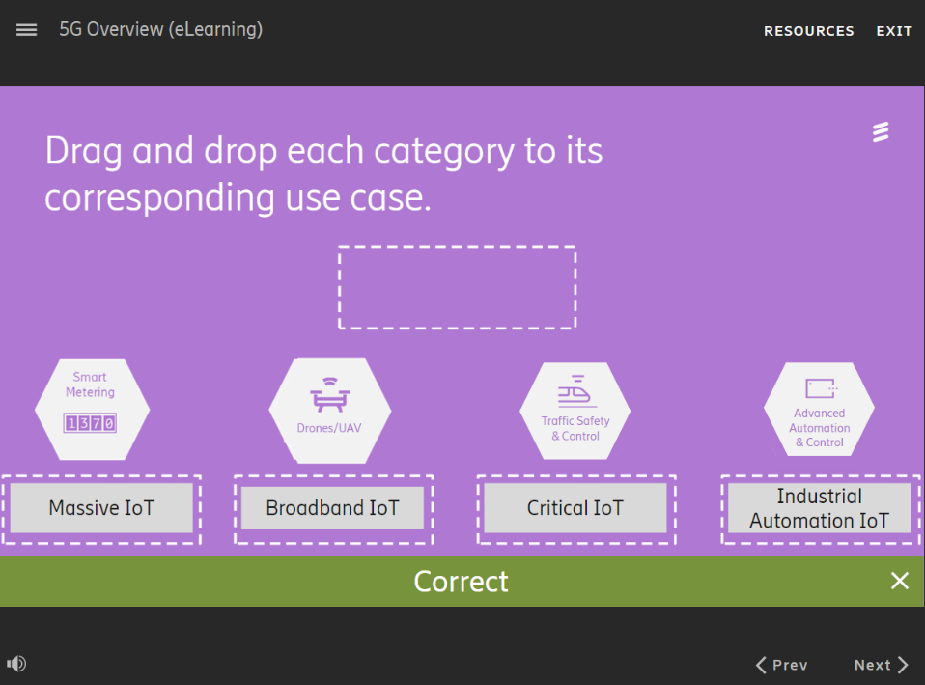

●**Ericsson Radio System**

1.

The radio site is in a rural countryside. Coverage(覆盖范围)

The radio site in a dense urban core with a heavy traffic load. Capacity (容量)

The radio site has space limitations with smaller site-to-site distances. Compact (紧凑)

2.

The frequency band with the radio type.

Low band Remote Radio

Mid band Massive MIMO Radio

High band mmWave Streetmacro

3.

The Site System product with the right description.

Smart connected sites This solution offers a unified way to enable remote control and monitor all site equipment.

Integrated site solutions This portfolio includes Lightpole Sites, Street Furniture Sites, Strand Sites, Vault Sites.

Installation and interconnect This portfolio contains items for mounting, grounding, cables & connectors.

4.

Which part(s) of the Antenna Systems portfolio also contain radios?

Active Antennas

Hybrid/Interleaved AIR

5.

MINI-LINK Ericsson’s family of microwave products

Router 6000 series Ericsson’s radio integrated, service provider SDN enabled IP transport portfolio

Fronthaul 6000 5G optical platform for RAN connectivity with Ethernet, (e)CPRI and Transpot.

6.

This Ericsson software feature allows operators to run LTE and NR simultaneously on the same carrier frequencies and base station hardware.

Ericsson Spectrum Sharing

7.

Which solution provides a tightly integrated and optimized deployment of radio, baseband hardware and software and operational tools that are optimized for performance, energy efficiency and size?

Purpose-built RAN

8.

The Radio Site portfolio uses the same O&M as Ericsson RAN products. True

9.

Which functions are provided by the RAN Compute units?

Traffic management

Baseband processing

Timing & radio interfacing

All of the above

10.

Which category of antenna would you choose if you had a strictly rural deployment?

Coverage

11.

Remote Radio Radio located near the antenna at the site

Massive MIMO Radio & Antenna in same unit

Streetmacro Radio, Antenna and baseband in same unit

12.

Fronthaul connects the radio unit to the baseband

Backhaul ties the baseband to the core

●[**Data Strategy Introduction**](https://degreed.com/view/Course/26679066?newWindow=true)

1.

Why do you think we have a data strategy?

To define how to manage and use data to generate value.

2.

Data democratization: Manage data and break down silos to enable authorized, seamless access to datasets.

Data accountability: Create a clear responsibility framework for data.

Data quality: Manage and improve data to make it fit for consumption to foster trust and reliability.

Data optimization: Employ strategies to improve the speed and performance of data operations.

Data capability: Build out the competence, skills and tools for working with data in an organization.

3.

What is name of the model that is being deployed across the organization to implement the Data Strategy?

Data Operating Model

4.

Data is treated as an asset:

Data has real, tangible, and measurable value for the whole organization.

Data is managed in a federated approach:

Organizations closest to the data are responsible for managing it.

Democratized approach to data usage:

Data access is restricted internally only if data is sensitive or the customer demands restricted access.

Data is used in transparent, compliant, and ethical ways:

Data is treated and made available in accordance with the regulations and the contractual terms agreed with the customers, employees and partners.

Data quality is ensured during the data lifecycle:

The condition of the data needs to fulfill the requirements set by the use cases and any data issues need to be transparent to the users. To ensure this, data management targets data integrity, lineage and traceability.

5.

What is the name of the strategy that Ericsson has developed in relation to data?

Ericsson Group Data Strategy.

6.

What are two of Ericsson’s data-driven strategic goals?

To monetize data via business models

To improve products and services via real-time feedback.

7.

How often is the Group Data Strategy updated?

Regularly in line with the business needs

8.

Why does Ericsson have a data strategy?

To unlock value from our network and enterprise data

Ericsson utilizes a value-backed approach to transforming our data into a usable asset, slicing it into logical units. What are these logical units called?

Data domains

9.

What statement is correct in relation to data strategies?

Market Areas, Business Areas, and Group Functions set their own data strategies

10.

How many individual data strategies exist in Ericsson?

One per Market Area, Business Area, Group function.

11.

What governs the execution of the Data Strategy across the organization?

The Data Operating Model

12.

The Data Strategy has eight principles. Which two of the following are principles of the Data Strategy?

Data architecture follows a federated approach.

Design and implement solutions towards scalability.

The Group Data Strategy has five objectives. Which two of the following are objectives of the Group Data Strategy?

Improve data quality to foster trust and reliability

Optimize data for speed and performance

●**Data Operating Model**

1.

Data lineage: Mapping the data origin, watching what happens to it, and where it moves over time

Single Source of Truth: Designating one official source of data, for data consumers to get the true and current version of that data

Data quality : Ensuring that data is fits for its intended use

Access requirements: Ensuring that data security and access are addressed and manged

Data domain rollout : Identifying data elements to be included in the scope of each data domain and prioritizing them into critical data elements

2.

Accuracy: The degree to which the data mirrors the characteristics of a real-world object or the object it represents.

Uniqueness: No event or elements shall be recorded more than once based upon how that event or elements is identified.

Validity: Data elements are compared to ensure that they match defined rules.

3.

IT : Implement and maintain data architecture, enables, and tools

Data enablement office: Develop and uphold a consistent data operating model ;Support data domain managers and implementation teams

Data council: Take strategic decisions around data; Own group-wide data strategy

Bas, Mas, & GFs: Develop and implement individual data strategies and data-related use cases.

Q1 What are two functions performed by the governance framework of Data Operating Model?(choose two)

Manages and controls the quality, usability, availability, security, and consistency of data

Ensure that standardized rules and regulations for data management are applied and followed

Q2 Which set of components are part of the part of the data operating model?

Governance, process, roles and responsibilities, technology and tools

Q3 Who coordinates and supports the governance of the data operating modal?

Data Enablement Office

Q4 Why is data security important?

To protect the integrity and confidentiality of data.

Q5 Who implements and maintains data management tools?

IT

Q6 Which tools supports users to find information about data?

Ericsson Data Catalog

Q7 You are ensuring that data security and access are addressed and managed. Which Data Operating Model activity is being described?

Access requirements

Q8 You are designating one official source of data consumers to get the true and current version of that data. Which Data Operating Model activity is being described?

Single Source of Truth

Q9 You are mapping the data origin, watching what happens to it and where it move over time.

Which data operating model activity is being described?

Data lineage

Q10 Who takes strategic decision around data and owns the group-wide data strategy?

Data council