Malware Reverse Engineering Lab – Fragmented XOR Analysis

1. Introduction
The purpose of this lab was to analyze a suspicious executable file and recover a hidden message. The executable generated multiple text files with unreadable content. Through reverse engineering and decryption, the original message was successfully reconstructed.
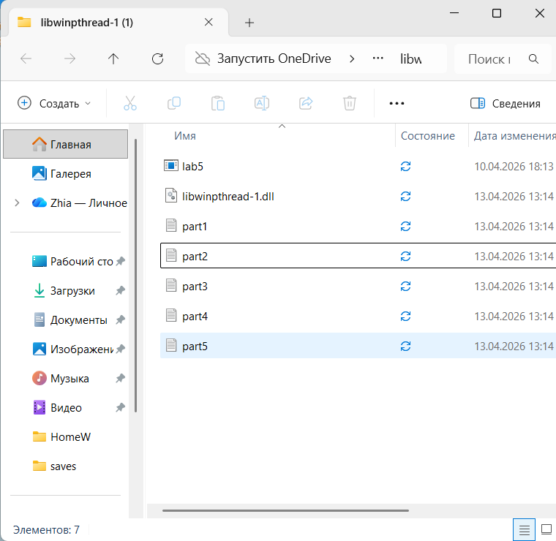
The program creates 5 files
Files are saved on the Desktop
Naming pattern:
part1.txt, part2.txt, part3.txt, part4.txt, part5.txt
The content of these files appeared unreadable and consisted of random symbols, indicating that the data was encrypted.
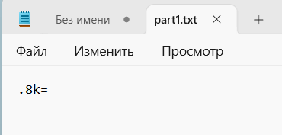
Example contents:
part1 !.8k=
part2 9*?>>
part3 '>&
part4 '*?"$%
part5 .3'''
Findings:
The data is not human-readable
All files contain similar structured encoded data
The content suggests a byte-level transformation
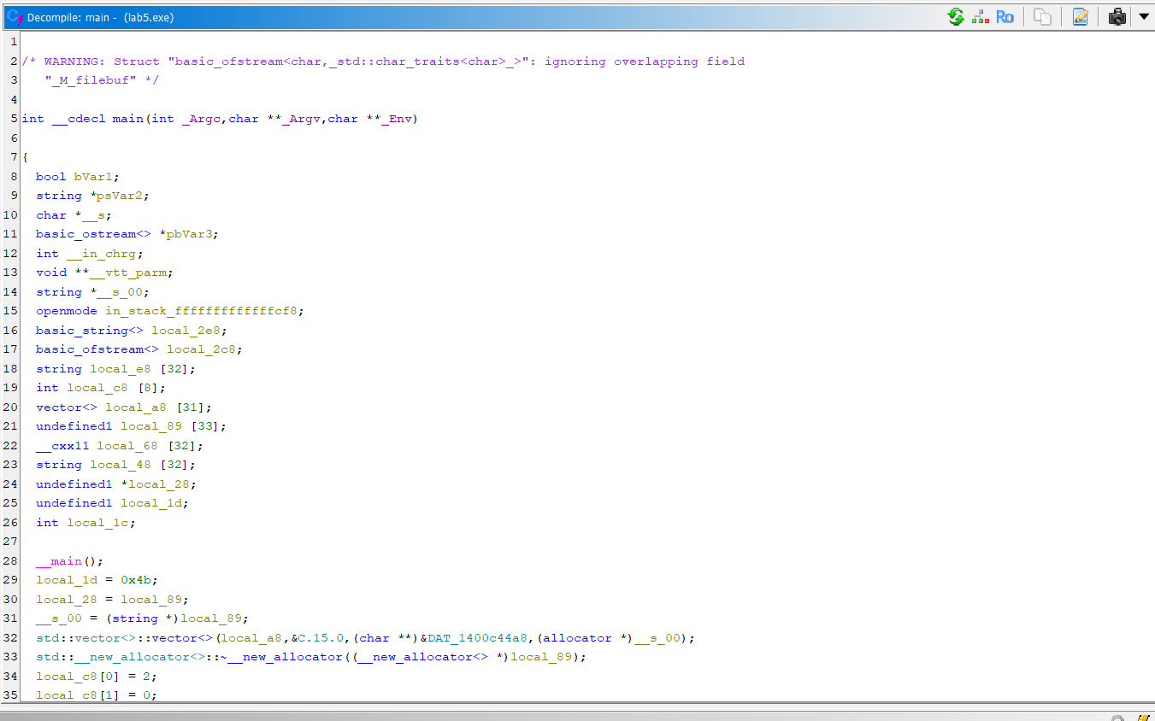
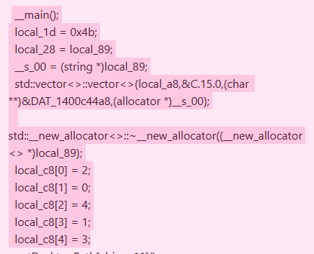
Key findings:
A vector structure stores multiple data fragments
A loop processes data byte-by-byte
A constant value is assigned:
local_1d = 0x4B
The program writes processed data using ofstream.write()
Fragment order is controlled by:
{2, 0, 4, 1, 3}

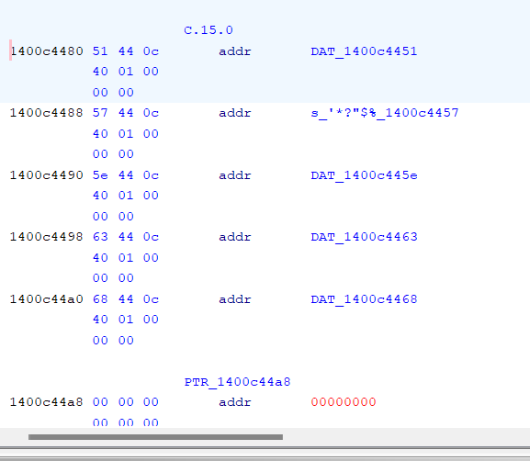
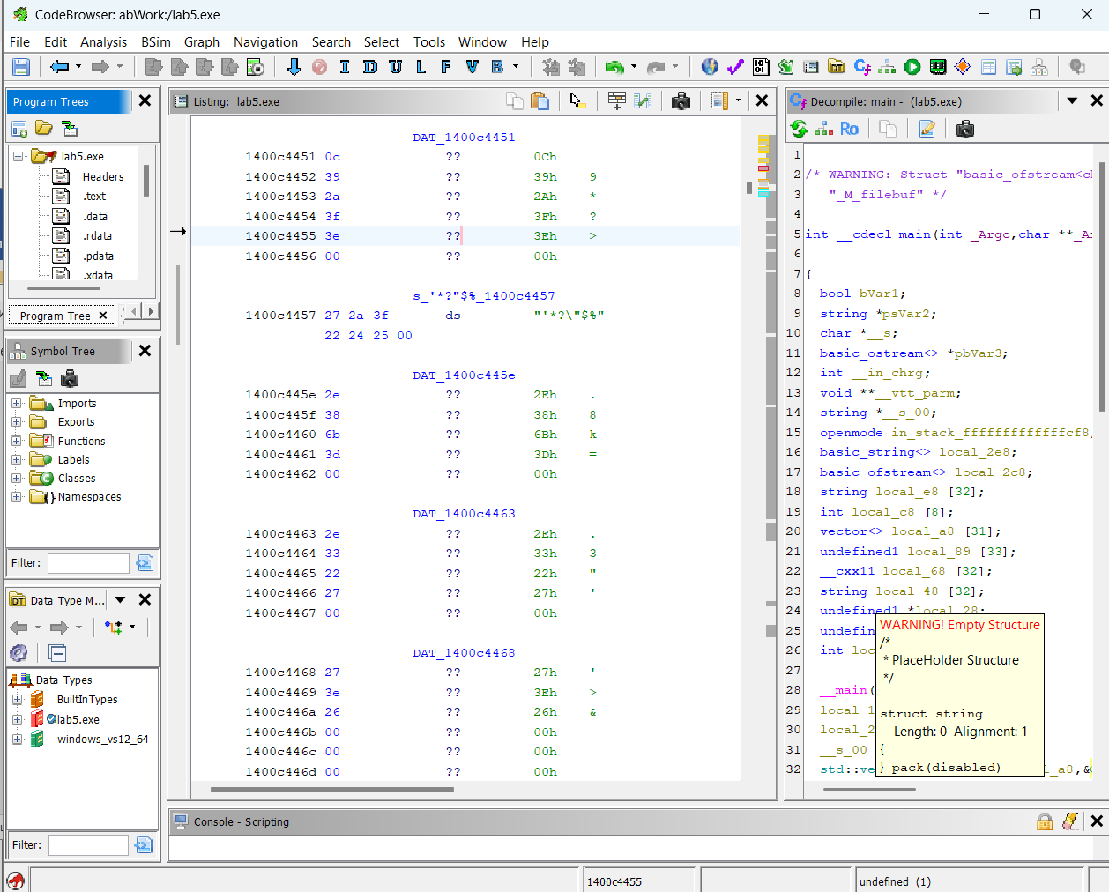

2, 0, 4, 1, 3
[2] DAT_1400c445e
[0] DAT_1400c4451
[4] DAT_1400c4468
[1] DAT_1400c4457
[3] DAT_1400c4463

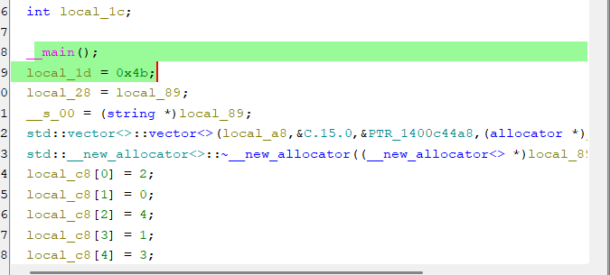

local_1d = 0x4b;
XOR key = 0x4B ('K')
rdata
Piece 0
0c 39 2a 3f 3e
Piece 1
27 2a 3f 22 24 25
Piece 2
2e 38 6b 3d
Piece 3
2e 33 22 27
Piece 4
27 3e 26

Transcript (XOR)
Formula:
decrypted_byte = encrypted^0x4B

Let's take the first byte:
0x0c^0x4B = 0x47 = 'G'
the beginning of the word G is already visible...
Deciphering all the pieces
Piece 0:
0c 39 2a 3f 3e

Piece 1:
27 2a 3f 22 24 25
lation

Piece 2:
2e 38 6b 3d
It's v

Piece 3:
2e 33 22 27
Exile

Piece 4:
27 3e 26
lum

In code
local_c8 = {2, 0, 4, 1, 3};

[2] es v
[0] Gratu
[4] lum
[1] lation
[3] exil

Gratulationes vexillum

10. Conclusion
The hidden message embedded in the executable is:
Gratulationes vexillum
This lab demonstrated key reverse engineering techniques including static analysis, identification of encryption methods, and reconstruction of fragmented data.

