|  |  |
| --- | --- |
| **Project Case** |  |
| COMP7094  Multimedia Programming Foundation |
| **Computer Science** | **E212-COMP7094-CC01-00** |
| ***Valid on*** *Even Semester Year 2020/2021* | **Revision 00** |

1. Seluruh kelompok tidak diperkenankan untuk:

*The whole group is not allowed to:*

* + - Melihat sebagian atau seluruh proyek kelompok lain,

*Seeing a part or the whole project from another groups*

* + - Menyadur sebagian maupun seluruh proyek dari buku,

*Adapted a part or the whole project from the book*

* + - Mendownload sebagian maupun seluruh proyek dari internet,

*Downloading a part or the whole project from the internet,*

* + - Mengerjakan soal yang tidak sesuai dengan tema yang ada di soal proyek,

*Working with another theme which is not in accordance with the existing theme in the matter of the project,*

* + - Melakukan tindakan kecurangan lainnya,

*Committing other dishonest actions,*

* + - Secara sengaja maupun tidak sengaja melakukan segala tindakan kelalaian yang menyebabkan hasil karyanya berhasil dicontek oleh orang lain / kelompok lain.

*Accidentally or intentionally conduct any failure action that cause the results of the project was copied by someone else / other groups.*

1. Jika kelompok terbukti melakukan tindakan seperti yang dijelaskan butir 1 di atas, maka **nilai kelompok** yang melakukan kecurangan (menyontek maupun dicontek) akan di – **NOL** – kan.

*If the group is proved to the actions described in point 1 above, the score of the group which committed dishonest acts (cheating or being cheated) will be “Zero”*

1. Perhatikan jadwal pengumpulan proyek, segala jenis pengumpulan proyek di luar jadwal tidak dilayani.

*Pay attention to the submission schedule for the project, all kinds of submission outside the project schedule will not be accepted*

1. Bila Anda tidak membaca peraturan ini, maka Anda dianggap telah membaca dan menyetujuinya

*If you have missed to read these regulations, so you are considered to have read and agreed on it*

1. Persentase penilaiaan untuk matakuliah ini adalah sebagai berikut:

*Marking percentage for this subject is described as follows:*

|  |  |  |
| --- | --- | --- |
| **Tugas Mandiri**  *Assignment* | **Proyek**  *Project* | **UAP**  *Final Exam* |
| 40% | 60% | - |

1. Software yang digunakan pada matakuliah ini adalah sebagai berikut:

*Software will be used in this subject are described as follows:*

|  |
| --- |
| **Software**  *Software* |
| Java 8  Eclipse 2020.6  VLCJ 3.12  VLC Media Player 3.0.11 |

## Ekstensi file yang harus disertakan dalam pengumpulan tugas mandiri dan proyek untuk matakuliah ini adalah sebagai berikut:

*File extensions should be included in assignment and project collection for this subject are described as follows:*

|  |  |  |
| --- | --- | --- |
| **Tugas Mandiri**  *Assignment* | **Proyek**  *Project* | **UAP**  *Final Exam* |
| JAVA, CLASS | JAVA, CLASS, Image Files (JPG / PNG), Audio Files (MP3 / WAV), Video Files (AVI / MP4) | - |

## Soal

*Case*

**CinemaCC**

**CinemaCC** is an application which is made to help customers to buy cinema tickets easier. You as programmer are asked to create an application to help customers to buy cinema tickets and show the outline of the **CinemaCC** using **Java Programming** **Language**.

When the program starts, it will **play a song (“music.mp3”) in the background**. The song will **stop** **when the welcome page change**. To play the song, use **VLCJ**.

The components and details for each page will be described below.

* **Welcome Page**
  + **Components**
    - **JFrame** for the welcome page
    - **JPanel** for the centre part of the page
    - **JLabel** for background image, next icon image, and next text
  + **Description**
    - * Use **Graphics2D** to draw the **logo** and **logo shadow** (using **Image Transformation** (**flip**))
      * 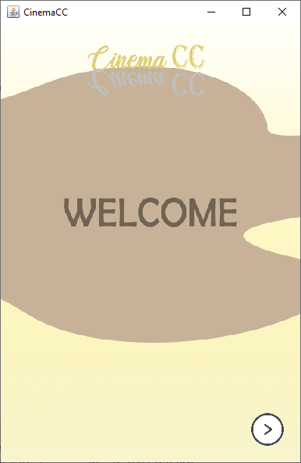If the user clicks **Next icon** (at the bottom right) at the page, change the background image

**Figure 1 Welcome Page (Page 1)**

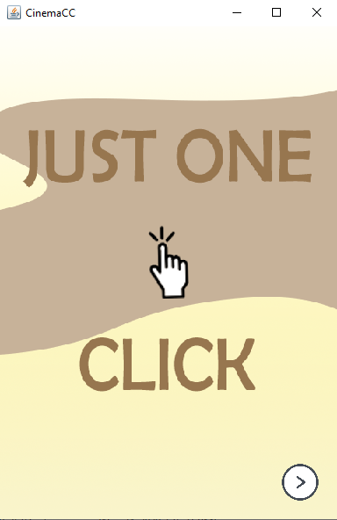Figure 2 Welcome Page (Page 2)

* If the user clicks **Next Button,** it will redirect to Login Page

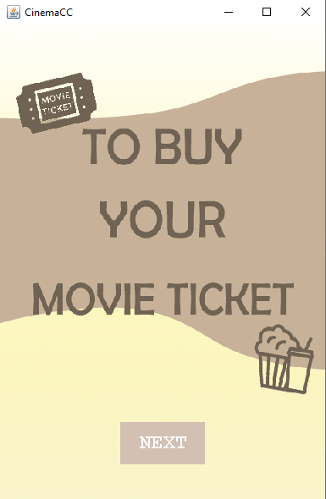

**Figure 3 Welcome Page (Page 3)**

* **Login Page**
  + **Components**
    - **JFrame** for the login page
    - **JPanel** for the centre part of the page
    - **JButton** for the submit button
    - **Jlabel** for the login title, email text, password text, register here text, and background
    - **JTextField** to input **email**
    - 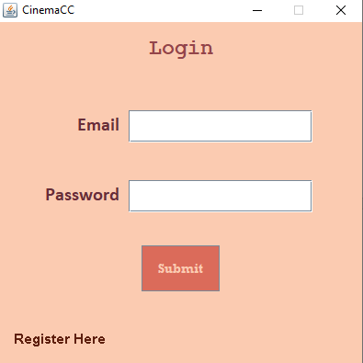**JPasswordField** to input **password**

**Figure 4 Login Page**

* + **Description**
    - If the user clicks **submit button**:
      * **Validate** that **email** and **password** must match the **registered user**
      * 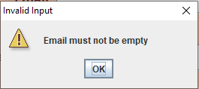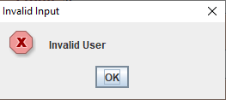If **email** or **password** is empty or credential entered is **incorrect**, show an **error message**

**Figure 5 Login Page (Invalid Input)**

* + - * **Otherwise**, redirect the user to **Main Page**
    - If the user clicks **Register** button, redirect the user to **Register Page**
* **Register Page**
  + **Components**
    - **JFrame** for register page
    - **JPanel** for the top, centre, and bottom part of the page
    - **JLabel** for register title, back text, name text, email text, password text, phone number text, dob text, gender text, city text, I agree text
    - **JButton** for submit button and back button
    - **JTextField** to input name, email, and phone number
    - **JPasswordField** to input password
    - **JCalendar** to select the date
    - **JRadioButton** to select the gender
    - **JComboBox** to select the city
    - 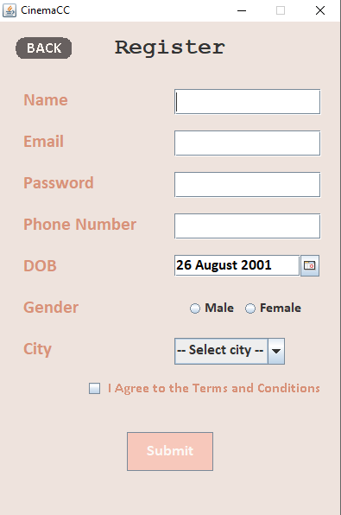**JCheckBox** to check the I agree to the Terms and Conditions

Figure 6 Register page

* + **Description**
    - There are several **validations** for input fields in this page:
      * **Name** must be between **5 – 20 characters**
      * **Password** must be **at least 5 characters** length and in **alphanumeric** format
      * **Email** must be in correct email format
      * **Phone number** must begin with **‘+62’**
      * **Gender** must be between **male or female**
      * User must be **at least 17 years** old
      * User must **check** I agree to the terms and conditions **check** **box**
    - All **JTextField** and **JPasswordField** have their own tooltip that shows the correct format

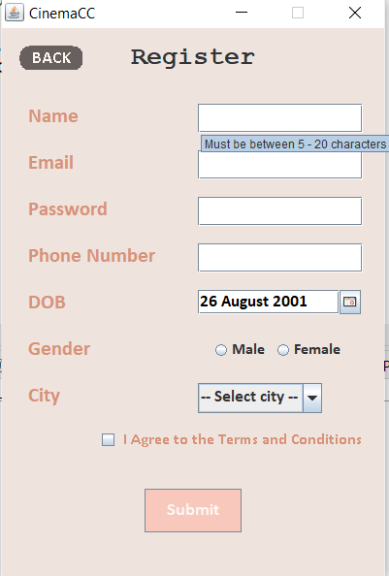**Figure 7 Register Page (with Tooltip)**

* + - If the user clicks **Register** button, **validate** all fields
      * If one or more fields **fails the validation**, **show** an **error message dialog**
      * **Otherwise**, **show** a **success message dialog**
    - 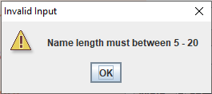If the user clicks **Back** button, redirect them to **Login Page**

Figure 8 Register Page (Invalid Input)

* **Main Page**
  + **Components**
    - **JFrame** for main page
    - **JPanel** for the center part of the page
    - **JScrollPane** for the poster scroll pane
    - **JMenuBar** for the menu bar
    - **JMenuItem** for the logo menu and user menu
  + **Description**
    - Use **Graphics2D** to draw the components needed
    - If the user clicks on any of the poster image, redirect them to **Movie Detail Page**
    - 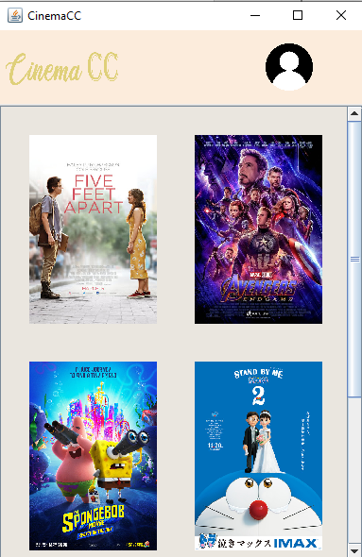If the user clicks on **User Menu**, **redirect** them back to **User Page**

**Figure 9 Main Page**

* **Movie Detail Page**
  + **Components**
    - **JFrame** for Movie Detail Page
    - **JPanel** for the top, center, and bottom part of the page
    - **JButton** for back button, watch trailer button, and buy tickets button
    - **JLabel** for movie title, poster image, author text, duration text, synopsis text
    - 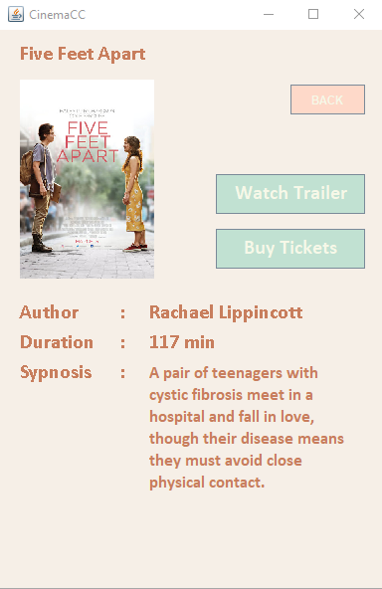**JTextArea** for synopsis description text

**Figure 10 Movie Detail Page**

* + **Description**
    - Use **Graphics2D** to draw the components needed
    - Validate if user **cannot close** the **frame** if the **close button** is **clicked**

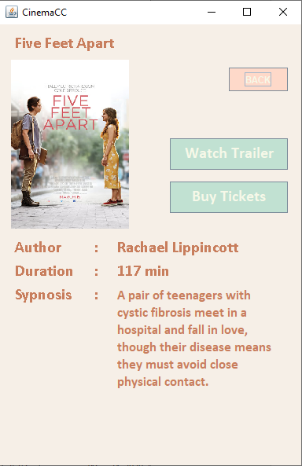

**Figure 11 Movie Detail Page (Zoom In)**

* + - If user **hover** over the **poster picture**, it will **zoom in**
    - If the user clicks **Back** button, redirect them to **Main Page**
    - If the user clicks **Watch Trailer** button, **show** a new **Watch Trailer Pop Up**
    - If the user clicks **Buy Tickets** button, **show** a new **Buy Tickets Pop Up**
* **Watch Trailer Pop Up**
  + **Component**
    - **JFrame** for watch trailer pop up
    - **JPanel** for the centre and video part of the page
    - **JButton** for the play/pause button, stop button, and back button
    - **EmbeddedMediaPlayerComponent** to **show the video**
  + **Description**
    - Play movie trailer **as selected** **from movie detail**
    - Validate if user **cannot close** the **frame** if the **close button** is **clicked**
    - Validate if user can only show one **Movie Trailer Pop Up** at a time
    - If the user’s mouse is on video panel, **volume** will change if the **mouse wheel** is moved
    - Validate the **volume** of the video changed must be **between 0 and 100**
    - If user clicks **Play / Pause button**, **play or pause** the **video**
    - If the user clicks **Stop button**, **stop** the **video**
    - If the user clicks **Back button**, close the **Watch Trailer Pop Up**

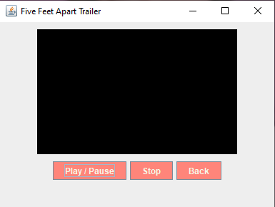

Figure 12 Movie Trailer Pop Up

* **Buy Tickets Pop Up**
  + **Component**
    - **JFrame** for buy tickets pop up
    - 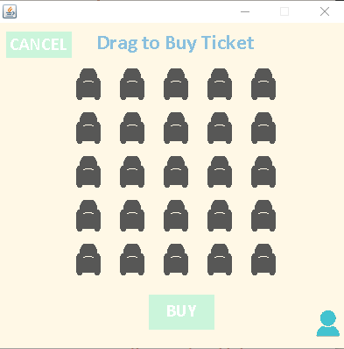**JPanel** for the center part of the page

Figure 13 Buy Tickets Pop Up

* + **Description**
    - Validate if user **cannot close** the **frame** if the **close button** is **clicked**
    - Validate if user can only show one **Buy Tickets Pop Up** at a time
    - 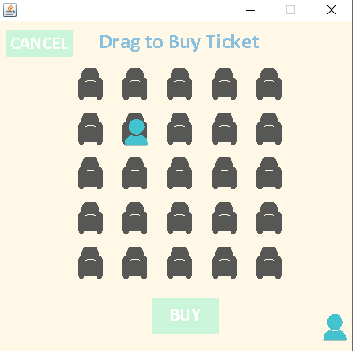Use **Graphics 2D** to draw **the seats and user image**

**Figure 14 Buy Tickets Pop Up (Drag User Image)**

* + - To buy ticket, user must **drag** the **user** **image** to the **seat** their want
    - If user click **Buy Button, validate** how many tickets they want to buy**:**
      * If there is **no ticket, show** an **invalid message**
      * **Otherwise**, **show** a **success buying message**
    - If user click **Cancel Button, close** the **Buy Tickets Pop Up**
* **User Page**
  + **Component**
    - **JFrame** for user page
    - **JPanel** for the top and center part of the page
    - **JMenuBar** for the menu bar
    - **JMenuItem** for the logo menu and user menu
    - **JLabel** for user name
    - 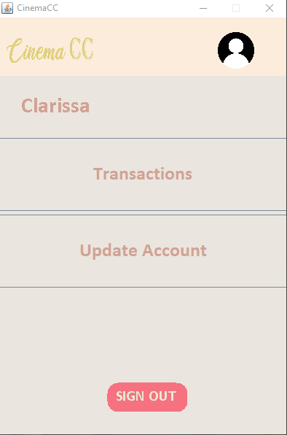**JButton** for transaction button, update account, and sign out button

Figure 15 User Page

* + **Description**
    - Validate if user **cannot close** the **frame** if the **close button** is **clicked**
    - If user click the **Transactions Button,** redirect them to **Transaction Page**
    - If user click the **Update Account Button**, redirect them to **Update Account Page**
    - If user click the **Sign Out Button,** redirect them to **Login Page**
    - If user click the **Logo Menu,** redirect them to **Main Page**
* **Transaction Page**
  + **Component**
    - **JFrame** for transaction page
    - **JPanel** for centre part of the page
    - **JLabel** for transaction history
    - **JButton** for back button
  + **Description**
    - Validate if user **cannot close** the **frame** if **close button** is **clicked**
    - User can only **see** **up to 3 latest transactions** they make
    - 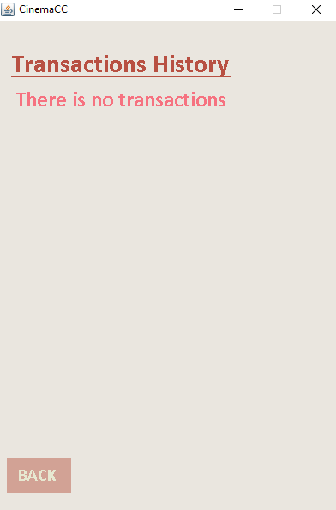If user did not do any transaction, show:

Figure 16 Transaction Page (No Transaction)

* + - 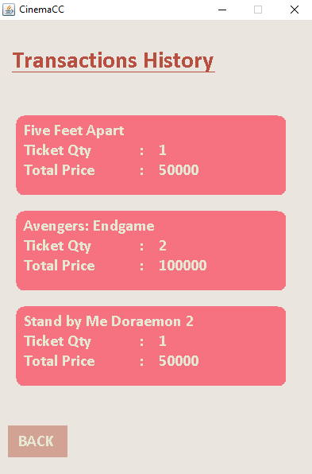**Otherwise**:

**Figure 17 Transaction Page (There is transactions)**

* + - If user click the **Back Button**, redirect them to **User Page**
* **Update Account Page**
  + **Component**
    - **JFrame** for update account page
    - **JPanel** for the top, centre, and bottom part of the page
    - **JPasswordField** for input old password and new password
    - **JLabel** for user’s name, old password, and new password
    - **JButton** for back button and update button
  + **Description**
    - Validate if user **cannot close** the **frame** if **close button** is **clicked**
    - User can **change** their **old password** to **new password**
    - Use **Graphics2D** to **draw** the components needed
    - If user click **update button,** validate the password inputted:
      * If the **old password** or **new password** is **empty**, **show** a **warning message**
      * If the **old password** and **new password** inputted is **same**, **show** an **error message**
      * If the **password** inputted **invalid**, **show** an **error message**
      * **Validate new password** must be **at least 5 characters** length and in **alphanumeric** format
      * **Otherwise**, update user’s **password**
    - 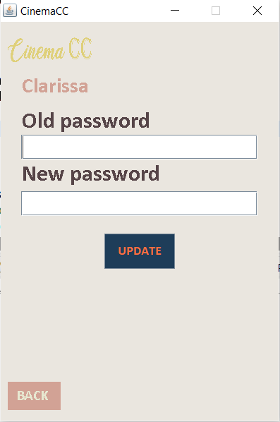If user click **Back Button**, redirect them to **User Page**

**Figure 18 Update Account Page**

**References:**

* Welcome Page(1): <https://drive.google.com/file/d/1yAUgoB8-52GMeyerNN_yPhWnBP24-GKT/view?usp=sharing>
* Welcome Page(2): <https://drive.google.com/file/d/1pykkzaBUBKLOP0WJShgseYZ0yWoN3XBN/view?usp=sharing>
* Welcome Page(3): <https://drive.google.com/file/d/19zgCXRVvK51bZWwJGUMe40kd8kDpsSrj/view?usp=sharing>
* Music: <https://www.youtube.com/watch?v=5nNVrUE4oDA>
* Poster 1: <https://upload.wikimedia.org/wikipedia/id/a/a7/Five_Feet_Apart_%282019_poster%29.png>
* Poster 2: <https://cdn.europosters.eu/image/750/posters/avengers-endgame-journey-s-end-i73600.jpg>
* Poster 3: <https://images-na.ssl-images-amazon.com/images/I/81jOPH03PWL._AC_SL1500_.jpg>
* Poster 4: <https://animeanime.global/wp-content/uploads/2020/10/361169.jpg>
* Poster 5: <https://i.pinimg.com/originals/d5/0a/00/d50a00236aae91a2713996ecc9b00cc1.jpg>
* Poster 6: <https://images-na.ssl-images-amazon.com/images/I/61c8%2Bf32PJL._AC_SY879_.jpg>
* Trailer 1: <https://www.youtube.com/watch?v=XtgCqMZofqM>
* Trailer 2: <https://www.youtube.com/watch?v=TcMBFSGVi1c>
* Trailer 3: <https://www.youtube.com/watch?v=neBkma9xtjM>
* Trailer 4: <https://www.youtube.com/watch?v=CgfRPba3u74>
* Trailer 5: <https://www.youtube.com/watch?v=Eh993__rOxA>
* Trailer 6: <https://www.youtube.com/watch?v=xRc3WviXk2M>
* Next Icon: <https://p.kindpng.com/picc/s/553-5534364_next-icon-png-image-free-download-searchpng-transparent.png>
* User Icon: <https://www.stickpng.com/img/icons-logos-emojis/users/simple-user-icon>
* User Icon Blue: <https://cdn.iconscout.com/icon/free/png-256/user-1648810-1401302.png>
* Chair: <https://www.vexels.com/png-svg/preview/131282/luxury-sofa-seat-icon>
* Logo: <https://drive.google.com/file/d/1MbwDy2tI6TjXhusGTsImS5SMpAgzCRME/view?usp=sharing>
* Logo grey: <https://drive.google.com/file/d/1eRj9kH_HQ0vDet4mYhpZQIwfyqpUuJs_/view?usp=sharing>

Here are the rules that you must follow to create your project:

1. Use appropriate software for this subject based on **Sistem Praktikum** that can be downloaded from Binusmaya.
2. Use the techniques taught during practicum.
3. Collect appropriate files for this subject based on **Sistem Praktikum** that can be downloaded from Binusmaya.
4. Include the other files that can support your project, such as:
   * All the files in your project.
   * Other files (image, audio, video, etc.) used in your project.
   * *.DOC file (documentation of your project) that contains the reference links of additional files (image, audio, video, etc.) used in your project.