Zhai Kexuan

kzhai@clemson.edu

[Homework 3 Aue881]

[Vehicle Structure with Matlab]



**Task 1: Model and plot an undeflected 2D side frame of a vehicle**

The code of modeling is shown in fig.1.1. The plot of the frame is defined by a function, which is shown in fig1.2. The result of task 1 is shown in fig1.3.

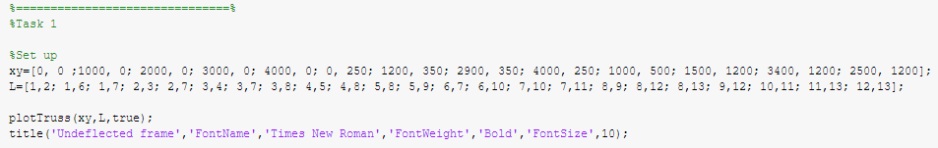

Fig.1.1

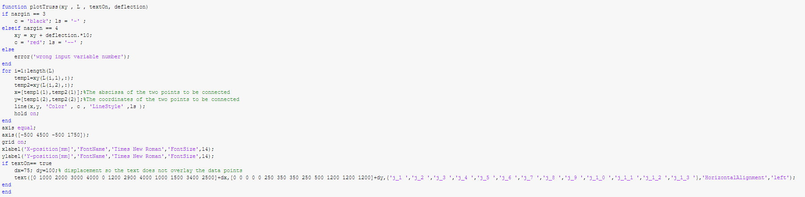

Fig.1.2

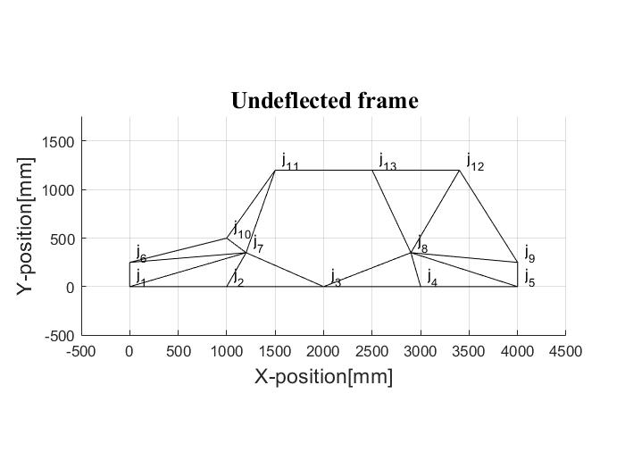

Fig.1.3

**Task 2: Calculate the deflection of the frame**

The code of calculating the deflection is shown in fig.2.1. The result of task 2 is shown in fig 2.2. The deflection of joint 3 is 48.34 mm.

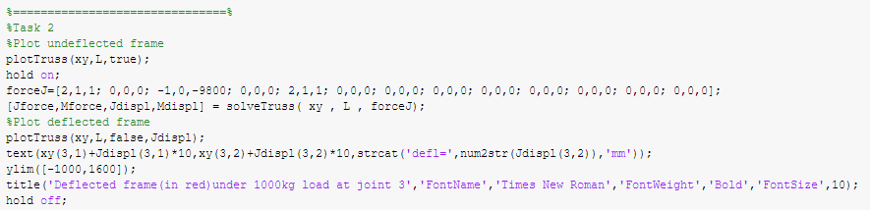

Fig.2.1

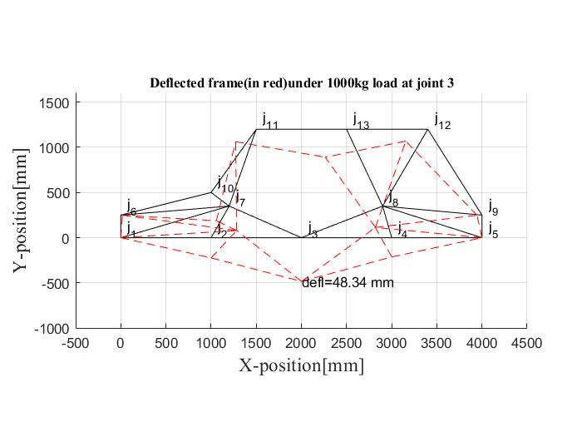

Fig.2.2

**Task 3: Increasing the stiffness of the vehicle frame**

There are 5 additional structural members and each condition is shown in table 3.1. The code of task 3 is shown in fig 3.1(j3, j11). As we can see in table 3.1, the structural members added between joint 3 and joint 11 minimize the deflection. The figures of each result are shown in fig 3.2 to fig 3.6.

|  |  |  |  |
| --- | --- | --- | --- |
| Number | Member | Deflection(mm) | Figure |
| 1 | j3, j11 | 13.66 | fig 3.2 |
| 2 | j8, j13 | 45.86 | fig 3.3 |
| 3 | j3, j11 | 27.87 | fig 3.4 |
| 4 | j3, j11 | 37.22 | fig 3.5 |
| 5 | j3, j11 | 16.60 | fig 3.6 |

Table 3.1

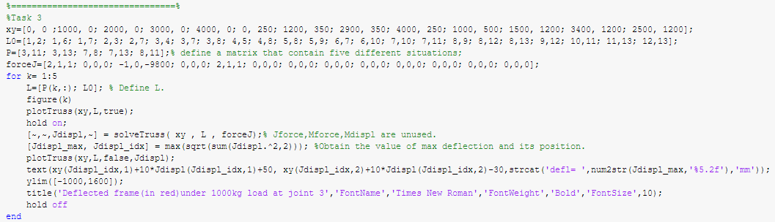

Fig.3.1

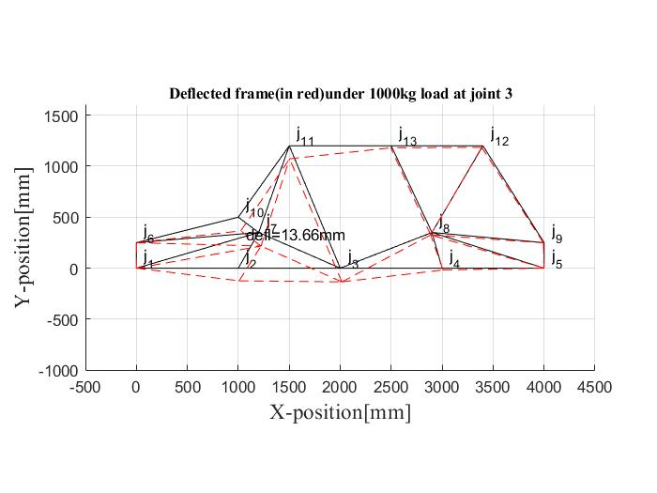

Fig.3.2

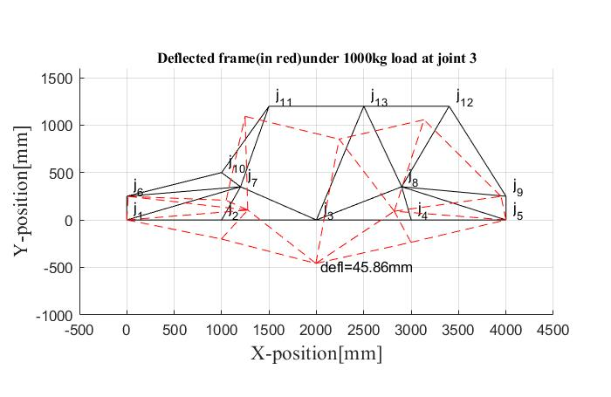

Fig.3.3

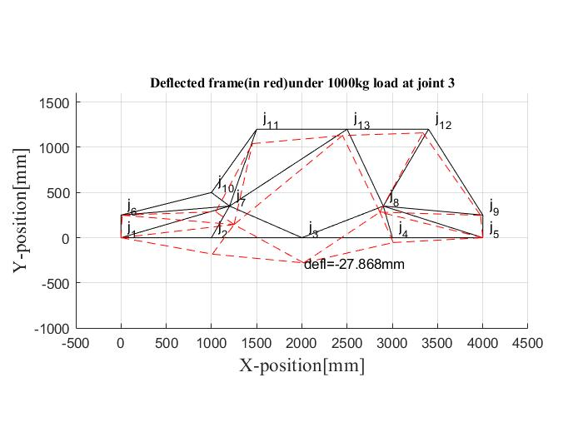

Fig.3.4

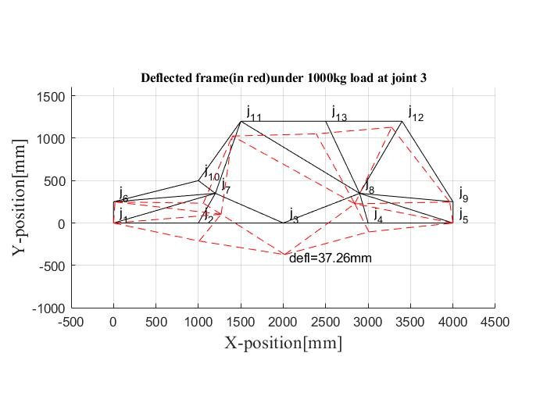

Fig.3.5

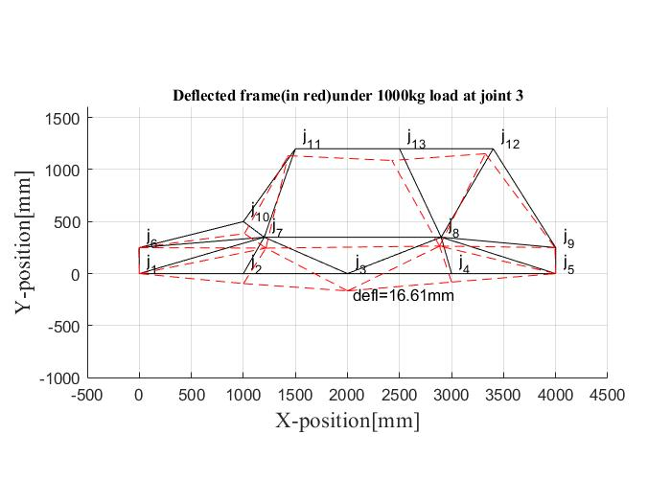

Fig.3.6

**Task 4: Interpretation of the results**

4.1. List five idealizations (simplifying assumptions) that you made in your model.

1. No bending for each member.

2. Simplify each welding node of the frame to a single point.

3. Simplifies the point of gravity and concentrates gravity on the joint 3.

4. The diameter of the truss structure is ignored. Simplify it into a line.

5. The fix body is simplified by two joints (joint 1 and joint 5).

6. The frame is simplified as a 2D structure which should be 3D structure in reality.

4.2. For Task 2, identify three members that are loaded under compression and three that are loaded under tension. Provide an intuitive reasoning for why these members experience either compression or tension.

1. Three members that are loaded under compression: j10, j11; j11, j13; j12, j13.

These members will be compressed. Because the structure connected to them tends to clamp.

2. Three members that are loaded under tension: j1, j2; j2, j3; j3, j4.

All three members are in similar conditions. J1 and j5 are fixed. Therefore, these members will be stretched, when force is applied on j3.

To identify the condition of each member, a compare method is taken. In this method, the condition is determined by measuring the length difference between original length and length after a deflection. The equation below shows the calculation method of length difference:

Length difference= Length after deflection- Original Length

The calculation process is operated by Matlab. When a result is a positive number, it represents the member is under tension. Conversely, a negative number represents a compression. The code is shown in fig 4.2.1. Table 4.2 shows the result of each member.

|  |  |  |  |  |  |
| --- | --- | --- | --- | --- | --- |
| **Sequence** | **Member** | **Original Length (Dist1)** | **Length after deflection (Dist2)** | **Length difference (Dist)** | **Condition** |
| 1 | j1, j2 | 1000 | 1000.3 | 0.3193 | tension |
| 2 | j1, j6 | 250 | 249.86 | -0.1378 | compression |
| 3 | J1, j7 | 1250 | 1250.7 | 0.7146 | tension |
| 4 | j2, j3 | 1000 | 1000.4 | 0.4081 | tension |
| 5 | j2, j7 | 403.11 | 403.22 | 0.1113 | tension |
| 6 | j3, j4 | 1000 | 1000.3 | 0.2960 | tension |
| 7 | j3, j7 | 873.21 | 874.58 | 1.3645 | tension |
| 8 | j3, j8 | 965.67 | 967.32 | 1.6557 | tension |
| 9 | j4, j5 | 1000 | 1000.2 | 0.1565 | tension |
| 10 | j4, j8 | 364.01 | 364.1 | 0.0986 | tension |
| 11 | j5, j8 | 1154.3 | 1155.1 | 0.8065 | tension |
| 12 | j5, j9 | 250 | 249.9 | -0.0978 | compression |
| 13 | j6, j7 | 1204.2 | 1208.7 | 4.5030 | tension |
| 14 | j6, j10 | 1030.8 | 1027.6 | -3.2146 | compression |
| 15 | j7, j10 | 250 | 249.47 | -0.5324 | compression |
| 16 | j7, j11 | 901.39 | 904.18 | 2.7906 | tension |
| 17 | j8, j9 | 1104.5 | 1105.3 | 0.7208 | tension |
| 18 | j8, j12 | 986.15 | 987.12 | 0.9556 | tension |
| 19 | j8, j13 | 939.41 | 939.57 | 0.1572 | tension |
| 20 | j9, j12 | 1123.6 | 1123 | -0.6561 | compression |
| 21 | j10, j11 | 860.23 | 858.50 | -1.7356 | compression |
| 22 | j11, j13 | 1000 | 999.33 | -0.6692 | compression |
| 23 | j12, j13 | 900 | 899.44 | -0.5591 | compression |

Table 4.2

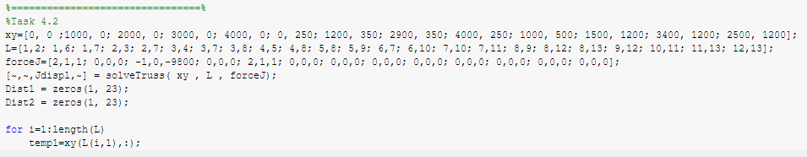

Fig.4.2.1

4.3. For Task 3, explain why adding some members has little impact on the deflection while adding others reduces the deflection significantly. What makes the difference?

For additional members j7, j13, and j8, j11, which is shown in fig 3.4 and 3.5. In both conditions, not all structures related to j3 are closed-loop triangle structure, which has a huge impact on the defection of the frame. With the lack of enough closed-loop triangle structure, the performance will be ineffective.

For additional member j3, j13, which is shown in fig 3.3. In this condition, each structure direct connects to j3 is a closed-loop triangle structure. However, there is not a closed-loop triangle structure on j13 which has a huge impact on j3, in another word, j13 is in the middle of a straight member. Therefore, j13 will move with j3 when deflection happens.

For additional members j3, j11 and j7, j8. The structure direct connected to j3 and joints related to j3 are closed loop triangle structures. Therefore, the performance of both of them are effective.4.4. Which of the additional members in Task 3 allow you to satisfy the bending stiffness requirement?

The deflection of the frame rail in the middle of the vehicle shall be less than 15mm. According to task 3, only the additional member added between joint 3 and joint 11 satisfy the bending stiffness requirement which is 13.66 mm.

4.5. In Task 2, what happens if the member between j5 and j9 were removed? Explain the error reported by MATLAB.

There are to warnings shows in the command window if the member between j5 and j9 were removed. The warnings are shown in fig 4.5.1.

The first warning is system may be only partially constrained. If member between j5 and j9 is removed, the constraints of j9 will be incomplete, in other words, j9 will move freely, no matter how much force is applied to j3.

The Second warning is Matrix is singular to working precision. The direct reason of this warning is that singular matrix is an irreversible matrix. Fundamentally, the error is caused by the last error.

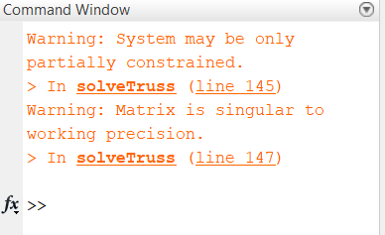

Fig 4.5.1

4.6. In addition to frame stiffness, strength should also be considered. Identify two failure modes that should be considered for all structural members.

1. Local buckling failure of a stressed member at a node

2. Tensile and compression exceeds the ultimate tensile strength and compressive strength of materials.