
Table of Contents
Part 1. System Overview and Mental Map
1.1. What Is the CIIDI Backend Really and How Should You Think About It as a Developer?
1.2. Project Folder Map: What Each Folder Does and What You Must Never Touch
1.3. The Complete Lifecycle of an HTTP Request (End to End)
Part 2. The Dual Core Architecture: Microkernel and MVC
2.1. The Microkernel Architecture (Plugin-Style Module System)
2.2. The ModuleContract Interface as a Universal Plug
2.3. The MVC Architecture Inside Each Module (Controller, Model, View, and Services)
2.4. The Three Route Types You Will Program: View, POST Action, and AJAX/JSON API
Part 3. Detailed Explanation of Core Files (Line-by-Line Screenshot Guide)
3.1. URL Rewriting and Entry Point: public/.htaccess and public/index.php
3.2. The Heart of the System: core/System/Kernel.php
3.3. The Mandatory Contract: core/Interfaces/ModuleContract.php
3.4. The Dynamic Module Loader: core/System/ModuleLoader.php
3.5. The System Router: core/Http/Router.php
3.6. The MVC Dispatcher and Error Handling: core/Http/Dispatcher.php
3.7. The Static Asset and Global View Manager: core/System/AssetResolver.php
3.8. The Core Master Templates: master.php, header.php, sidebar.php, and home_bienvenida.php
3.9. Database Layer: core/Database/Connection.php and core/Database/QueryBuilder.php
3.10. Security, Permissions, Auditing, and Environment Variables: Auth.php, CSRF.php, AuditLogger.php, FeatureFlagMiddleware.php, and Env.php
Part 4. Step-by-Step Practical Guide: How to Create and Add a New Module from Scratch
4.1. Step 1: Create the Folder Structure of the New Module
4.2. Step 2: Create index.php and Implement ModuleContract
4.3. Step 3: Create the PostgreSQL Table and Program the Model in models/
4.4. Step 4: Program the Controller in controllers/ (Views, POST, and JSON)
4.5. Step 5: Create the Views in views/ and the CSS and JS Files in assets/
4.6. Step 6: Automatic Verification, RBAC Permissions, and SuperAdmin Settings
Part 5. How to Modify or Extend an Existing Module Without Breaking the System
5.1. How to Add a New Screen (View) to an Existing Module
5.2. How to Add a New POST Form or Save/Delete Action
5.3. How to Add an AJAX (JSON) Endpoint to Communicate with JavaScript
5.4. How to Add a Sidebar Menu Sub-Item and Configure Its Active Triggers
5.5. How to Handle Custom JSON Configurations and File or Image Uploads
Part 6. Troubleshooting Common Issues (Developer Quick Diagnostic Guide)
6.1. Issues with Routes, 404 Errors, and Missing Modules
6.2. Issues with Views, CSS Styles, JS Scripts, and AJAX Responses
6.3. Issues with the Database, QueryBuilder, 403 Permissions, and CSRF Tokens
6.4. Issues with the ONNX Neural Engine, Background Vectorization, and Tokenizer
Part 7. ONNX Neural Engine Architecture, Asynchronous Vectorization Cycle, and Step-by-Step Retraining (Fine-Tuning) Guide
7.1. How the Neural Engine Really Works in CIIDI and Why You Must Never Train It on the Local Server
7.2. When to Retrain the Model, What Happens When Adding a New Research Line, and Anti-Bias Balancing
7.3. Anatomy and Hygiene of the Training Dataset (Golden Rules Before Uploading to Google Colab)
7.4. Step-by-Step Practical Guide: How to Retrain and Quantize the Model in Google Colab (The 6 Official Cells)
7.5. Deploying the New Model in PHP, Cleaning Up Old Files, and Re-Indexing in the SuperAdmin Panel
7.6. Recommended Screenshot Guide to Visually Document Retraining and the ONNX Panel

Part 1. System Overview and Mental Map
1.1. What Is the CIIDI Backend Really and How Should You Think About It as a Developer?
When you dive into the CIIDI Repository System codebase for the first time, the simplest and most accurate way to picture it is like a video game console or a smart power strip. In an old-fashioned traditional web application, every screen, route, and menu is tangled together inside the same central files; if you want to add a new section, you have to open five core system files, edit the global menu by hand, and pray you do not break another developer's work. In CIIDI, that never happens because the system was built around one golden rule: completely separate the central engine (called the Core) from the business features (called Modules).
The Core (located in the core/ folder) is a domain-blind yet highly organized engine. We call it blind because the Core has no idea what a scientific article is, what a course is, what a research line is, or what a Socio-Technological Project (PST) is. All the Core knows how to do is receive a web request, verify that the visitor is not an attacker, ask the installed modules which routes and menu buttons each one provides, execute the matching controller, and render the master visual template around the output.
Meanwhile, each Module (located inside its own subfolder under modules/) is a complete, self-contained mini-application. A module ships with its own controllers, its own database models, its own HTML/PHP views, its own CSS stylesheets, its own JavaScript scripts, and an entry manifest file named index.php. Thanks to this design, whenever you as a developer need to build a new module or modify an existing one, 99% of your work takes place strictly inside the modules/TuModulo/ folder, without having to touch a single line of the Core.
1.2. Project Folder Map: What Each Folder Does and What You Must Never Touch
Before reading a single line of PHP code, you need to get your bearings across the main folders at the project root (C:/wamp64/www/proyect_CIIDI/). Each directory has a strict responsibility:
• public/: This is the sole public entry point exposed to the web server. It houses the .htaccess file that intercepts clean URLs, the index.php file that boots the entire system, global graphic assets (public/assets/), and the public directories where user-uploaded covers or images are stored (public/uploads/).
• core/: This is the untouchable heart of CIIDI's custom framework. It contains the Microkernel logic (core/System/), the HTTP router and dispatcher (core/Http/), the PostgreSQL connection and query builder (core/Database/), the security shields, sessions, RBAC permissions, and auditing (core/Security/), the standalone installer (core/Installer/), the module contract (core/Interfaces/), and the master views that assemble the header, sidebar, and footer (core/Views/). As a general rule, when developing a new module, you must not modify files inside core/; instead, you consume its classes and utilities.
• modules/: This is your primary workspace as a developer. Each folder inside here (Articulos, Autenticacion, Cursos, Investigaciones, LineasInvestigacion, RepositorioPST, SuperAdmin, VinculacionEmpresarial) is an independent module that automatically plugs into the system on boot.
• storage/: This is the system's on-disk runtime storage. It holds real-time JSON configuration files (such as config_system.json, which tracks which modules and routes are enabled or disabled, maintenance.json for maintenance windows, db_config.json for database credentials, and system_config.json), the installed.lock lockfile confirming that the system has already been installed, and the storage/logs/ folder where error logs and audit backups are written.
• vendor/: Stores external third-party libraries installed via Composer. It is autoloaded at the beginning of every request.
To visualize how these four major layers relate to one another, see Figure 1, which illustrates the overall architecture map of the CIIDI ecosystem and how modules connect to the Core and the PostgreSQL database.
Figure 1
General layer map of the CIIDI ecosystem (Separation between Entry Point, Core, Modules, and Persistence)
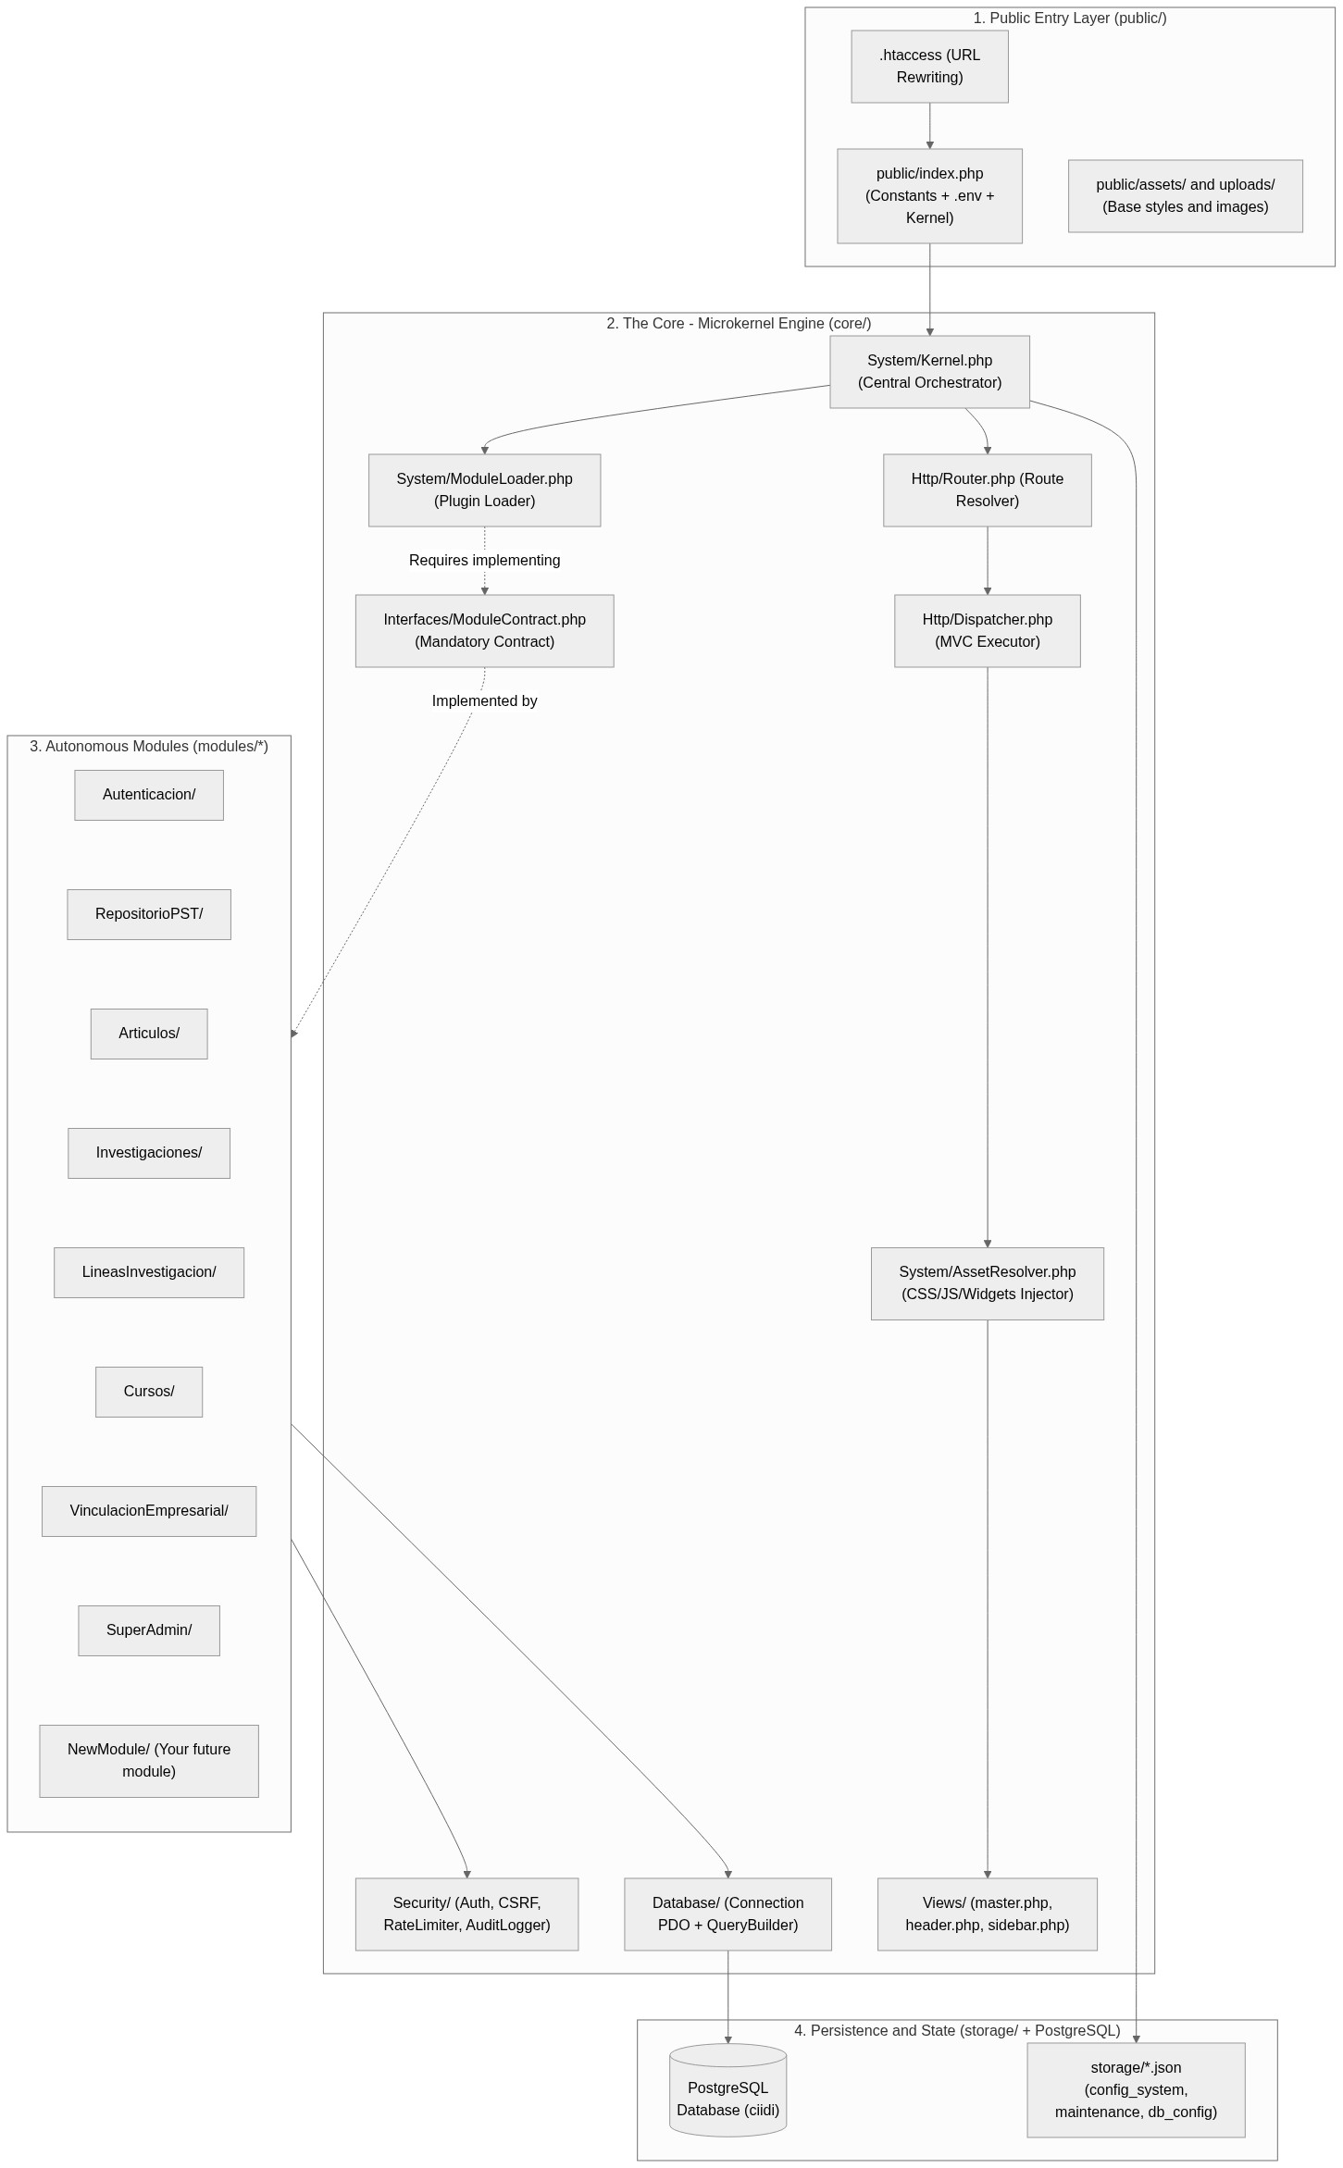
1.3. The Complete Lifecycle of an HTTP Request (End to End)
To understand how everything communicates on the backend, let us trace the exact path the system takes when a user types an address such as http://localhost/proyect_CIIDI/articulos into their browser or clicks any option in the sidebar menu:
• Step 1 (URL interception in Apache): The Apache web server receives the request. The .htaccess file checks whether the browser is requesting an actual physical file (such as a .webp image or a .css stylesheet). Since 'articulos' is not a physical file, .htaccess internally rewrites the request and forwards it to public/index.php?ruta=articulos.
• Step 2 (Environment bootstrap in public/index.php): public/index.php executes. This file defines the absolute path constants (BASE_PATH, CORE_PATH, MODULES_PATH, STORAGE_PATH), loads the variables from the .env file via the Env class, configures whether PHP errors are displayed or hidden based on APP_DEBUG, and instantiates the system's main class: $app = new Kernel(); followed by $app->run();.
• Step 3 (Module discovery in the Kernel constructor): When new Kernel() runs, the Kernel instantiates its helper services (SessionManager, ModuleLoader, AssetResolver, Router, Dispatcher, etc.) and checks whether the storage/installed.lock file exists. If it exists, it immediately calls $this->moduleLoader->loadModules(). At that moment, ModuleLoader scans every folder inside modules/, loads the index.php file of each active module, and merges all of their routes into a master dictionary named $rutasGlobales and all of their navigation buttons into $menuGlobal.
• Step 4 (Security filters and interceptors in Kernel::run): When $app->run() executes, before looking up the 'articulos' route, the Kernel sends web security headers, starts the PHP session, and runs the request through a line of guards: RateLimiter (which blocks blacklisted IPs or SQL injection and XSS attacks), InstallerHook (which redirects to the installer if the system is not yet installed), MaintenanceService (which renders the 503 screen when maintenance mode is active), and FeatureFlagMiddleware (which checks whether the SuperAdmin disabled or set that specific route to Read-Only mode).
• Step 5 (Route lookup in the Router): If the request clears every preceding check, the Kernel passes the route name ('articulos') and the $rutasGlobales dictionary to $this->router->resolve(). The Router checks whether 'articulos' exists as a key in $rutasGlobales. Upon finding it, it returns a resolution payload ($match) specifying which controller, method, view, title, and CSS or JS files belong to that route.
• Step 6 (Controller and Model execution in the Dispatcher): The Kernel hands that $match over to $this->dispatcher->dispatch(). The Dispatcher includes the module's controller file (for example, modules/Articulos/controllers/ArticulosController.php), instantiates it via new ArticulosController(), and invokes the configured method (for example, index()). Inside that method, the controller checks permissions via Auth, requests data from the Model (which queries PostgreSQL using QueryBuilder or Connection::getInstance()), and returns an associative array containing the data ready for display.
• Step 7 (Variable unpacking and rendering in master.php): The Dispatcher takes the array returned by the controller and runs PHP's native extract($datosVista) function on it, turning each array key into a standalone variable ready to use in the view. Next, it asks AssetResolver for the module's CSS and JS file paths and finally includes core/Views/master.php. This master template renders the top header (header.php), the left sidebar (sidebar.php), injects the module's specific view ($vista_modulo_path) into the center area, and finishes with the footer (footer.php).
Figure 2
Sequence diagram of the complete HTTP request lifecycle from the browser to PostgreSQL and the master view
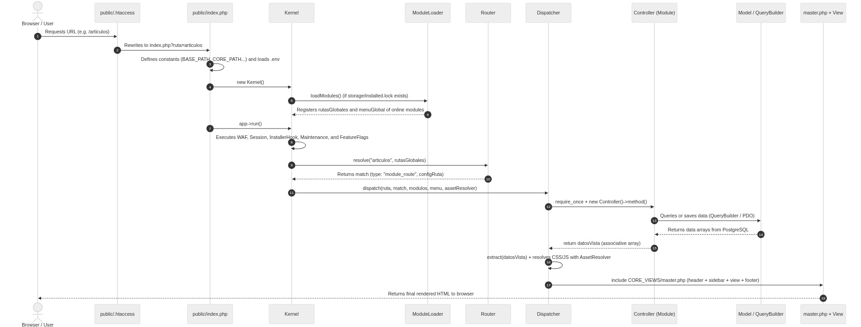
Part 2. The Dual Core Architecture: Microkernel and MVC
2.1. The Microkernel Architecture (Plugin-Style Module System)
The CIIDI system combines two software architectures working in tandem at different stages of a request: the Microkernel architecture (at the macro system level) and the MVC or Model-View-Controller architecture (at the micro level inside each module). Understanding where the Microkernel ends and MVC begins is the key to mastering the backend.
What exactly is the Microkernel architecture in CIIDI? It consists of stripping the system core down to the bare minimum essential responsibilities (module loading, routing, cross-cutting security, database connectivity, and the base visual layout) while delegating all business logic to independent modules that plug in dynamically. In CIIDI, the Microkernel is primarily formed by the pairing of Kernel.php and ModuleLoader.php, backed by AssetResolver.php.
What makes this design so compelling is how the Core discovers modules without anyone having to register them manually in a hardcoded list. On every incoming request, ModuleLoader uses PHP's scandir() function to inspect which folders exist inside modules/. If you create a folder named modules/Laboratorios/ today and place a valid index.php file inside it, on the very next browser reload the Microkernel automatically knows that module exists, reads its routes, adds its button to the left sidebar menu, places its showcase card on the welcome screen, and lists it in the SuperAdmin control panel so it can be toggled on or off on the fly.
Furthermore, the Microkernel honors each module's operational state stored in storage/config_system.json. If a module is marked as 'offline' in that file (because an administrator disabled it in the Module Manager), ModuleLoader simply omits that module's routes from the $rutasGlobales array, shutting down the entire module instantly without deleting a single file. The only exceptions to this rule are the system's two vital modules: Autenticacion and SuperAdmin, which are flagged in code as Core modules ($esCore = true) to prevent an administrator from accidentally locking themselves out of the system.
Figure 3
Internal flow of the Microkernel architecture during module scanning and registration in ModuleLoader
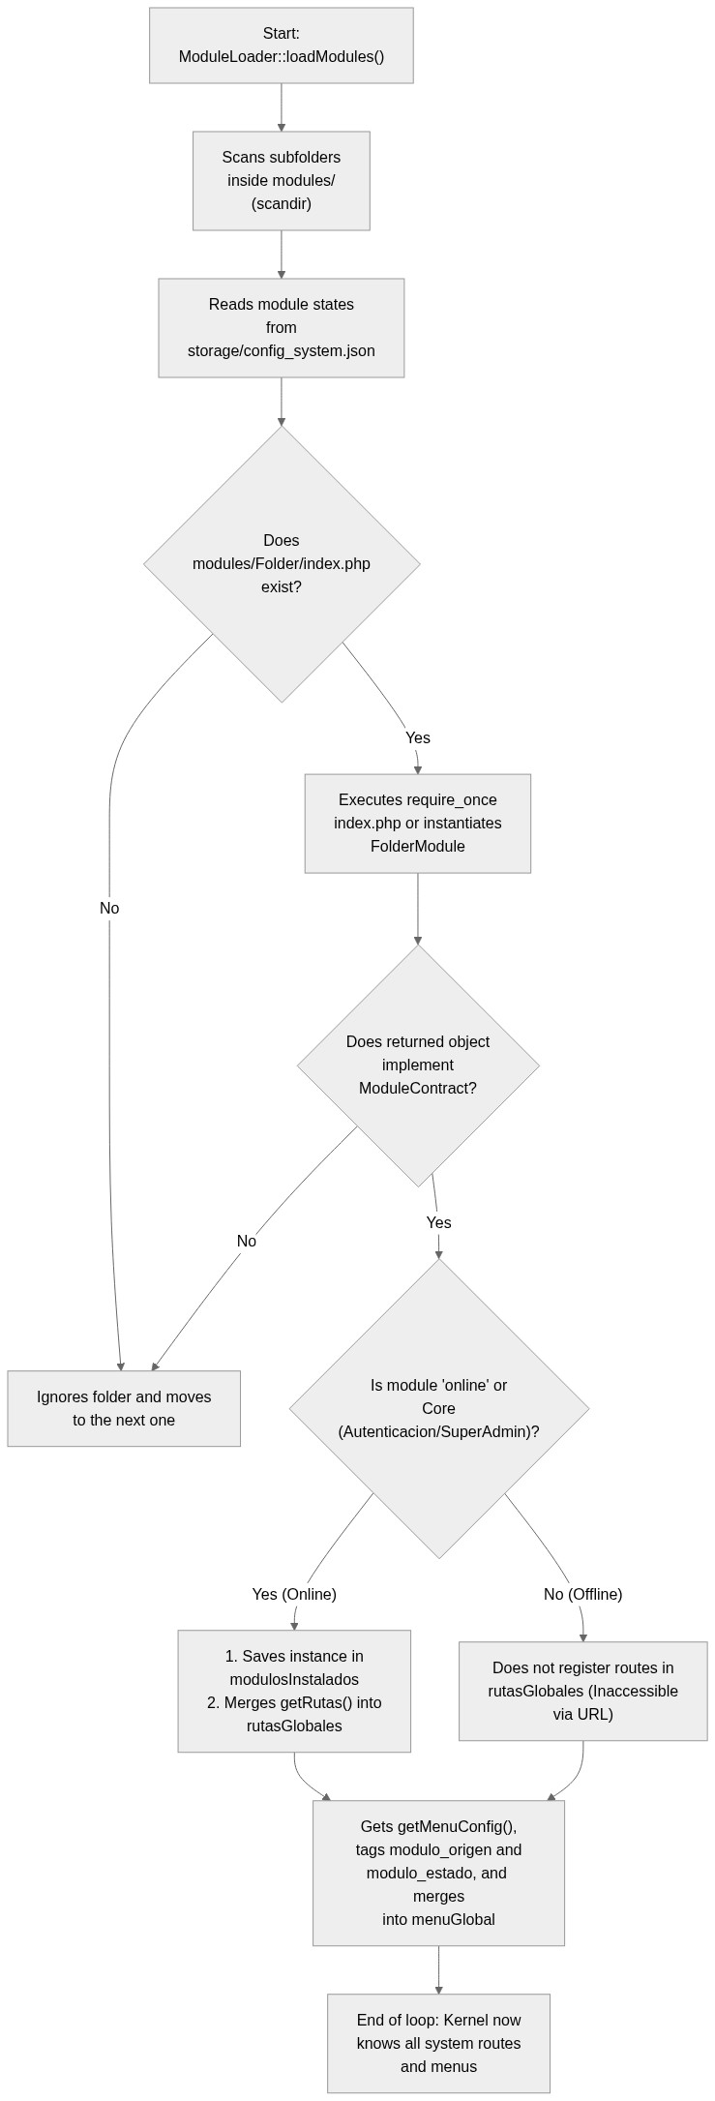
2.2. The ModuleContract Interface as a Universal Plug
For the Microkernel to connect to any module without knowing its internal details, every module must expose the exact same plug shape. In object-oriented PHP programming, that standardized plug is achieved through an Interface (interface). In CIIDI, that interface is named ModuleContract and lives in core/Interfaces/ModuleContract.php.
When ModuleLoader opens modules/TuModulo/index.php, it checks via if ($modulo instanceof ModuleContract) whether your class fulfills the contract. If your class does not implement ModuleContract or is missing any of the 7 methods required by the interface, the system rejects it or PHP halts execution telling you exactly which method is missing. Thanks to this simple rule, the Core has an ironclad guarantee that it can always ask any installed module the exact same seven questions: what your name is (getNombre), which routes you handle (getRutas), which buttons you want in the sidebar menu (getMenuConfig), what you do (getDescripcion), which other modules you depend on (getDependencias), what you want to display on the home page (getHomeConfig), and which controls you want to inject into the top bar (getHeaderConfig).
2.3. The MVC Architecture Inside Each Module (Controller, Model, View, and Services)
Once the Microkernel has done its job of identifying which module owns the requested URL, the system's second architecture takes over: the MVC (Model-View-Controller) pattern. Every module inside modules/ organizes its internal code into three primary layers (plus an optional services layer):
• The Controller (controllers/ folder): Acts as the request orchestrator. When the Core Dispatcher invokes the controller method bound to the route, the controller handles four concrete tasks: first, verifying that the user is authorized to access it using Auth::requierePrivilegioMinimo(); second, receiving and sanitizing parameters coming from $_GET or $_POST (and validating the CSRF token on form submissions); third, calling Model methods to fetch or persist data; and fourth, returning an array of data to the view or redirecting the user.
• The Model (models/ folder): The sole layer authorized to communicate with the PostgreSQL database. Neither views nor the module's index.php file should ever run SQL queries. The model instantiates the Core QueryBuilder (new QueryBuilder()) or retrieves the active PDO connection (Connection::getInstance()) to execute SELECT, INSERT, UPDATE, or DELETE queries and return clean PHP arrays to the controller.
• The View (views/ folder): The PHP file containing the HTML markup for the screen shown to the user. It receives the variables returned by the controller ready to use (thanks to the extract() call performed by the Dispatcher) and focuses strictly on iterating over them with foreach, outputting escaped text via htmlspecialchars(), and rendering forms or tables. A view never worries about opening <html>, <head>, or <body> tags or including the sidebar, because the Dispatcher automatically injects your view inside the <div class='main-content'> container of the master template core/Views/master.php.
• Services (optional services/ folder): Whenever a module has auxiliary tasks that are not pure database queries yet should not clutter the controller either (for instance, processing and converting an uploaded image to .webp format, reading a module-specific JSON configuration file, or communicating with a neural network or external API), that logic is isolated into a dedicated class inside the module's services/ folder.
2.4. The Three Route Types You Will Program: View, POST Action, and AJAX/JSON API
A common point of confusion when starting out on the CIIDI backend is assuming that all routes declared in getRutas() behave the same way. In reality, depending on how you configure a route in your index.php file and what your controller method does, there are three distinct route types:
• Type 1: Full View Route (GET): The standard route used to render a screen (for example, 'cursos' or 'gestor-articulos'). In getRutas(), you define 'controlador_path', 'controlador', 'metodo', 'vista', 'titulo', and optionally 'css' and 'js'. Your controller method fetches data from the model and finishes with return ['variable' => $valor];. The Dispatcher takes that array, runs extract(), resolves the CSS/JS assets, and loads master.php to render the full interface complete with header, sidebar, your view in the center, and footer.
• Type 2: Form Action or Processing Route (POST / Redirect): An invisible route designed to handle a form submission (for example, 'procesar-articulo' or 'cursos-eliminar'). In getRutas(), you only need to declare 'controlador_path', 'controlador', and 'metodo' (omitting the 'vista' key). The controller method validates the CSRF token, instructs the model to save or delete records, stores a success or error flash message in $_SESSION, and terminates with header('Location: ruta-destino'); exit;. Because the method calls exit; right after sending the redirect header, the Dispatcher stops right there and the browser jumps cleanly to the target screen.
• Type 3: API or AJAX Endpoint Route (JSON): A route designed to be called asynchronously from JavaScript via fetch() without reloading the page (for example, 'api-catalogos-art' or 'toggle-estado-articulo'). Just like POST routes, in getRutas() you only declare 'controlador_path', 'controlador', and 'metodo' (without 'vista'). Inside the controller method, you send header('Content-Type: application/json');, output the payload with echo json_encode(['ok' => true, 'datos' => $resultado]);, and strictly end with exit; (or return false;) on the final line. That exit; or return false; is critical because it prevents the Dispatcher from continuing execution and appending the HTML of master.php right after your JSON response.
Figure 4
The three execution paths in the MVC Dispatcher by route type (Full View, POST Action, and JSON API)
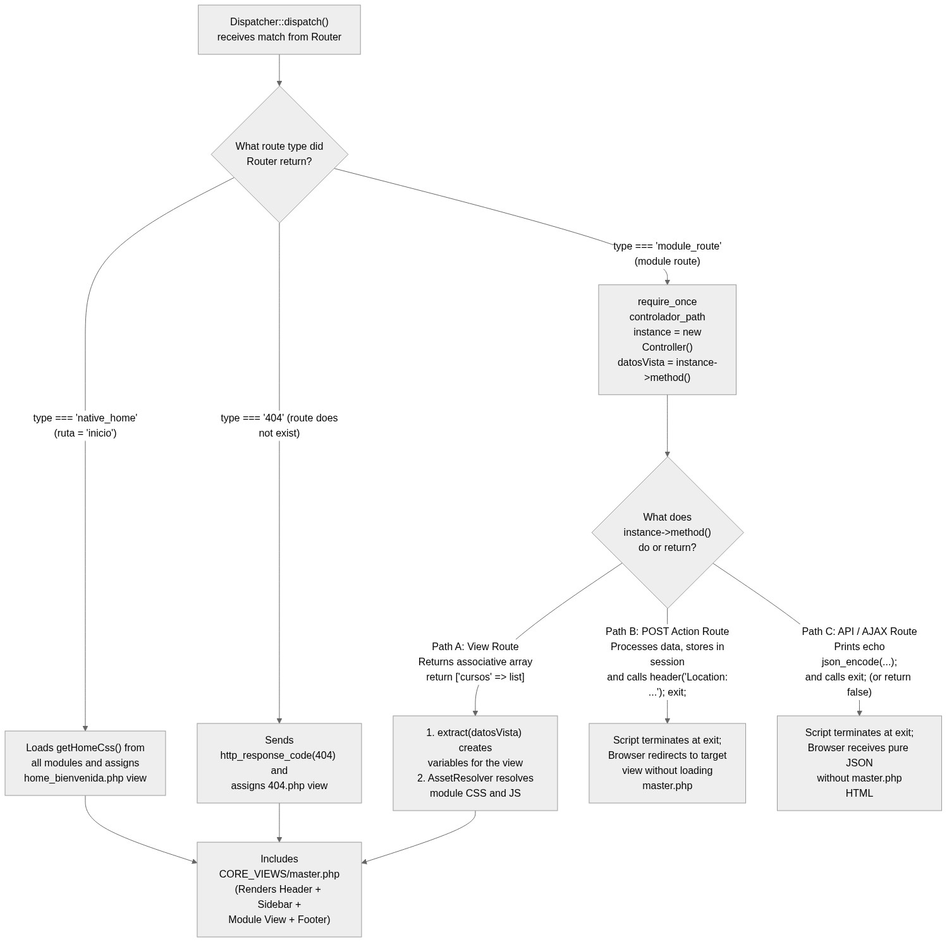
Part 3. Detailed Explanation of Core Files (Line-by-Line Screenshot Guide)
In this section, we will open and dissect the most important Core files one by one. These are the exact files you need to understand in order to know what happens under the hood whenever you create or modify a module. For each file, you will find a bracketed indicator line specifying the exact file to open and the exact start and end line numbers to capture in a screenshot accompanying the explanation.
3.1. URL Rewriting and Entry Point: public/.htaccess and public/index.php
Everything begins when a request reaches the public/ folder. Two small yet foundational files work together here: public/.htaccess and public/index.php.
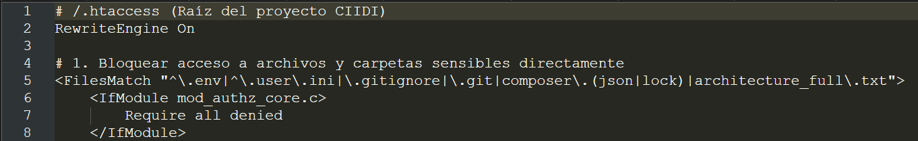 (Rewrite rule to index.php?ruta=$1)
Lines 1 to 8 of public/.htaccess enable Apache's URL rewriting engine (RewriteEngine On). The two RewriteCond directives (lines 4 and 5) perform a smart check: they ask the server whether the requested path is NOT an existing physical file (!-f) and NOT an existing physical directory (!-d). Thanks to this, when the browser requests a stylesheet like assets/css/style.css or a photo under uploads/, Apache serves it directly without invoking PHP. Conversely, when a user requests a logical route such as /articulos or /cursos-crear, line 8 kicks in: RewriteRule ^(.*)$ index.php?ruta=$1 [QSA,L]. This directive captures the URL path and automatically places it inside $_GET['ruta'], while preserving any additional GET query parameters thanks to the QSA (Query String Append) flag.
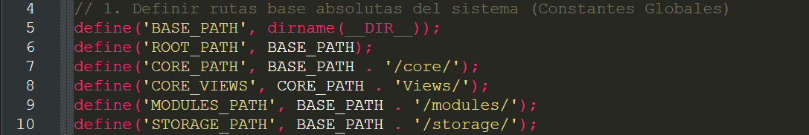 (Definition of global system path constants)
Once Apache forwards the request to public/index.php, lines 4 to 10 define six global constants that will be available across every single one of your modules, controllers, models, and views:
• BASE_PATH and ROOT_PATH (lines 5 and 6): Point to the project root (C:/wamp64/www/proyect_CIIDI) using dirname(__DIR__).
• CORE_PATH (line 7): Points directly to the core/ folder, trailing slash included. You will use it whenever you need to import Core utilities from your module—for example: require_once CORE_PATH . 'Security/Auth.php';.
• CORE_VIEWS (line 8): Points to core/Views/, where master.php, header.php, sidebar.php, footer.php, and the 403, 404, 500, and 503 error screens reside.
• MODULES_PATH (line 9): Points to the modules/ folder, used by ModuleLoader to scan all installed modules.
• STORAGE_PATH (line 10): Points to the storage/ folder, where configuration .json files, lockfiles, and logs are stored.
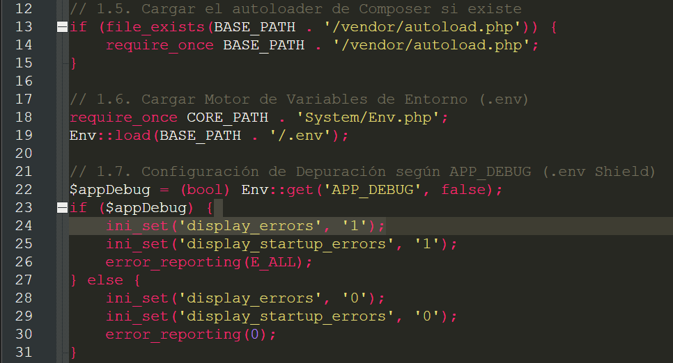 (Composer autoloading, .env environment variables, and APP_DEBUG shield)
In lines 12 to 31 of public/index.php, the system prepares the runtime environment. First (lines 13 to 15), it checks whether vendor/autoload.php exists to autoload Composer libraries. Next (lines 18 and 19), it imports core/System/Env.php and runs Env::load(BASE_PATH . '/.env') to load the project's environment variables. Immediately afterward (lines 22 to 31), it checks the value of APP_DEBUG: if you are developing locally and APP_DEBUG is true, it enables display_errors and error_reporting(E_ALL) so any error appears right on screen; if the system is in production and APP_DEBUG is false, it suppresses raw PHP errors so internal file paths and technical details are never exposed to end users.
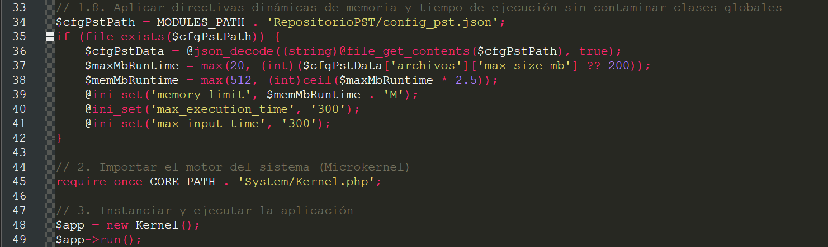 (Dynamic memory tuning and Kernel instantiation)
Finally, lines 33 to 42 dynamically tune PHP's memory (memory_limit) and execution time (max_execution_time) limits at runtime by reading the document management configuration so large uploads can be handled without crashing PHP. Then, in lines 45 to 49, the engine formally ignites: core/System/Kernel.php is imported, $app = new Kernel(); is instantiated, and $app->run(); is invoked.
3.2. The Heart of the System: core/System/Kernel.php
The core/System/Kernel.php file is the chief orchestrator of the entire backend. It coordinates security, module loading, state interceptors, and dispatching into the MVC layer.
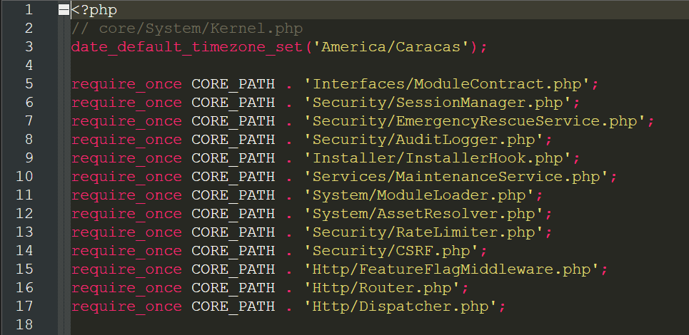 (Timezone setup and importing essential Core components)
In lines 1 to 18, the Kernel first sets the official timezone to America/Caracas (line 3) so all audit timestamps, sessions, and scheduled tasks match local time. It then uses require_once to import all the building blocks that make up the Core: ModuleContract, SessionManager, EmergencyRescueService, AuditLogger, InstallerHook, MaintenanceService, ModuleLoader, AssetResolver, RateLimiter, CSRF, FeatureFlagMiddleware, Router, and Dispatcher.
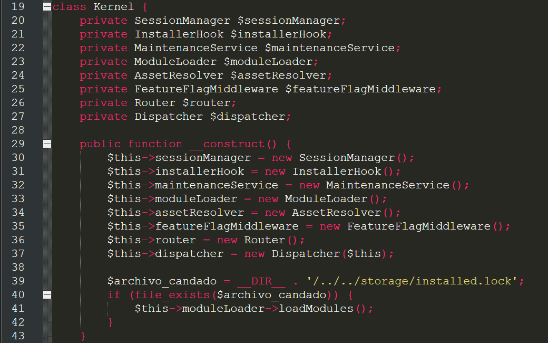 (Kernel properties and constructor with module loading)
Lines 19 to 43 declare the Kernel's typed private properties and its __construct() constructor. Notice that when new Kernel() runs (lines 29 to 37), all subsystems are instantiated, and on line 37 $this is passed into the Dispatcher (new Dispatcher($this)) so views can query the Kernel for home page cards and header controls. Pay special attention to lines 39 to 42: the Kernel checks for the storage/installed.lock file. Only if that file exists (meaning the system has already been installed) does it execute $this->moduleLoader->loadModules(). This prevents the system from attempting to load modules or query database tables before the database has even been created.
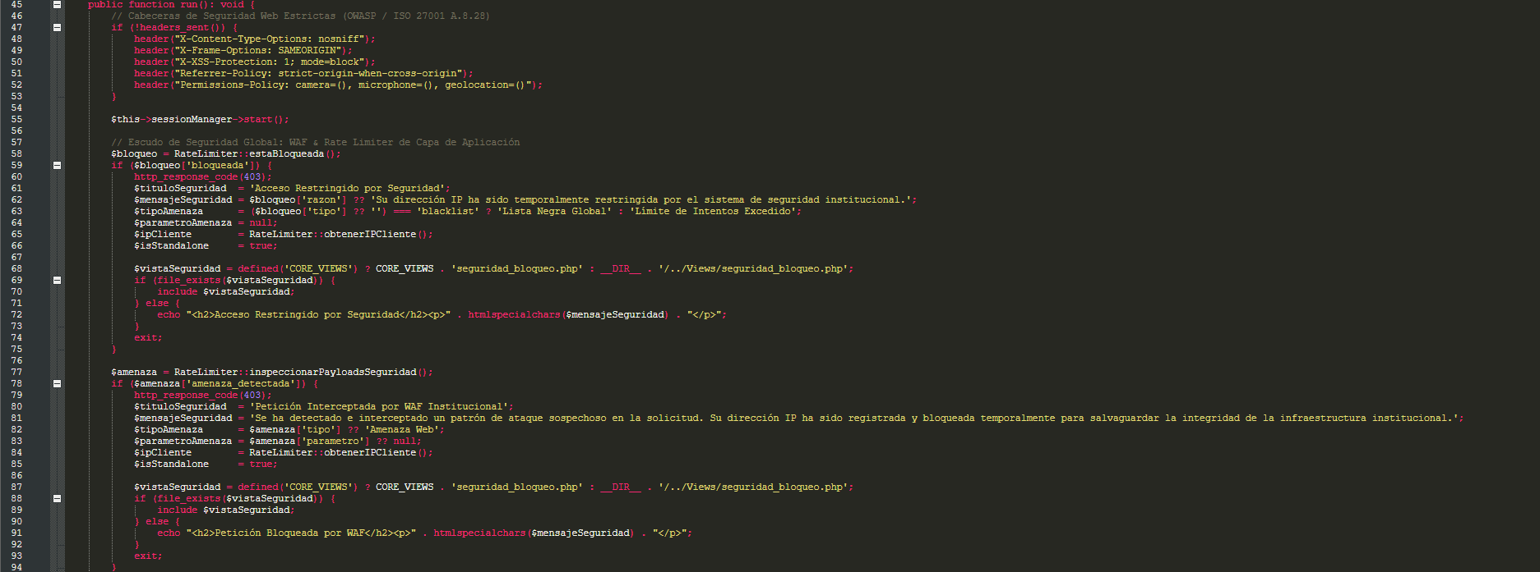 (Start of run(), OWASP headers, session, and RateLimiter WAF shield)
Lines 45 to 94 begin the run() method. Its very first action (lines 47 to 53) is sending HTTP security headers (X-Content-Type-Options: nosniff, X-Frame-Options: SAMEORIGIN, X-XSS-Protection, Referrer-Policy, and Permissions-Policy). On line 55, it starts the PHP session via $this->sessionManager->start(). Immediately afterward, across lines 58 to 94, it runs two perimeter security checks through RateLimiter: first, it calls RateLimiter::estaBloqueada() to check whether the visitor's IP address is blacklisted or locked out due to excessive failed attempts (lines 58 to 75); second, it inspects the entire request payload with RateLimiter::inspeccionarPayloadsSeguridad() (lines 77 to 94) looking for SQL injection or XSS attack patterns. If either check detects a threat, it responds with HTTP status code 403, renders core/Views/seguridad_bloqueo.php, and halts execution immediately with exit.
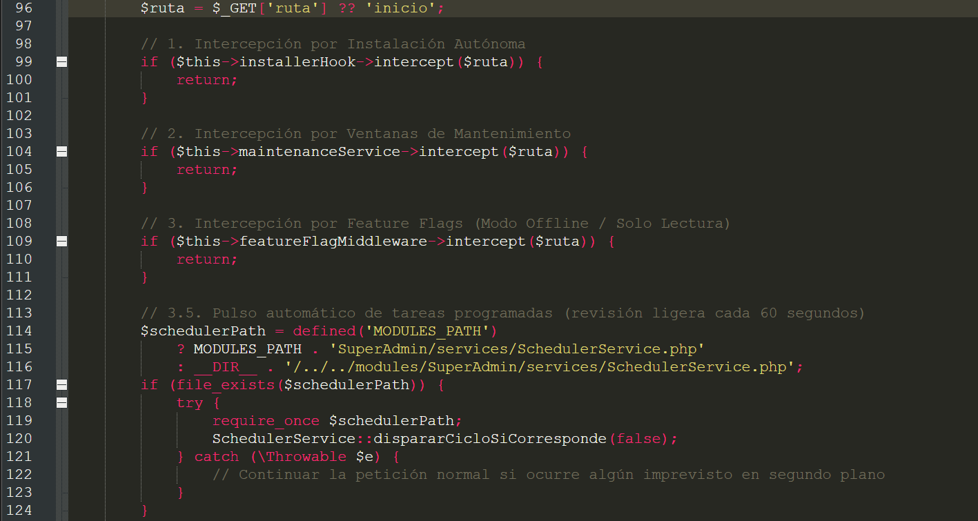 (Route capture and installation, maintenance, feature flag, and scheduler interceptors)
On line 96, the Kernel reads the route requested by the user: $ruta = $_GET['ruta'] ?? 'inicio';. If the user visited the root URL without specifying a route, it defaults to 'inicio'. Next (lines 98 to 124), it passes that $ruta variable through three interceptors and an automated heartbeat:
• 1. InstallerHook (lines 99 to 101): If the system is not installed yet, it intercepts the request and displays the installation wizard wizard.php.
• 2. MaintenanceService (lines 104 to 106): Checks storage/maintenance.json to see whether a maintenance window is active. If so, and the current user is not an administrator, it displays the 503 maintenance screen and halts execution.
• 3. FeatureFlagMiddleware (lines 109 to 111): Checks storage/config_system.json to see whether that specific route was set to 'offline' or 'solo_lectura' by the SuperAdmin.
• 3.5. SchedulerService Heartbeat (lines 114 to 124): Silently triggers a check for scheduled tasks (such as automated database backups) every 60 seconds without interrupting the user's browsing experience.
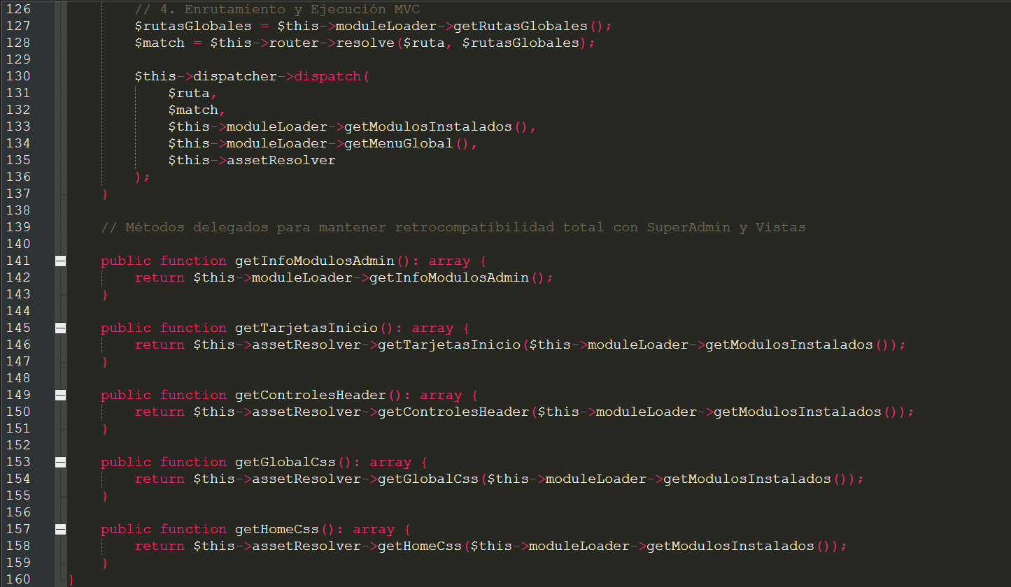 (Routing, MVC dispatching, and helper delegate methods for views)
Lines 126 to 137 represent the culmination of the Kernel's job: it retrieves all compiled routes from ModuleLoader ($rutasGlobales = $this->moduleLoader->getRutasGlobales()), asks the Router to resolve the current route ($match = $this->router->resolve($ruta, $rutasGlobales)), and finally hands everything off to the Dispatcher via $this->dispatcher->dispatch(...). Lastly, in lines 141 to 159 you will find five bridge methods (getInfoModulosAdmin, getTarjetasInicio, getControlesHeader, getGlobalCss, and getHomeCss) that delegate queries to ModuleLoader and AssetResolver so global views can invoke them effortlessly.
Figure 5
Security pipeline and lifecycle interceptors inside Kernel::run()
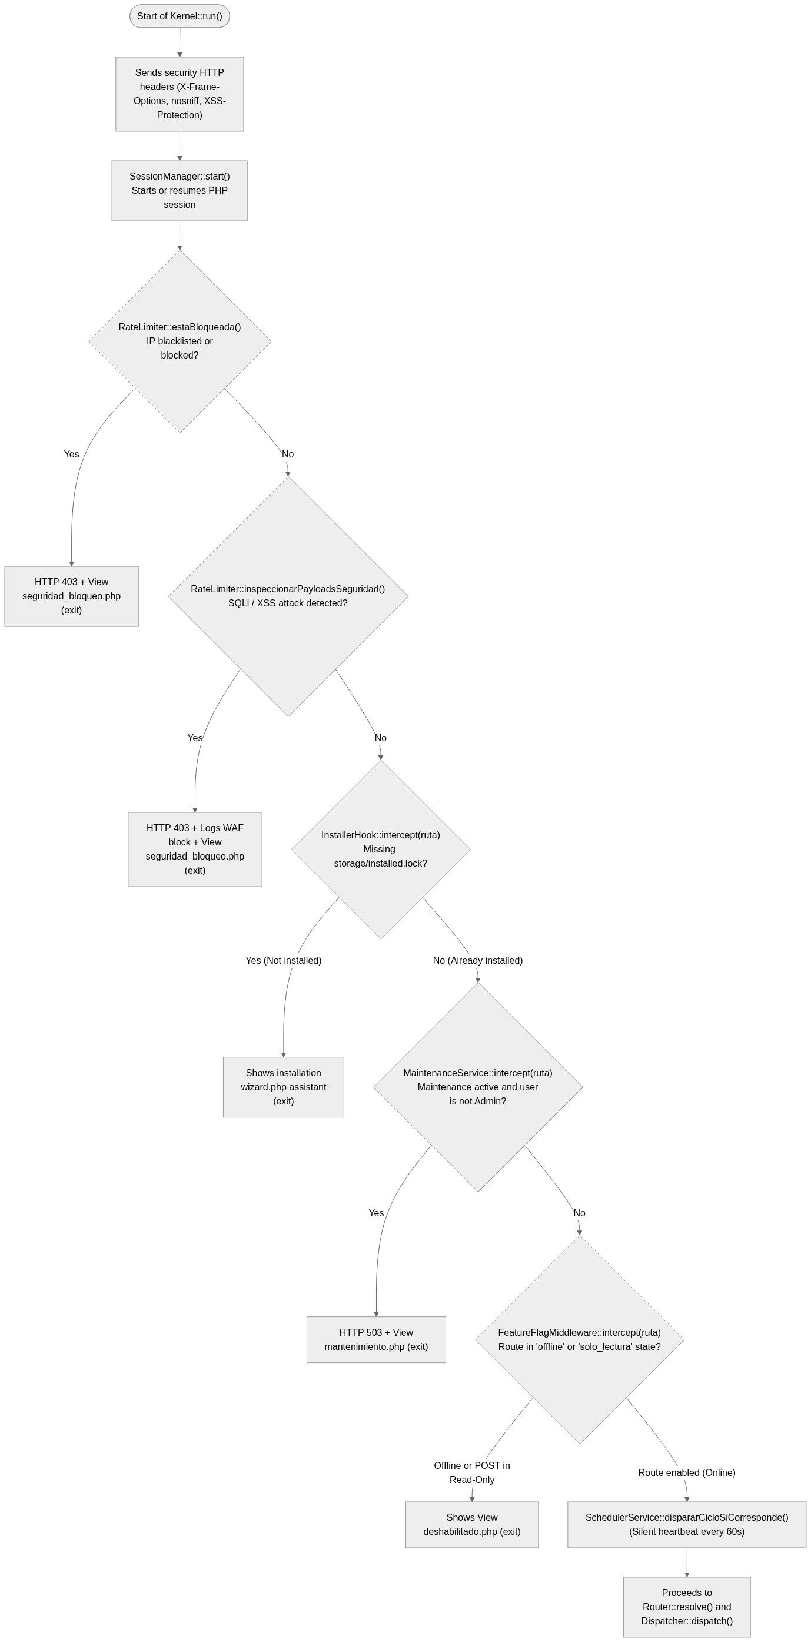
3.3. The Mandatory Contract: core/Interfaces/ModuleContract.php
If you are going to build a new module, this is the single most important file to know by heart. It is a concise 26-line interface, yet it defines the ground rules for every module in the system.
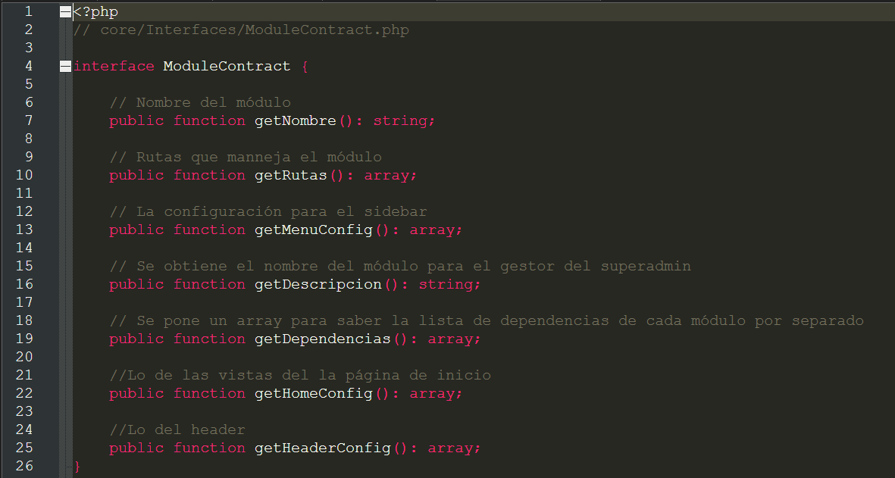 (Complete ModuleContract interface with its 7 mandatory methods)
Lines 1 to 26 of core/Interfaces/ModuleContract.php declare the 7 public methods that every main module class (located at modules/NombreModulo/index.php) is required to implement:
• getNombre(): string (line 7): Returns the human-readable display name of your module (for example, 'Training and Courses Module'). Used in the SuperAdmin panel.
• getRutas(): array (line 10): Returns an associative array where each key is the URL slug (without a leading slash, e.g., 'cursos' or 'nuevo-curso') and its value is a sub-array holding that route's configuration: 'controlador_path', 'controlador', 'metodo', 'vista', 'titulo', 'css', 'js', and optionally 'layout'.
• getMenuConfig(): array (line 13): Returns an array defining the navigation buttons or dropdown menus your module wants to inject into the left sidebar (sidebar.php).
• getDescripcion(): string (line 16): Returns a short paragraph describing what the module does. This description appears on the cards inside the SuperAdmin Module Manager.
• getDependencias(): array (line 19): Returns an array listing the folder names of other modules that yours depends on (for example, ['Autenticacion']). If it has no specific module dependencies, it simply returns an empty array [].
• getHomeConfig(): array (line 22): Defines the promotional section or showcase card your module wants to display on the system's welcome page (the 'inicio' route). If your module is strictly administrative or internal and should not appear on the public home page, return [].
• getHeaderConfig(): array (line 25): Allows your module to inject search bars, buttons, or custom partial views into the top-right corner of the global header (header.php). If you do not need to add anything to the top bar, return [].
3.4. The Dynamic Module Loader: core/System/ModuleLoader.php
The core/System/ModuleLoader.php file is the engine that brings the Microkernel architecture to life. Its job is to scan the modules/ directory, validate every module against ModuleContract, and merge their routes and menus.
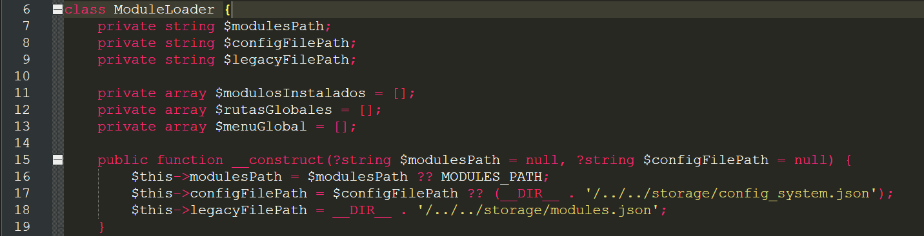 (Internal properties and constructor of ModuleLoader)
Lines 6 to 19 define the three master registries where the loader stores everything it discovers: $modulosInstalados (holds the instances of each active module), $rutasGlobales (holds the merged routes of all online modules), and $menuGlobal (holds all sidebar menu entries). Inside the constructor (lines 15 to 19), the state configuration file path is set to storage/config_system.json.
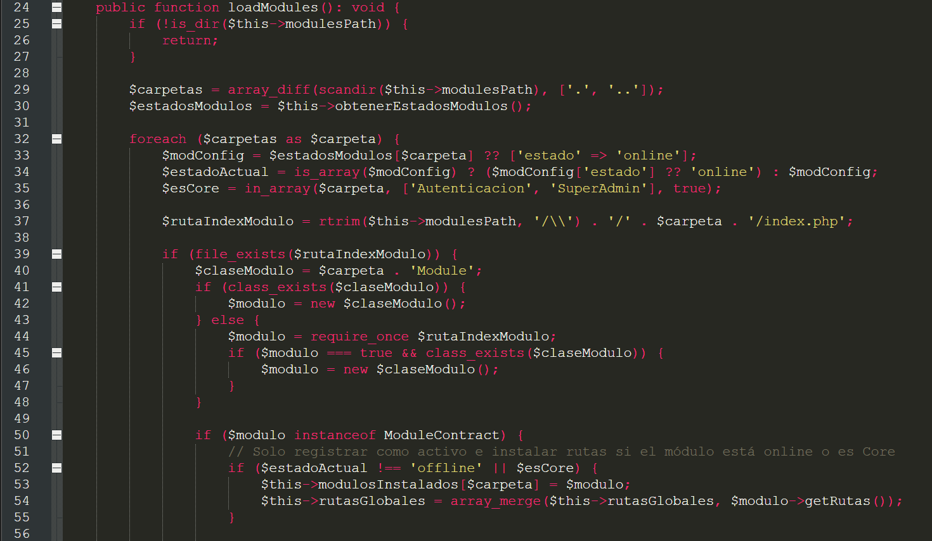 (Folder scanning, index.php instantiation, and merging into rutasGlobales)
Lines 24 to 56 contain the first half of the loadModules() method. Let us examine what it does closely, because it enforces two rules every developer must know:
• Folder scanning and state lookup (lines 29 to 35): Using scandir($this->modulesPath), it retrieves the names of all folders inside modules/. For each folder, it checks its status in storage/config_system.json (if the module is brand new and not yet listed in the JSON file, it defaults to 'online'). Additionally, line 35 flags only 'Autenticacion' and 'SuperAdmin' with $esCore = true.
• How your index.php file is loaded (lines 37 to 48): It looks for modules/NombreCarpeta/index.php. Note that it supports two ways of obtaining your module instance: the recommended approach (line 44), where your index.php file ends with return new NombreCarpetaModule();, or the naming-convention fallback (lines 40 and 45), where it looks for a class named after the exact folder name suffixed with Module (for example, if the folder is named Cursos, it looks for the CursosModule class).
• Contract verification and route registration (lines 50 to 55): On line 50, it checks if ($modulo instanceof ModuleContract). If the module fulfills the contract and is not 'offline' (line 52), it stores the instance in $this->modulosInstalados[$carpeta] and merges its routes into the global dictionary via $this->rutasGlobales = array_merge($this->rutasGlobales, $modulo->getRutas());.
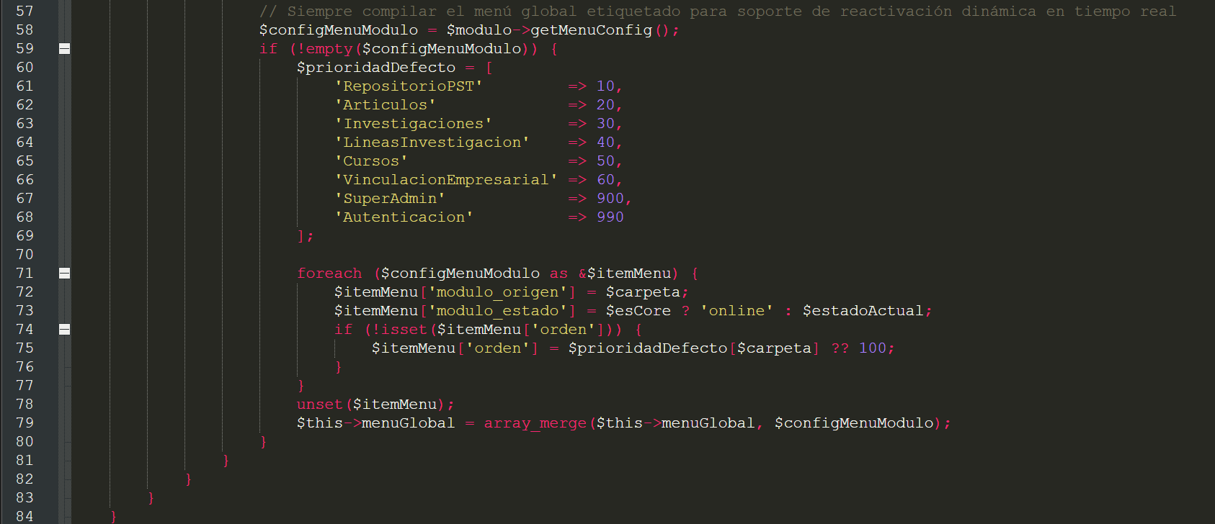 (Global sidebar menu compilation and priority assignment)
Lines 57 to 84 process the sidebar menu by calling $modulo->getMenuConfig(). ModuleLoader automatically injects two handy internal metadata keys into every menu item: 'modulo_origen' (the module's folder name) and 'modulo_estado' ('online' or 'offline'). Moreover, if you did not define an 'orden' key on a menu item in your module, lines 74 to 76 assign a default priority (100 for any new module) before appending it to $this->menuGlobal.
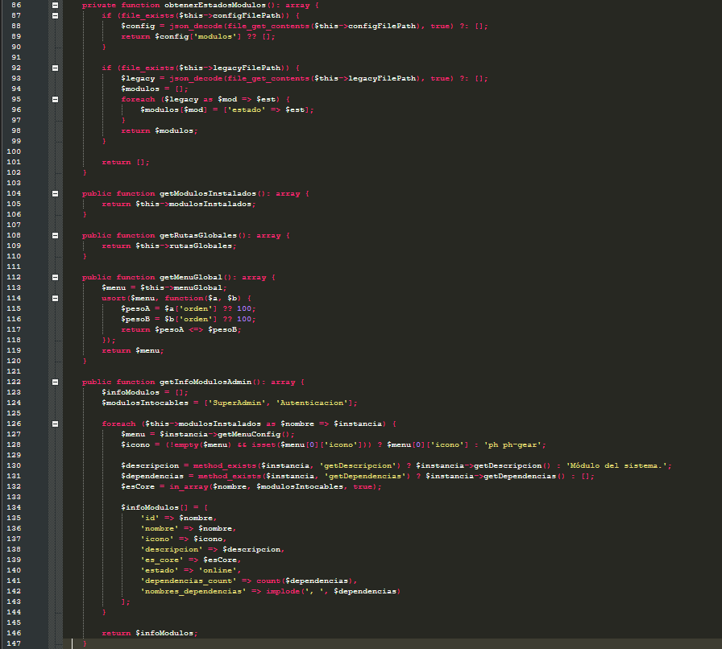 (Reading status JSON, menu sorting, and SuperAdmin metadata)
Rounding out this file, lines 86 to 102 contain the private method obtenerEstadosModulos(), which reads storage/config_system.json. In lines 112 to 120, getMenuGlobal() sorts all sidebar menu buttons in ascending order by their 'orden' key using PHP's spaceship operator (<=>). Finally, in lines 122 to 147, getInfoModulosAdmin() builds a summary of every installed module (ID, name, icon, description, core status, and dependencies) for display in the SuperAdmin administration panel.
3.5. The System Router: core/Http/Router.php
The core/Http/Router.php file is remarkably clean and straightforward (37 lines in total). Its sole mission is to take the route slug requested by the user and look it up inside the $rutasGlobales array assembled by ModuleLoader.
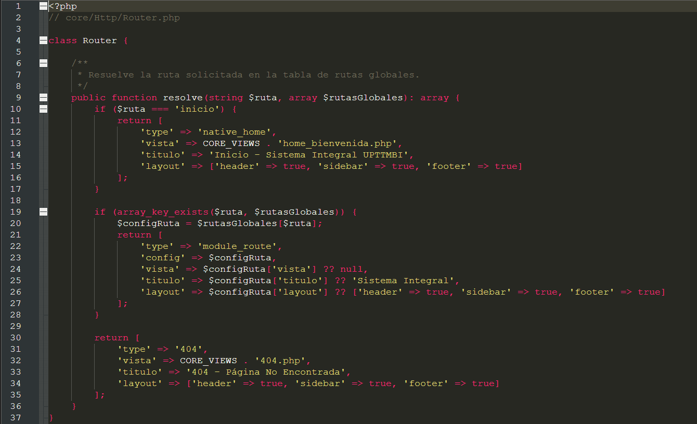 (Complete Router class and the 3 match outcomes in resolve())
Looking at lines 1 to 37 of core/Http/Router.php, you will see that resolve(string $ruta, array $rutasGlobales) evaluates three possible scenarios and always returns a standardized array:
• Scenario 1: The route is 'inicio' (lines 10 to 17): Returns 'type' => 'native_home' and points directly to the native view CORE_VIEWS . 'home_bienvenida.php'.
• Scenario 2: The route exists in $rutasGlobales (lines 19 to 28): Checks via array_key_exists($ruta, $rutasGlobales). If found, it returns 'type' => 'module_route', stores the full configuration declared by the module under the 'config' key, and extracts 'vista' (or null for POST/API routes), 'titulo', and 'layout' (which enables header, sidebar, and footer as true by default).
• Scenario 3: The route does not exist in any active module (lines 30 to 35): Returns 'type' => '404' and points to the view CORE_VIEWS . '404.php'.
3.6. The MVC Dispatcher and Error Handling: core/Http/Dispatcher.php
If the Router is the navigator looking up the address on the map, the Dispatcher (core/Http/Dispatcher.php) is the driver that takes you there, executes your controller, passes variables into your view, and wraps everything inside the master template.
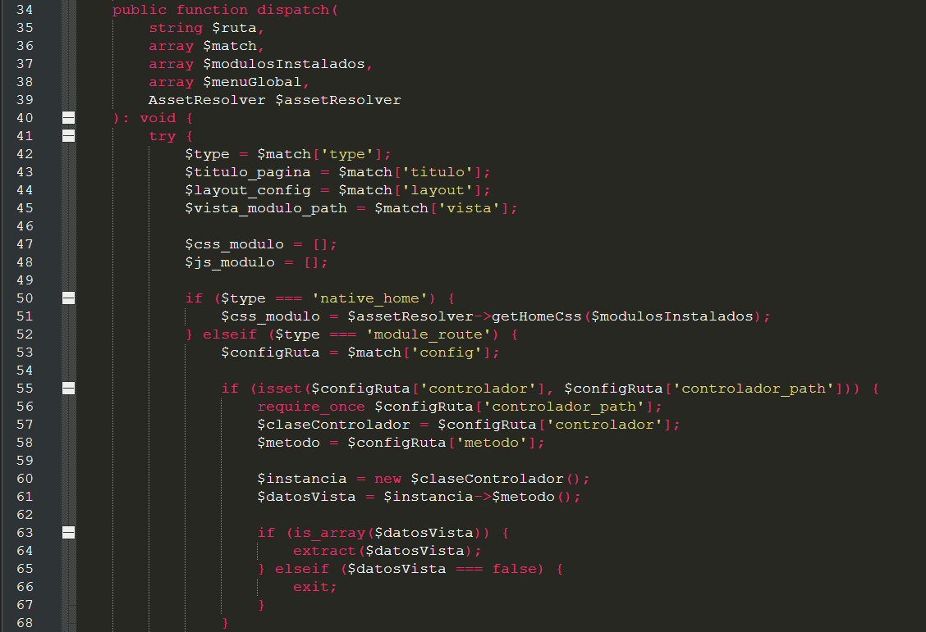 (Dynamic execution of the controller, method, and extract() of view data)
Lines 34 to 68 of core/Http/Dispatcher.php form the exact bridge between the Core and your module's MVC code. When $type is 'module_route' (line 52), the Dispatcher grabs the route configuration ($configRuta) and on line 55 checks whether you defined 'controlador' and 'controlador_path'. If both are present, four key steps happen across lines 56 to 67:
• 1. Loading and instantiation (lines 56 to 60): Executes require_once $configRuta['controlador_path'];, stores the class name in $claseControlador, and instantiates the object via $instancia = new $claseControlador();.
• 2. Method invocation (line 61): Dynamically invokes the configured method: $datosVista = $instancia->$metodo();.
• 3. Variable unpacking with extract (lines 63 and 64): If your controller method returned an array (for example, ['titulo_curso' => 'PHP', 'total' => 15]), line 64 executes extract($datosVista). This native PHP function creates the variables $titulo_curso and $total right inside the current scope. Because master.php and your module's view are included a few lines further down within this very same dispatch() method, your view has direct access to $titulo_curso and $total as regular variables.
• 4. Clean exit for endpoints returning false (lines 65 and 66): If your controller method explicitly returns false (elseif ($datosVista === false) { exit; }), the Dispatcher stops execution immediately without loading master.php.
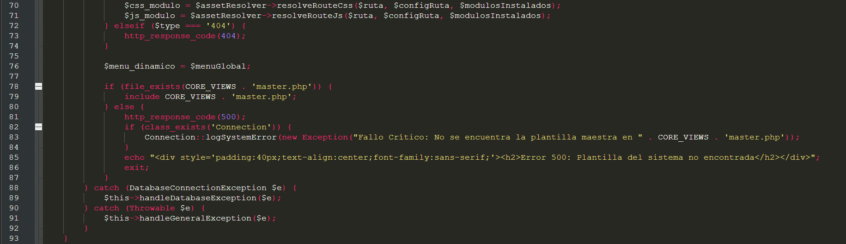 (Module CSS/JS resolution and inclusion of master.php)
On lines 70 and 71, the Dispatcher calls $assetResolver->resolveRouteCss(...) and $assetResolver->resolveRouteJs(...) to obtain the paths to the CSS and JS files specific to that screen, storing them in $css_modulo and $js_modulo. On line 76, it stores the sidebar menu in $menu_dinamico = $menuGlobal; and on lines 78 and 79, it verifies that CORE_VIEWS . 'master.php' exists and includes it via include CORE_VIEWS . 'master.php';.
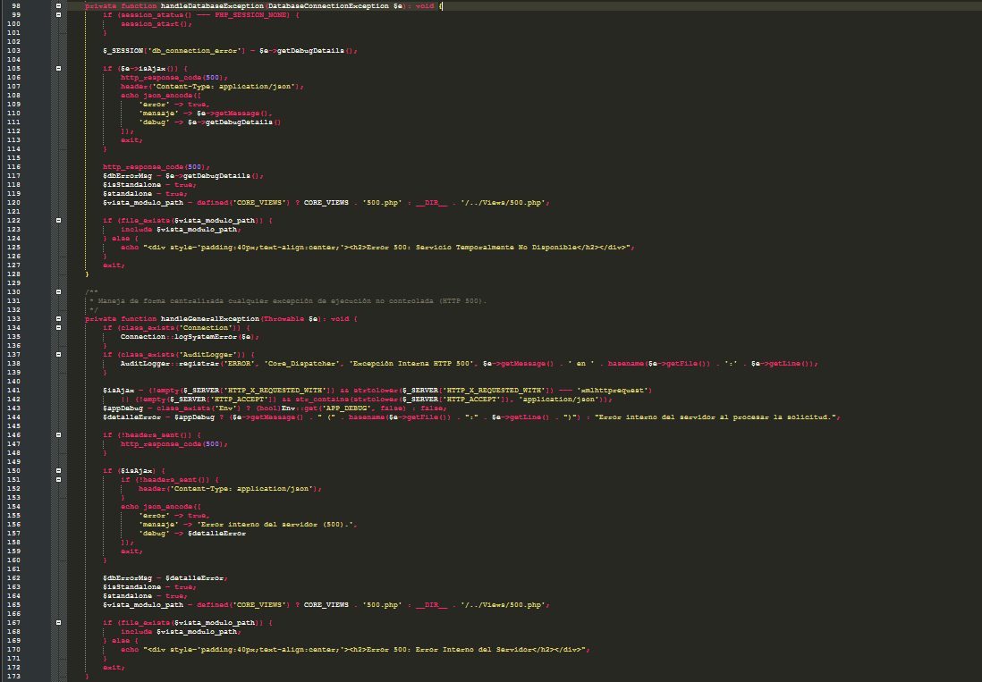
(Centralized handling of database errors and HTTP 500 exceptions)
The entire dispatch() method block is protected by a try / catch that leads into lines 98 to 173. If the PostgreSQL connection fails, handleDatabaseException() is triggered (lines 98 to 128); if any other fatal error or exception occurs in a controller or model, handleGeneralException() is triggered (lines 133 to 173). Both methods are very smart: they log the failure in both the error log and AuditLogger, and automatically detect whether the request came via AJAX (by inspecting the HTTP_X_REQUESTED_WITH and HTTP_ACCEPT headers) to return a clean JSON response with status code 500, or whether it was regular browser navigation to render the user-friendly core/Views/500.php view.
3.7. The Static Asset and Global View Manager: core/System/AssetResolver.php
When you build a module, you place your stylesheets in modules/TuModulo/assets/css/ and your scripts in modules/TuModulo/assets/js/, yet in your index.php file you only write 'css' => ['mi_estilo.css']. How does the system know where to find your module's exact folder? That is the job of core/System/AssetResolver.php.
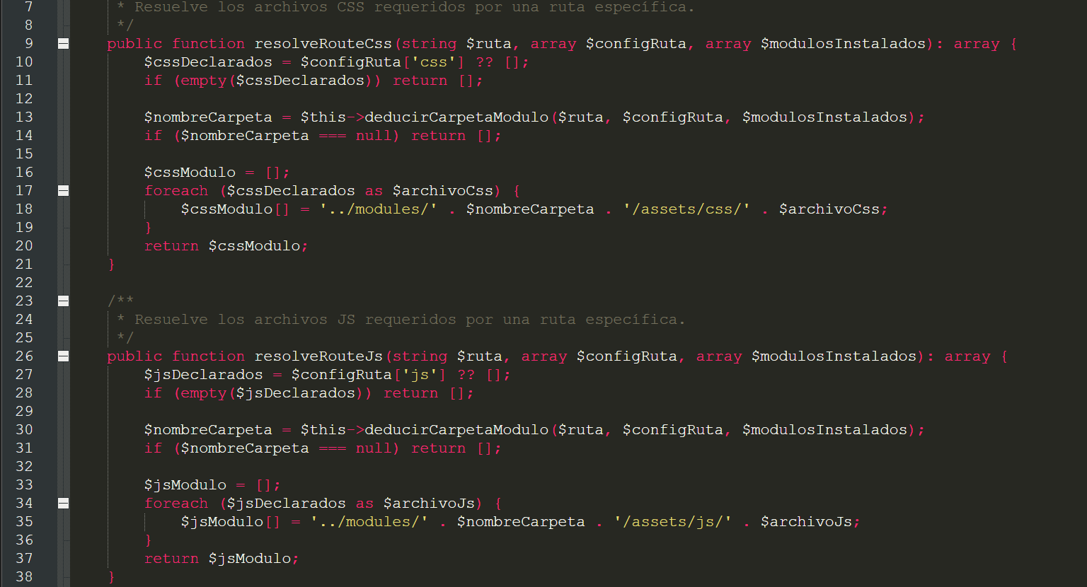 (Methods resolveRouteCss() and resolveRouteJs())
Lines 9 to 38 contain the resolveRouteCss() and resolveRouteJs() methods. Both read the 'css' and 'js' keys you declared in the route, determine the module's folder name by calling $this->deducirCarpetaModulo(...), and build the exact relative path: '../modules/' . $nombreCarpeta . '/assets/css/' . $archivoCss (and likewise for '/assets/js/').
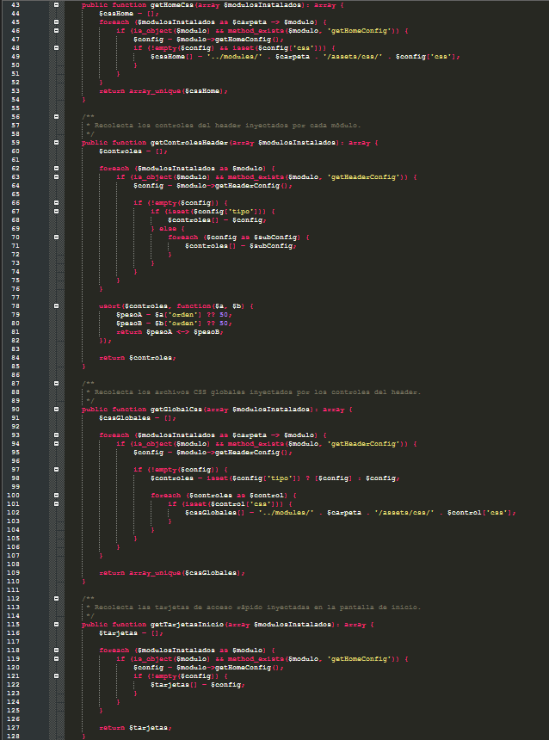
(Collecting Home CSS, Header controls, and home page cards)
Between lines 43 and 128, AssetResolver iterates through all active modules ($modulosInstalados) to collect what each one contributes to the global screens: getHomeCss() (lines 43 to 54) gathers the landing page stylesheets; getControlesHeader() (lines 59 to 85) gathers the top bar widgets and sorts them by their 'orden' key; getGlobalCss() (lines 89 to 110) gathers the CSS files required by those header widgets; and getTarjetasInicio() (lines 115 to 128) gathers the module sections for the welcome page.
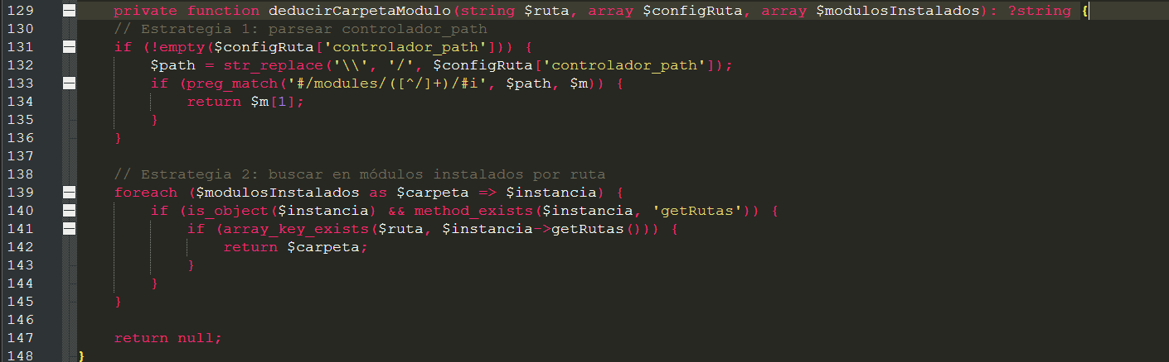 (Private method deducirCarpetaModulo())
Lines 129 to 148 contain the deducirCarpetaModulo() method. It uses two strategies in sequence: first, it tries to extract the folder name by matching the 'controlador_path' path against the regular expression #/modules/([^/]+)/#i (lines 131 to 136); and if the route has no controller (for example, a route that only renders a static view), it searches across all installed modules to find which one registered that key in its getRutas() method (lines 139 to 145).
3.8. The Core Master Templates: master.php, header.php, sidebar.php, and home_bienvenida.php
Inside core/Views/ live the templates that visually wrap every module so the system maintains a unified institutional look and feel.
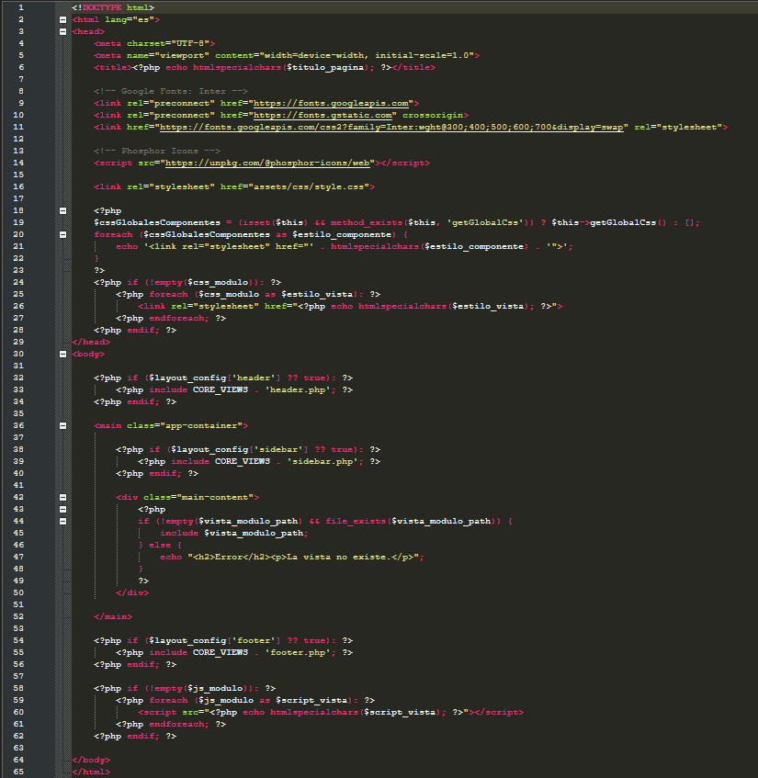 (Complete master template: CSS injection, Header, Sidebar, Module View, and JS)
Reviewing lines 1 to 65 of core/Views/master.php reveals how all the pieces prepared by the Dispatcher fit together:
• In the <head> (lines 3 to 29): It sets the browser tab title using $titulo_pagina (line 6), loads the Inter font and the Phosphor Icons library (lines 11 and 14), loads the base stylesheet assets/css/style.css (line 16), injects the global header CSS files (lines 19 to 22), and loops over the $css_modulo array to output a <link rel='stylesheet'> tag for every CSS file requested by your route (lines 24 to 28).
• In the <body> (lines 30 to 64): If $layout_config['header'] is true, it includes header.php (lines 32 to 34). Next, it opens <main class='app-container'>: if $layout_config['sidebar'] is true, it includes sidebar.php on the left (lines 38 to 40), and on the right it opens <div class='main-content'> (line 42), where it includes your module's view file ($vista_modulo_path) on lines 44 and 45. Finally, it includes footer.php (lines 54 to 56) and injects all <script> tags from the $js_modulo array at the end of the body (lines 58 to 62). Important note: if you ever want to hide the header, sidebar, or footer on a special route in your module (such as a print view or splash/transition screen), simply add the key 'layout' => ['header' => false, 'sidebar' => false, 'footer' => false] to that route in your index.php.
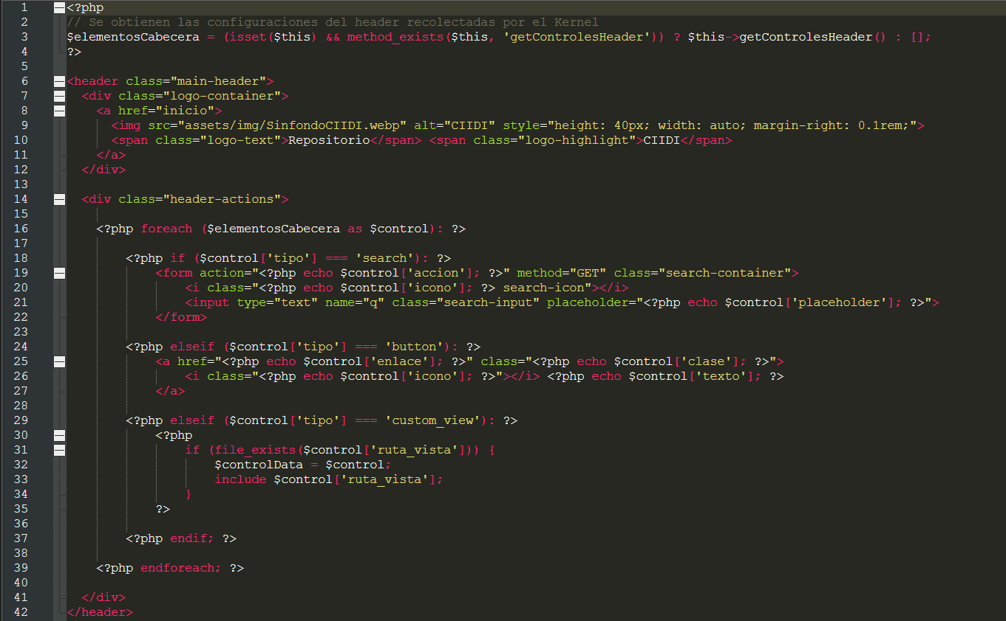 (Dynamic rendering of controls in the top bar)
Lines 1 to 42 of core/Views/header.php render the top bar. On the left, it displays the CIIDI logo (lines 7 to 12), and on the right (lines 14 to 41), it iterates through the controls returned by each module's getHeaderConfig(), supporting three formats: 'tipo' => 'search' (renders a GET search form), 'tipo' => 'button' (renders an icon link button), and 'tipo' => 'custom_view' (includes a custom view file from the path specified in 'ruta_vista', such as the logged-in user's profile widget).
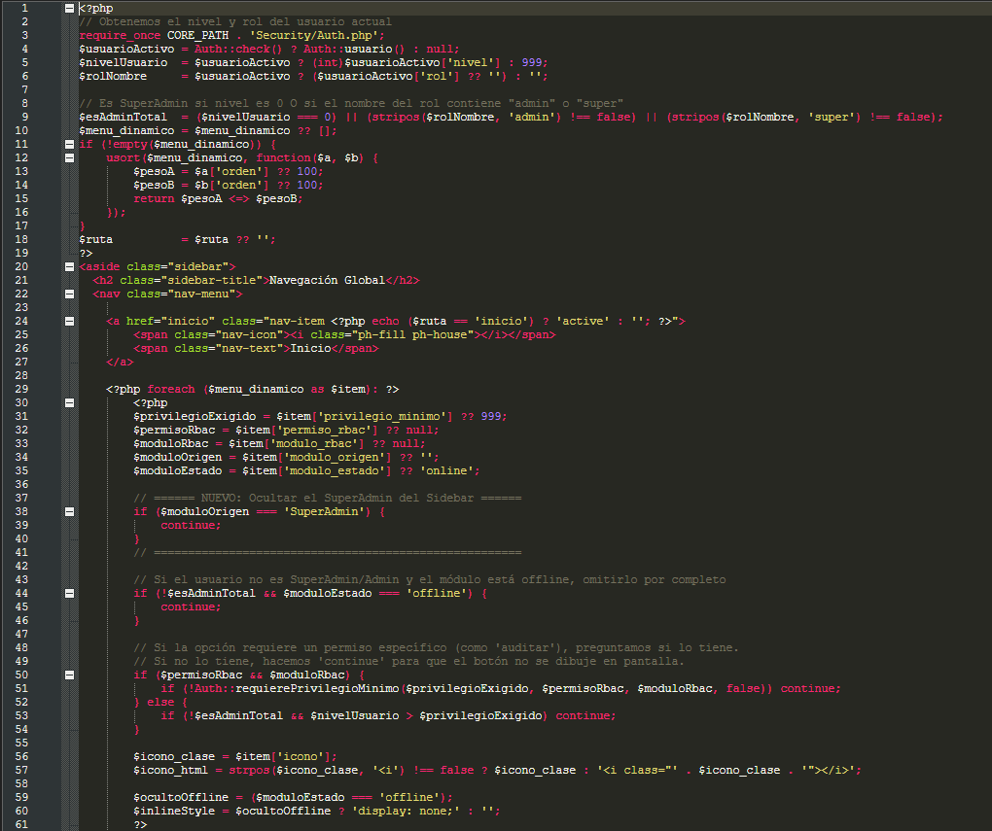 (Retrieving the active user and permission filtering for the sidebar menu)
On lines 1 to 61 of core/Views/sidebar.php, the sidebar checks who the current user is via Auth::check() and Auth::usuario() (lines 4 to 6). If the visitor is not signed in, their $nivelUsuario defaults to 999 (public visitor). Next, as it loops through each option in $menu_dinamico (line 29), it applies the visibility rules: it hides the SuperAdmin module from the standard sidebar menu (lines 38 to 40), hides modules marked 'offline' from regular users (lines 44 to 46), and on lines 50 to 54 checks whether the user meets the 'privilegio_minimo' or holds the specific RBAC matrix permission ('permiso_rbac' and 'modulo_rbac'). If the user lacks the required level, it executes continue; and the button is not even rendered in the HTML.
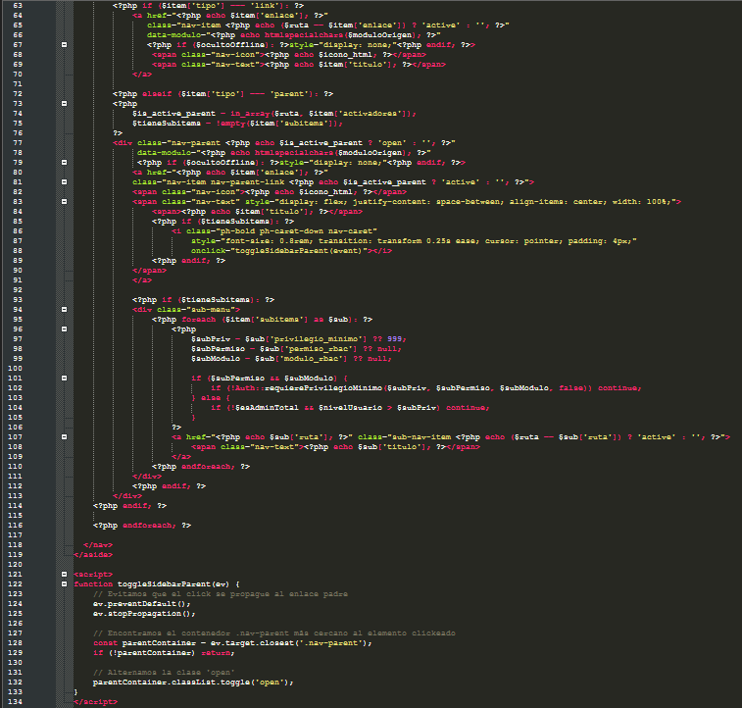 (Rendering link items, parent dropdown menus, and subitems)
Lines 63 to 134 of core/Views/sidebar.php render the two types of menu entries you can configure in getMenuConfig(): when 'tipo' is 'link' (lines 63 to 70), it creates a simple direct link; when 'tipo' is 'parent' (lines 72 to 114), it creates a collapsible dropdown container. Notice line 74: $is_active_parent = in_array($ruta, $item['activadores']);. If the current route the user is browsing appears inside the 'activadores' array you declared in your module, the parent menu is rendered with the 'open' and 'active' CSS classes, keeping the submenu expanded automatically.
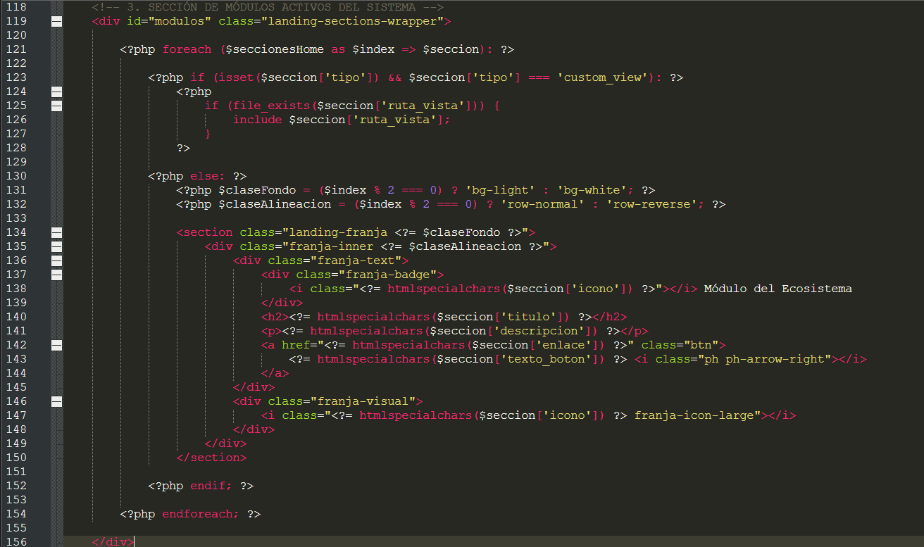 (Rendering module sections and cards on the home screen)
Lines 118 to 156 of core/Views/home_bienvenida.php iterate over the $seccionesHome array (sourced from each module's getHomeConfig() method). If your module returns 'tipo' => 'custom_view', it includes the custom view specified in 'ruta_vista' (lines 123 to 128); otherwise, it automatically renders an institutional banner section alternating between light and white backgrounds with your module's icon, title, description, and call-to-action button (lines 130 to 150).
Figure 6
Injection map from the module's index.php methods into the zones of the master.php master template
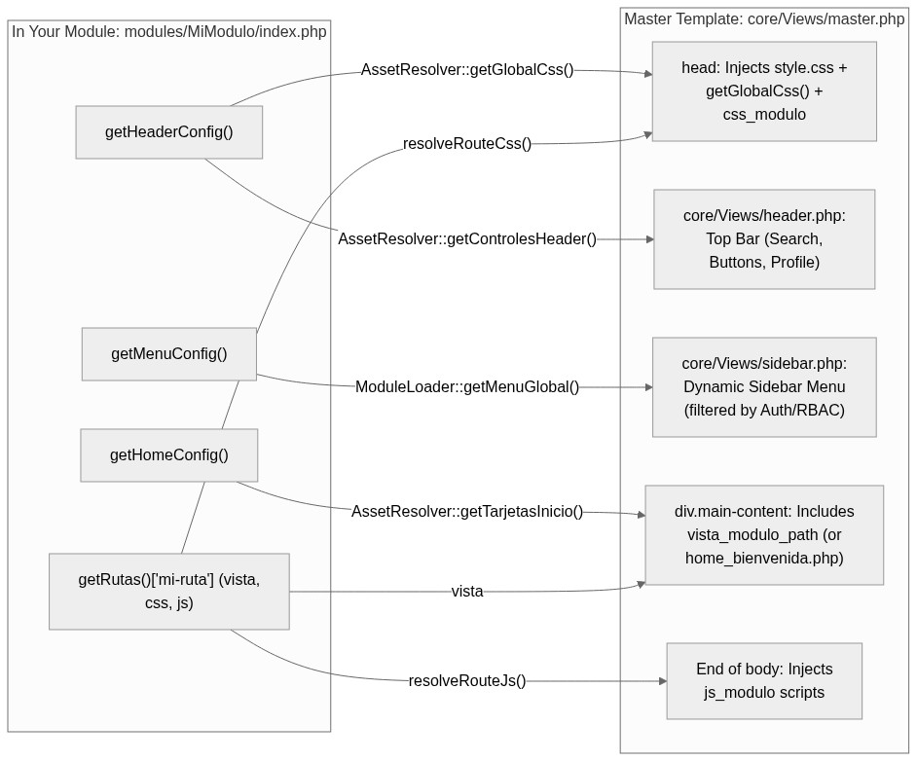
3.9. Database Layer: core/Database/Connection.php and core/Database/QueryBuilder.php
To communicate with PostgreSQL from your module's models, the Core provides two classes located in core/Database/: Connection.php (which manages the single PDO connection) and QueryBuilder.php (which lets you build secure SQL queries without writing repetitive raw SQL by hand).
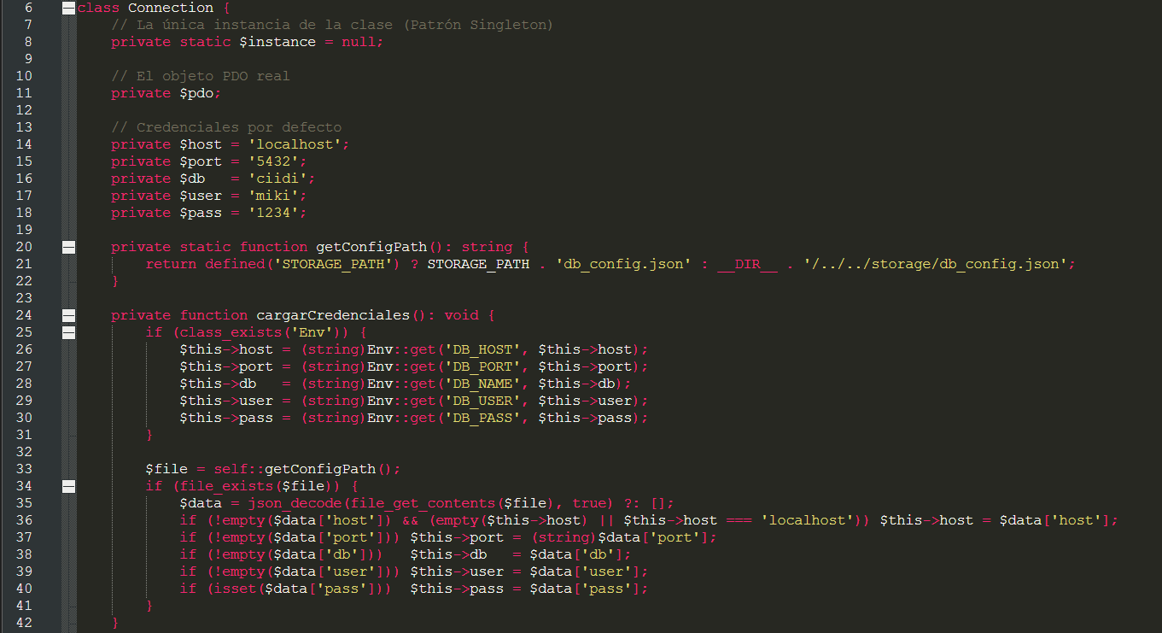 (Singleton pattern and credential loading from .env and db_config.json)
Lines 6 to 42 of core/Database/Connection.php implement the Singleton pattern via the static property private static $instance = null;. The private method cargarCredenciales() (lines 24 to 42) first reads the DB_HOST, DB_PORT, DB_NAME, DB_USER, and DB_PASS variables from the Env class (.env) and supplements or backs them up using storage/db_config.json.
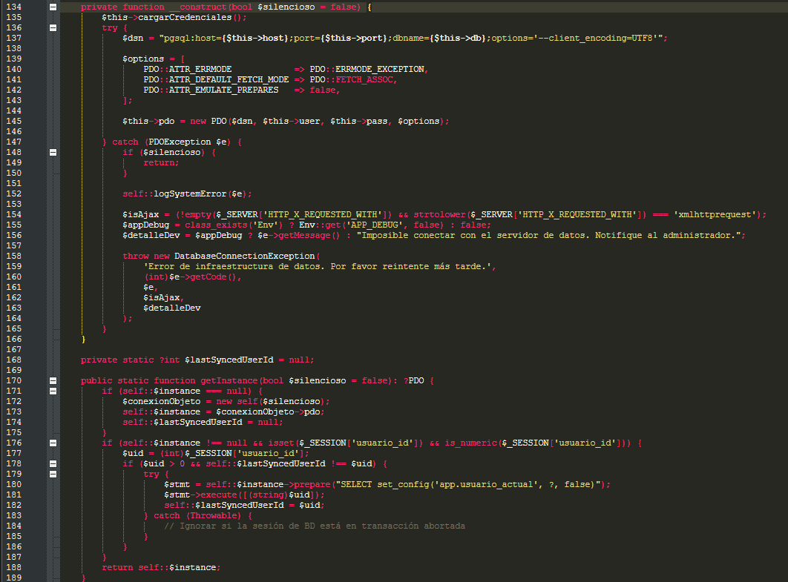 (PostgreSQL PDO constructor and Connection::getInstance() method)
On lines 134 to 166, the private constructor opens the PDO connection to PostgreSQL using UTF8 encoding, exception error mode (PDO::ERRMODE_EXCEPTION), associative array fetching by default (PDO::FETCH_ASSOC), and native prepared statements (PDO::ATTR_EMULATE_PREPARES => false). Next, lines 170 to 189 define the static method Connection::getInstance(). This method guarantees that no matter how many models you instantiate during a single request, only one connection to PostgreSQL is opened. Also notice lines 176 to 187: if a user is logged in under $_SESSION['usuario_id'], it automatically executes SELECT set_config('app.usuario_actual', ?, false) in PostgreSQL so internal database triggers know which user performed every insert, update, or delete.
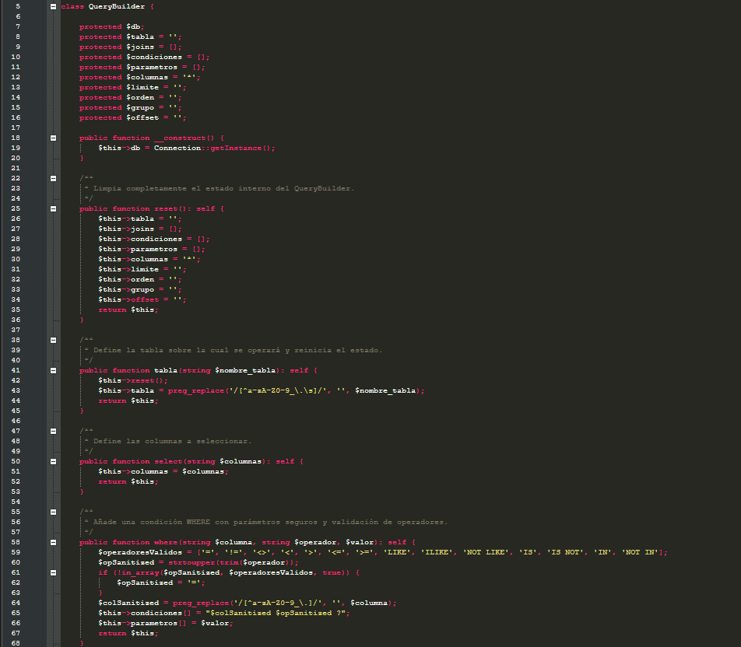 (QueryBuilder initialization and reset(), tabla(), select(), and where() methods)
Lines 5 to 68 of core/Database/QueryBuilder.php show how the query builder initializes by requesting $this->db = Connection::getInstance(); in its constructor (line 19). The tabla(string $nombre_tabla) method (lines 41 to 45) automatically clears any previous query state by calling $this->reset() and sanitizes the table name. The where($columna, $operador, $valor) method (lines 58 to 68) validates that the operator is safe (=, !=, <, >, LIKE, ILIKE, IN, etc.), sanitizes the column name, and stores the value separately in the $this->parametros array to pass it via question-mark placeholders (?) in a prepared statement, shielding your module against any SQL injection attempt.
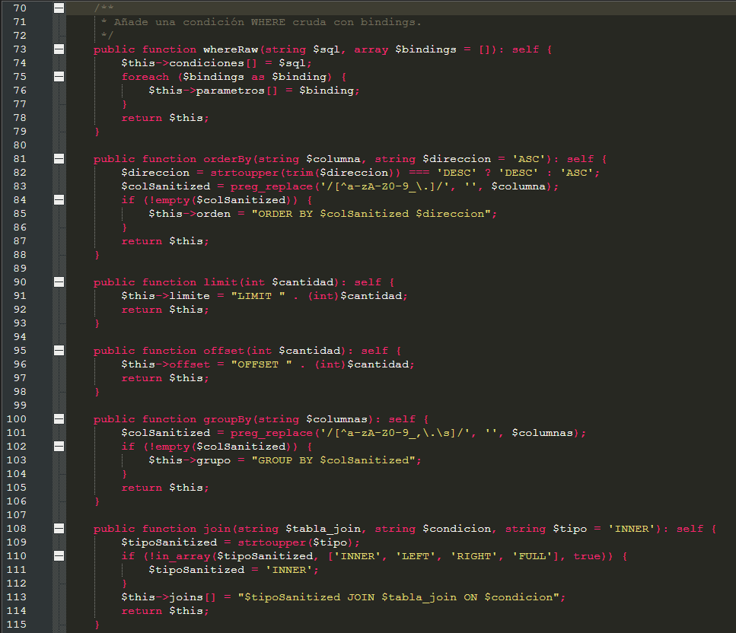

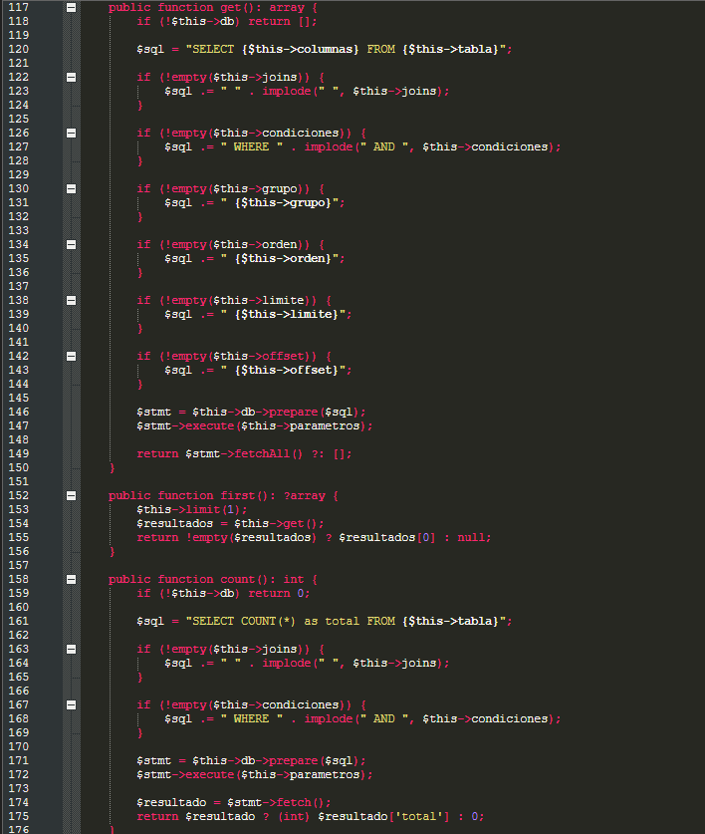
(Methods whereRaw(), orderBy(), limit(), offset(), join(), get(), first(), and count())
Lines 70 to 115 contain the chainable modifiers for compound conditions (whereRaw), sorting (orderBy), pagination (limit and offset), grouping (groupBy), and table joins (join). Lines 117 to 176 define the three terminal read methods that execute the chain: get() (lines 117 to 150, which assembles the full SELECT statement, runs prepare/execute, and returns an array of all matching rows), first() (lines 152 to 156, which applies limit(1) and returns only the first row or null if none exists), and count() (lines 158 to 176, which returns an integer with the total number of records matching the conditions).
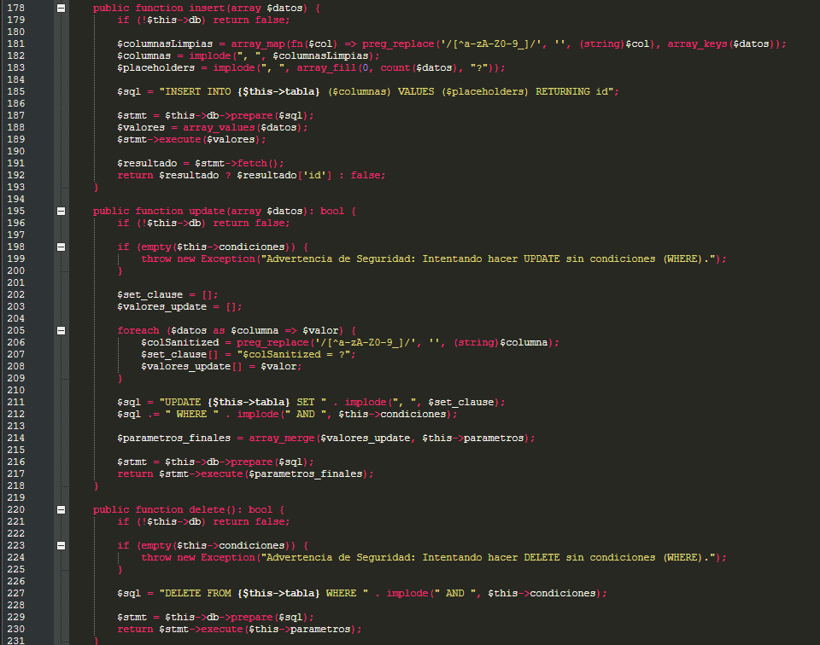 (Write methods insert(), update(), and delete() with WHERE protection)
Lines 178 to 231 contain the three database write methods:
• insert(array $datos) (lines 178 to 193): Accepts an associative array ['columna' => $valor], builds PostgreSQL's INSERT INTO ... VALUES (...) RETURNING id statement, and directly returns the newly created row id (or false if it failed).
• update(array $datos) (lines 195 to 218): Updates the columns passed in the $datos array. Pay close attention to lines 198 to 200: if you attempt to call update() without calling ->where(...) first, it throws a security exception to prevent accidentally overwriting the entire table.
• delete() (lines 220 to 231): Deletes the records matching the conditions. Just like update(), lines 223 to 225 strictly require at least one WHERE condition to be present before executing the DELETE.
Figure 7
Persistence flow from Controller and Model to PostgreSQL using QueryBuilder or direct PDO
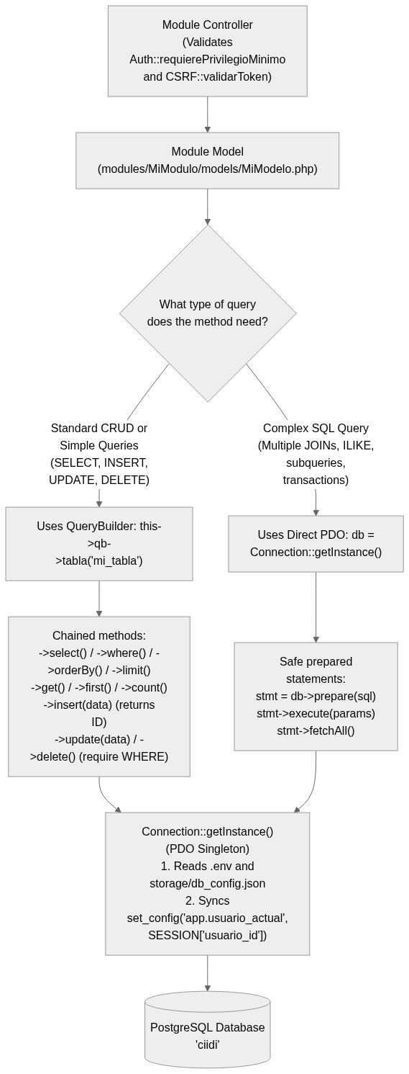
3.10. Security, Permissions, Auditing, and Environment Variables: Auth.php, CSRF.php, AuditLogger.php, and FeatureFlagMiddleware.php
To wrap up our tour of the Core, let's examine the four security and access-control classes you will invoke constantly inside your modules' controllers and views.
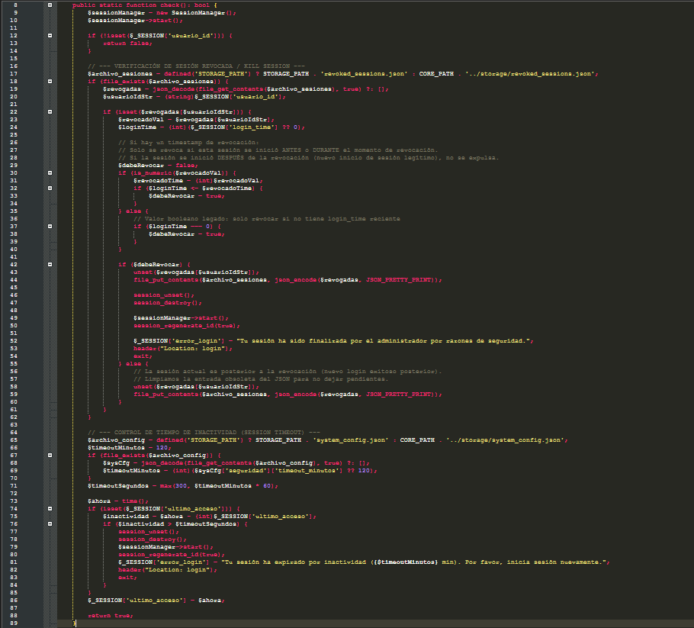 (Method Auth::check() with revoked-session enforcement and inactivity expiration)
On lines 8 to 89 of core/Security/Auth.php, the static method Auth::check() verifies not only whether $_SESSION['usuario_id'] exists, but also two real-time security mechanisms: first (lines 17 to 62), it checks storage/revoked_sessions.json to see whether the SuperAdmin forcibly terminated that user's session (Kill Session); and second (lines 65 to 87), it calculates how many seconds the user has been idle by comparing time() against $_SESSION['ultimo_acceso'] and logs them out to the sign-in screen if they exceeded the configured maximum timeout.
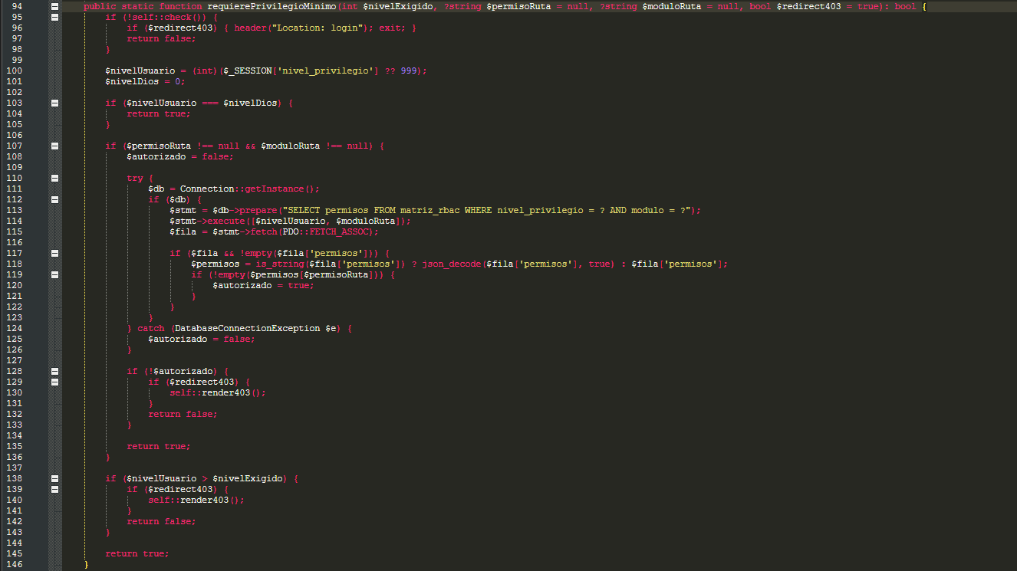 (Method Auth::requierePrivilegioMinimo() and validation against matriz_rbac)
Lines 94 to 146 contain the guard you will place on the very first line of your administrative methods: Auth::requierePrivilegioMinimo(int $nivelExigido, ?string $permisoRuta = null, ?string $moduloRuta = null, bool $redirect403 = true). In CIIDI, the smaller the nivel_privilegio number, the higher the user's authority: level 0 is God-mode (SuperAdmin, which always passes on line 103); levels such as 1 or 2 correspond to administrators or faculty; and 999 represents the general public. If you also pass the $permisoRuta (for example, 'auditar', 'crear', 'editar', or 'eliminar') and $moduloRuta (for example, 'Articulos') parameters, lines 107 to 136 query the matriz_rbac table in PostgreSQL to verify whether that user level has that specific permission enabled in its JSON column. If permission is denied and $redirect403 is true, it automatically renders the 403 access-denied view and halts the controller.
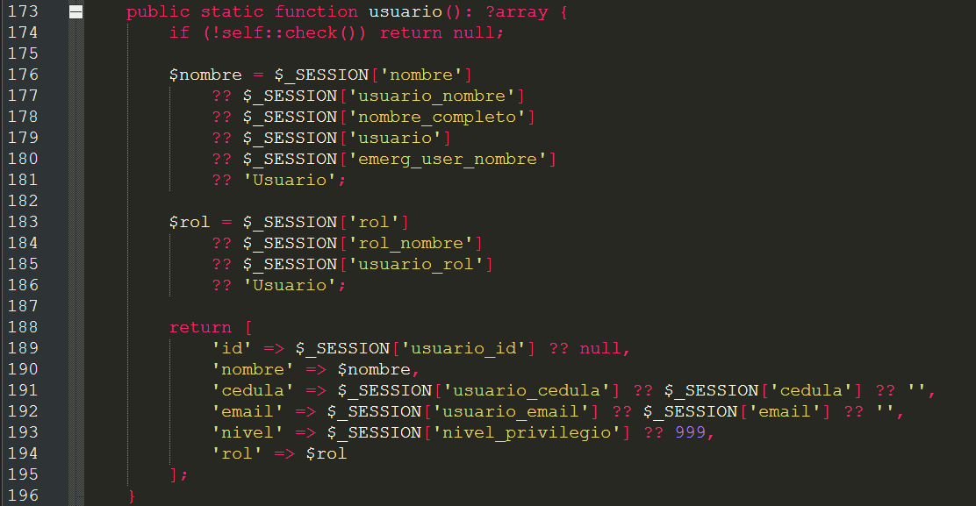 (Method Auth::usuario() for retrieving the logged-in user's data)
On lines 173 to 196 of core/Security/Auth.php, the Auth::usuario() method returns a clean array containing the 'id', 'nombre', 'cedula', 'email', 'nivel', and 'rol' keys of the currently signed-in user, or null for an anonymous visitor.
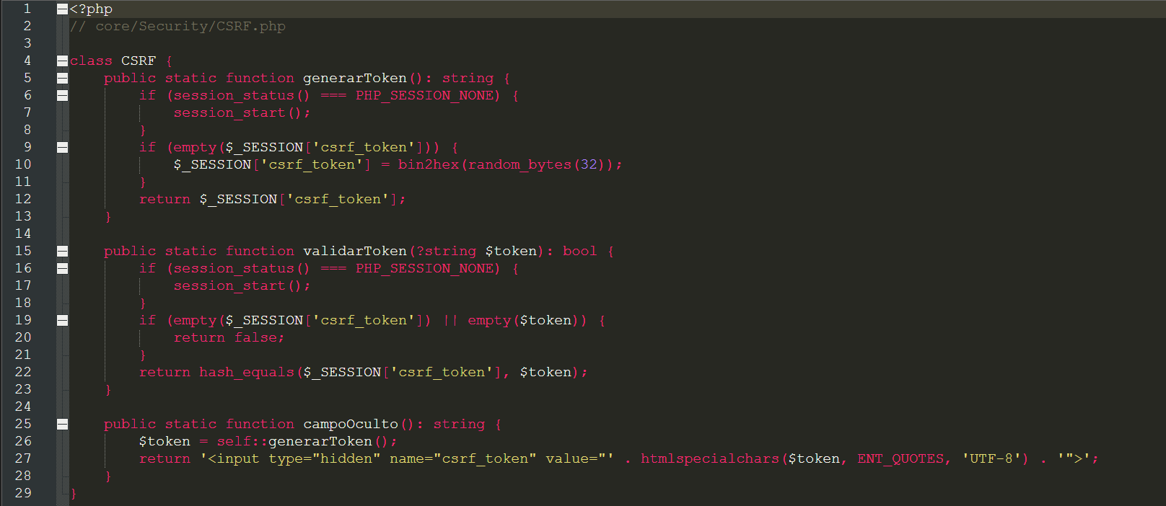 (Complete CSRF class: generarToken(), validarToken(), and campoOculto())
Lines 1 to 29 of core/Security/CSRF.php implement Cross-Site Request Forgery (CSRF) protection. Using it in your modules takes just two steps: inside your view's HTML form, output <?= CSRF::campoOculto() ?> (lines 25 to 28), which generates an <input type='hidden' name='csrf_token'> carrying a random 64-character hexadecimal token; and in the controller method receiving $_POST, check if (!CSRF::validarToken($_POST['csrf_token'] ?? null)) (lines 15 to 23), which uses timing-safe hash_equals() comparison to verify that the submitted token matches the session token.
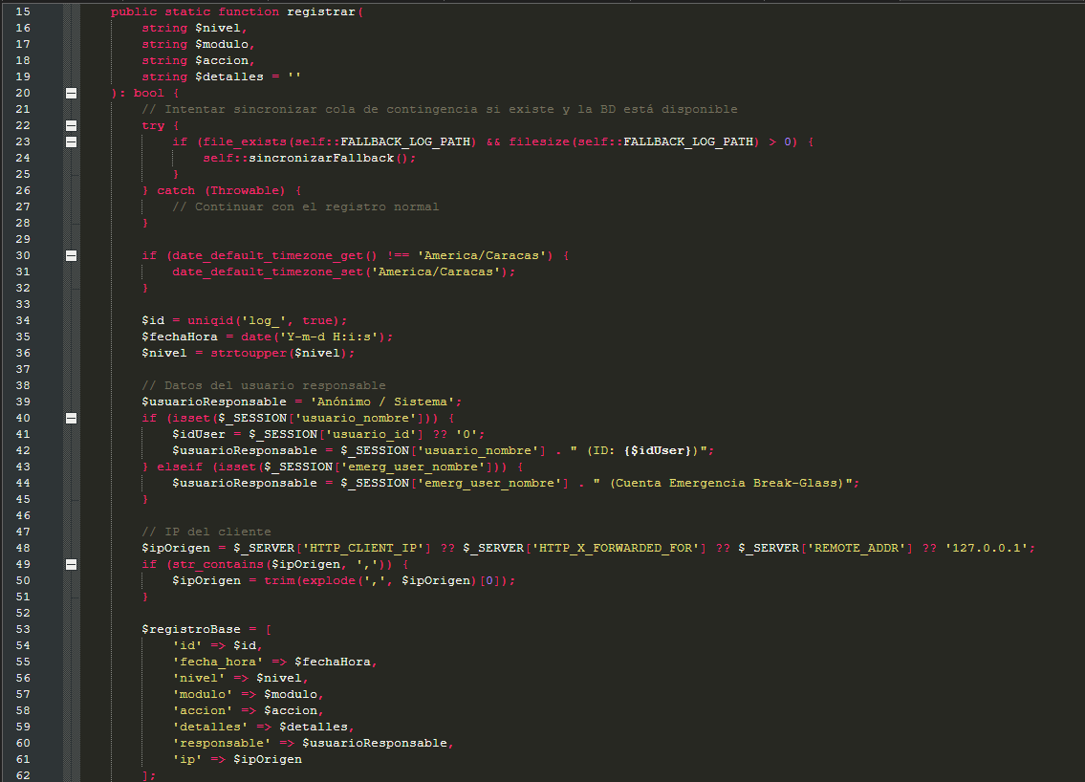
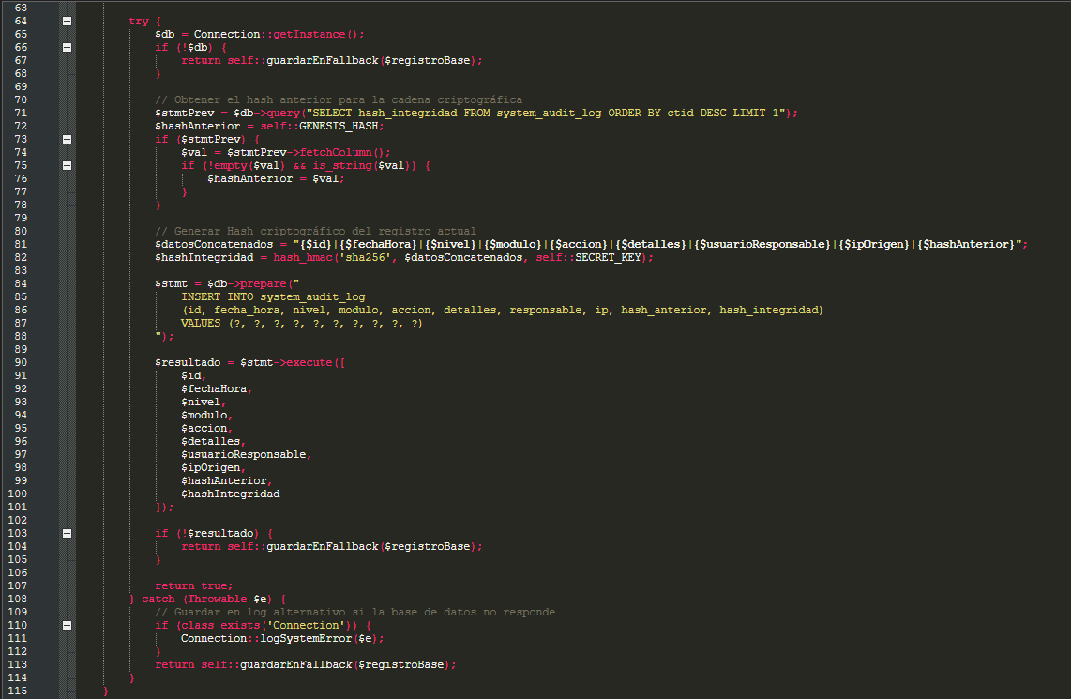 (Method AuditLogger::registrar() with HMAC SHA-256 hash chaining)
Lines 15 to 115 of core/Security/AuditLogger.php define the static method AuditLogger::registrar($nivel, $modulo, $accion, $detalles). Every time a user creates, edits, deletes, or changes the configuration of a record in your module, you must call this method. It automatically detects the active session user's name, ID, and IP address, queries the hash of the most recent event in the system_audit_log table, computes a chained cryptographic signature via hash_hmac('sha256', ...), and writes the entry to PostgreSQL (or to the fallback file storage/logs/audit_fallback.jsonl if the database is unreachable).
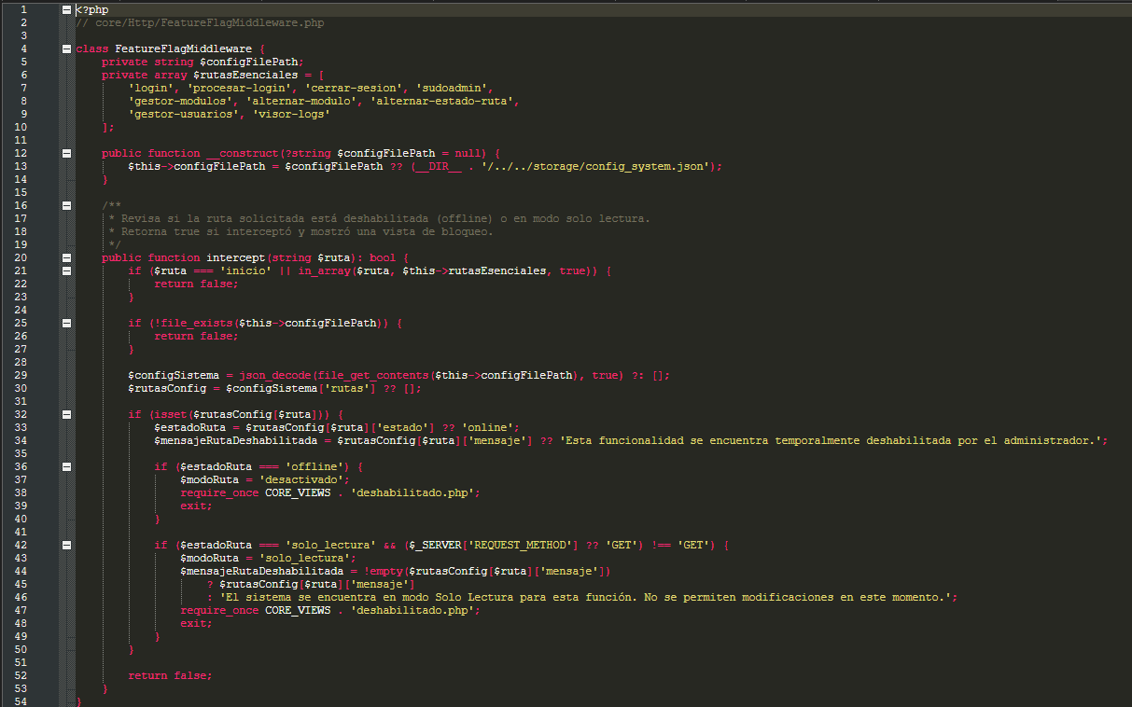 (Intercepting routes in offline or solo_lectura mode)
Finally, lines 1 to 54 of core/Http/FeatureFlagMiddleware.php show how the Core lets administrators control every individual route of your module from the SuperAdmin panel without touching your code. When one of your module's routes is marked 'offline' in storage/config_system.json (lines 36 to 40), the middleware halts the request and renders core/Views/deshabilitado.php. And when it is marked 'solo_lectura' (read-only, lines 42 to 49), it lets all GET requests through so users can continue viewing and reading screens, while blocking any POST, PUT, or DELETE request that attempts to modify data.
Part 4. Step-by-Step Practical Guide: How to Create and Add a New Module from Scratch
Now that you understand how the Core works under the hood and what each of its files does, let's move on to hands-on practice. In this section, we will build a complete new module from scratch called Eventos (to manage CIIDI academic conferences and symposiums). By following these six steps in order, you will be able to create any new module in the system without touching a single line of the Core.
Figure 8
6-step roadmap to create and plug in a new module in CIIDI
4.1. Step 1: Create the Folder Structure of the New Module
First, open the modules/ directory and create a folder named after your module in PascalCase (capitalizing the first letter of each word, with no spaces, accent marks, or special characters). For our example, we will create modules/Eventos/. Inside it, create the following standard directory layout:
modules/
└── Eventos/
├── index.php
├── controllers/
│ └── EventosController.php
├── models/
│ └── EventoModel.php
├── views/
│ ├── catalogo_eventos.php
│ └── gestor_eventos.php
├── services/
└── assets/
├── css/
│ └── eventos.css
├── js/
│ └── eventos.js
└── img/
Always keep the exact subfolder names assets/css/ and assets/js/, because as we saw in Section 3.7, the Core's AssetResolver class looks for your stylesheets and scripts specifically in '../modules/NombreCarpeta/assets/css/' and '../modules/NombreCarpeta/assets/js/'.
4.2. Step 2: Create index.php and Implement ModuleContract
The file modules/Eventos/index.php is your module's manifest. When ModuleLoader scans the modules/Eventos/ folder, this is the only file it opens directly. For it to work on the first try, you must follow three mandatory rules:
• Rule 1 (Class name): The class name must match the folder name followed by the word Module (in this case, EventosModule) and must declare implements ModuleContract.
• Rule 2 (Route names without a leading slash): The array keys returned by getRutas() must never start with a leading forward slash '/'. Write 'eventos' or 'eventos-guardar', never '/eventos'.
• Rule 3 (Return the instance at the end of the file): The very last line of your index.php file must always be return new EventosModule();.
Below is the complete, annotated template for modules/Eventos/index.php, including a public view route, an administrative view route, a POST action route, and an AJAX JSON API route:
<?php
// modules/Eventos/index.php

require_once CORE_PATH . 'Interfaces/ModuleContract.php';
require_once __DIR__ . '/../SuperAdmin/services/SystemConfigService.php';

class EventosModule implements ModuleContract {

public function getNombre(): string {
return 'Módulo de Eventos y Jornadas Científicas';
}

public function getRutas(): array {
$ctrl = __DIR__ . '/controllers/EventosController.php';

return [
// 1. Public View Route (GET)
'eventos' => [
'controlador_path' => $ctrl,
'controlador' => 'EventosController',
'metodo' => 'catalogoPublico',
'vista' => __DIR__ . '/views/catalogo_eventos.php',
'titulo' => 'Eventos Académicos - CIIDI UPTTMBI',
'css' => ['eventos.css'],
'js' => ['eventos.js']
],

// 2. Administrative View Route (GET)
'eventos-gestion' => [
'controlador_path' => $ctrl,
'controlador' => 'EventosController',
'metodo' => 'gestorAdmin',
'vista' => __DIR__ . '/views/gestor_eventos.php',
'titulo' => 'Gestión de Eventos - Administración',
'css' => ['eventos.css'],
'js' => ['eventos.js']
],

// 3. Action Route to Process Form (POST + Redirect)
// Note that it does NOT include 'vista' because the controller redirects when finished
'eventos-guardar' => [
'controlador_path' => $ctrl,
'controlador' => 'EventosController',
'metodo' => 'procesarGuardar'
],

// 4. Action Route to Delete (POST + Redirect)
'eventos-eliminar' => [
'controlador_path' => $ctrl,
'controlador' => 'EventosController',
'metodo' => 'procesarEliminar'
],

// 5. API / AJAX Route (Returns pure JSON to JS fetch)
'api-eventos-detalle' => [
'controlador_path' => $ctrl,
'controlador' => 'EventosController',
'metodo' => 'apiObtenerDetalle'
]
];
}

public function getMenuConfig(): array {
// Retrieve privilege levels from global configuration
// By default: 999 (any visitor sees the catalog) and 1 (only admin/faculty manages)
$nivelPublico = SystemConfigService::get('accesos_modulos.eventos.publico', 999);
$nivelAdmin = SystemConfigService::get('accesos_modulos.eventos.admin', 1);

return [
[
'tipo' => 'parent',
'titulo' => 'Eventos',
'icono' => 'ph-fill ph-calendar-check',
'orden' => 70,
'enlace' => 'eventos',
'privilegio_minimo' => $nivelPublico,
// IMPORTANT: List all of your module's routes in 'activadores' so that
// the sidebar menu stays open when the user navigates across them
'activadores' => ['eventos', 'eventos-gestion'],
'subitems' => [
[
'ruta' => 'eventos',
'titulo' => 'Cartelera de Eventos',
'privilegio_minimo' => $nivelPublico
],
[
'ruta' => 'eventos-gestion',
'titulo' => 'Gestor de Eventos',
'privilegio_minimo' => $nivelAdmin
]
]
]
];
}

public function getDescripcion(): string {
return 'Gestión y cartelera pública de congresos, ponencias y jornadas académicas del CIIDI.';
}

public function getDependencias(): array {
return ['Autenticacion'];
}

public function getHomeConfig(): array {
return [
'tipo' => 'standard',
'icono' => 'ph-fill ph-calendar-check',
'titulo' => 'Jornadas y Eventos Científicos',
'descripcion' => 'Consulta el calendario de congresos, defensas públicas y simposios tecnológicos.',
'enlace' => 'eventos',
'texto_boton' => 'VER CALENDARIO'
];
}

public function getHeaderConfig(): array {
return [];
}
}

return new EventosModule();
4.3. Step 3: Create the PostgreSQL Table and Program the Model in models/
First, create the corresponding table in the PostgreSQL database (ciidi). For example, a table named public.eventos:
CREATE TABLE IF NOT EXISTS public.eventos (
id SERIAL PRIMARY KEY,
titulo VARCHAR(200) NOT NULL,
descripcion TEXT NOT NULL,
fecha_evento DATE NOT NULL,
lugar VARCHAR(150) NOT NULL,
estado VARCHAR(30) DEFAULT 'publicado',
id_creador INTEGER REFERENCES public.usuarios(id) ON DELETE SET NULL,
fecha_creacion TIMESTAMP DEFAULT CURRENT_TIMESTAMP
);
Next, create the file modules/Eventos/models/EventoModel.php. This model demonstrates how to use both QueryBuilder (for quick inserts, lookups by ID, updates, and deletes) and Connection::getInstance() (for cases where you need a SELECT with LEFT JOIN and dynamic filters):
<?php
// modules/Eventos/models/EventoModel.php

require_once CORE_PATH . 'Database/QueryBuilder.php';

class EventoModel {

private QueryBuilder $qb;
private ?PDO $db;

public function __construct() {
$this->qb = new QueryBuilder();
$this->db = Connection::getInstance();
}

/**
* Example using QueryBuilder to fetch all published events.
*/
public function listarPublicados(): array {
return $this->qb
->tabla('eventos')
->select('*')
->where('estado', '=', 'publicado')
->orderBy('fecha_evento', 'ASC')
->get();
}

/**
* Example using direct PDO (Connection::getInstance) when we need
* to join the eventos table with the usuarios table to fetch the creator's name.
*/
public function listarTodosConCreador(): array {
if (!$this->db) return [];

$sql = "
SELECT e.*, u.nombre_completo AS nombre_creador
FROM public.eventos e
LEFT JOIN public.usuarios u ON e.id_creador = u.id
ORDER BY e.fecha_creacion DESC
";
$stmt = $this->db->prepare($sql);
$stmt->execute();
return $stmt->fetchAll() ?: [];
}

/**
* Find a specific event by its ID using QueryBuilder.
*/
public function obtenerPorId(int $id): ?array {
return $this->qb
->tabla('eventos')
->where('id', '=', $id)
->first();
}

/**
* Insert a new event and return the newly generated ID.
*/
public function crear(array $datos) {
return $this->qb
->tabla('eventos')
->insert([
'titulo' => $datos['titulo'],
'descripcion' => $datos['descripcion'],
'fecha_evento' => $datos['fecha_evento'],
'lugar' => $datos['lugar'],
'estado' => $datos['estado'] ?? 'publicado',
'id_creador' => $datos['id_creador'] ?? null
]);
}

/**
* Update an existing event (always remember to call ->where before ->update).
*/
public function actualizar(int $id, array $datos): bool {
return $this->qb
->tabla('eventos')
->where('id', '=', $id)
->update($datos);
}

/**
* Delete an event (always remember to call ->where before ->delete).
*/
public function eliminar(int $id): bool {
return $this->qb
->tabla('eventos')
->where('id', '=', $id)
->delete();
}
}
4.4. Step 4: Program the Controller in controllers/ (Views, POST, and JSON)
Now let's create modules/Eventos/controllers/EventosController.php. Pay close attention to how the three method types are written: methods that return an associative array for the Dispatcher to render the view (catalogoPublico and gestorAdmin), methods that process a POST form by validating CSRF, logging to AuditLogger, and redirecting via header('Location: ...') (procesarGuardar and procesarEliminar), and methods that return pure JSON for AJAX calls (apiObtenerDetalle):
<?php
// modules/Eventos/controllers/EventosController.php

require_once __DIR__ . '/../models/EventoModel.php';
require_once CORE_PATH . 'Security/Auth.php';
require_once CORE_PATH . 'Security/CSRF.php';
require_once CORE_PATH . 'Security/AuditLogger.php';
require_once __DIR__ . '/../../SuperAdmin/services/SystemConfigService.php';

class EventosController {

private EventoModel $model;
private int $nivelAdmin;

public function __construct() {
$this->model = new EventoModel();
$this->nivelAdmin = (int) SystemConfigService::get('accesos_modulos.eventos.admin', 1);
}

/**
* 1. Public View Method: returns an associative array that the Dispatcher
* will extract into variables ($eventos, $usuario_actual) for catalogo_eventos.php
*/
public function catalogoPublico(): array {
$eventos = $this->model->listarPublicados();
$usuario_actual = Auth::usuario();

return [
'eventos' => $eventos,
'usuario_actual' => $usuario_actual
];
}

/**
* 2. Administrative View Method: enforces minimum privilege before querying data.
*/
public function gestorAdmin(): array {
Auth::requierePrivilegioMinimo($this->nivelAdmin);

$eventos = $this->model->listarTodosConCreador();
$mensaje_exito = $_SESSION['evt_exito'] ?? null;
$mensaje_error = $_SESSION['evt_error'] ?? null;
unset($_SESSION['evt_exito'], $_SESSION['evt_error']);

return compact('eventos', 'mensaje_exito', 'mensaje_error');
}

/**
* 3. POST Action Method: validates session, validates CSRF, saves to DB,
* logs to AuditLogger, and redirects with exit.
*/
public function procesarGuardar(): void {
Auth::requierePrivilegioMinimo($this->nivelAdmin);

if ($_SERVER['REQUEST_METHOD'] !== 'POST') {
header('Location: eventos-gestion');
exit;
}

if (!CSRF::validarToken($_POST['csrf_token'] ?? null)) {
$_SESSION['evt_error'] = 'Token de seguridad CSRF inválido. Intente nuevamente.';
header('Location: eventos-gestion');
exit;
}

$titulo = trim($_POST['titulo'] ?? '');
$descripcion = trim($_POST['descripcion'] ?? '');
$fecha = trim($_POST['fecha_evento'] ?? '');
$lugar = trim($_POST['lugar'] ?? '');

if ($titulo === '' || $descripcion === '' || $fecha === '' || $lugar === '') {
$_SESSION['evt_error'] = 'Todos los campos son obligatorios.';
header('Location: eventos-gestion');
exit;
}

$usuario = Auth::usuario();
$nuevoId = $this->model->crear([
'titulo' => mb_substr($titulo, 0, 200),
'descripcion' => mb_substr($descripcion, 0, 5000),
'fecha_evento' => $fecha,
'lugar' => mb_substr($lugar, 0, 150),
'estado' => 'publicado',
'id_creador' => $usuario['id'] ?? null
]);

if ($nuevoId) {
AuditLogger::registrar('INFO', 'Eventos', 'Creación de Evento', "Se creó el evento ID #{$nuevoId}: {$titulo}");
$_SESSION['evt_exito'] = 'El evento fue registrado correctamente.';
} else {
$_SESSION['evt_error'] = 'No se pudo guardar el evento.';
}

header('Location: eventos-gestion');
exit;
}

/**
* 4. POST Action Method to delete a record.
*/
public function procesarEliminar(): void {
Auth::requierePrivilegioMinimo($this->nivelAdmin);

if ($_SERVER['REQUEST_METHOD'] !== 'POST' || !CSRF::validarToken($_POST['csrf_token'] ?? null)) {
$_SESSION['evt_error'] = 'Solicitud no autorizada.';
header('Location: eventos-gestion');
exit;
}

$id = (int)($_POST['id'] ?? 0);
if ($id > 0 && $this->model->eliminar($id)) {
AuditLogger::registrar('WARNING', 'Eventos', 'Eliminación de Evento', "Se eliminó el evento ID #{$id}");
$_SESSION['evt_exito'] = 'Evento eliminado correctamente.';
} else {
$_SESSION['evt_error'] = 'No se pudo eliminar el evento solicitado.';
}

header('Location: eventos-gestion');
exit;
}

/**
* 5. AJAX API Method (JSON): outputs pure JSON and halts execution with exit
* so the Dispatcher does not append the HTML from master.php.
*/
public function apiObtenerDetalle(): void {
header('Content-Type: application/json; charset=utf-8');

$id = (int)($_GET['id'] ?? 0);
$evento = $id > 0 ? $this->model->obtenerPorId($id) : null;

if (!$evento) {
http_response_code(404);
echo json_encode(['error' => true, 'mensaje' => 'Evento no encontrado']);
exit;
}

echo json_encode(['error' => false, 'datos' => $evento]);
exit;
}
}
4.5. Step 5: Create the Views in views/ and the CSS and JS Files in assets/
The views you place inside modules/Eventos/views/ are automatically injected into <div class='main-content'> inside master.php. Therefore, you must not write <html>, <head>, or <body> tags in your views. Remember two mandatory best practices in CIIDI: always escape any variable coming from the database with htmlspecialchars($valor, ENT_QUOTES, 'UTF-8') to prevent XSS attacks, and always include <?= CSRF::campoOculto() ?> inside every <form method='POST'>.
Let's look at a clean example for the administrative view modules/Eventos/views/gestor_eventos.php:
<?php
// modules/Eventos/views/gestor_eventos.php
require_once CORE_PATH . 'Security/CSRF.php';
?>
<div class="eventos-contenedor">
<h1>Gestor de Eventos Académicos</h1>

<?php if (!empty($mensaje_exito)): ?>
<div class="alerta-exito"><?= htmlspecialchars($mensaje_exito, ENT_QUOTES, 'UTF-8') ?></div>
<?php endif; ?>

<?php if (!empty($mensaje_error)): ?>
<div class="alerta-error"><?= htmlspecialchars($mensaje_error, ENT_QUOTES, 'UTF-8') ?></div>
<?php endif; ?>

<!-- Form to create a new event -->
<form action="eventos-guardar" method="POST" class="form-evento">
<?= CSRF::campoOculto() ?>

<label>Título del Evento:</label>
<input type="text" name="titulo" required maxlength="200">

<label>Fecha del Evento:</label>
<input type="date" name="fecha_evento" required>

<label>Lugar / Auditorio:</label>
<input type="text" name="lugar" required maxlength="150">

<label>Descripción:</label>
<textarea name="descripcion" rows="4" required></textarea>

<button type="submit" class="btn">Guardar Evento</button>
</form>

<!-- Table of registered events -->
<table class="tabla-eventos">
<thead>
<tr>
<th>ID</th>
<th>Título</th>
<th>Fecha</th>
<th>Lugar</th>
<th>Acciones</th>
</tr>
</thead>
<tbody>
<?php foreach ($eventos as $ev): ?>
<tr>
<td><?= (int)$ev['id'] ?></td>
<td><?= htmlspecialchars($ev['titulo'], ENT_QUOTES, 'UTF-8') ?></td>
<td><?= htmlspecialchars($ev['fecha_evento'], ENT_QUOTES, 'UTF-8') ?></td>
<td><?= htmlspecialchars($ev['lugar'], ENT_QUOTES, 'UTF-8') ?></td>
<td>
<form action="eventos-eliminar" method="POST" style="display:inline;">
<?= CSRF::campoOculto() ?>
<input type="hidden" name="id" value="<?= (int)$ev['id'] ?>">
<button type="submit">Eliminar</button>
</form>
</td>
</tr>
<?php endforeach; ?>
</tbody>
</table>
</div>
Meanwhile, modules/Eventos/assets/css/eventos.css and modules/Eventos/assets/js/eventos.js will load automatically because you already declared them under 'css' => ['eventos.css'] and 'js' => ['eventos.js'] in your index.php.
4.6. Step 6: Automatic Verification, RBAC Permissions, and SuperAdmin Settings
The very moment you save the files from the previous steps and reload your browser, ModuleLoader automatically detects the modules/Eventos/ folder. You do not need to run any console commands or register the module in any Core file. You will immediately see three results:
• 1. In the sidebar menu (Sidebar): The 'Eventos' dropdown menu will appear with its sub-items, respecting the position specified in 'orden' => 70.
• 2. On the welcome page (Home): The promotional banner configured in getHomeConfig() will automatically appear with the 'VER CALENDARIO' button pointing to the 'eventos' route.
• 3. In the SuperAdmin Module Manager: When you sign in with a level-0 account and navigate to the 'gestor-modulos' route, you will see the card for your new Eventos module with a toggle switch to enable or disable it on the fly, and opening its details view will display all 5 of its routes ('eventos', 'eventos-gestion', 'eventos-guardar', 'eventos-eliminar', and 'api-eventos-detalle') so you can set any of them to active, read-only, or disabled mode.
Part 5. How to Modify or Extend an Existing Module Without Breaking the System
In your day-to-day work as a CIIDI developer, you will often not need to create a module from scratch, but rather modify or extend one of the existing modules (such as Articulos, Cursos, Investigaciones, LineasInvestigacion, RepositorioPST, or VinculacionEmpresarial). Below are the exact recipes for carrying out the five most common modifications without breaking anything.
5.1. How to Add a New Screen (View) to an Existing Module
If you are asked to add a new screen to an existing module (for example, a statistics screen in the Cursos module), you only need to touch three files inside that module:
• 1. In modules/NombreModulo/views/: Create your new PHP view file (for example, estadisticas_cursos.php) containing the HTML for your screen.
• 2. In modules/NombreModulo/controllers/: Open the module's controller and add a new public method (for example, public function mostrarEstadisticas(): array) that queries the data from the model and returns it in an associative array.
• 3. In modules/NombreModulo/index.php: Inside the getRutas() array, add a new key with the route name (for example, 'cursos-estadisticas') pointing to the controller, the new 'mostrarEstadisticas' method, and the new view '__DIR__ . /views/estadisticas_cursos.php'.
5.2. How to Add a New POST Form or Save/Delete Action
To add a new button that submits data or modifies the database:
• 1. In the view (.php): Create your <form action='nombre-ruta-post' method='POST'> tag and never forget to place <?= CSRF::campoOculto() ?> inside it.
• 2. In the module's index.php: Register 'nombre-ruta-post' in getRutas(), specifying only 'controlador_path', 'controlador', and 'metodo' (omitting 'vista').
• 3. In the controller and model: In the controller method, verify permissions with Auth::requierePrivilegioMinimo(), validate the token with CSRF::validarToken($_POST['csrf_token'] ?? null), call the model method that performs the insert/update/delete, log the action with AuditLogger::registrar(), and always finish with header('Location: ruta-vista'); exit;.
5.3. How to Add an AJAX (JSON) Endpoint to Communicate with JavaScript
Whenever you need a JavaScript script in your view to query or send data to the server using fetch() without reloading the page:
• 1. Register the route in getRutas(): Add it to your module's index.php without a 'vista' key (for example, 'api-filtrar-datos').
• 2. Program the method in the controller: Place header('Content-Type: application/json; charset=utf-8'); on the very first line, process the query, output the response with echo json_encode(['ok' => true, 'data' => $resultados]);, and strictly include exit; at the end of the method.
• 3. Call it from your JS file in assets/js/: From JavaScript, simply call fetch('api-filtrar-datos?param=valor') or send a POST request with FormData.
5.4. How to Add a Sidebar Menu Sub-Item and Configure Its Active Triggers
Whenever you add a new screen to a module and want it to appear as an additional option inside that module's dropdown menu in the left sidebar, open modules/NombreModulo/index.php and go to the getMenuConfig() method. There you must do two things simultaneously:
• 1. Add the sub-item to 'subitems': Add an entry to the 'subitems' sub-array with the keys 'ruta', 'titulo', and 'privilegio_minimo'.
• 2. Add the route name to 'activadores': Right above 'subitems' you will see an array named 'activadores'. Add the name of your new route there as well (along with any internal sub-routes such as edit or detail forms). If you forget to include your route in 'activadores', when the user clicks your new menu option, the sidebar accordion will collapse instead of staying expanded and highlighted.
5.5. How to Handle Custom JSON Configurations and File or Image Uploads
Many CIIDI modules (such as Cursos, Articulos, RepositorioPST, or VinculacionEmpresarial) include their own settings screen to adjust pagination limits, maximum file sizes, or dynamic text without requiring an extra table in PostgreSQL. The standard practice in CIIDI is to store a JSON file inside the module folder (for example, modules/Cursos/config_cursos.json) or use a small ConfigService class inside the module's services/ folder that reads the JSON via json_decode(file_get_contents(...), true) and merges it with default values using array_replace_recursive().
As for file uploads (such as course covers or research images), images that need to be publicly visible in <img> tags are stored under public/uploads/nombre_modulo/ (using the constant BASE_PATH . '/public/uploads/...'), always validating the actual file extension, the MIME type via finfo_file(), and the size in megabytes beforehand, prior to moving the file with move_uploaded_file().
Part 6. Troubleshooting Common Issues (Developer Quick Diagnostic Guide)
To wrap up this guide, here is the quick diagnostic reference covering the most common issues you may encounter when programming or modifying a module in CIIDI, why they occur inside the Core, and how to fix them in seconds.
6.1. Issues with Routes, 404 Errors, and Missing Modules
Symptom or Issue | Backend Cause (Core) | Exact Solution
I created my folder in modules/, but the system completely ignores it (no routes and no menu). | ModuleLoader::loadModules() (lines 39-50) looks for index.php and requires it to return an instance implementing ModuleContract. | Verify that modules/TuModulo/index.php exists, that the class declares implements ModuleContract, and that the final line is return new TuModuloModule();
I navigate to my new route in the browser and get the 404 Error screen. | Router::resolve() (line 19) looks up the exact key in $rutasGlobales, or the module is marked 'offline' in storage/config_system.json. | 1. Remove any leading '/' from the key in getRutas() (use 'mi-ruta', not '/mi-ruta'). 2. Check under SuperAdmin > Module Manager that the module is Online.
My module's button does not appear in the left sidebar menu. | sidebar.php (lines 50-54) hides the button if the current user's privilege level number is higher than the configured privilegio_minimo. | If the button should be visible to unauthenticated visitors, set 'privilegio_minimo' => 999 in getMenuConfig().
When I open a view in my module, the sidebar dropdown menu collapses on its own. | sidebar.php (line 74) checks in_array($ruta, $item['activadores']) to keep the 'open' CSS class active. | Add the exact name of that route to the 'activadores' array inside getMenuConfig() in your index.php.

6.2. Issues with Views, CSS Styles, JS Scripts, and AJAX Responses
Symptom or Issue | Backend Cause (Core) | Exact Solution
My screen loads the header and sidebar, but the center says: 'Error: The view does not exist'. | master.php (line 44) runs file_exists($vista_modulo_path) and could not find the physical file. | Always use __DIR__ . '/views/archivo.php' in the 'vista' key of getRutas(), and verify that the filename matches in exact case (uppercase and lowercase).
I declared my CSS or JS file in getRutas(), but the styles or scripts are not applied. | AssetResolver (lines 18 and 35) always searches inside ../modules/Carpeta/assets/css/ and ../modules/Carpeta/assets/js/. | Make sure you placed the file inside assets/css/ (or assets/js/), and in getRutas() specify only the filename: 'css' => ['estilo.css'].
I make an AJAX fetch() request to my API route, and JSON parsing fails because the response comes back concatenated with the entire HTML of master.php. | Dispatcher::dispatch() (lines 78-79) always includes master.php after the controller method finishes unless you halt execution. | Right after calling echo json_encode(...); in your controller method, always place exit; (or return false;) on the next line.
In my PHP view I get 'Undefined variable' when trying to use a value I computed in the controller. | Dispatcher::dispatch() (line 64) calls extract($datosVista) on the array returned by the controller. | Make sure your controller method ends with return ['nombre_variable' => $valor];. The array key name becomes the $nombre_variable variable name inside the view.

6.3. Issues with the Database, QueryBuilder, 403 Permissions, and CSRF Tokens
Symptom or Issue | Backend Cause (Core) | Exact Solution
When calling update() or delete() in my model, a 500 Error is thrown saying 'Security Warning: Attempting to run UPDATE/DELETE without conditions'. | QueryBuilder (lines 198 and 223) blocks any update or deletion if the $this->condiciones array is empty. | Always chain at least one ->where('id', '=', $id) call before invoking ->update($datos) or ->delete().
I run two consecutive QueryBuilder queries in the same model, and the second query ends up with data or filters left over from the first. | You did not call ->tabla('nombre') at the start of the second query, leaving previous conditions stored in the instance. | Always start every query by calling $this->qb->tabla('nombre_tabla') first, since the tabla() method automatically calls reset().
My POST form keeps rejecting submissions, stating that the CSRF token is invalid. | CSRF::validarToken() (line 19) compares $_POST['csrf_token'] against $_SESSION['csrf_token']. | Place <?= CSRF::campoOculto() ?> inside the <form>...</form> tags in your view and verify that the form method is POST.
I access an administrative route with a faculty or administrator account and get sent straight to the 403 Access Denied screen. | Auth::requierePrivilegioMinimo() (lines 107-143) compared the user's privilege level or checked a permission in the matriz_rbac table. | Check which privilege level you passed to the method, and if you used the $permisoRuta and $moduloRuta arguments, verify in SuperAdmin that the corresponding role has that checkbox enabled in the RBAC matrix.

6.4. Issues with the ONNX Neural Engine, Background Vectorization, and Tokenizer
Symptom or Issue | Backend Cause (Core) | Exact Solution
On Windows or Linux, an error is thrown: 'ONNX Runtime library not found at vendor/ankane/onnxruntime/.../onnxruntime.dll (or .so)'. | Composer downloaded the ankane/onnxruntime PHP package, but either the native C++ binary has not been downloaded yet or the FFI extension is disabled in php.ini. | 1. Run in the terminal: php -r "require 'vendor/autoload.php'; OnnxRuntime\Vendor::check();". 2. Verify in php.ini that ffi.enable=true is enabled for both apache2 and cli.
After replacing the ONNX model with a new one, the semantic search engine throws an invalid input exception or returns incoherent scores. | The legacy model (all-MiniLM-L6-v2 / BERT) used vocab.txt and required 3 input tensors (including token_type_ids), whereas the current multilingual model (paraphrase-multilingual-MiniLM-L12-v2 / XLM-RoBERTa) uses tokenizer.json and accepts only 2 input tensors. | Ensure the PHP service reads tokenizer.json (SentencePiece tokenizer with the '▁' prefix) and passes only ['input_ids' => ..., 'attention_mask' => ...] to predict(), removing token_type_ids and deleting the obsolete files vocab.txt and model.onnx.data.
New PSTs were uploaded to the repository, but when searching with Neural Networks they still do not appear in the semantic ranking. | To protect server RAM and CPU, vectorization does not run synchronously during PDF upload; instead, it runs asynchronously via cron_runner.php (2 PSTs every 5 minutes). | Wait for the automatic 5-minute cycle of the cron_runner.php daemon, or go to SuperAdmin > ONNX Model Panel and click the 'Vectorize Pending Now' button.
The model.onnx file was replaced after retraining in Colab, but searches are comparing new vectors against old vectors. | The 384-dimensional vectors previously stored in PostgreSQL (pgvector) were computed using the mathematical weights of the earlier model version. | Every time you update model.onnx on the server, open the ONNX Model Panel in SuperAdmin and run 'Re-index All' to recalculate the vectors across the entire database under the new semantic space.

Part 7. ONNX Neural Engine Architecture, Asynchronous Vectorization Cycle, and Step-by-Step Retraining (Fine-Tuning) Guide
7.1. How the Neural Engine Really Works in CIIDI and Why You Must Never Train It on the Local Server
When working with CIIDI's semantic search engine, the first architectural rule you must commit to memory is the difference between Training a model (Fine-Tuning) and Running an already trained model (Inference). Although the multilingual model paraphrase-multilingual-MiniLM-L12-v2 (based on the XLM-RoBERTa architecture) is remarkably compact compared to large commercial language models, it is still a deep neural network featuring 12 Transformer layers, a vocabulary of 250,002 tokens, and millions of mathematical parameters.
If you attempt to run training or retraining directly on the institutional server or on a machine with modest hardware specifications (for example, a computer with a 2- or 4-core processor, 4 GB to 8 GB of RAM, and no dedicated NVIDIA graphics card with CUDA cores), you will trigger an immediate system collapse. During training, PyTorch must load the model in full 32-bit floating-point precision (FP32), hold all intermediate batch activation states in memory, compute backward partial derivatives (Backpropagation), and update millions of weights simultaneously. On a server without a dedicated GPU, that operation exhausts physical RAM within seconds, forces the Linux or Windows operating system into heavy disk paging (Swap memory), freezes the PostgreSQL engine, and crashes the Apache web service—or else takes days just to complete a handful of epochs.
For this reason, CIIDI's Artificial Intelligence architecture is strictly decoupled into two independent environments working in synergy:
• 1. Google Colab with an NVIDIA T4 GPU: All fine-tuning and mathematical compression take place outside the university server, using Google's free cloud platform Google Colaboratory (Google Colab). At zero cost, Colab provisions a specialized NVIDIA Tesla T4 GPU (equipped with 15 GB of dedicated VRAM and thousands of Tensor/CUDA cores) capable of reading 1,000 Socio-Technological Projects (PST), adjusting the neural weights across all 12 layers in under 3 minutes, and exporting the final artifact.
• 2. The Ultra-Lightweight Inference Engine on the CIIDI Server: Once the model finishes learning in Google Colab, we never install PyTorch or a heavy Python stack on the production server. Instead, we export the neural network to the open ONNX (Open Neural Network Exchange) standard and apply 8-bit Dynamic Quantization (INT8). This compresses the 32-bit floating-point weights down to 8-bit integers, producing a self-contained model.onnx file of just ~113.4 MB (116,154 KB) that runs directly from PHP at native C++ speed via PHP's FFI extension and the ankane/onnxruntime library.
Furthermore, to prevent any bottleneck when coordinators upload new theses to the repository, the system never vectorizes documents synchronously during PDF upload. Instead, it operates through an independent, two-stage asynchronous pipeline:
• Step A: An automated background script (cron_runner.php) wakes up every 5 minutes (an interval configurable from SuperAdmin), queries PostgreSQL for PST records whose vector column is still empty, and processes a controlled batch of only 2 PSTs per cycle. It extracts their key metadata (Title, Abstract, Keywords, and General Objective), feeds them through the ONNX model, and stores the resulting L2-normalized 384-dimensional vector in PostgreSQL's vector column (pgvector).
• Step B: When a user searches the catalog, they can choose between traditional lexical mode (SQL Full-Text) and Neural Networks mode. When searching with Neural Networks, the ONNX model only needs to convert the short query phrase typed by the user into a 384-number vector (which takes just a few milliseconds on CPU) and compare it mathematically via Cosine Similarity against the pre-computed vector index in PostgreSQL, instantly returning the most semantically relevant projects without ever overloading the server.
In Figure 9 you can see how the heavy cloud training workload in Google Colab is physically separated from the lightweight asynchronous vectorization cycle and real-time query execution inside the CIIDI server.
Figure 9
Decoupled architecture separating heavy Training in Google Colab (GPU) from quantized ONNX Inference and asynchronous Vectorization on the CIIDI server (CPU)
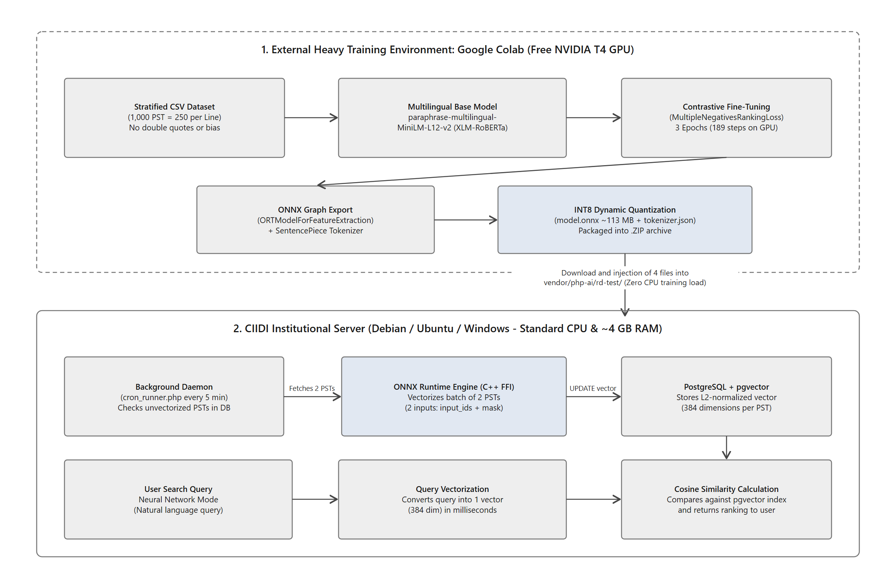
7.2. When to Retrain the Model, What Happens When Adding a New Research Line, and Anti-Bias Balancing
A fundamental question every CIIDI developer or technical administrator should ask is: what happens to the neural network if tomorrow the Scientific Research Committee approves and implements a new Research Line—complete with its corresponding Operational Dimensions—inside the system? Understanding the model's mathematical behavior under this scenario will prevent false expectations and enable you to plan evolutionary AI maintenance with engineering rigor.
When new PSTs belonging to a newly created Research Line are registered in the database before retraining the model.onnx file, two seemingly opposite technical phenomena occur at the same time:
• 1. Why the search engine still manages to rank a new project near the top when you search for something similar: Even if the model has not yet been trained on that new Research Line, the semantic search engine is neither blind nor useless on new documents. Why? First, because the underlying foundation model already understands Spanish out of the box and grasps the general meaning of tens of thousands of technical and academic concepts thanks to its 250,002-token SentencePiece vocabulary. Second, because prior fine-tuning on 1,000 UPTTMBI PSTs already taught it the syntactic structure of how a university Title, Abstract, and General Objective are written. Therefore, if a new line is created tomorrow (for example, 'Agricultural Robotics and Automation') and a student searches for 'sensors for automated crop irrigation', the model will compute the vectors based on general Spanish semantics and conceptual word overlap, ranking that project near the top of the search results even though it belongs to a line that did not exist during its last training run.
• 2. Why vectorization will NOT be 100% optimal and may blur category boundaries until you retrain: Although general Spanish comprehension lets the model find basic similarities, vectorization for that new line will not achieve peak precision (that >91% fine-grained fidelity) until the network is retrained. Recall that during Fine-Tuning we trained the network to cluster vectors tightly around the research lines and operational dimensions present in the dataset. Because the model does not yet know the specialized technical jargon, domain acronyms, or conceptual boundaries of the new Research Line, when vectorizing those new documents it will mathematically 'pull' them toward whichever existing line or dimension sounds closest (for example, projecting a project from the new line into the vector space of 'Information Systems' or 'Data Transmission Models'). Consequently, the Intra-Line Coherence metric will drop, and the 'Related Research' section may suggest projects from unrelated lines.
To correct this drift and teach the neural network the contextual terminology of the new Research Line, you must run a new retraining cycle in Google Colab while strictly enforcing the Stratified Balance Rule:
• The Rule of Balanced Proportions per Line and Dimension: A neural network learns from statistical frequency. Currently, the master dataset of 1,000 PSTs is divided into 4 exact sections (the 4 PNFI Research Lines active in 2026) with 250 PSTs per line, and within each 250-document block, records are distributed evenly across its respective Operational Dimensions (20 dimensions in total). If you append a 5th Research Line to the CSV with only 15 documents while the other four lines have 250 each, the neural network will suffer from majority-class bias: it will almost completely ignore the new line during weight updates because it accounts for barely 1.4% of the data.
• How to Scale the Dataset When Adding a New Line: Whenever a new Research Line is incorporated into training, it must be injected with the exact same number of records as every other line (that is, 250 PSTs for the new line, expanding the CSV file from 1,000 to 1,250 total records), distributing those 250 records evenly across its internal Operational Dimensions. If in practice the committee does not yet have 250 physical theses for that newly created line, you should gather a real seed group (for example, 25 base projects distributed across its dimensions) and apply controlled Data Augmentation by generating 9 contextualized synthetic variations per seed project (25 real + 225 synthetic = 250 PSTs), mirroring how CIIDI's baseline dataset was built. That said, real documents are always vastly preferable and provide higher domain fidelity; whenever synthetic records are generated, they must undergo thorough human review to avoid introducing semantic search distortions down the road.
7.3. Anatomy and Hygiene of the Training Dataset
The file fed into Google Colab is a UTF-8 encoded CSV document. To ensure the Python training script using pandas reads it cleanly without splitting rows or creating phantom categories, any developer editing or expanding the dataset must verify these four hygiene rules:
• Rule 1: The header in the first row must keep the exact lowercase, unaccented column names: id, linea_investigacion, dimension_operativa, titulo, resumen, palabras_clave, objetivo_general. Never leave empty cells in any row.
• Rule 2: To Python, the strings 'Edumatica' (without an accent mark) and 'Edumática' (with an accent mark), or 'Sistema de informacion colaborativos' (singular) and 'Sistemas de información colaborativos' (plural), are completely distinct categories. Before exporting your CSV, use a pivot table or filter to verify that there is the exact official number of research lines and dimensions spelled with identical accents and capitalization.
• Rule 3: Inside the text of titulo, resumen, palabras_clave, and objetivo_general, using straight double quotes ("), curly Word quotes (“ ”), or guillemets (« ») is strictly prohibited. Whenever you quote the name of an institution, school, or technology inside a text field, always use straight single quotes—for example: Universidad Politécnica Territorial del Estado Trujillo 'Mario Briceño Iragorry' or Ambulatorio 'La Paz'. Technical note: When opening a raw .csv file in Notepad, it is normal to see the spreadsheet editor wrap an entire cell in double quotes whenever the text contains commas (,); that is the standard CSV field delimiter, whereas inside the sentence itself only single quotes should appear.
• Rule 4: When copying and pasting abstracts from PDF or Word files into Excel, invisible carriage returns often slip in (sometimes stored by Excel as _x000D_ or multi-line breaks within a single cell). If you leave a line break inside an abstract, exporting to CSV will split that record into two broken lines. Ensure every cell is a single continuous paragraph on one line.
7.4. Step-by-Step Practical Guide: How to Retrain and Quantize the Model in Google Colab
Once your CSV file is clean and balanced, the entire process of retraining and quantizing to ONNX in Google Colab takes under 10 minutes by following the 6-step workflow illustrated in Figure 10.
Figure 10
6-step roadmap to curate the dataset, retrain in Google Colab, quantize to ONNX, and update the neural engine in CIIDI
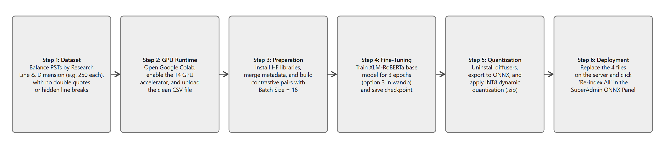
Before running the first line of code at https://colab.research.google.com/, complete these two setup actions in the Google Colab interface:
• Preliminary Action: In Google Colab's top menu bar, open Runtime > Change runtime type, and under 'Hardware accelerator' select T4 GPU. Never train in CPU mode.
• Preliminary Action B: In Colab's left sidebar, click the folder icon (Files), click the upload file button, and select your clean dataset.
With the GPU enabled and the CSV file uploaded to Colab's root directory, create and run the following 6 Python code cells in order:
• Cell 1: Install Hugging Face, Sentence-Transformers, and Optimum ONNX Libraries: Downloads the training ecosystem and the ONNX exporter. Important note: If at the end of this cell Colab displays red lines warning about version conflicts with packages named gradio or diffusers, ignore them completely; those are pre-installed image-generation libraries bundled in Colab that play no part in our text training pipeline.
!pip install -q transformers datasets sentence-transformers optimum[onnxruntime] accelerate
• Cell 2: Load the Dataset with Pandas and Build the Unified Semantic Block: Reads the CSV file, clears any potential null values, and concatenates the six descriptive columns (linea_investigacion, dimension_operativa, titulo, resumen, palabras_clave, and objetivo_general) to verify record integrity.
import pandas as pd
from datasets import Dataset

# 1. Read the clean and balanced dataset
df = pd.read_csv('Dataset_RD_1000_Comillas_Simples.csv')

# 2. Ensure there are no empty values and build the complete semantic block
df = df.fillna('')
df['texto_entrenamiento'] = (
"Línea: " + df['linea_investigacion'] + " - " + df['dimension_operativa'] + " \n "
"Título: " + df['titulo'] + " \n "
"Resumen: " + df['resumen'] + " \n "
"Palabras Clave: " + df['palabras_clave'] + " \n "
"Objetivo: " + df['objetivo_general']
)

# 3. Convert to Hugging Face Dataset format
dataset_hf = Dataset.from_pandas(df[['texto_entrenamiento']])
print(f"Dataset loaded successfully with {len(dataset_hf)} projects ready for training.")
• Cell 3: Download the Base XLM-RoBERTa Model and Build Contrastive Pairs: Downloads the foundational sentence-transformers/paraphrase-multilingual-MiniLM-L12-v2 model from Hugging Face. Next, it builds contrastive learning pairs where the first element joins the Title and General Objective (simulating semantic search queries and research aims) and the second (positive) element joins the Abstract, Keywords, Research Line, and Operational Dimension. By grouping them into batches of 16 (batch_size=16) using the MultipleNegativesRankingLoss loss function, the neural network learns to pull projects sharing the same technical context closer together in 384-dimensional vector space while pushing projects from different lines apart. With 1,000 projects and a batch size of 16, each epoch consists of 63 steps.
from sentence_transformers import SentenceTransformer, InputExample, losses
from torch.utils.data import DataLoader

# Load the foundational multilingual MiniLM model (XLM-RoBERTa architecture)
nombre_modelo_base = 'sentence-transformers/paraphrase-multilingual-MiniLM-L12-v2'
modelo = SentenceTransformer(nombre_modelo_base)

# Prepare contrastive pairs (Anchor: Title + Objective | Positive: Abstract + Keywords + Research Line/Dimension)
ejemplos_entrenamiento = []
for _, fila in df.iterrows():
consulta_ancla = f"{fila['titulo']}. {fila['objetivo_general']}"
contexto_positivo = f"{fila['resumen']} Palabras clave: {fila['palabras_clave']}. ({fila['linea_investigacion']} - {fila['dimension_operativa']})"
ejemplos_entrenamiento.append(InputExample(texts=[consulta_ancla, contexto_positivo]))

# With 1,000 rows and batch_size=16, each epoch runs 63 steps (189 steps across 3 epochs)
cargador_datos = DataLoader(ejemplos_entrenamiento, batch_size=16, shuffle=True)

# Industry-standard loss function for semantic search and ranking
loss_train = losses.MultipleNegativesRankingLoss(model=modelo)
print("Base model and DataLoader configured successfully.")
• Cell 4: Run Fine-Tuning for 3 Epochs: Starts weight optimization on the T4 GPU and saves the resulting model to the temporary folder ./Nombre_del_modelo.
Note on Weights & Biases (wandb): At the top of the cell we set os.environ['WANDB_DISABLED'] = 'true' to prevent Colab from pausing execution to prompt for an external account; if in some environment an interactive prompt still appears asking 'wandb: Enter your choice:', simply type the number 3 (Don't visualize my results) and press Enter.
import os
import time

# Disable the external Weights & Biases assistant so training runs directly
os.environ["WANDB_DISABLED"] = "true"

print("Starting 'Neural Network' Fine-Tuning...")
inicio = time.time()

modelo.fit(
train_objectives=[(cargador_datos, loss_train)],
epochs=3,
warmup_steps=20,
show_progress_bar=True
)

fin = time.time()
print(f"Training completed in {round((fin - inicio) / 60, 2)} minutes!")

# Temporarily save the fine-tuned model in PyTorch format
ruta_guardado = "./ Red_Neuronal_Entrenada"
modelo.save(ruta_guardado)
print(f"Trained model saved to: {ruta_guardado}")
• Cell 5: Export to ONNX Format and Apply INT8 Dynamic Quantization: This is the most critical cell for keeping the CIIDI server lightweight and responsive. First, it silently uninstalls Colab's pre-installed diffusers package (preventing import clashes with huggingface_hub when loading Optimum), then converts the fine-tuned PyTorch model into an ONNX computation graph, and finally applies INT8 dynamic quantization (AutoQuantizationConfig.avx2). It also includes a native fallback block (Path B) in case Google Colab updates its internal library versions in the future.
# 1. Remove the pre-installed image library in Colab that causes an import conflict
!pip uninstall -y -q diffusers

import os
import shutil
import torch
from transformers import AutoTokenizer, AutoModel

ruta_guardado = "./ Red_Neuronal_Entrenada"
ruta_onnx = "./Red_Neuronal_onnx"
ruta_onnx_cuantizado = "./Red_Neuronal_Onnx_Quantized"

os.makedirs(ruta_onnx, exist_ok=True)
os.makedirs(ruta_onnx_cuantizado, exist_ok=True)

tokenizer = AutoTokenizer.from_pretrained(ruta_guardado)

try:
# Path A: Export and quantize with Optimum
from optimum.onnxruntime import ORTModelForFeatureExtraction, ORTQuantizer
from optimum.onnxruntime.configuration import AutoQuantizationConfig

print("Exporting to ONNX with Optimum...")
modelo_onnx = ORTModelForFeatureExtraction.from_pretrained(ruta_guardado, export=True)
modelo_onnx.save_pretrained(ruta_onnx)
tokenizer.save_pretrained(ruta_onnx)

print("Applying INT8 dynamic quantization...")
quantizer = ORTQuantizer.from_pretrained(modelo_onnx)
dqconfig = AutoQuantizationConfig.avx2(is_static=False, per_channel=False)
quantizer.quantize(save_dir=ruta_onnx_cuantizado, quantization_config=dqconfig)
tokenizer.save_pretrained(ruta_onnx_cuantizado)

except Exception as e:
# Path B (Native Fallback): Direct export with PyTorch + ONNX Runtime
print(f"Using direct native exporter ({e})...")
!pip install -q onnx onnxscript
from onnxruntime.quantization import quantize_dynamic, QuantType

modelo_pt = AutoModel.from_pretrained(ruta_guardado)
modelo_pt.eval()
modelo_pt.to("cpu")

entrada_dummy = tokenizer("Proyecto Socio Tecnológico UPTTMBI", return_tensors="pt")
archivo_onnx_base = os.path.join(ruta_onnx, "model.onnx")

torch.onnx.export(
modelo_pt,
(entrada_dummy["input_ids"], entrada_dummy["attention_mask"]),
archivo_onnx_base,
input_names=["input_ids", "attention_mask"],
output_names=["last_hidden_state", "pooler_output"],
dynamic_axes={
"input_ids": {0: "batch_size", 1: "sequence"},
"attention_mask": {0: "batch_size", 1: "sequence"},
"last_hidden_state": {0: "batch_size", 1: "sequence"}
},
opset_version=14
)
tokenizer.save_pretrained(ruta_onnx)

archivo_onnx_quant = os.path.join(ruta_onnx_cuantizado, "model_quantized.onnx")
quantize_dynamic(
model_input=archivo_onnx_base,
model_output=archivo_onnx_quant,
weight_type=QuantType.QUInt8
)
tokenizer.save_pretrained(ruta_onnx_cuantizado)

# Rename model_quantized.onnx to model.onnx for direct drop-in replacement in PHP
ruta_q_old = os.path.join(ruta_onnx_cuantizado, "model_quantized.onnx")
ruta_q_new = os.path.join(ruta_onnx_cuantizado, "model.onnx")
if os.path.exists(ruta_q_old):
shutil.move(ruta_q_old, ruta_q_new)

print(f"Export and quantization completed! Files ready in {ruta_onnx_cuantizado}")
• Cell 6: Package into a .ZIP Archive and Download to Your Computer: Compresses both the quantized folder (the one deployed to the CIIDI server) and the unquantized FP32 ONNX folder (for archival backup), then triggers the browser download.
import shutil
from google.colab import files

# Compress the quantized ONNX folder (Production) and the standard folder (Backup)
shutil.make_archive('Red_Neuronal _ONNX_Quantized', 'zip', ruta_onnx_cuantizado)
shutil.make_archive('Red_Neuronal_ONNX_FP32_Backup', 'zip', ruta_onnx)

# Download the quantized package ready for the CIIDI server
files.download('Red_Neuronal_ONNX_Quantized.zip')
7.5. Deploying the New Model in PHP, Cleaning Up Old Files, and Re-Indexing in the SuperAdmin Panel
Once Nombre_Modelo.zip finishes downloading to your computer, deploying this newly trained model into the CIIDI backend consists of three exact steps:
• Step 1: Extract the archive and navigate to the directory where the system stores the model binaries (for example, vendor/php-ai/rd-test/ or the directory configured in the RepositorioPST module). Copy and overwrite exactly these 4 files there: model.onnx (~116,154 KB, which already embeds all quantized weights), tokenizer.json (~16,683 KB, containing the 250,002 XLM-RoBERTa SentencePiece tokens), tokenizer_config.json (~2 KB), and special_tokens_map.json (~1 KB). If you find legacy files in that directory named model.onnx.data or vocab.txt (leftovers from the older English BERT-based model), delete them to free up nearly 89 MB of disk space.
• Step 2: Always remember that our current paraphrase-multilingual-MiniLM-L12-v2 model belongs to the XLM-RoBERTa family and NOT the classic BERT family. This has two direct implications in the PHP service that invokes OnnxRuntime\Model: first, tokenization reads the model.vocab array inside tokenizer.json, prepending the special character '▁' (U+2581) to the beginning of each word and wrapping the sequence between the <s> (ID 0) and </s> (ID 2) tokens; second, when calling $this->modelo->predict($entradas), you must pass only the two tensors ['input_ids' => [$ids], 'attention_mask' => [$mask]], never passing token_type_ids.
• Step 3: Replacing the model.onnx file in the folder updates the neural engine, but the 384-dimensional vectors already stored in PostgreSQL were computed with the previous model weights. Therefore, the mandatory final step after replacing the files is to sign in to the system with a SuperAdmin or Coordinator account, open the Neural Network ONNX Model Management Panel, and click the 'Re-index All' button (or 'Vectorize Pending Now'). This instructs the system to recalculate the vectors for every PST under the new mathematical coordinates. Finally, run a test query for the new Research Line in the 'Live Inference and Fidelity Simulator' within that same panel to verify that the Vector Precision Index, Intra-Line Coherence, and L2 Unit Norm indicators are all green.

