**CS5352 Advanced Operating Systems**

**Spring 2022**

**Final Exam (05/09/2022)**

**Instructor:** Dr. Tommy Dang

**Office:** EC 306C

**Email:** tommy.dang@ttu.edu

|  |
| --- |
| **Student Name: (Last, First)** |
| **Final Score: (Total: 100 points)** |

**General Instructions:**

* The maximum is 30 points, equivalent to 30% of your final score.
* There are **17** questions over 9 pages.
* This is an 80-minute close-book and close-note exam.
* Please explain your answer clearly and be concise. **Please show the steps how you obtain your result and make sure your handwriting is readable**.
* Good luck.

**Question 1:** ***(4 points)*** Suppose that processes have 60% of I/O wait of the total time, each of them needs 10 seconds to complete (including CPU and I/O times), and they start simultaneously. We have a **single** CPU.

1. Suppose that we have 2 processes. What is the CPU utilization in this case if they run in concurrently? How long will the last one take to complete these 2 processes in the best case, average case, and worst case? Assume that they perform different types of I/0 (no conflicts) *(2 points)*
2. How many processes can complete in 30 seconds in **the best case** if they run in parallel (assuming that there is no I/O conflicts)? Please draw your solution *(1 point)*

What is the CPU utilization in this case? *(1 point)*

1. How many processes can complete in 30 seconds in **the worst case** if they run in parallel (assuming that there is no I/O conflicts)? Please draw your solution *(1 point)*

What is the CPU utilization in this case?*(1 point)*

**Question 2:** ***(3 points)*** Cluster Computing

In a cluster center, we have 2 computing nodes and a master node which runs the scheduler. A user submits 6 jobs with the 80% I/O percentage. Each job requires 20s seconds to complete, including 10 seconds of CPU and 10 seconds of I/O time. The scheduler can decide how to split the jobs on 2 computing nodes:

1. 3 jobs per computing node
2. 4 jobs on the first computing node and 2 jobs on the second computing node
3. 5 jobs on the first computing node and 1 job on the second computing node

Please answer the following questions:

1. What is the average CPU utilization of the cluster in Case **A**?

How much time to complete all jobs?

1. What is the average CPU utilization of the cluster in Case **B**?

How much time to complete all jobs?

1. What is the average CPU utilization of the cluster in Case **C**?

How much time to complete all jobs?

**Question 3:** ***(2 points)***  Structured Peer-to-Peer Architectures

In a P2P network with 1,024 possible nodes, how many entries in the routing table (of each computer) if we are using Simple Routing vs. Chord Routing. Please explain your answers.

Why is not Chord Routing beneficial when the number of available nodes is small?

**Question 4:** ***(2 points)***  Structured Peer-to-Peer Architectures

Given the P2P network below. Using the Chord Routing, please show the routing table for:

* **Node 14**
* **Node 6**

The routing table should include Start, Interval, Successor, and IP address (for each row)

**Question 5: *(2 points)***

Given the following example, please draw and discuss steps in the Bully algorithm

**Question 6***:* ***(2 points)*** A computer provides each process with 64KB of address space divided into pages of 4KB. A particular program has a text size of 29 KB, a data size of 18 KB, and a stack size of 15KB bytes.

*Each page must contain either text, data, or stack, not a mixture of two or three of them.*

Please explain your answers.

1. Will this program fit in the address space? *(1 point)*
2. If the page size were 2KB, would it fit? *(1 point)*

**Question 7:** ***(2 points)*** In the following figure, we have the relation between virtual addresses and physical memory addresses given by page table.

1. What is the physical address of #91A2? *(1 point)*
2. What is the physical address of #E88C? *(1 point)*

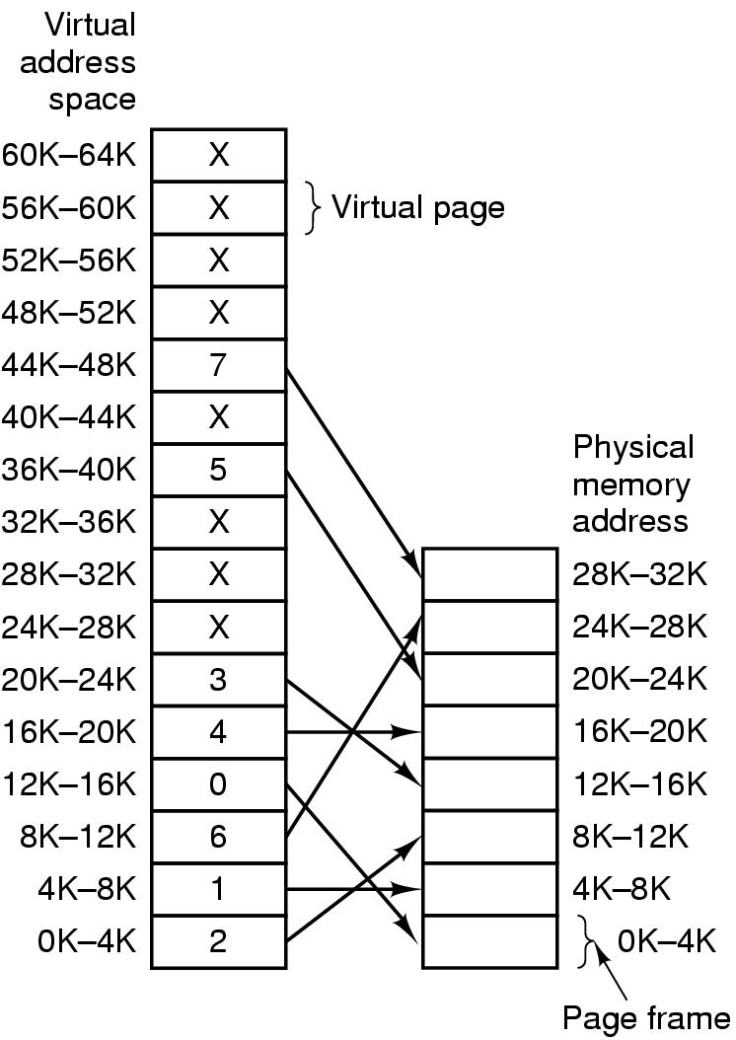

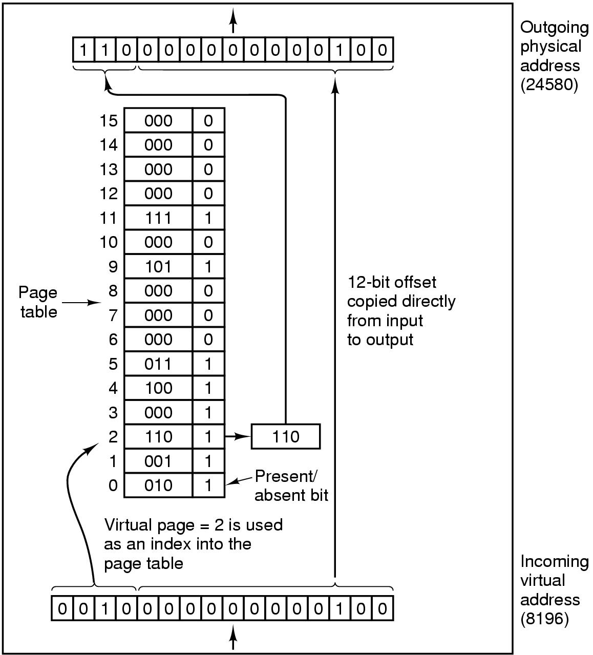

‘

**Question 8:** ***(3 points)*** Page replacement algorithms

Given the hardware implementation of Least Recent Used (LRU) for 6 pages: 0, 1, 2, 3, 4, and 5.

LRU using a matrix when pages are referenced in the order 0, 1, 2, 3, 4, 5, 0, 3, 2, 4 as shown below.

1. Please draw the matrix at each reference
2. Which page will be picked right after each reference? Please justify your answers.

**Question 9: *(2 points)***

Please discuss the basic differences between Cluster Computing, Grid Computing, and Cloud computing?

**Question 10:*****(1 point)***

What are Rowhammer attacks? Please discuss the ZebRAM solution?

**Question 11:*****(1 point)***

What are the 2 main objectives of Energy efficient scheduling of parallelizable jobs?

**Question 12:*****(1 point)***

What is the core idea of Weighted Latest Arrival Processors Sharing with Energy?

**Question 13:*****(1 point)***

How can the scheduler minimize energy consumption of Parallelizable Jobs?

**Question 14:*****(1 point)***

What are the differences between ginseng vs. existing OS?

**Question 15:*****(1 point)***

What is Q-bit? And Q bit presentation?

**Question 16:*****(1 point)***

Does Arachne implement user-thread level or kernel thread level? What are the advantages and disadvantages.

‘

**Question 17:*****(1 point)***

What is Noria? How can it improve the performance of read-heavy web applications?

----------------------------------------------- THE END ------------------------------------------------------