**Advanced Operating Systems Design – Spring 2022**

**Quiz 6 (04/07/2022)**

Student Name: ______________ (First Last)

Student R#: ______________

Score: _______________ (Total: 3%)

**Question 1:** (1%) Page replacement algorithms

Given the hardware implementation of Least Recent Used (LRU) for 4 pages: 0, 1, 2, and 3.

LRU using a matrix when pages are referenced in the order 0, 1, 2, 3, 2, 1, 0, 3, 2, 3 as shown below.

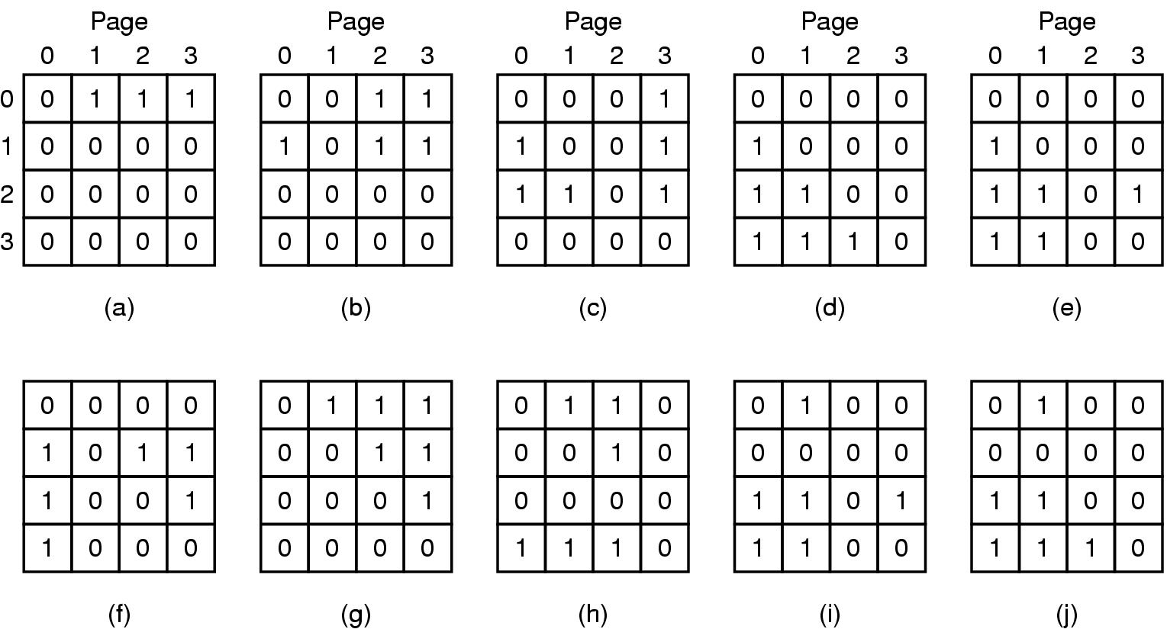

**The next reference is page 1.**

1. Please draw the matrix when page 1 is referenced
2. Assuming that we need to replace a page after page 1 is referenced, which page will be picked. Please explain your answer.

**Question 2:** (2%) Structured Peer-to-Peer Architectures

1. Please discuss the pros and cons of Simple Routing vs. Chord Routing. (1%)
2. In a P2P network with 2,048 possible nodes, How many entries in the routing table (of each computer) if we are using Simple Routing vs. Chord Routing. Please explain your answers. (1%)