**How to Install a Network Printer using EPAM** **Printers** **Installation** **Wizard**

**On Windows 7/8/10 OS**

1. Click the **Start** button , in the search bar type **Control Panel** - open the **Control Panel** - and then click **Get Programs**:
2. 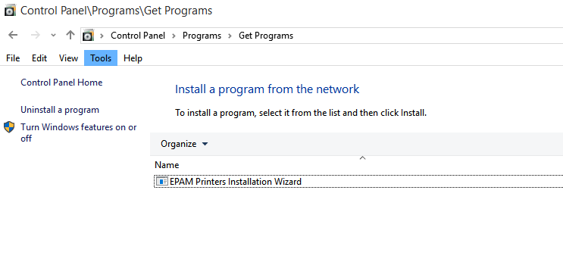Select the **EPAM Printers Installation Wizard** from the list, and then click **Install**.
3. Follow the instructions on your screen.
4. Administrator permission required If you're prompted for an administrator password or confirmation, type the password or provide confirmation.
5. The **EPAM Printers Installation Wizard** opens:

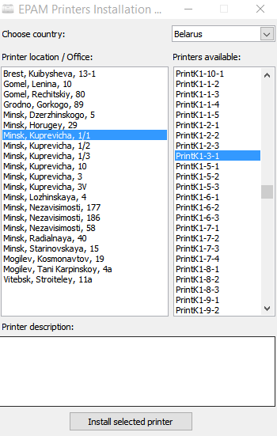

1. In the **Choose country** section select your country. In the **Printer location / Office** section select a location, and then select a printer in the **Printers available** section.
2. Click **Install selected printer** and wait while the printer is being installed.
3. Upon completion, the **Printers** folder will open. By default, the newly installed or updated common printer will be set as the default printer.

**On MAC OS**

1.   Select **System Preferences** from the Apple menu.

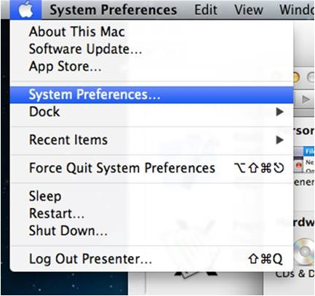

     2.   Double-click on **Print & Scan** **(Print & Fax).**

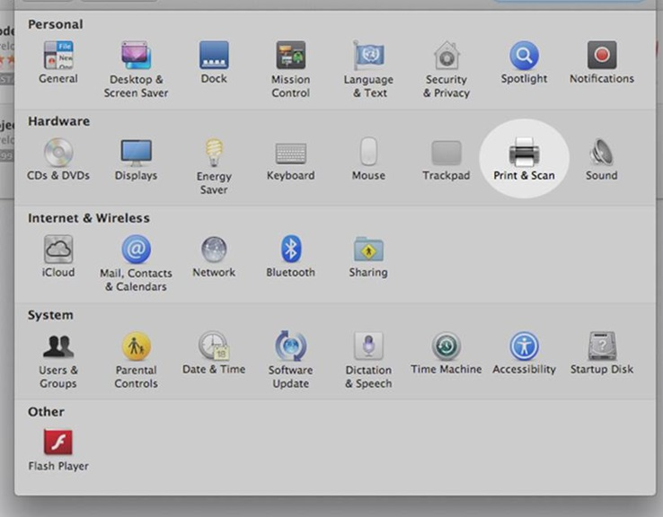

     3.   In the Print & Scan (Print & Fax) window, click on the **plus** sign button.

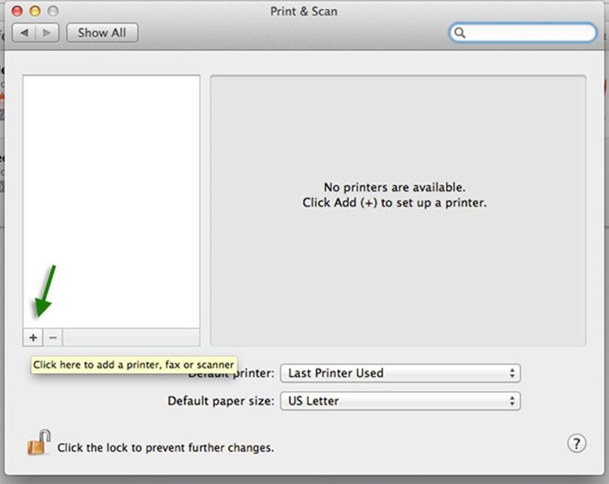

      4.   Click on the **IP** tab in the Print Browser window.

* Set **Protocol** to **HP Jetdirect - Socket**.
* For **Address**, *ask Local IT for help*.
* Leave the **Queue** field blank. The **Name** and **Location** fields are for your reference to keep track of your printers and differentiate between multiple ones.
* For **Print Using**, *do not select* **Generic Postscript Printer.** OS X will try to locate an appropriate driver but if it cannot then It is recommended to download the correct driver from the manufacturer.

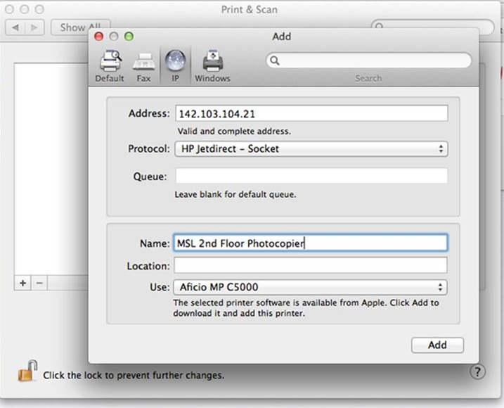

  5.     Click **Add**. The lab printer will be added to your list of printers.  
  
     