SCAPE FROM MON Project

Test Logs

Version 1.2

Contents

**Test Case 1: Switching Successfully Sound on 4**

**Test Case 2: Switching Successfully Sound off 5**

**Test Case 3: Switching Successfully Language Turkish 6**

**Test Case 4: Switching Successfully Language English 6**

**Test Case 5: Select Successfully Level 7**

**Test Case 6: Reach Successfully Game End 7**

**Test Case 7: The Level Unsuccessfully End 8**

**Revision History**

|  |  |  |  |
| --- | --- | --- | --- |
| **Date** | **Version** | **Description** | **Author** |
| 21/04/2022 | 1.0 | Draft 1 | SCAPE FROM MON |
| 29/04/2022 | 1.1 | Version 1.1 | SCAPE FROM MON |
| 20/05/2022 | 1.2 | Version 1.2 | SCAPE FROM MON |

# Change Settings Use Case Test Cases

# Test Case 1: Switching Successfully Sound on

*Screenshot-1*

*Screenshot-2*

# Test Case 2: Switching Successfully Sound off

*Screenshot -3*

# Detailed Logs: Switching Successfully Sound on or off

*Screenshot -4*

**Test Case 3: Switching Successfully Language Turkish**

**Test Case 4: Switching Successfully Language English**

From tht setting button. The language is changed Turkish to English and reverse direction.

*Screenshot -5*

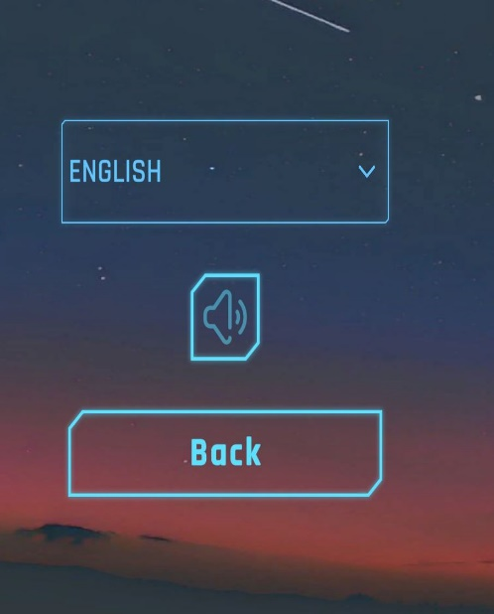

*Screenshot -6*

**Test Case 5: Select Successfully Level**

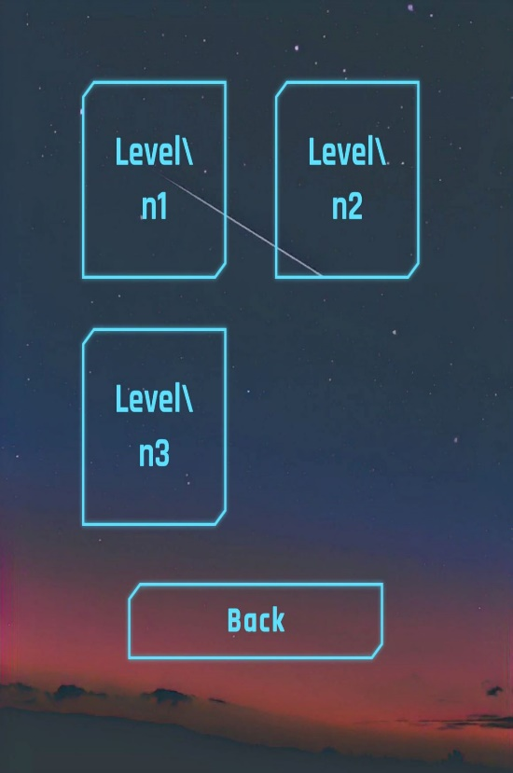

*Screenshot -7*

**Test Case 6: Reach Successfully Game End**

Incomplete task: The game shows a video about the journey of the space shuttle.

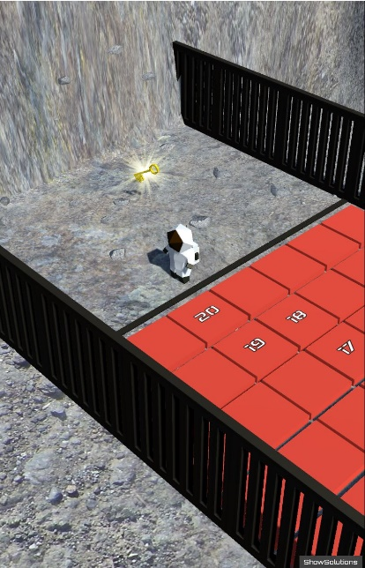 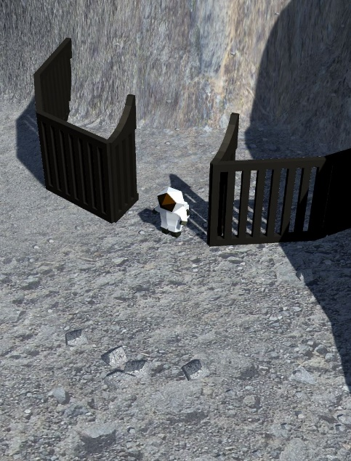

*Screenshot -8-9*

**Test Case 7: The Level Unsuccessfully End**

Fail Step: The player receives a failure message

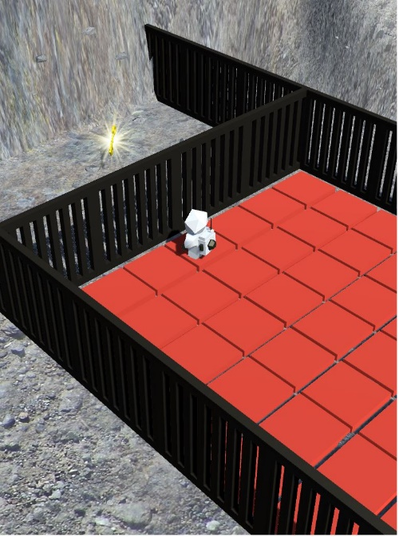*

*Screenshot -10 -11*

**General Bug: The astronaut can entry at the door without solving the puzzle.**

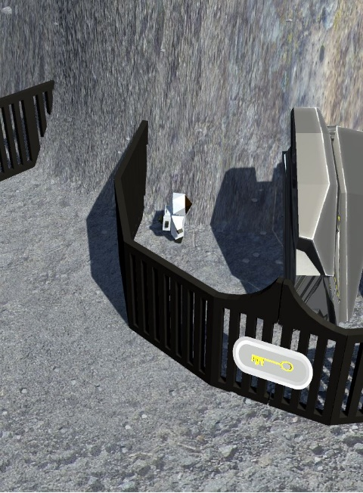

*Screenshot -12*