Effect of NSW Job Training on 1978 Earnings

1. Introduction
This note replicates the LaLonde NSW training evaluation to demonstrate the manuscript-assembly stage of the Paper-WorkFlow pipeline. The substantive question is whether participation in the National Supported Work demonstration raised earnings in 1978, and how sensitive the answer is to the control set.

2. Results
Column (1) of Table 2 regresses 1978 earnings on the training indicator with no controls and recovers a negative point estimate, which is the well-known consequence of comparing the treated sample to an observational comparison group that differs sharply in pre-treatment characteristics. Adding the full control set in column (2) reverses the sign: training is associated with 1548.244 dollars of additional 1978 earnings, significant at the 5 percent level. The estimation sample contains 614 observations throughout, so the movement between columns is driven entirely by the conditioning set rather than by a change in sample.
Table 2. Effect of NSW job training on 1978 earnings
 | (1) OLS (no controls) | (2) OLS (full controls) | (3) IV-2SLS
Intercept | 6984.170*** | -1174.130 | 295.630
 | (352.329) | (2540.349) | (3280.766)
Job training (NSW) | -635.026 | 1548.244** | -5955.471
 | (676.748) | (740.576) | (4072.115)
age |  | 12.978 | 65.533*
 |  | (31.704) | (36.238)
educ |  | 403.941** | 655.990***
 |  | (160.395) | (183.652)
married |  | 406.621 | 1354.891*
 |  | (658.549) | (796.593)
nodegree |  | 259.817 | 697.551
 |  | (891.786) | (1015.016)
re74 |  | 0.296***
 |  | (0.071)
re75 |  | 0.232*
 |  | (0.119)
race_hispan |  | 1739.541* | -1025.507
 |  | (1023.763) | (2129.765)
race_white |  | 1240.644* | -2299.665
 |  | (695.766) | (2284.319)
First-stage F |  |  | 14.21
Hansen J p-value |  |  | 0.029
N | 614 | 614 | 614
R^2 | 0.002 | 0.148 | -0.047
DV mean
First-stage F
Standard errors in parentheses
*** p<0.01, ** p<0.05, * p<0.10
The instrumental-variables specification in column (3) is reported for completeness rather than as a preferred estimate: its first-stage F statistic of 14.21 sits close to conventional weak-instrument thresholds and the Hansen J p-value of 0.029 rejects the overidentifying restrictions, so the column is not evidence for a causal claim and is not read as one here.
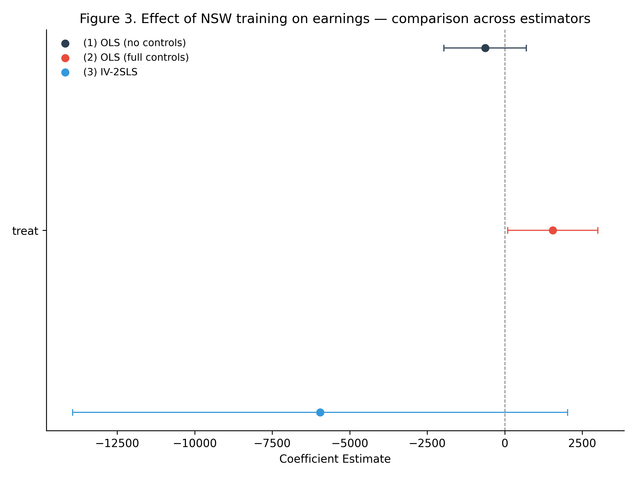
Figure 1. Coefficient estimates across specifications
Figure 1 plots the treatment coefficient across specifications and makes the sensitivity visible directly: the estimate is not stable enough across control sets for this design to support an unqualified causal reading, which is the honest conclusion the exhibits actually license.

3. Conclusion
The exercise reproduces the standard LaLonde teaching result and, more to the point here, produces a single Word file that contains the prose, the table, the figure and the reference list together, with every printed number traceable to a committed analysis artifact.

参考文献 / References
Dehejia, Rajeev H., Wahba, Sadek (1999). Causal Effects in Nonexperimental Studies. Journal of the American Statistical Association, 94, 1053–1062.
LaLonde, Robert J. (1986). Evaluating the Econometric Evaluations of Training Programs with Experimental Data. American Economic Review, 76, 604–620.

