Python实验报告13

学号：117060400212 姓名：张佳奇 班级：应用统计学2班

指导老师:林卫中

实验题目1：

算法实现：

from random import random

def printIntro():

print("这个程序模拟两个选手A和B的某种竞技比赛")

print("程序运行需要A和B的能力值（以0到1之间的小数表示）")

def getInputs():

a = eval(input("请输入选手A的能力值(0-1): "))

b = eval(input("请输入选手B的能力值(0-1): "))

n = eval(input("模拟比赛的场次: "))

return a, b, n

def simNGames(n, probA, probB):

winsA, winsB = 0, 0

for i in range(n):

scoreA, scoreB = simOneGame(probA, probB)

if scoreA > scoreB:

winsA += 1

else:

winsB += 1

return winsA, winsB

def gameOver(a,b):

return a==11 or b==11

def simOneGame(probA, probB):

scoreA, scoreB = 0, 0

serving = 0 #表示A发球

t =0

while not gameOver(scoreA, scoreB):

if serving == 0:

if random() < probA:

scoreA += 1

else:

scoreB += 1 #否则就给B加一分

else:

if random() < probB:

scoreB += 1

else:

scoreA += 1 #否则就给A加一分

t=t+1

if t%2 ==0:

serving = (serving\*1)%2

return scoreA, scoreB

def printSummary(winsA, winsB):

n = winsA + winsB

print("竞技分析开始，共模拟{}场比赛".format(n))

print("选手A获胜{}场比赛，占比{:0.1%}".format(winsA, winsA/n))

print("选手B获胜{}场比赛，占比{:0.1%}".format(winsB, winsB/n))

def main():

printIntro()

probA, probB, n = getInputs()

winsA, winsB = simNGames(n, probA, probB)

printSummary(winsA, winsB)

main()

实验结果：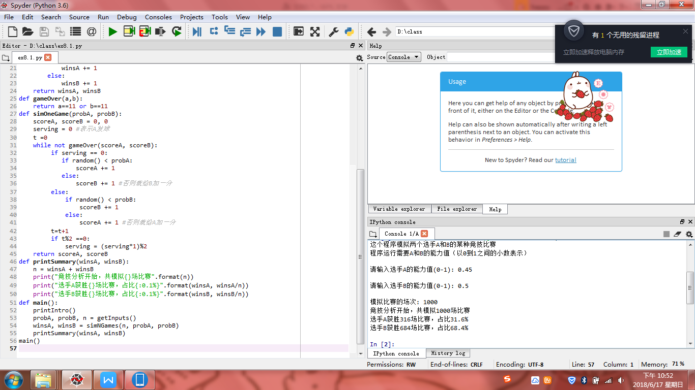

实验题目2：

算法实现：

from random import random

def printIntro():

print("这个程序模拟两个选手A和B的某种竞技比赛")

print("程序运行需要A和B的能力值（以0到1之间的小数表示）")

def getInputs():

a = eval(input("请输入选手A的能力值(0-1): "))

b = eval(input("请输入选手B的能力值(0-1): "))

n = eval(input("模拟比赛的场次: "))

return a, b, n

def simNGames(n, probA, probB):

winsA, winsB = 0, 0

for i in range(n):

scoreA, scoreB = simOneGame(probA, probB)

if scoreA > scoreB:

winsA += 1

else:

winsB += 1

return winsA, winsB

def gameOver(a,b):

return a==21 or b==21

def simOneGame(probA, probB):

scoreA, scoreB = 0, 0

serving = 0 #表示A发球

t =0

while not gameOver(scoreA, scoreB):

if serving == 0:

if random() < probA:

scoreA += 1

else:

scoreB += 1 #否则就给B加一分

else:

if random() < probB:

scoreB += 1

else:

scoreA += 1 #否则就给A加一分

t=t+1

if t%5 ==0:

serving = (serving\*1)%5

return scoreA, scoreB

def printSummary(winsA, winsB):

n = winsA + winsB

print("竞技分析开始，共模拟{}场比赛".format(n))

print("选手A获胜{}场比赛，占比{:0.1%}".format(winsA, winsA/n))

print("选手B获胜{}场比赛，占比{:0.1%}".format(winsB, winsB/n))

def main():

printIntro()

probA, probB, n = getInputs()

winsA, winsB = simNGames(n, probA, probB)

printSummary(winsA, winsB)

main()

实验结果：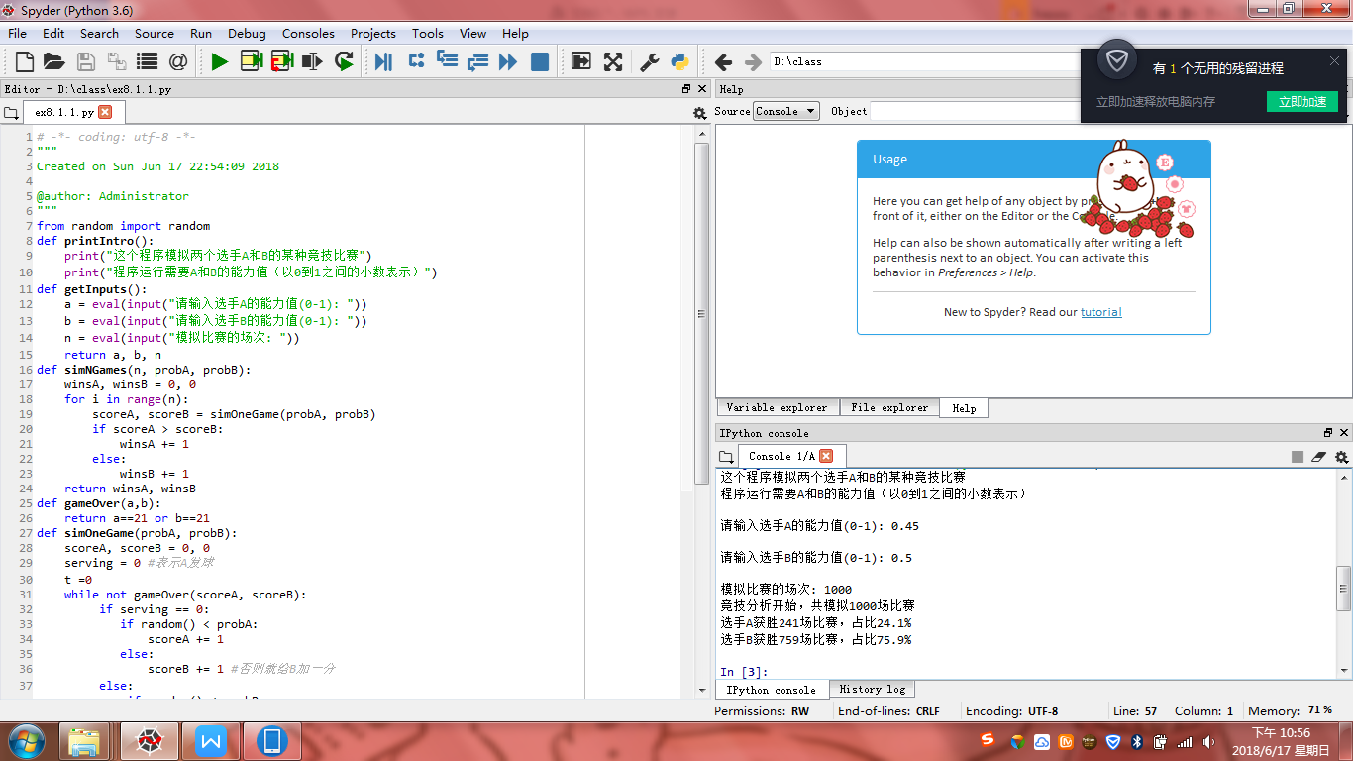

实验题目3：

算法实现：

from random import random

def printIntro():

print("这个程序模拟两个选手A和B的某种竞技比赛")

print("程序运行需要A和B的能力值（以0到1之间的小数表示）")

def getInputs():

a = eval(input("请输入选手A的能力值(0-1): "))

b = eval(input("请输入选手B的能力值(0-1): "))

n = eval(input("模拟比赛的场次: "))

return a, b, n

def simNGames(n, probA, probB):

winsA, winsB = 0, 0

for i in range(n):

scoreA, scoreB = simOneGame(probA, probB)

if scoreA > scoreB:

winsA += 1

else:

winsB += 1

return winsA, winsB

def gameOver(a,b):

if (a==11 and b<=9) or (b==11 and a<=9):

return True

elif (30>a>=10 and a-b==2) or (30>b>=10 and b-a==2):

return True

elif a==30 or b==30:

return True

return False

def simOneGame(probA, probB):

scoreA, scoreB = 0, 0

serving = 0 #表示A发球

t =0

while not gameOver(scoreA, scoreB):

if serving == 0:

if random() < probA:

scoreA += 1

else:

scoreB += 1 #否则就给B加一分

else:

if random() < probB:

scoreB += 1

else:

scoreA += 1 #否则就给A加一分

t=t+1

if t%2 ==0:

serving = (serving\*1)%2

return scoreA, scoreB

def printSummary(winsA, winsB):

n = winsA + winsB

print("竞技分析开始，共模拟{}场比赛".format(n))

print("选手A获胜{}场比赛，占比{:0.1%}".format(winsA, winsA/n))

print("选手B获胜{}场比赛，占比{:0.1%}".format(winsB, winsB/n))

def main():

printIntro()

probA, probB, n = getInputs()

winsA, winsB = simNGames(n, probA, probB)

printSummary(winsA, winsB)

main()

实验结果：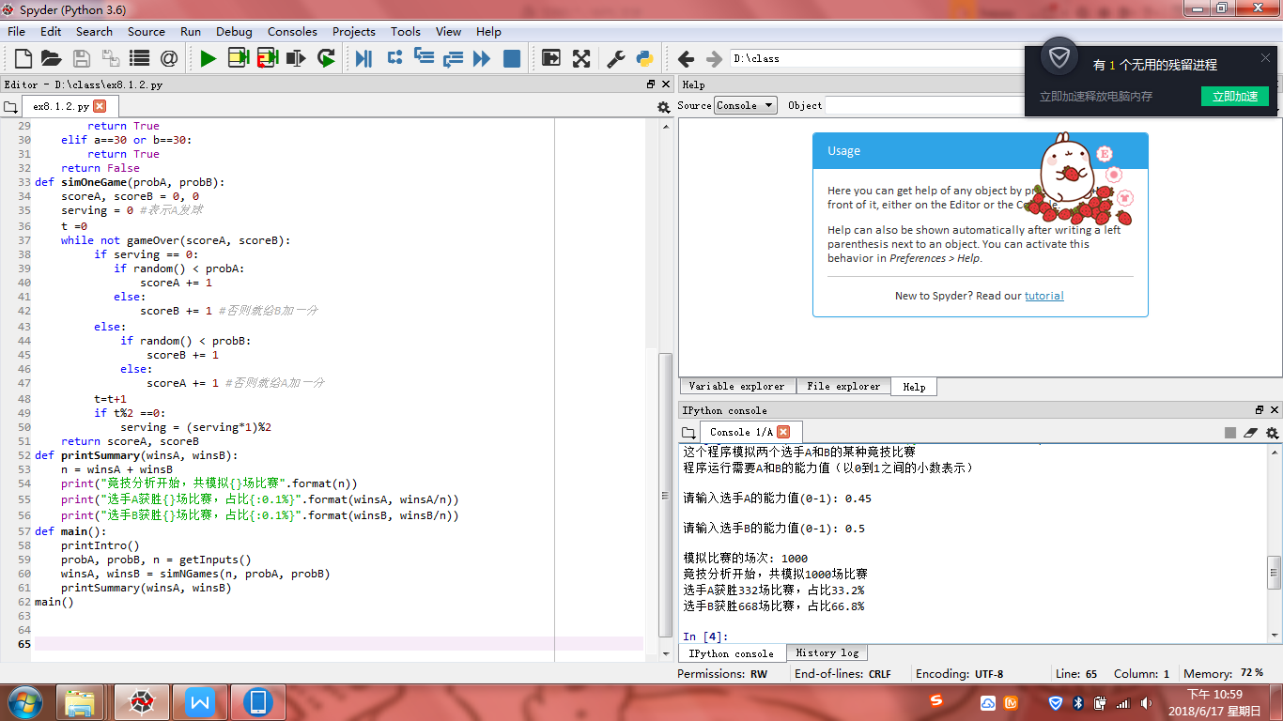

实验题目4：

算法实现：

from random import random

from random import randint

def printIntro():

print("这个程序模拟两个选手A和B的某种竞技比赛")

print("程序运行需要A和B的能力值（以0到1之间的小数表示）")

def getInputs():

a = eval(input("请输入A队投篮能力(0-1): "))

b = eval(input("请输入B队投篮能力(0-1): "))

c = eval(input("请输入A队抢篮板能力(0-1):"))

d = eval(input("请输入B队抢篮板能力(0-1):"))

n = eval(input("模拟比赛的场次: "))

return a, b, c, d, n

def simNGames(n, probA, probB, boardA, boardB):

winsA, winsB = 0, 0

for i in range(n):

scoreA, scoreB = simOneGame(probA, probB,boardA, boardB)

if scoreA > scoreB:

winsA += 1

else:

winsB += 1

return winsA, winsB

def gameOver(t):

return t>=12\*60

def simOneGame(probA, probB, boardA, boardB):

scoreA, scoreB = 0, 0

serving = 0 #表示A发球

totalTime =0

while not gameOver(totalTime):

t = randint(1,24)

totalTime += t

if t == 24:

serving = (serving + 1) %2

else:

if serving == 0:

if random() < probA:

scoreA += 1

serving = 1

else:

if random() < boardA:

serving = 0

else:

serving = 1

else:

if random() < probB:

scoreB += 1

serving = 0

else:

if random() < boardB:

serving = 1

else:

serving = 0

return scoreA, scoreB

def printSummary(winsA, winsB):

n = winsA + winsB

print("竞技分析开始，共模拟{}场比赛".format(n))

print("选手A获胜{}场比赛，占比{:0.1%}".format(winsA, winsA/n))

print("选手B获胜{}场比赛，占比{:0.1%}".format(winsB, winsB/n))

def main():

printIntro()

probA, probB,boardA, boardB, n = getInputs()

winsA, winsB = simNGames(n, probA, probB, boardA, boardB)

printSummary(winsA, winsB)

main()

实验结果：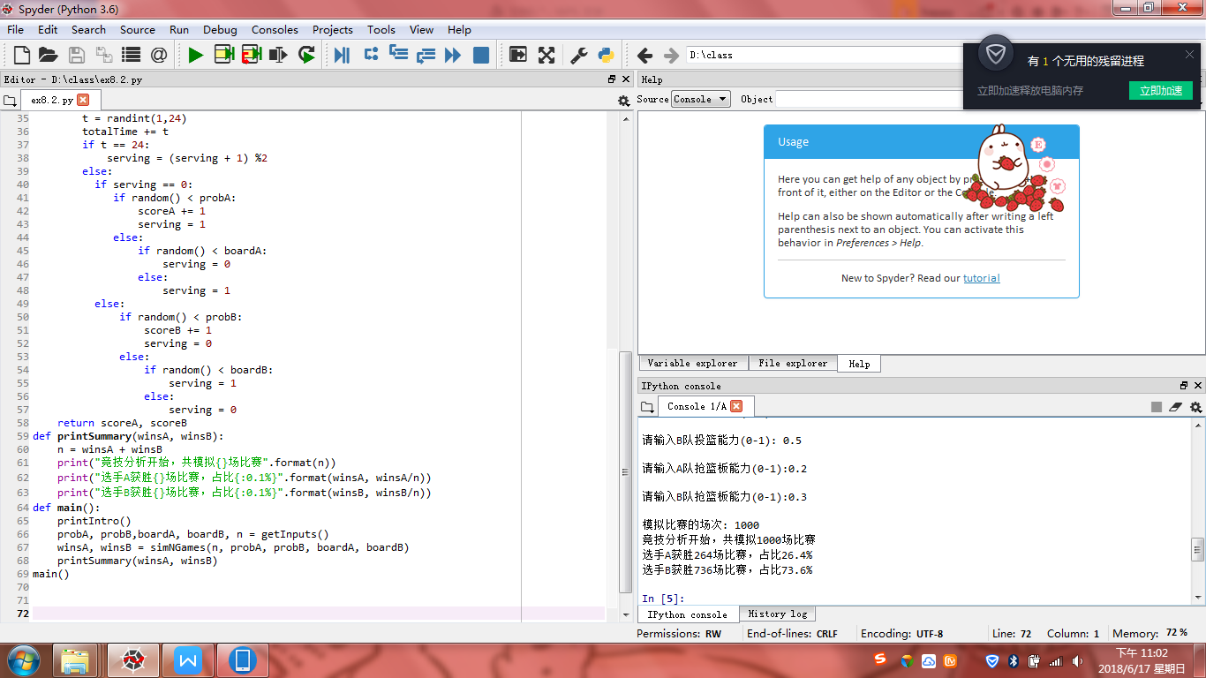

小结：这周做的类型题比较多，就熟能生巧。最后的实验8.4因为没有文件就只能下一次补上了。下次再好好做吧。要考试了，但是老师发的题还是不会做。有点烦，还要加油呢！！