HomeWork2:

1.Derivation of optimal w for a binary SVM

2.Derivation of optimal w's for a3-layer MLP

3.Define a loss-function for SVM

第1.2題

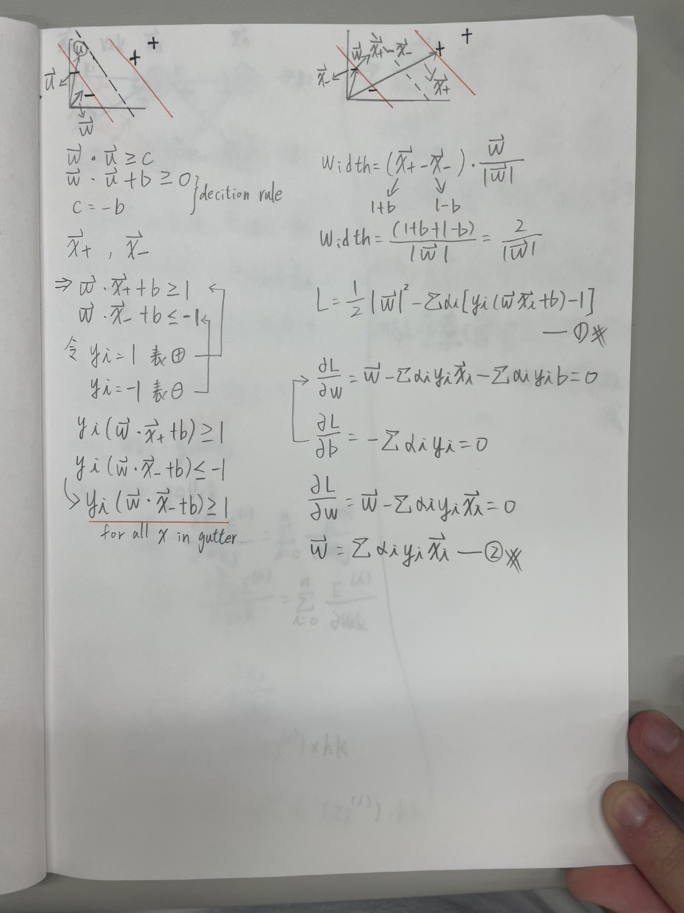

第3題

