**Answer：**

E1. uname -sv

E2. echo $HOME

E3. whoami

E4. chmod +x 1.sh

E5. du -d 1 -h

E6. ssh oyel@10.19.248.12

E7. sudo apt-get install jq

E8. pwd

E9. vim 1.sh (and then type the content)

E10. mv 1.sh 2.sh

E11. mkdir folder1

E12. cp 3.sh folder1/3.sh

E13. cat 2.sh > 3.sh

E14. cat -n file1 > file2

E15. ls -a

E16. find . -ctime -10

E17. chomd -R 777 dir

E18. kill -9 12345

N1. cat /etc/hosts | head -n 10 | tail -n 5

N2. copy -p 1.sh ~

N3. [ ! -x  /etc/profile ] && echo "No x mode"

N4. grep -A 1 -B 1 “url” commits.json

N5. du -s * | sort -nr | head -n 3

H1. echo {a..c}{a..c}

H2. ls -l | awk ‘{print $1”\t”$2}’ | grep -v total

H3. cat input.txt | tr ‘A-Z’ ‘a-z’ >> output.txt

或者

tr '[:upper:]' '[:lower:]' < input.txt > output.txt

H4.

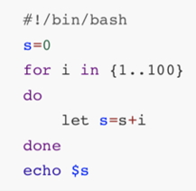

H5.

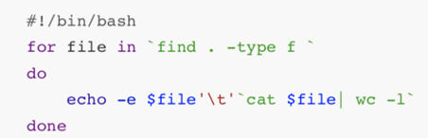

H6.

#!/bin/bash

UserNum=`who |wc -l`

if [ $UserNum -gt 3 ] ; then

echo "Alert , too many login users ( Total: $UserNum )."

else

echo "Login users:"

who | awk '{print $1,$2}'

fi