Contents

1. Installation guideline 1

a. Set up 1

b. Login/logout 1

c. Create a mission 2

d. View existing mission 4

e. Edit mission 4

f. Selecting a space shuttle 6

g. Create selection criteria 8

h. Edit selection criteria 9

i. Find best candidates 10

2. Troubleshooting 10

## Installation guideline

### Set up

To install the Mission to Mars system, you need to have IntelliJ IDEA and JAVA 11 in your computer. Once you set up the java environment in your PC, you need to open the project in your IDE. Then click the RUN button to run the system.

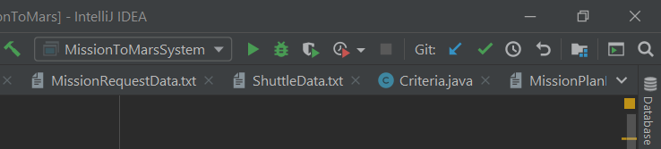

### Login/logout

The first screen provides you two options. One is sign up, the other one is login. Sign up is not our requirement. Therefore, we press enter 2 to go to login screen.

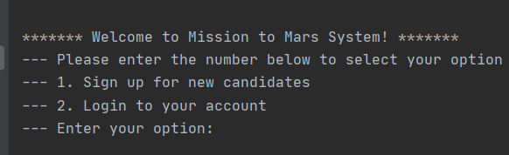

For mission coordinator, the username is Michael and the password is 123. For administrator, the username is Haoran Zhang and the password is 123.

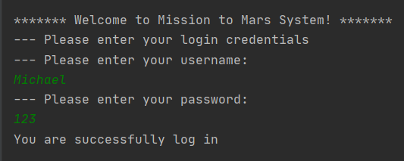

After mission coordinators login, they will see the mission coordinator home screen. If they want to logout, they can enter option 4 to logout the system.

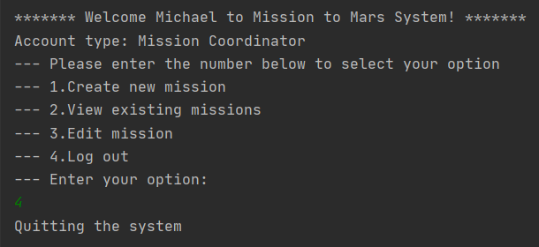

Once administrators login the system, they will see the different home screen which include more option. Similarly, administrators can enter option 7 to logout.

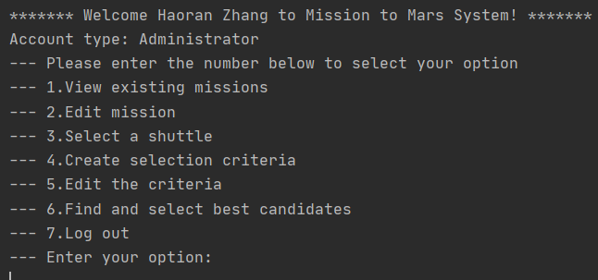

### Create a mission

Once users want to create a mission, they will fill in the attributes of the mission request step by step.

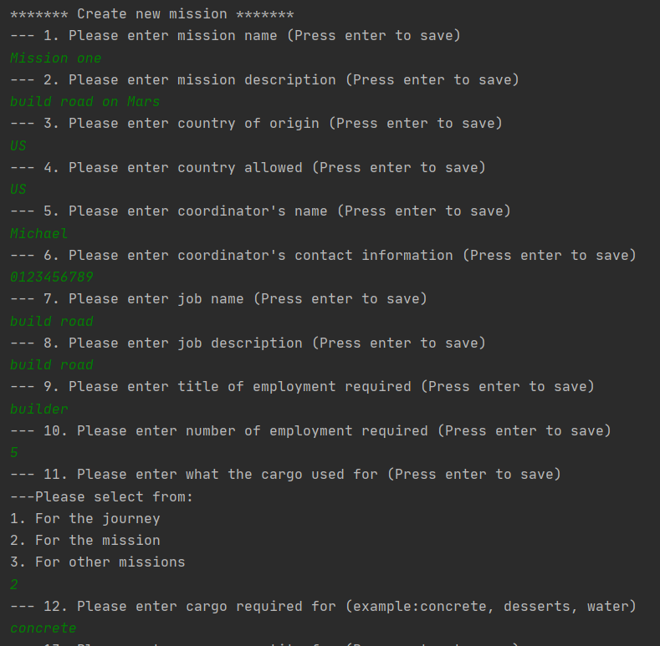

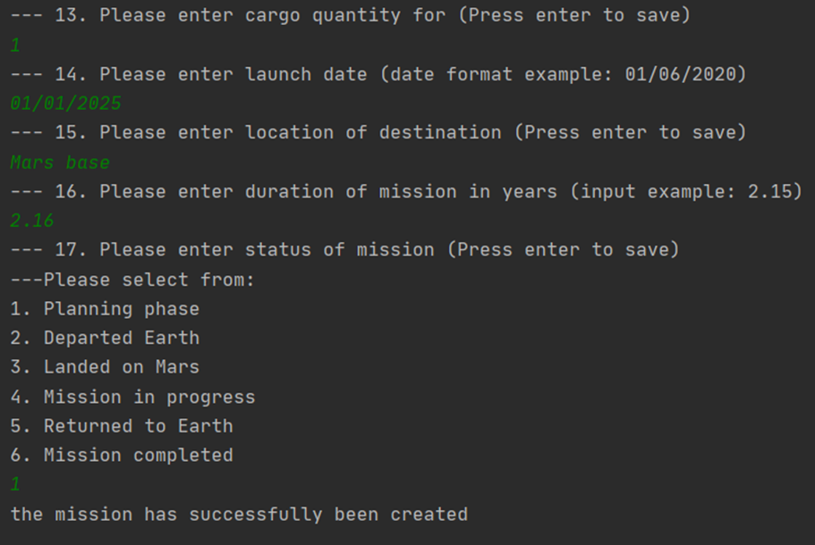

### View existing mission

Once the mission has been created, users can view the existing mission. They can choose the mission that they want to view in the mission list.

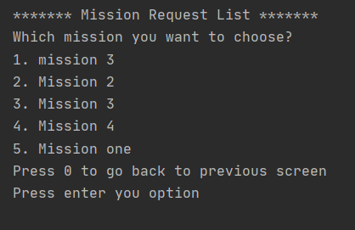

### Edit mission

Once users want edit the mission, they can choose a mission that they want to view in the mission list.

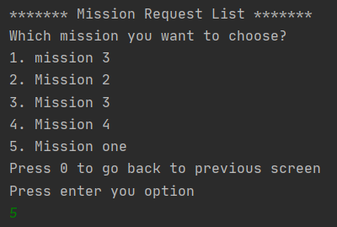

Then, the mission detail will be displayed. Users can choose one of the attribute to modify its data.

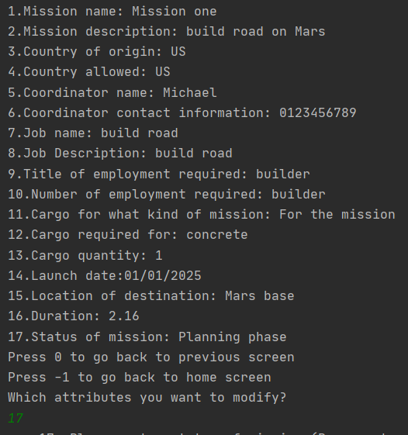

For example, users enter option 17 and change the mission status to Mission completed.

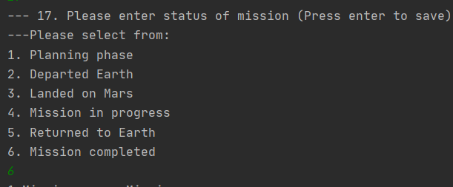

If they view the mission detail again, they will found the mission status has been changed.

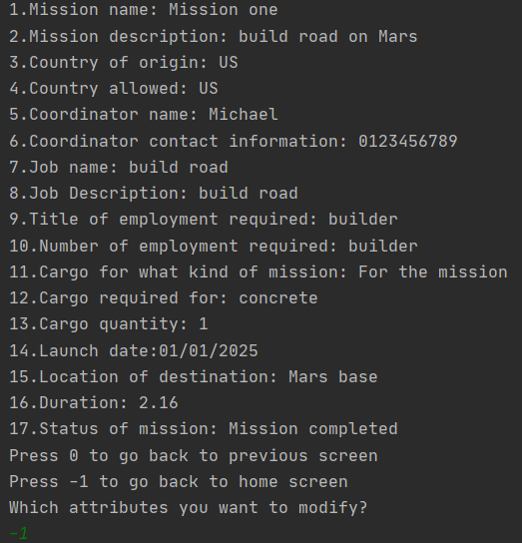

So far, all the action that mission coordinator can take has been traduced.

### Selecting a space shuttle

Once administrators want to select a shuttle for a mission, they can select from the mission list. Then the shuttle list will be displayed to ask administrator to select a shuttle.

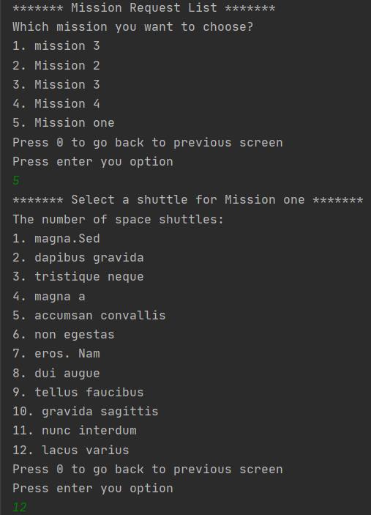

Once the shuttle has been selected, the shuttle details will be displayed. Administrator can enter -1 to confirm the selection.

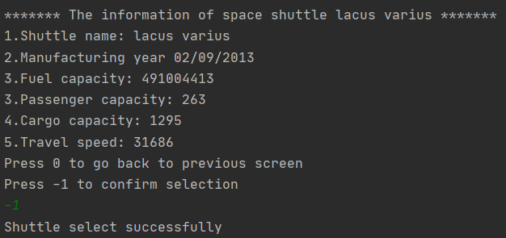

Once the shuttle selection has been successful, the mission details and associated shuttle details will be displayed.

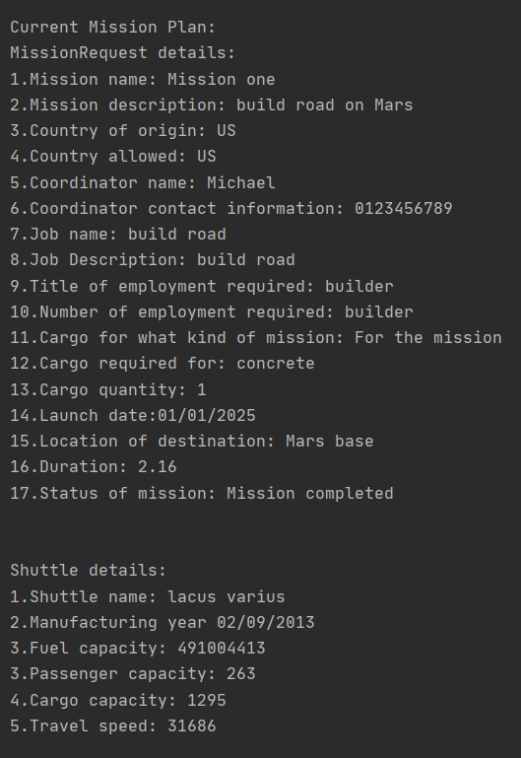

### Create selection criteria

Once users want to create a selection criterion, they can choose a mission from mission list. Then they can select a job title which need to create criteria for. After that, users need to fill the data of each attributes step by step.

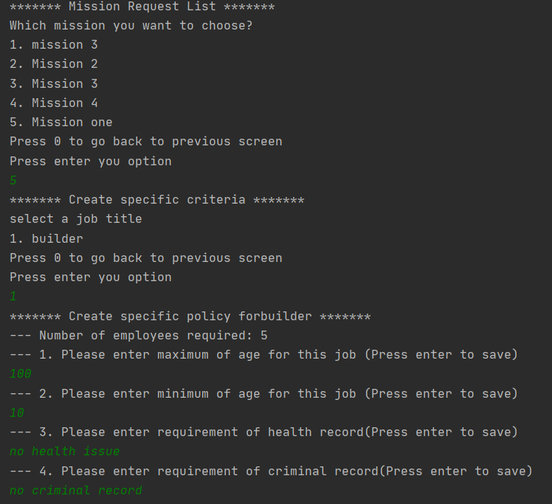

Once the criteria has been created, users can see the mission with associated shuttle and criteria.

### Edit selection criteria

Once users want to edit selection criteria, they can select a mission from mission list and choose a job title. Then they can select which attribute they want to modify and enter the data for that attribute.

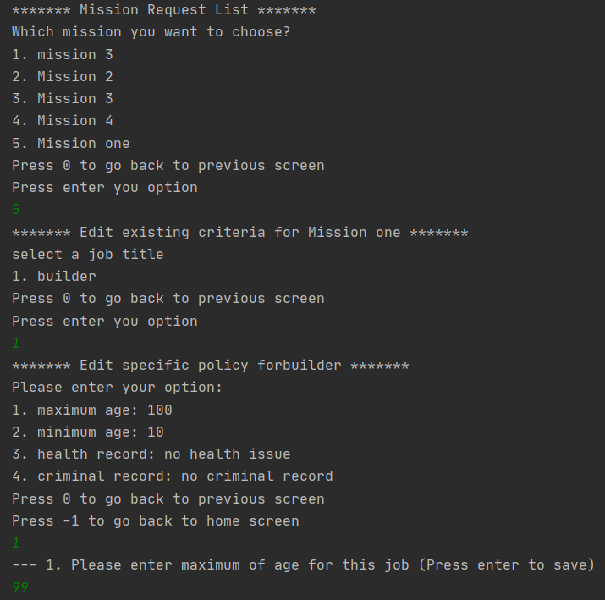

### Find best candidates

Once user want to find candidate who match the criteria, they can enter the number of candidate that they want to find. The system will find the best matching candidate for specified number.

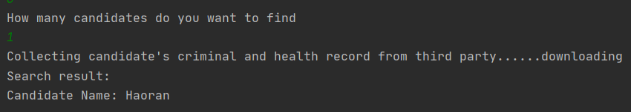

## Troubleshooting

No error found