1. Phone interview (30mins most)
   1. Common questions:
      1. What is your current situation?

My name is Haoran Zhang.

I am a passionate software developer. I finished my IT bachelor and master’s degree in software development at Monash. Currently, I am working as a software developer in an e-learning company called A I English. My duty is mainly focusing on developing an enterprise resource planning system with JavaScript. My tech stack includes React as frontend and Node.js as backend. I can write uniting testing to ensure code quality and use AWS to deploy services. I usually use GitHub Pipeline to automate the CICD process. Totally, I have 2-year coding experience in software development.

I am an efficient team player. I currently working in a 10 people’s scrum team with UI designer, Business analyst and Devops. I am one of 4 major full-stack developer. We have 2 weeks per scrum. Every scrum we have daily stand up, retrospective and refinement. I like to get involved in the discussion and contribute my idea to the project team.

I can adapt to multicultural environment. My colleague comes from different cultural background. I like to chat with them and enjoy their traditional food. I respect all kinds of people with different backgrounds.

Tony总您好，我叫张浩然。本科和硕士毕业于monash大学IT系。我现在一家向东亚学生提供在线直播教学的公司做software developer。我所在的项目组隶属于IT部，现在有10个人包括UI设计，BA还有develops。我在里面的角色是全栈开发，主要负责企业管理系统的开发，维护和部署。技术方面前端运用的是React, 框架是Ant design Pro，后端运用的是node.js框架运用Express，架构上运用的是microservices, 我会用JEST写单元测试，运用的是AWS实现部署，我会运用Github pipeline实现自动化集成和部署。目前项目组运用的是敏捷开发流程，每两周一个迭代，我们在refinement meeting上确定需求，在retrospective meeting进行每个迭代的自我反思和自我提升，在每日站会上汇报昨天做了什么，今天要做什么，遇到了啥问题。目前我所在的公司是多元文化环境，所以我自己本身可以尊重来个各个文化背景的同事，并和他们友好交流。

对于这次在yephome申请全栈开发岗位，最吸引我的地方一个是该职位符合我的技术栈，能够发挥我得技能。其次我知道yephome是澳洲太平洋投资集团旗下的注重于新房交易的平台。该平台把房产交易和科技相结合，例如运用VR看房和加密货币支付，理念非常新颖和吸引人。我对此抱有浓厚的兴趣。

* + 1. Why are you looking for a job?

I have been working at my current company for almost one year now and have got a great amount of experience in software development. A few months ago, I got promoted and directly report to CTO and undertake his important mission such as research and develop our company core products. At this point in my career, I have skills to go beyond the duties of my current role. I’m looking for an opportunity where I can put my skills to work for a mission that I am passionate about and take on more responsibility.

我找工作的原因是从职业发展的角度来的，基于我现阶段积累的技能和经验，我希望能够找到一家可以发挥自己技能然后自己也感兴趣的平台从事全职的全栈开发工作。

* + 1. What kind of job are you looking?

Currently, I am looking for software developer position from junior level to mid-level. Work mode can be onsite or remote. The tech stack use React as frontend and use node.js as backend would be better. If tech stack doesn’t match, it’s ok. I am a quicker learner based on my coding experience. Full-time + 70k + 10% super

* + 1. What’s your plan?

For my career plan, I want to become mid level developer within 3 years. I have been refining my technical skills during the work and also in my leisure time. I usually have side project in GitHub to practice my skills which can make me approach my goal.

* + 1. Have you heard about our company?

Yes, I have. XXX is a XXX company.

* + 1. Why did you apply this role?

The most attractive part of this role is that the candidate should have ability to adapt and learn new tech. it suits me perfectly. I like to accept new challenge and improve myself. When I was joining my current company, I never use Ant design Pro as frontend technology before. But after several days self-learning with my side project, I gradually know how to use it and make contribution to our project team.

* + 1. What is your achievement?

From career aspect, I got promoted by CTO and directly report to him. At the beginning, I was working in the software development team with my team leader and other developers. One day, CTO told me he thinks I am a hard-working and proactive person and should directly report to him and under his important mission. Then I started to take his extra requirements and work for researching and developing our company’s core products.

From technical aspect, I successfully developed a highly reliable ERP system called AI system to automate company’s daily business and save the operation staff precious time.

* + 1. What is your strength?

The role matches my tech stack. Since your product is built with React, my strong JS and React skills are going to pickup the development quickly with high quality. I worked as a software developer for last company for almost a year. My experience can save company’s precious time to train a new employee.

* + 1. What is your weakness?

I love technologies. There are plenty of techs that I really need to enhance such as Java as backend technology. I am planning to self-learn Java and Spring boot in next 3 months. I would like to start my side project right now and learn from practice

* + 1. Tell me about your experiences on your resume

First, I would introduce my current role in AI English as software developer. I currently working in a 10 people’s scrum team with UI designer, Business analyst and Devops. I am one of 4 major full-stack developer. We have 2 weeks per scrum. Every scrum we have daily stand up, retrospective and refinement. I like to get involved in the discussion and contribute my idea to the project team. My duty is mainly focusing on developing an enterprise resource planning system with JavaScript. I use React as frontend and Node.js as backend. I write uniting testing and use AWS to deploy services. I usually use GitHub Pipeline to automate the CICD process. From the system architectures, we use microservices and RESTful APIs.

We developed the highly reliable ERP system called AI system to automate daily business for operations staff and their precious time. The value that the product bring to company is remarkable. Before they use our system, they only can manually schedule class only one day early. But now the system will automate class scheduling for them. Also, the class network monitor will provide the operations staff a emergency alert if the class network is unstable and let them take action in time. The system improves the class quality that our company delivered and make our client satisfied.

* + 1. Tell me about your qualifications

Skill match JD

* + 1. What questions do you have for me?

What is the tech stack of current project team?

What are they currently working on?

I want to know this role belongs to which department?

What’s importance of this department in your organization?

1. Technical interview (60mins)
   1. HTML:
      1. Describe the difference between a cookie, session storage and local storage

Cookies store a small amount of data that was sent to server with request and expiration can be manually set from client or server. Local storage has no expiration date and can be accessible from any window. Session storage can be accessed form same tab and expire on tab close

* 1. CSS:
     1. What is the difference between classes and IDs?

IDs - Meant to be unique within the document. Can be used to identify an element when

linking using a fragment identifier. Elements can only have one id attribute.

Classes - Can be reused on multiple elements within the document. Mainly for styling and

targeting elements.

* + 1. Describe floats and how they work

Float is a CSS positioning property. Floated elements remain a part of the flow of the page,

and will affect the positioning of other elements (e.g. text will flow around floated elements),

unlike position: absolute elements, which are removed from the flow of the page.

* 1. JS
     1. What is the difference between == and ===?

== is the abstract equality operator while === is the strict equality operator. The == operator

will compare for equality after doing any necessary type conversions. The === operator will

not do type conversion, so if two values are not the same type === will simply return false.

* + 1. Difference between var and let

Global scope, function scope, block scope

Hoisting: 提升变量名，声明被提升到当前scope最上方。

解决var变量提升后没有block scope而产生的变量污染问题，用let，let是block scope

* + 1. Closure

没有运行前的静态场景下，function在那里定义的，值在哪里取。如果在当前定义域取不到，就去当前定义域上级的值

* 1. React

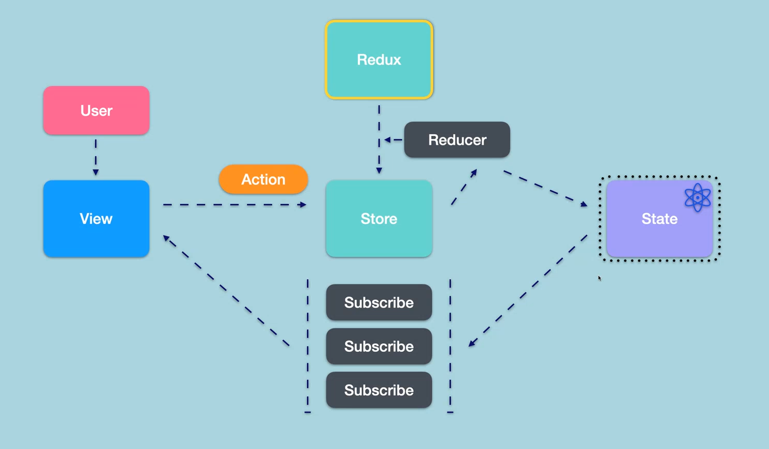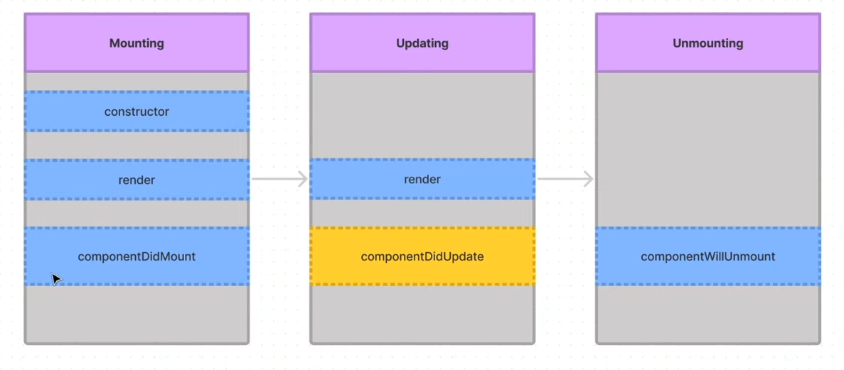

* 1. Node.js
  2. AWS deploy
  3. CICD
  4. Design pattern & principle
  5. agile