

Gaussian Voxelization with Ray-Mesh Intersection Point Classification Method

**Supervisor: Yukiko Kenmochi**

**Reporter: Yiheng Zhang**

**02/10/2018**

# Abstract

This paper presents a Gaussian voxelization algorithm for manifold and water-tight polygon mesh.

Firstly, a ray casting method is used to locate ray-mesh intersection points, the rays are parallel to an axis and cross voxel centers. Secondly, we tag these intersection points along each ray by analyzing the dot production(s) of the ray and corresponding surface(s) normal. Finally, voxels along each ray would be validated based on the sequence and tags of the intersection points.

Our implementation and result shows that this algorithm can perform Gaussian voxelization which is solid, geometrically and topologically correct when given appropriate voxel size.

**Keywords:** Gaussian voxelization, ray-mesh intersection

# Introduction

The 3D discrete space is represented as a set of grid points such as integer Cartesian coordinates (x, y, z) in 3D Euclidean space. The voxel is a unit cubic volume that centered at the integral grid point. In 3D image processing, the voxelization is to convert an object from its continuous geometric representation into an approximate discrete volumetric representation. We commonly assign 0 to voxels who represents transparent background in the space, for those who are given non-0 values are representing opaque objects. The value could be a dynamic range that can represent either partial coverage, variable densities, or graded opacities. In this paper, the non-0 voxels are all assigned to 1 and called validated voxels.

The resulting data structure of voxelization is useful in numerous fields. In game industry, voxels can be used in global illumination, collision detection or terrain simulation. In medicine, voxel dataset usually stores volumetric image that acquired by a CT or MRI scanner. Voxel set can be visualized as polygon mesh by extracting its iso-surfaces, sometimes, the scientists would like to make a study of how to keep both geometric and topology of the original voxel set after voxelizing the moved, rotated polygon mesh. Therefore, Gaussian voxelization algorithm is needed to produce accurate volumetric representation of the polygon mesh.

There are multiple algorithms and applications that perform fast and approximate voxelization, they either do only surface voxelization or could not guarantee the accuracy that causes unexpected lost or emergence of voxel(s). In this paper, we studied and borrowed two main ideas, ray-triangle intersection processing and general voxelization scheme from existing algorithms, and then come up with our gaussian voxelization algorithm.

# Related work

Fakir S. Nooruddin and Greg Turk proposed a ray casting method called “parity count” to solve point-in-polygon problem for non-watertight mesh [1]. The idea is to count the number of times that a ray launched by the voxel center intersects the polygon mesh. An odd number of intersections means the voxel is inside of the model, an even number indicates the voxel is outside. In essence, the rays are parallel and casted on a plane of two axes. The rays go through the mesh and each of them would identify all the voxels along the ray.

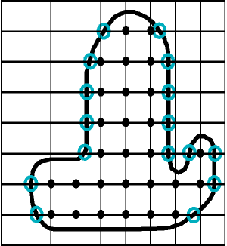 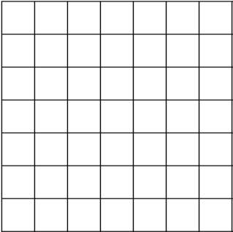

(a) (b)

**Fig.1.** (a) A profile of an object that voxelized by parity count. Direction of rays is from left to right, black dots are voxels inside mesh, while other voxels are outside mesh, blue circles are ray-mesh intersection points. (b) The ambiguity of counting intersections on vertex or polygon surface. Blue circles are intersection points, red circles are unwanted extra voxels, green circles are unwanted lost voxels.

Usually, the voxelization like Fig.1a works fine with parity count. At initial state, all voxel counting values are 0. Along each ray (horizontal line),

for each intersection point (the blue circle), all voxel values behind would increase 1, then the interior voxels’ value are all odd numbers and outside voxels’ value are all even numbers. However, the situation like Fig.1b is not neglectable, but Fakir S. Nooruddin and Greg Turk didn’t explain how would parity count work with intersection points on the mesh vertices or surfaces. The idea of ray casting inspired our further works.

For a triangle mesh, in order to get ray-mesh intersection points, we need to process triangle by triangle. Michael Schwarz and Hans-Peter Seidel proposed a method to process each triangle by projecting the triangle into origin plane of rays and iteratively check if ray’s origin is covered by projected triangle in the range of projected triangle’s bounding box [2]. We also inserted this procedure into our algorithm.

# Gaussian voxelization

To avoid the problem of parity count, we suggest to classify all intersection points and validate voxels based on the points tag along each ray to achieve Gaussian voxelization. We define four intersection point tags which are “enter”, “exit”, “touch_start” and “touch_end”. We also need to define three ray-triangle intersection cases like Fig.2, using the sign of the dot product of a ray and intersected triangle’s normal.

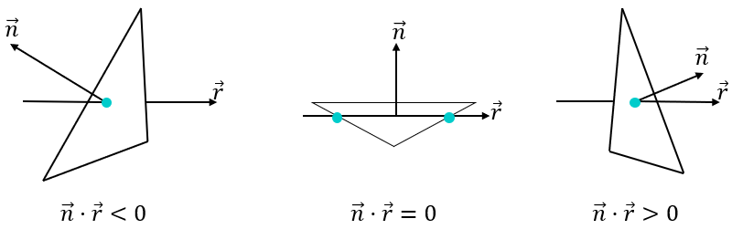

**Fig.2.** Ray-triangle intersection cases

An intersection point could be shared by multiple triangles when it is on the edge or vertex of the triangle, therefore, we need to analyze all intersection cases of a point before tagging it.

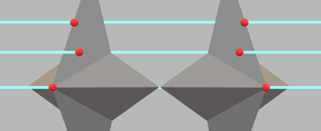  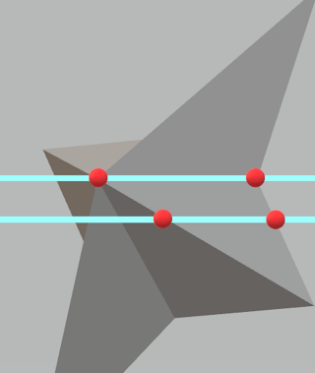

(a) (b) (c)

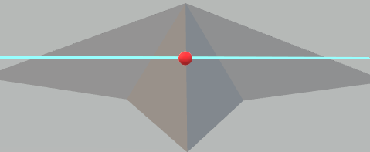 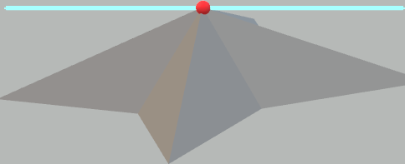 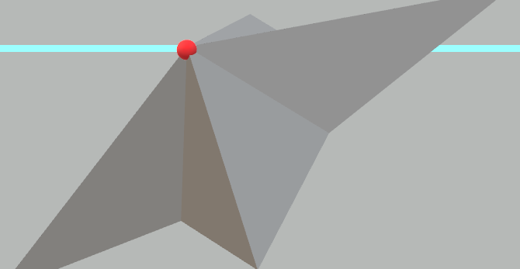 

(d) (e) (f) (g)

**Fig.3.** General conditions of ray-mesh intersection, ray direction from left to right, red dots are intersection points

We use “T” to represent a set of triangles that are sharing an intersection point and “t” to represent the triangle in “T”. By observing the example Fig.3a, we can easily conclude that these three intersection points should be tagged as “enter” while they satisfy $∀t∈T, \vec{n_{t}}·\vec{r}<0$. Similarly, the three intersection points in Fig.3b should be tagged as “exit” while they satisfy $∀t∈T, \vec{n_{t}}·\vec{r}>0$. For the four intersection points in Fig.3c, they satisfy $∃t∈T,\vec{n_{t}}·\vec{r}=0$, the left two points would have the tag “touch_start” and the right two points would contain the tag “touch_end”. There is a triangle processing trick, when $\vec{n_{t}}·\vec{r}=0$ and there is only one intersection point and the point is one of the triangle vertices, we don’t tag anything and continue to process next triangle. The reason to do this trick is that we need the point with tag “exit” or “exit” and “touch_end” to stop voxel validation along the ray.

The Fig.d, Fig.e, Fig.f, Fig.g all satisfy that $(∃t∈T,\vec{n_{t}}·\vec{r}<0)∧(∃t∈T,\vec{n_{t}}·\vec{r}>0)∧￢(∃t∈T,\vec{n_{t}}·\vec{r}=0)$. However, the intersection point in Fig.d would be fixed as “enter” and “exit” and shared by two triangles. For conditions like Fig.e, Fig.f and Fig.g, the further classification is needed.

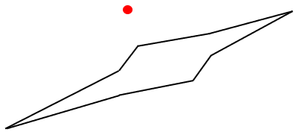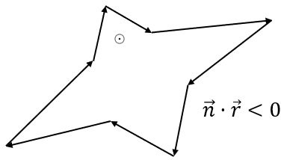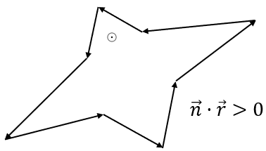

(a) (b) (c)

**Fig.4.** The rays’ origin plane projection of the intersection point and its opposite edges in related triangles. (a) Projection of Fig.e. (b) Projection of Fig.f. (c) Projection of Fig.g, the circled dot means ray is vertical to the paper and going out

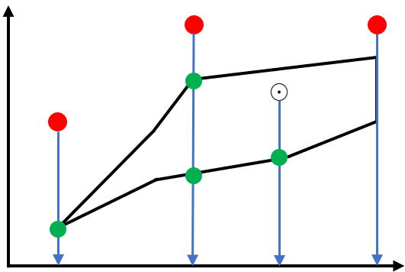 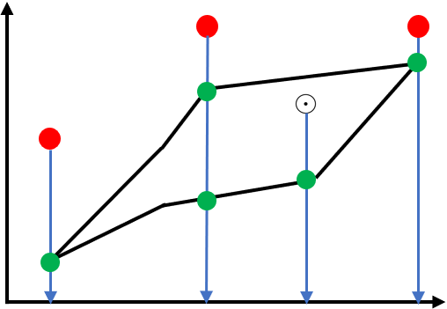

**Fig.5.** General conditions of ray-shape intersection, red dots and circled dots are projected intersection points, green dots are ray-shape intersection point.

Because of the existing condition $￢(∃t∈T,\vec{n_{t}}·\vec{r}=0)$, tag “touch_start” and “touch_end” are not enabled now, then after the projection as Fig.4, the projected intersection point would only be interior or exterior to the projected shape, therefore, if the point is outside the shape, we can easily identify the condition Fig.3e. To do this classification, we propose a variant of parity count method. Take Fig.5 for example, on the projected plane, we cast a ray from the projected intersection point to the opposite direction of an axis, if the ray is on an edge, we collapse this edge and recast the ray. When there is an intersection point on the vertex, if the ray is between two related edges, we count one on this point, otherwise, we count two. When the intersection point is on the edge, we count one. If the sum of counts is odd, the projected intersection point is inside the shape, otherwise, it’s outside. Another special case is that projected edges have overlaps and the shape is not closed, then the projected intersection point is outside the shape.

For the projected intersection point inside shape, if the dot production of the shape’s normal and the ray in 3D is less than 0, remove the tag “exit” from the intersection point, if the dot production is bigger than 0, then remove “enter” instead.

By now, the intersection points tagging processing is done, the voxel validation process along each ray starts from the smallest intersection point with tag “enter” and not “exit” until meet the closest point with tag “exit” and not “enter” and not “touch_start”. If the next intersection point contains tag “touch_start”, then validate voxels behind until meet the point that contains tag “touch_end”. If the next intersection point’s tags are “enter” and “exit”, the voxel is validated when the intersection point is the voxel center. We iteratively validate voxels along the rays using previous steps, then a new voxel dataset is created.

The full algorithm is put in the appendix.

# Implementation and result

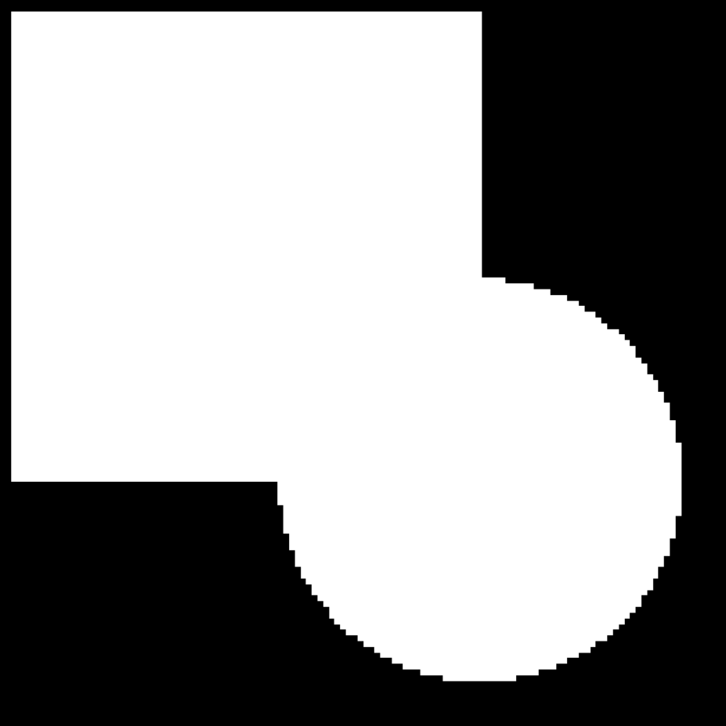 

(a) (b)

 

(c) (d)

**Fig.6.** (a) profile with z = 63 of original voxel set with size $128×128×128$;

(b) profile with z = 63 of gaussian voxelized new voxel set;

(c) subtraction of original voxel set and new voxel set;

(d) subtraction of new voxel set and original voxel set

The program is written in C++ with boost library included. In order to avoid inaccurate calculations caused by precision limitations of float and double type, the boost rational type is used to participate all mathematical calculations. After implementing voxelization, we subtract original voxel set with new voxel set, the window shows as Fig.6c which indicate no voxel is lost. Later we subtract new voxel set with original voxel set, the window shows as Fig.6d which means no extra voxel is created. By now, from algorithm to implementation, we have achieved gaussian voxelization.

There are two feasible features that can improve the program in the future. The program can be boosted by using multithread processing when processing the triangles of the mesh. The voxel data can be stored in bitwise or octree to reduce the data volume.

# Another proposal

We may use another method that can do gaussian voxelization based on the reverse action of marching cube algorithm.

We firstly get all grid-mesh intersection points, then we set 0 to voxel in origin, which is usually not included in the mesh. The intersection points on the voxel grid can generate iso-surface(s), the voxels on the same side as origin would be assign to 0 and voxels on the other side would be assign to 1. Then for each voxel grid nearby, at least 4 voxels are validated and we can use the same way to validated rest voxels.

The main possible problem of this method is that the intersection point is actually on the voxel center. We can try to move the point out from validated voxel to unvalidated voxel to get proper iso-surface.

This method doesn’t have the complex tagging procedure and time complexity is likely to be linear which is good to try.

# References

1. Fakir S. Nooruddin and Greg Turk, “Simplification and Repair of Polygonal Models Using Volumetric Techniques”, *IEEE Translation Visualization and Computer Graphics*, vol. 9, NO. 2, April-June 2003
2. Michael Schwarz and Hans-Peter Seidel, “Fast Parallel Surface and Solid Voxelization on GPUs”, *ACM Translation on Graphics*, 29, December 2010

**Algorithm:** Gaussian_Voxelization

**Input:** mesh = (Vertex, Face); space size $S_{minx}$, $S_{miny}$, $S_{minz}$, $S_{maxx}$, $S_{maxy}$, $S_{maxz}$; number of voxels for x-axis, y-axis and z-axis $N_{x}$, $N_{y}$, $N_{z}$; ray direction d.

**Output:** voxelset

**Initialization**

**for** each f ∈ Face

normal $∶=$ FACE_NORMAL (f)

dot_production $∶=$ RAY_NORMAL_DOT_PRODUCTION (normal, d)

rayset $∶=$ RAY_RAYSET (f, d) // find the set of rays going through f with direction d

**for** each $ray∈rayset$

point.value $∶=$ FIND_INTERSECTION (f, ray)

//if dot_production = 0, return first and last point value

//if first point.value equals to last point.value, jump to next loop

**if** dot_production < 0 **then** point.enter $∶=$ true

**else if** dot_production > 0 **then** point.exit $∶=$ true

**else if** dot_production = 0 **then** point.touch_start $∶=$ true, point.touch_end $∶=$ true

**if** point $∉$ intersection_list **then**

insert point into intersection_list by point.value increasing order

**else** locate point in intersection_list

intersection_list.point.enter $∶=$ intersection_list.point.enter **or** point.enter

intersection_list.point.exit $∶=$ intersection_list.point.exit **or** point.exit

intersection_list.point.touch $∶=$ intersection_list.point.touch **or** point.touch

**for** each ray in direction d

**while** intersection_list is not empty

**for** each point $∈$ intersection_list

**if** point.shared_triangles $≥$ 3

**if** point.enter = true **and** point.exit = true **and** point.touch_start = false

project point and point’s opposite edges of all shared triangles into plane of ray’s origin

**if** projected point is not outside the polygon of projected edges

**then** **if** RAY_NORMAL_DOT_PRODUCTION (polygon_normal, d) > 0

**then** point.enter $∶=$ false **else** point.exit $∶=$ false

**for** each ray in direction d

**while** intersection_list is not empty

**for** each point $∈$ intersection_list

**if** point.enter = true **and** point.exit = false **then**

start_value = point.value

**while** **not** (point.enter = false **and** point.touch_start = false **and** point.exit = true)

move to next point

end_value = point.value

**for** each voxel_center $∈$ [start_value, end_value]

voxel = 1

**else** **if** point.touch_start = true

start_value = point.value

move to next point

end_value = point.value

**for** each voxel_center $∈$ [start_value, end_value]

voxel = 1

**else if** point.enter = true **and** point.exit = true **and** point.value = voxel_center **then**

voxel = 1

**return** voxelset