同济大学计算机系

计算机组成原理实验报告



学 号 2251745
姓 名 张宇
专 业 计算机科学与技术
授课老师 张冬冬老师

- 实验内容
通过本次试验，了解除法器的实现原理，并学习如何实现一个除法器，本实验将实现 32 位无符号除法器和32位带符号除法器。
实验目标：
- 了解32位带符号、无符号除法器的实现原理；
- 使用Verilog实现32位无符号除法器和带符号除法器。
- 模块建模
1、32位无符号乘法器

module DIVU(
input [31:0] dividend,
input [31:0] divisor,
input start,
input clock,
input reset,
output [31:0] q,
output [31:0] r,
output reg busy
);
wire ready;
reg [5:0] count;
reg [31:0] reg_q;
reg [31:0] reg_r;
reg [31:0] reg_b;
reg busy2, r_sign;
assign ready = ~busy & busy2;
wire [32:0] sub_add = r_sign ? ({reg_r, q[31]} + {1'b0, reg_b}) :
({reg_r, q[31]} - {1'b0, reg_b});
assign r = r_sign ? reg_r + reg_b : reg_r;
assign q = reg_q;
always @(posedge clock or posedge reset)
begin
if (reset == 1)
begin
count <= 0;
busy <= 0;
busy2 <= 0;
end
else
begin
busy2 <= busy;
if(start == 1)
begin
reg_r <= 32'b0;
r_sign <= 0;
reg_q <= dividend;
reg_b <= divisor;
count <= 0;
busy <= 1;
end
else if (busy == 1)
begin
reg_r <= sub_add[31:0];
r_sign <= sub_add[32];
reg_q <= {reg_q[30:0], ~sub_add[32]};
count <= count + 1;
if(count == 31) busy <= 0;
end
end
end
endmodule

2、32位带符号乘法器

module DIV(
input [31:0] dividend,
input [31:0] divisor,
input start,
input clock,
input reset,
output [31:0] q,
output [31:0] r,
output reg busy
);
wire ready;
reg [5:0] count;
reg [31:0] reg_q;
reg [31:0] reg_r;
reg [31:0] reg_b;
wire [31:0] reg_r2;
reg busy2, r_sign, sign;
assign ready = ~busy & busy2;
wire [32:0] sub_add = r_sign ? ({reg_r, reg_q[31]} + {1'b0, reg_b}) :
({reg_r, reg_q[31]} - {1'b0, reg_b});
assign reg_r2 = r_sign ? reg_r + reg_b : reg_r;
assign r = dividend[31] ? (~reg_r2 + 1) : reg_r2;
assign q = (divisor[31]^dividend[31]) ? (~reg_q + 1) : reg_q;
always @ (posedge clock or posedge reset)
begin
if(reset == 1)
begin
count <= 0;
busy <= 0;
busy2 <= 0;
end
else
begin
busy2 <= busy;
if(start == 1)
begin
reg_r <= 32'b0;
r_sign <= 0;
if(dividend[31] == 1)
begin
reg_q <= ~dividend + 1;
end
else reg_q <= dividend;
if(divisor[31] == 1)
begin
reg_b <= ~divisor + 1;
end
else reg_b <= divisor;
count <= 0;
busy <= 1;
end
else if(busy == 1)
begin
reg_r <= sub_add[31:0];
r_sign <= sub_add[32];
reg_q <= {reg_q[30:0], ~sub_add[32]};
count <= count + 1;
if(count == 31) busy <= 0;
end
end
end
endmodule

- 测试模块建模
1、32位无符号乘法器
module DIVU_tb();
reg [31:0] dividend;
reg [31:0] divisor;
wire start;
reg is_div;
reg clock;
reg reset;
wire [31:0] q;
wire [31:0] r;
wire busy;
assign start = is_div & ~busy;
DIVU uut(dividend, divisor, start, clock, reset, q, r, busy);
initial
begin
clock = 0;
reset = 1;
is_div = 0;
dividend = 500;
divisor = 10;
#50 reset = 0;
#5 is_div = 1;
#20 is_div = 0;
end
always
begin
#10 clock=~clock;
end
endmodule
2、32位带符号乘法器
module DIV_tb();
reg [31:0] dividend;
reg [31:0] divisor;
wire start;
reg is_div;
reg clock;
reg reset;
wire [31:0] q;
wire [31:0] r;
wire busy;
assign start = is_div & ~busy;
DIV uut(dividend, divisor, start, clock, reset, q, r, busy);
initial
begin
clock = 0;
reset = 1;
is_div = 0;
dividend = -5;
divisor = 2;
#50 reset = 0;
#5 is_div = 1;
#20 is_div = 0;
end
always
#10 clock = ~clock;
endmodule
- 实验结果
1、32位无符号乘法器
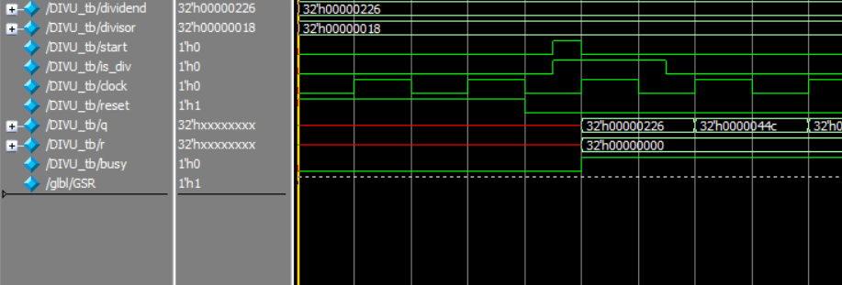
2、32位带符号乘法器
