同济大学计算机系

数字逻辑课程实验报告



学 号 2251745
姓 名 张宇
专 业 计算机科学与技术
授课老师 张冬冬

- 实验内容
RAM 与寄存器堆实验。在本次实验中，我们将使用 Verilog HDL 语言实现RAM 以及寄存器堆的设计和仿真。
实验目标：
- 深入了解 RAM 与寄存器堆的原理；
- 用 Logisim 画出一个包含 16 个寄存器的寄存器堆原理图；
3、学习使用 Verilog HDL 语言设计实现 RAM 以及寄存器堆。
- 硬件逻辑图

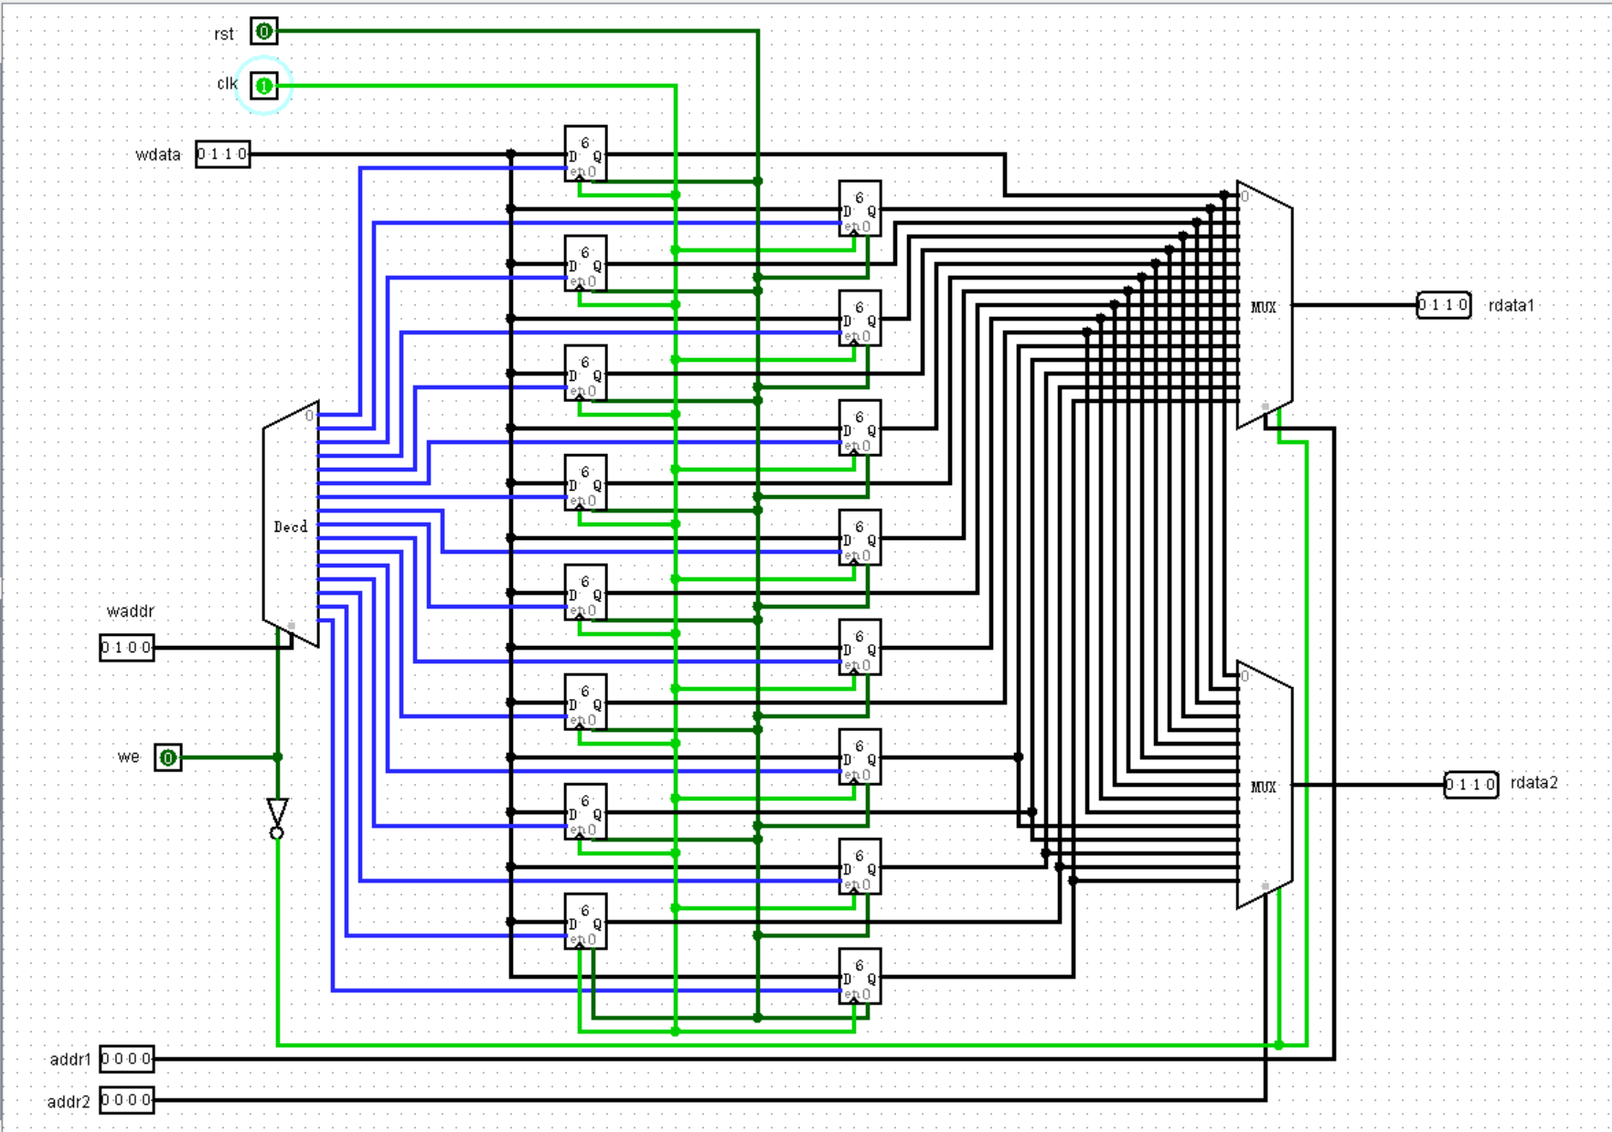
- 模块建模
1、RAM
module ram(
input clk,
input ena,
input wena,
input [4:0] addr,
input [31:0] data_in,
output reg [31:0] data_out
);
reg [31:0] data [0:31];
integer i;
initial
begin
for(i = 0; i < 32; i = i + 1)
data[i] <= 32'bzzzzzzzzzzzzzzzzzzzzzzzzzzzzzzzz;
end
always@(posedge clk) begin
if(ena)
if(wena)
data[addr] <= data_in;
end
always@*
if(!ena)
data_out <= 32'bzzzzzzzzzzzzzzzzzzzzzzzzzzzzzzzz;
else
data_out <= data[addr];
endmodule
2、RAM2
module ram2(
input clk,
input ena,
input wena,
input [4:0] addr,
inout wire [31:0] data
);
reg [31:0] memory [0:31];
integer i;
initial
begin
for(i = 0; i < 32; i = i + 1)
memory[i] <= 32'bzzzzzzzzzzzzzzzzzzzzzzzzzzzzzzzz;
end
always@(posedge clk) begin
if(ena)
if(wena)
memory[addr] <= data;
end
assign data = ena ? memory[addr] : 32'bzzzzzzzzzzzzzzzzzzzzzzzzzzzzzzzz;
endmodule
3、Regfiles
module decoder(
input [4:0] iData,
output reg [31:0] oData
);
always@ (iData) begin
oData=32'b00000000000000000000000000000000;
oData[iData]=1'b1;
end
endmodule

module selector41(
input we, rst,
input [4:0]raddr,
input [31:0]iC1,iC2,iC3,iC4,iC5,iC6,iC7,iC8,iC9,iC10,iC11,iC12,iC13,iC14,iC15,iC16,iC17,iC18,iC19,iC20,iC21,iC22,iC23,iC24,iC25,iC26,iC27,iC28,iC29,iC30,iC31,iC32,
output reg [31:0] oZ
);
always @(raddr or we or rst) begin
if(we==1'b1||rst==1'b1)
oZ=32'bzzzzzzzzzzzzzzzzzzzzzzzzzzzzzzzz;
else
case (raddr)
5'b00000:oZ=iC1;
5'b00001:oZ=iC2;
5'b0
- 测试模块建模
1、RAM
module ram_tb;
reg clk;
reg ena;
reg wena;
reg [4:0] addr;
reg [31:0] data_in;
wire [31:0] data_out;
always #20 clk = ~clk;
always #40 wena = ~wena;
initial begin
data_in = 32'b11111111111111111111111111111111;
addr =5'b00000;
clk = 0;
ena=0;
wena = 0;
#40
addr = 5'b00001;
#40
ena = 1;
addr = 5'b00010;
#40
addr = 5'b00100;
#40
addr = 5'b01000;
#40
addr = 5'b10000;
#40
addr = 5'b00011;
#40
addr = 5'b00110;
#40
addr = 5'b01100;
#40
addr = 5'b11000;
end
ram uut(
.clk(clk),
.ena(ena),
.wena(wena),
.addr(addr),
.data_in(data_in),
.data_out(data_out)
);
endmodule
2、RAM2
module ram2_tb;
reg clk;
reg ena;
reg wena;
reg [4:0] addr;
wire [31:0] data;
always #20 clk = ~clk;
always #40 wena = ~wena;
initial begin
force data = 32'b11111111111111111111111111111111;
addr =5'b00000;
clk = 0;
ena = 0;
wena = 0;
#40
addr = 5'b00001;
#40
ena = 1;
addr = 5'b00010;
#40
addr = 5'b00100;
#40
addr = 5'b01000;
#40
addr = 5'b10000;
#40
addr = 5'b00011;
#40
addr = 5'b00110;
#40
addr = 5'b01100;
#40
addr = 5'b11000;
end
ram2 uut(
.clk(clk),
.ena(ena),
.wena(wena),
.addr(addr),
.data(data)
);
endmodule
3、Regfiles
module Regfiles_tb;
reg clk;
reg rst;
reg we;
reg [4:0] raddr1;
reg [4:0] raddr2;
reg [4:0] waddr;
reg [31:0] wdata;
wire [31:0] rdata1;
wire [31:0] rdata2;
always #20 clk = ~clk;
always #40 we = ~we;
always #40 raddr1 = raddr1 + 1;
always #40 raddr2 = raddr2 + 1;
initial begin
clk = 0;
rst = 0;
we = 0;
raddr1 = 5'b00000;
raddr2 = 5'b00000;
waddr = 5'b00100;
wdata = 32'h77777777;
#40
rst = 1;
#40
rst = 0;
end
Regfiles uut(
.clk(clk),
.rst(rst),
.we(we),
.raddr1(raddr1),
.raddr2(raddr2),
.waddr(waddr),
.wdata(wdata),
.rdata1(rdata1),
.rdata2(rdata2)
);
endmodule
- 实验结果
1、RAM
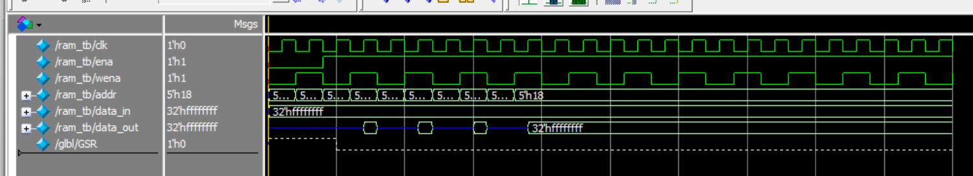
2、RAM2
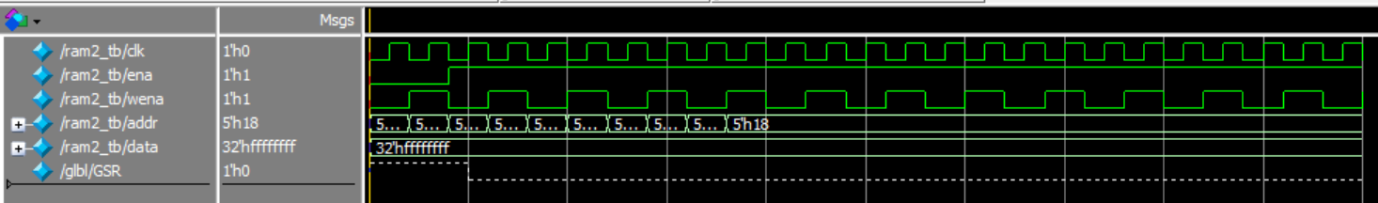
3、Regfiles
