**Modules**

1. **HMAC Module :-** This module implements the HMC init, calculation and verification procedures for HMC simulations .
2. **RSA Module:-** This module implements the RSA init , signing and verification procedures for RSA simulations.
3. **ECDSA Module:-** This module implements the ECDSA digital signature generation , signing and verification procedures .
4. **Enhancement Module:-** This module implements the proposed base paper enhancement parts of the project.
5. ***Double Encryption Module: -*** This module implements the key generation , serialization double encryption and decryption using the Blowfish algorithm and Base64 encoding .
6. ***SSL Module:-*** This module implements the SSL client authentication and key distribution part of the proposed enhancement.
7. **Base station Module:-** This module implements the user interface of Base station.
8. **Sensor node Module:-** This module implements the user interface of Sensor nodes.
9. **Enhanced Base station Module:-** This module implements the proposed user interface enhancement of Base station.
10. **Enhanced Sensor node Module:-** This module implements the proposed user interface enhancement of Sensor node.
11. **Stopwatch Module:-** This module implements a stop watch for the calculation of processing time / CPU resource management.
12. **Simulation Result Module:-** This module will output the graphical representation of simulation results.

**Hardware / Software Requirements**

1. **Software Requirements .**
2. IDE :- Netbeans IDE 7.2.1 or higher
3. JDK7.0 or higher
4. Java Enabled Operating systems ( Eg. Windows )
5. **Hardware Requirements.**
6. Pentium Dualcore Processor or higher.
7. 2GB RAM or higher.
8. 80GB HDD

**Screenshots**

1. **Splash Screen.**

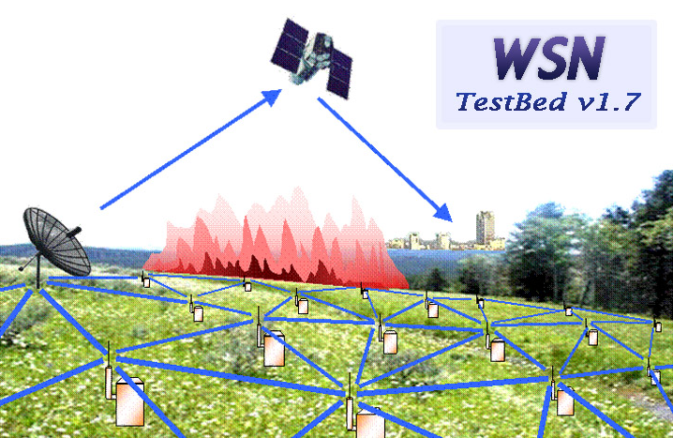

1. **Main Window**

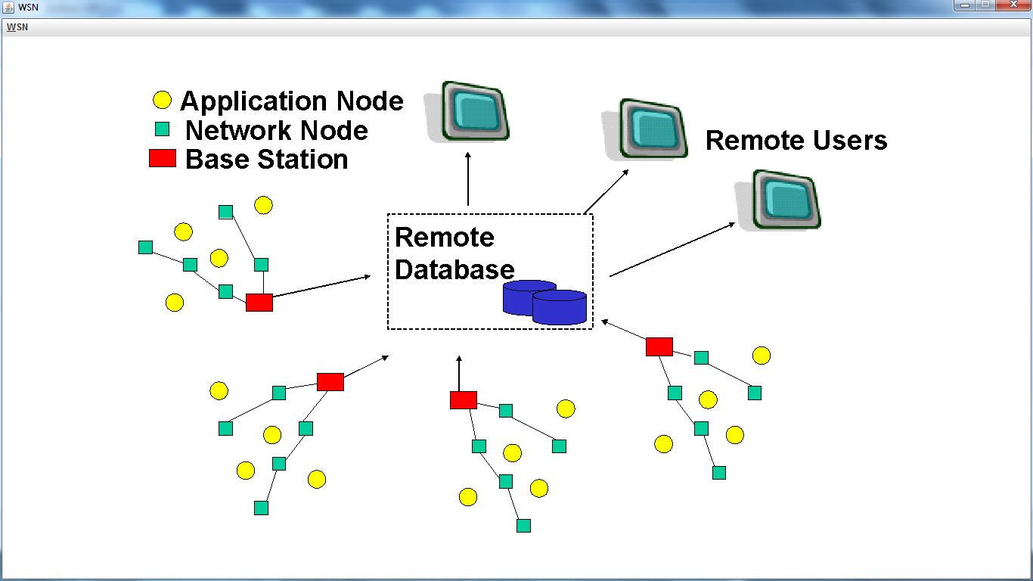

1. **Simulation Window**

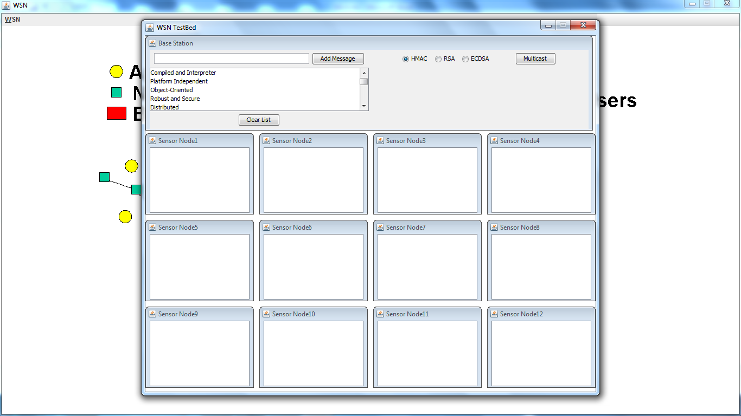

1. **Enhanced Simulation Window**

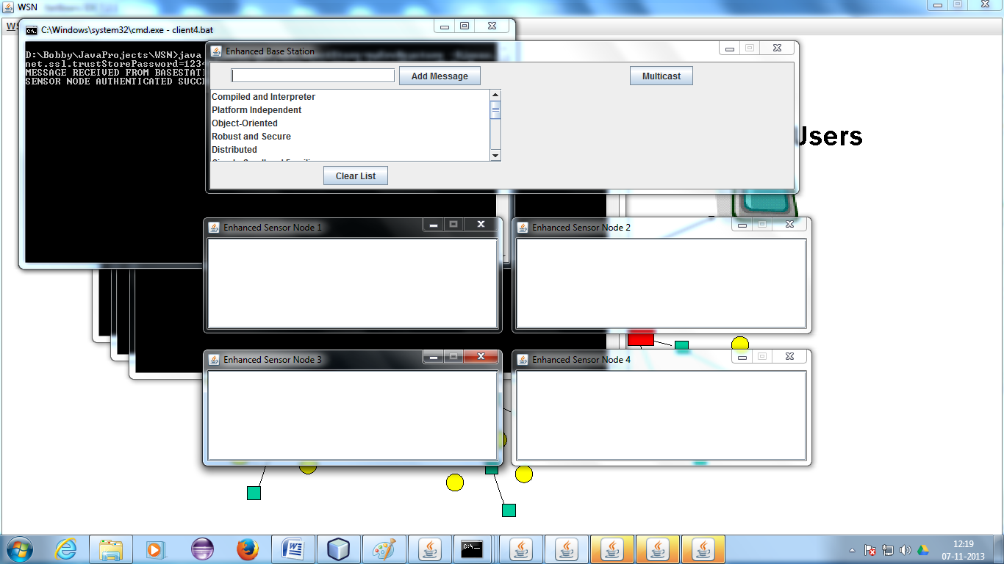

1. **Result Window**

