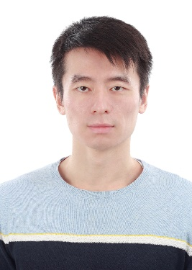
Ao Zhang
Ao Zhang received his M.ASc degree in Electrical and Computer Engineering at University of Ottawa, Ottawa, Ontario, Canada in 2021. He is currently pursuing a PhD at the School of Electronic Information and Communication, Huazhong University of Science and Technology. His research interests include large-scale novel view synthesis, 3D scene reconstruction and volumetric video generation.


Qiong Liu
Qiong Liu (Senior Member, IEEE) received the
Ph.D. degree in computer science from the School of Computer Science, Wuhan University, Wuhan, China, in 2008. Since 2009, she has been with the School of Electronic Information and Communications, Huazhong University of Science and Technology, Wuhan, and Division of Intelligent Media and Fiber Communications, Wuhan National Laboratory of Opto-Electronics, Wuhan, where she is currently a Full Professor with Information Engineering Department. From 2010 to 2012, she was a Postdoctoral Fellow with Automation Department, Tsinghua University, Beijing, China. She has authored or coauthored more than 50 technical articles and authorized more than 30 patents. Her research interests include cross-discipline researches between artificial intelligence and 3D computer vision, including 3D visual communication, human-robot interaction, human intention, and interactive visual applications. Dr. Liu is a Committee or TPC member of more than ten international conferences and a Reviewer of more than ten prestigious international journals from IEEE, ACM, and OSA. She was the recipient of the High Commended in 2020 E and T Innovation Award of Outstanding Innovation in Communication and IT.

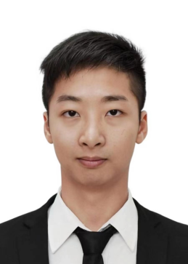

Wenxuan He
Wenxuan He received the M.S. degree in Computer Science from the School of Shantou University, Shantou, China, in 2024. He is currently working toward the Ph.D. degree in Signal and Information Processing with School of Electronic Information and Communications, Huazhong University of Science and Technology, China. His research interests include 3D representation, 3D generation and video compression.

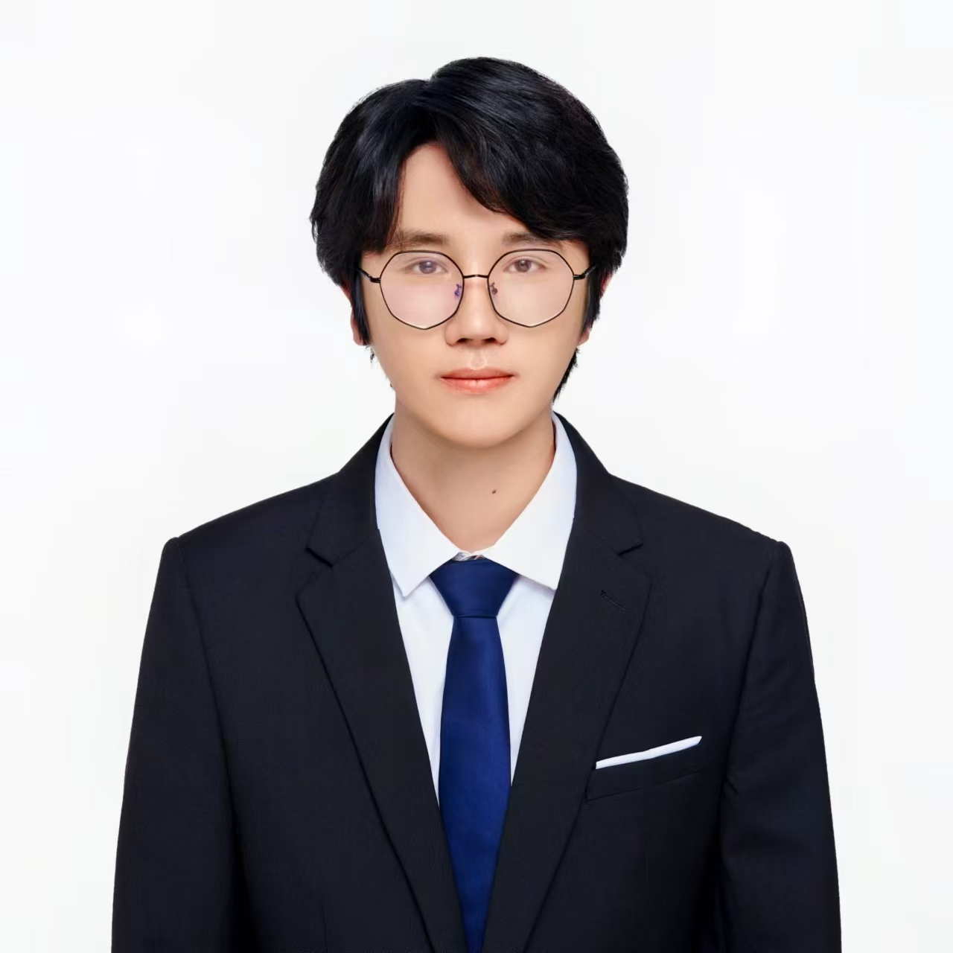
Jiabo Wu
Jiabo Wu received his Master's degree in Electronics and Communication Engineering from Northwestern Polytechnical University in 2021. He is currently pursuing a PhD at the School of Electronic Information and Communication, Huazhong University of Science and Technology. His research interests include volumetric video coding compression and AIGC.

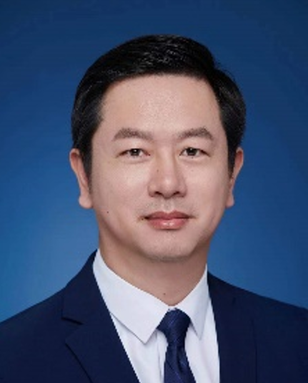
You Yang
You Yang (Senior Member, IEEE)} received the Ph.D. degree in computer science from the Institute of Computing Technology, Chinese Academy of Sciences, Beijing, China, in 2009. He was a Postdoctoral Fellow with Automation Department, Tsinghua University, from 2009 to 2011, and a Chief Scientist with Sumavision Research, from 2011 to 2013. Since 2013, he has been with the School of Electronic Information and Communications, Huazhong University of Science and Technology, Wuhan, China, and Division of Intelligent Media and Fiber Communications, Wuhan National Laboratory of Optoelectronics, Wuhan, where he is currently a Full Professor and the Vice Dean. He has authored or coauthored more than 110 peer-reviewed articles and authorized 41 domestic and U.S. patents. His research interests include 3D visual communications and its applications, including multiview imaging systems, 3D/VR/AR content processing and visual communications, human-machine interaction techniques, and interactive visual applications..

