班级 nz222 姓名 张博雅 学号 225849

实验三 JavaScript

- 实验目的
JavaScript练习
- 实验内容
new HTML page
a script
JavaScript file called ‘randominteger.js’
function ‘randomInt’
a simple number guessing game
三、实验结果
核心代码
Ex1
<!DOCTYPE html>
<html>
<head>
<title>lab3-1</title>
</head>
<body>

<script>
document.write('<h1>This is my Heading</h1>');

document.write('<p>This is my lovely paragraph.</p>');
</script>

</body>
</html>

Ex2
<!DOCTYPE html>
<html lang="zh-CN">
<head>
<meta charset="UTF-8">
<meta name="viewport" content="width=device-width, initial-scale=1.0">
<title>lab3-2</title>
</head>
<body>

<h1>Navigator Language example</h1>
<p id="languageDisplay">Your preferred language will be displayed here.</p>

<script>
function displayPreferredLanguage() {
var preferredLanguage = navigator.language;
console.log("Your preferred language is: " + preferredLanguage);
document.getElementById("languageDisplay").textContent = "Your preferred language is: " + preferredLanguage;
}
window.onload = displayPreferredLanguage;
</script>

</body>
</html>

Ex3
// randominteger.js
function randomInt() {
return Math.floor(Math.random() * 100) + 1;
}

<!DOCTYPE html>
<html lang="zh-CN">
<head>
<meta charset="UTF-8">
<meta name="viewport" content="width=device-width, initial-scale=1.0">
<title>lab3-3</title>
<script src="randominteger.js"></script>
</head>
<body>
<h1>random integer</h1>
<p>Generated Random Integer: <span id="randomIntDisplay"> </span></p>

<script>
document.getElementById("randomIntDisplay").textContent = randomInt();
</script>

</body>
</html>

Ex4
// random.js
function getRandomNumber(min, max) {
return Math.floor(Math.random() * (max - min + 1)) + min;
}

<!DOCTYPE html>
<html lang="zh-CN">
<head>
<meta charset="UTF-8">
<meta name="viewport" content="width=device-width, initial-scale=1.0">
<title>lab3 game</title>
<style>
body {
font-family: Arial, sans-serif;
text-align: center;
margin-top: 50px;
}
button {
background-color: rgb(249, 224, 246);
margin-top: 10px;
padding: 10px 20px;
font-size: 16px;
}
input {
padding: 10px;
font-size: 16px;
}
</style>
</head>
<body>
<div class="container">
<h1>Let's guess the number</h1>
<p>Please input a number between 1 and 100:</p>
<input type="number" id="guessInput" min="1" max="100">
<button onclick="makeGuess()">ok</button>
<p id="message"></p>
<p>numbers you previously guessed:<span id="guesses"></span></p>
<button id="restartButton" onclick="restartGame()" style="display: none;">restart</button>
</div>

<script src="random.js"></script>
<script>
let targetNumber;
let attemptsLeft;
let guessedNumbers;

function startGame() {
targetNumber = getRandomNumber(1, 100);
attemptsLeft = 10;
guessedNumbers = [];
document.getElementById('message').textContent = '';
document.getElementById('guesses').textContent = '';
document.getElementById('guessInput').value = '';
document.getElementById('restartButton').style.display = 'none';
}

function makeGuess() {
const guess = parseInt(document.getElementById('guessInput').value);
if (isNaN(guess) || guess < 1 || guess > 100) {
alert('Please enter a valid number (1-100).');
return;
}

guessedNumbers.push(guess);
let message = '';

if (guess === targetNumber) {
message = 'Congratulations!!you guessed it!';
document.getElementById('restartButton').style.display = 'block';
} else {
attemptsLeft--;
if (attemptsLeft > 0) {
message = guess < targetNumber ? 'Too low!' : 'Too high!';
message += ` You have ${attemptsLeft} more chances.`;
} else {
message = `Game over! The correct answer is ${targetNumber}。`;
document.getElementById('restartButton').style.display = 'block';
}
}

document.getElementById('message').textContent = message;
document.getElementById('guesses').textContent = guessedNumbers.join(', ');
}
function restartGame() {
startGame();
}
// 初始化游戏,重新开始
startGame();
</script>
</body>
</html>

运行效果：
Ex1
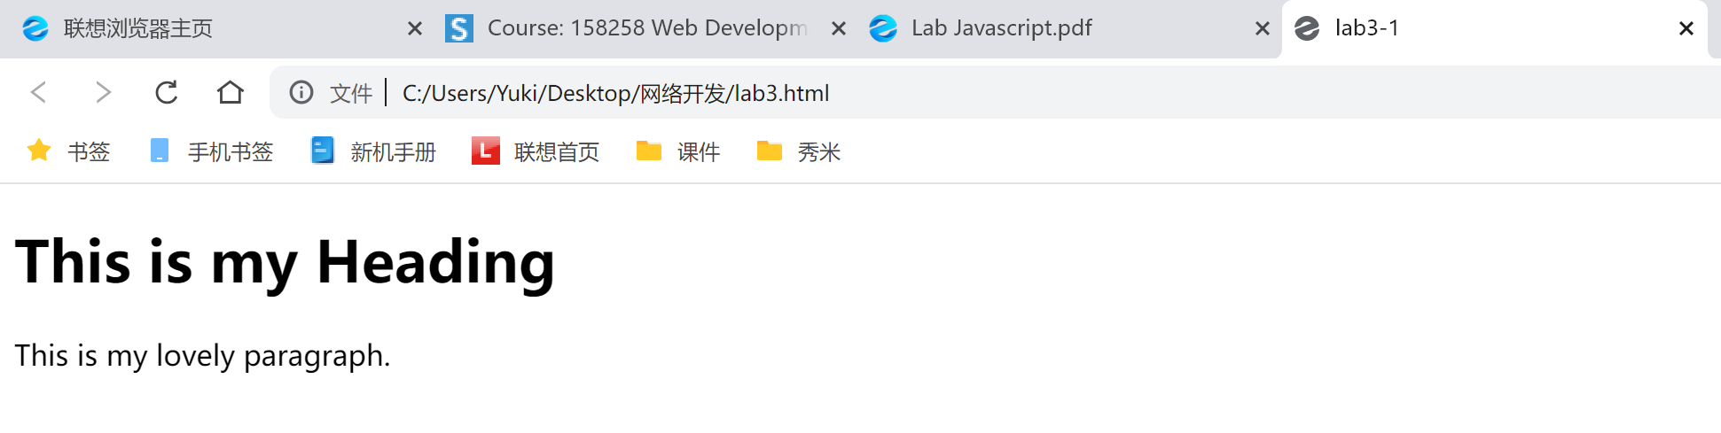

Ex2
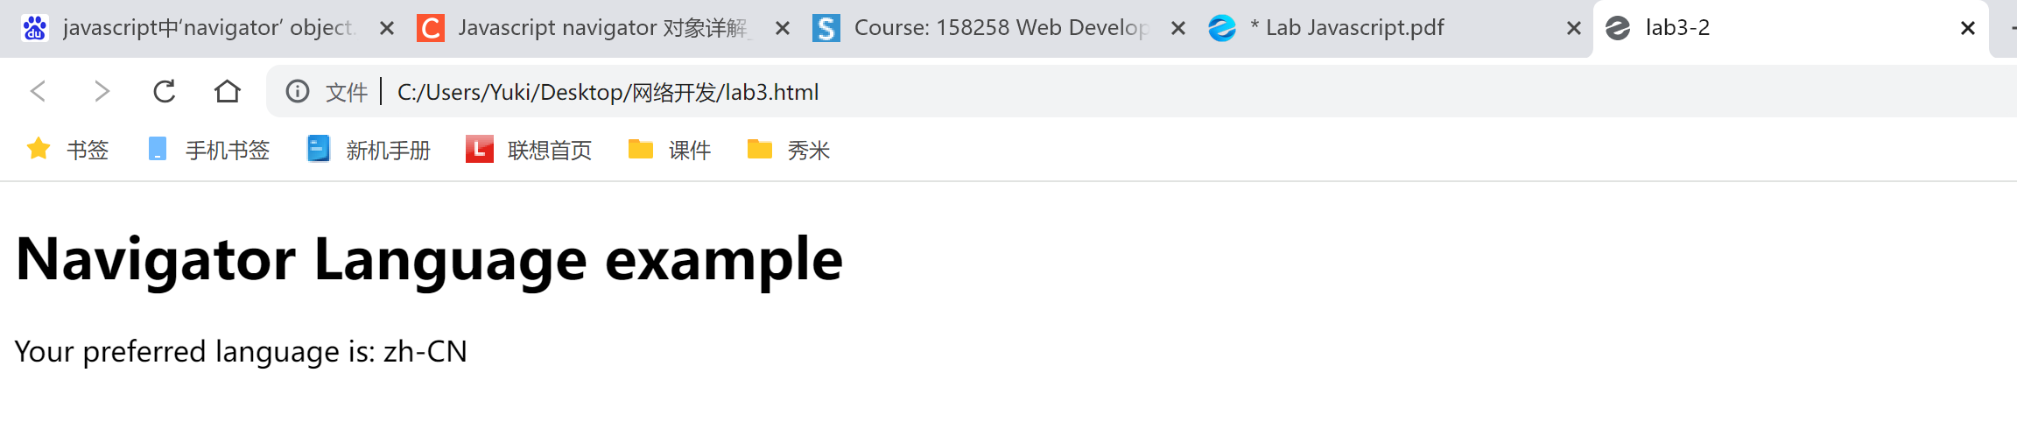

Ex3
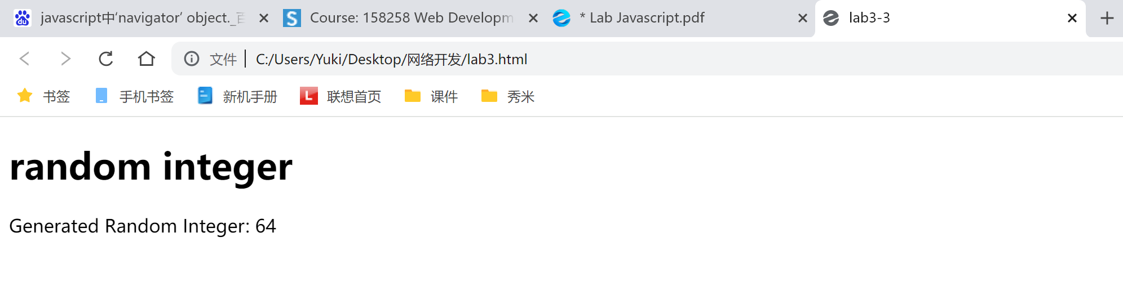

Ex4
