Table of Contents

Study Information

Design Plan

Sampling Plan

Variables

Analysis Plan

Other

### Study Information

1. Title (required)

Pause for thought: Effects of pauses in play on risky decision-making

1. Authors (required)

Zhang Chen, Charlotte Eben, Frederick Verbruggen

1. Description (optional)

In two previous experiments (Ns = 47 and 55), we observed that participants became more sensitive to EV ratios in their risky decisions after taking a pause of 3 seconds compared to no pause. However, in these two experiments, we included catch trials in the no-pause condition only. These catch trials had more extreme EV ratios than the experimental trials, and as such, might reduce people's sensitivity to EV ratios in the experimental trials (i.e., the range adaptation idea; see e.g. Rangel, & Clithero, 2012; Palminteri, & Lebreton, 2021). This experiment aims to rule out this alternative explanation by including the same catch trials in both the short-pause (300 milliseconds) and the long-pause (3000 milliseconds) conditions (note that this is different from the previous experiments, which used a 3-second pause vs. no pause manipulation. See Section 8).

1. Hypotheses (required)

There are (at least) two competing hypotheses for the previous finding:

1) The *range adaptation* hypothesis: According to this hypothesis, the reduced sensitivity to EV ratios with no pause was caused by the inclusion of catch trials in the no-pause condition only (which made the range of EV ratios larger). By including the same catch trials in both conditions, there should be no difference in the sensitivity to EV ratios in the short pause vs. long pause condition.

2) The *pause* hypothesis: According to this hypothesis, the previous findings were not caused by range adaptation, but by the pause per se. Participants should therefore still be more sensitive to EV ratios after a long pause (3000 milliseconds) compared to a short pause (300 milliseconds) in this experiment.

We expect to find evidence in line with the pause hypothesis. In other words, we expect the EV ratio * pause interaction effect on choices to be statistically reliable, such that participants become more sensitive to EV ratios after a long compared to a short pause.

### Design Plan

1. Study type (required)

Experiment

1. Blinding (required)

No blinding is involved in this study. We will use a within-subject design. Participants will experience all experimental conditions.

1. Is there any additional blinding in this study?

No.

1. Study design (required)

Participants will alternate between two games, a guess game in which they need to guess the eventual color of a blue-yellow wheel, and a choice game in which they need to choose which option to play with (i.e., the Vancouver Gambling task). We will use a 2 (outcome of a guess game, win vs. loss) by 2 (pause, 300 vs. 3000 ms) within-subject design. The 10 trials from the Vancouver Gambling task will be presented in each cell twice (to counterbalance the left vs. right position of the high-probability option), resulting in 80 experimental pairs.

Six catch trials will be presented once in each cell, resulting in 24 catch pairs. The left vs. right position of the high-probability option in the catch pairs will be counterbalanced. The table below shows the catch trials that we are going to use. HP stands for the high-probability option, and LP stands for the low-probability option.

| HP Prob | HP Amount | HP EV | LP Prob | LP Amount | LP EV | Optimal |
| --- | --- | --- | --- | --- | --- | --- |
| 0.8 | 40 | 32 | 0.2 | 20 | 4 | HP |
| 0.7 | 30 | 21 | 0.3 | 10 | 3 | HP |
| 0.8 | 50 | 40 | 0.2 | 30 | 6 | HP |
| 0.6 | 0 | 0 | 0.2 | 40 | 8 | LP |
| 0.7 | 0 | 0 | 0.4 | 30 | 12 | LP |
| 0.8 | 0 | 0 | 0.3 | 20 | 6 | LP |

The current experiment will differ from the previous experiment in three aspects.

(1) Instead of using a pause (3 seconds) vs. no-pause (0 second) manipulation, we will use a long pause (3000 milliseconds) vs. a short pause (300 milliseconds) manipulation, so that in both conditions the 'loading the game' message would be presented. This is included to rule out some low-level confounds in previous experiments (e.g. whether there is a message or not), and we do not expect this change to influence the results.

(2) We will evenly distribute the catch trials in both the short-pause and the long-pause condition.

(3) For the LP-optimal catch trials (see the table above), we will set the win amount for the HP option to 0. In the previous experiment, the LP option had a larger EV than the HP option, but some participants might still be so risk-averse that they still chose the HP option. In this experiment, we set the win amount of the HP option to 0 - even very risk-averse participants should now choose the LP option on these trials.

1. Randomization (optional)

Not applicable. We will use a within-subject design.

### Sampling Plan

1. Existing data (required)

Registration prior to creation of data: As of the date of submission of this research plan for preregistration, the data have not yet been collected, created, or realized.

1. Explanation of existing data (optional)

Not applicable.

1. Data collection procedures (required)

Participants will be recruited from Prolific.co, with the following criteria: (1) between 18 and 55 years old; (2) having an approval rate of at least 85% on Prolific.co; (3) being fluent in English; and (4) having no issues seeing colors; (5) not having participated in the previous two experiments in this project. Participants will be paid 3.75 British pounds for their time (estimated to be around 25 minutes; 9 pounds per hour), plus any extra bonus they may win from the task (between 0 and 1 British pound).

1. Sample size (required)

We aim to have 100 participants, after potential exclusions (see Sections 22 and 23).

1. Sample size rationale (optional)

Assuming that the previously observed effect was indeed due to the pauses (i.e., the pause hypothesis), we assessed the chance of replicating this effect with 100 participants in a simulation. We use the data from the most recent experiment (N = 57), which had the same experimental and catch pairs. After fitting a Bayesian logistic regression to the data (see the brms formula in Section 19), we then used the posterior distributions to generate data for 100 experiments, with 100 participants in each experiment. Each data set was analyzed with the planned model, and the posterior estimate and the 95% credible interval for the EV ratio * pause interaction effect (i.e., the main effect of interest) was recorded. Figure 1 shows the results. For 83 out of the 100 simulated experiments, the lower bound of the 95% CI excludes 0. In other words, the ‘power’ to detect the effect (as assumed by the pause hypothesis) is around 83%.

Note that increasing the number of simulated experiments (e.g. to 1000) would make the results more reliable. However, analyzing hundreds of data sets using Bayesian hierarchical models is computationally very expensive. We therefore view 83% as a rough estimate of the ‘power’, and consider it to be acceptable.

Figure 1. Posterior estimates and 95% credible intervals for the EV ratio * pause interaction effect in the 100 simulated experiments (sample size = 100). The simulations were ordered based on the lower bound of the 95% CI.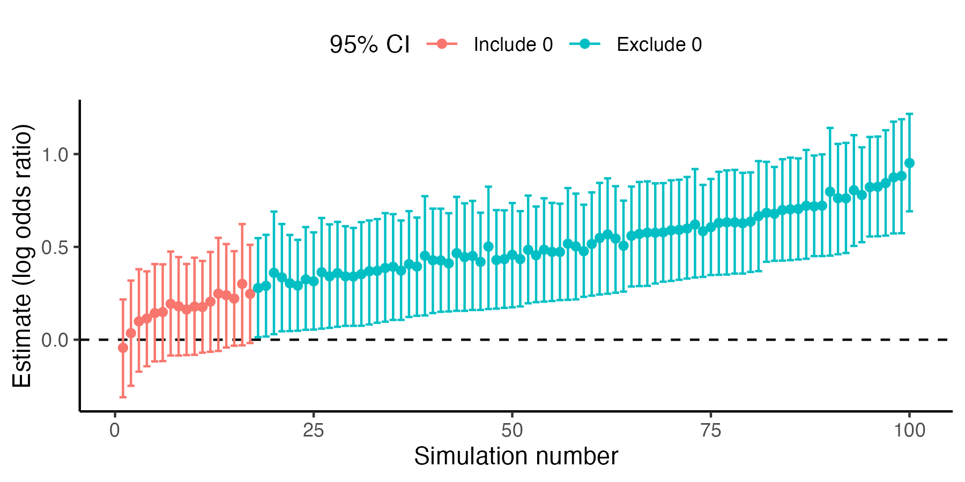

1. Stopping rule (optional)

Not applicable.

### Variables

1. Manipulated variables (optional)

We will manipulate the outcome in a guess game (win vs. loss), and the duration of the pause between a guess game and a choice game (300 vs. 3000 milliseconds). Furthermore, for the experimental pairs we will use the 10 trials from the Vancouver Gambling task (the choice game). The EV ratios of the trials will also be used in the analysis of the choices.

1. Measured variables (required)

The main measured variables include: (1) how quickly participants start a choice game (start RT, in milliseconds); (2) whether participants choose the high-probability option or not in a choice game; and (3) how quickly participants pick an option in a choice game (choice RT, in milliseconds).

1. Indices (optional)

For each choice game, following previous work, we will compute an expected value ratio. More concretely, the expected value of each option will be computed as the win amount times the win probability. The EV ratio will then be:

EV ratio = (EV of the HP - EV of the LP)/[(EV of the HP + EV of the LP)/2]

HP stands for the high-probability option, and LP stands for the low-probability option.

### Analysis Plan

1. Statistical models (required)

We will use Bayesian hierarchical models, with the brms package in R.

For the main analysis on choices in the VGT, we will use hierarchical logistic regressions, with the following coding of variables.

Choice = whether participants choose the HP option or not. Choose the HP = 1, choose the LP = 0.

Prev_outcome = outcome of the preceding guess game, loss = 0.5, win = -0.5.

Pause = the duration of the pause, long pause = 0.5, short pause = -0.5.

EV ratio = EV ratio of the two options, computed based on the equation in Section 18.

Pseudo-code for the brms model in R:

brm(Choice ~ Prev_outcome * Pause * EV ratio +

(Prev_outcome * Pause * EV ratio | subject),

family = bernoulli(link = "logit"),

prior = c(prior(normal(0, 2), class = Intercept),

prior(normal(0, 1), class = b),

prior(normal(0, 1), class = sd),

prior(lkj(2), class = cor)

)

)

For the models on reaction times (start RT and choice RT), we will use hierarchical linear regressions, with the following coding of variables.

log_RT = reaction time, using a logarithm transformation (see Section 20 below).

Prev_outcome = outcome of the preceding guess game, loss = 0.5, win = -0.5.

Pause = the duration of the pause, long pause = 0.5, short pause = -0.5.

Pseudo-code for the brms model in R:

brm(log_RT| trunc(ub = log(5001)) ~ Prev_outcome * Pause +

(Prev_outcome * Pause | subject),

family = student(),

prior = c(

prior(normal(6.5, 1.5), class = Intercept),

prior(normal(0, 1), class = b),

prior(normal(0, 1), class = sd),

prior(normal(0, 1), class = sigma),

prior(gamma(2, 0.1), class = nu),

prior(lkj(2), class = cor)

)

)

1. Transformations (optional)

For the coding of categorical variables, see above. For both the start RT and choice RT, the same data exclusion and transformation will be used. First, RTs above 5000 milliseconds will be excluded. Next, we will add 1 millisecond to all observations. The reason for this adjustment is because in the previous experiment, we observed that on one trial the start RT was 0, which poses a problem for the model since log(0) is -infinity. We therefore add 1 to all observations to prevent this potential problem. Next, the natural logarithm of the adjusted RT (original RT + 1) will be computed and used as the dependent variable in the model listed above.

1. Inference criteria (optional)

We will follow a parameter estimation approach, and report the point estimate and 95% credible interval for the posterior distribution of all parameters. As a decision rule, when the 95% CI does not include 0, we will infer the effect to be reliable.

1. Data exclusion (optional)

We will include 24 catch trials, 12 in which the HP option has a higher win amount than the LP option (i.e. HP-optimal trials), and 12 in which the LP option has a higher EV (i.e. LP-optimal trials; note on these trials, the HP option has an EV of 0). These catch trials are included as attention checks (although they may also influence the responses on the experimental trials, as the range adaptation hypothesis suggests). Participants will need to (1) choose the HP option on >= 9 HP-optimal trials (75%), and (2) choose the LP option also on >= 9 LP-optimal trials (75%).

Sometimes participants may restart the experiment. Any participants who restart the experiment during the experimental blocks will be excluded.

1. Missing data (optional)

Participants with more than 10% of trials missing in the experimental blocks (e.g., due to server issues or quitting the experiment early) will be excluded.

Note that all excluded participants (criteria in Sections 22 and 23 combined) will be replaced until we reach 100 participants in the final sample.

1. Exploratory analysis (optional)

None.

### Other

1. Other (Optional)

References

Rangel, A., & Clithero, J. A. (2012). Value normalization in decision making: Theory and evidence. Current Opinion in Neurobiology, 22(6), 970–981. <https://doi.org/10.1016/j.conb.2012.07.011>

Palminteri, S., & Lebreton, M. (2021). Context-dependent outcome encoding in human reinforcement learning. Current Opinion in Behavioral Sciences, 41, 144–151. <https://doi.org/10.1016/j.cobeha.2021.06.006>