Pre: Insert MinimumGPA table

CREATE TABLE `MinimumGPA`(

`cName` char(20) NOT NULL,

`major` char(20) NOT NULL,

`minGPA` DECIMAL(3,2) DEFAULT NULL

) ENGINE=InnoDB DEFAULT CHARSET=latin1;

INSERT INTO `MinimumGPA` (`cName`, `major`, `minGPA`) VALUES

('OSU', 'CS', '3.75'),

('OSU', 'EE', '3.5'),

('OSU', 'history', '2.8'),

('U of O', 'CS', '3.6'),

('U of O', 'biology', '3.75'),

('Cornell', 'bioengineering', '3.8'),

('Cornell', 'CS', '3.4'),

('Cornell', 'EE', '3.6'),

('Cornell', 'history', '3.6'),

('Cornell', 'psychology', '2.8'),

('MIT', 'biology', '3.5'),

('MIT', 'bioengineering', '3.5'),

('MIT', 'CS', '3.9'),

('MIT', 'marine biology', '3.5');

ALTER TABLE `MinimumGPA`

ADD PRIMARY Key (cName,major);

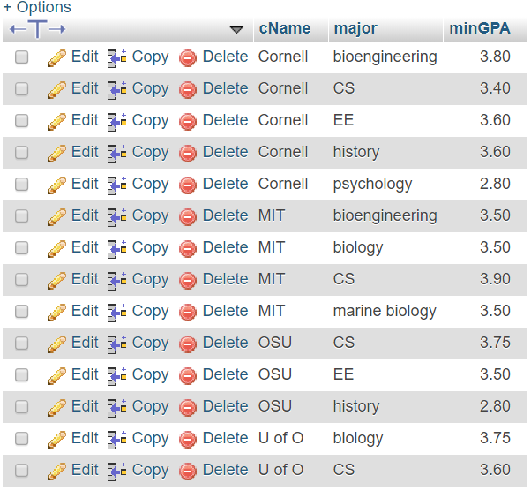

-- q1.  (a) List the sID, name and number of applications (as Number of Apps) that each student submitt

-- If the students did not make any applications the Number of Apps is 0.

SELECT sID, sName, count(decision)

FROM(

SELECT S.sID, S.sName, A.decision

FROM Student S LEFT JOIN Apply A ON S.sID = A.sID

)AS t

GROUP BY sID

Or this one underneath both work

SELECT Student.sName, Student.sID, count(Apply.sID)

FROM Student

LEFT JOIN Apply ON Student.sID = Apply.sID

GROUP BY Student.sID

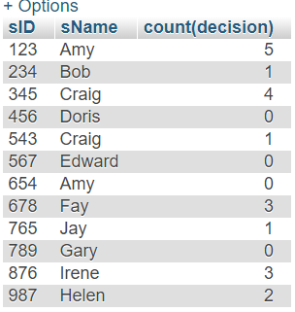

-- (b) List the sID, name and number of applications (as Number of Apps)

-- for each student that submitted three or more applications.

SELECT sID, sName, offer

FROM(

SELECT sID, sName, count(decision) AS offer

FROM(

SELECT S.sID, S.sName, A.decision

FROM Student S LEFT JOIN Apply A ON S.sID = A.sID

)AS t

GROUP BY sID

)As p

WHERE offer >= 3

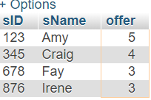

-- 2)   List the sID and name of each student from a small HS

-- (less than 600 students) who is applying to a CS major.

SELECT S.sID, S.sName FROM Apply A, Student S

WHERE S.sID = A.sID and S.sizeHS <=600 and A.major = 'CS'

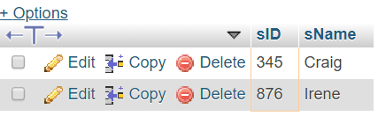

-- 3)   (a) Determine the average minimum GPA requirement for each college.

SELECT M.cName, AVG(minGPA)

FROM MinimumGPA M GROUP BY M.cName

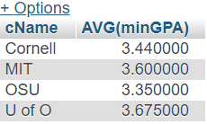

-- (b) Determine the name of the college with the greatest average

-- minimum GPA requirement.

SELECT t.cName, avgVal

FROM(

SELECT M.cName , AVG(minGPA) AS avgVal

FROM MinimumGPA M

GROUP BY M.cName

) AS t

WHERE avgVal = (select max(avgVal)

FROM (select M.cName,AVG(minGPA) AS avgVal

from MinimumGPA M GROUP BY M.cName) as p)

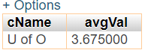

-- 4)   List the name and id of the students that applied to OSU

-- but did not apply to U of O.

SELECT t.sName, t.sID

FROM(

    SELECT S.sName, S.sID

    FROM Student S, Apply A

    WHERE S.sID = A.sID AND A.cName = 'OSU'

    GROUP BY S.sName

)AS t

WHERE t.sID Not In (

    SELECT S.sID

    FROM Student S, Apply A

    WHERE S.sID = A.sID AND A.cName = 'U of O')

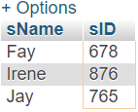

-- 5)   For students with GPA’s higher than the minimum requirements

-- for the major they applied for, give the student’s name, GPA, college name and major.

SELECT sName, sID, cName, GPA, major

FROM Student NATURAL JOIN Apply NATURAL JOIN MinimumGPA

WHERE GPA > minGPA

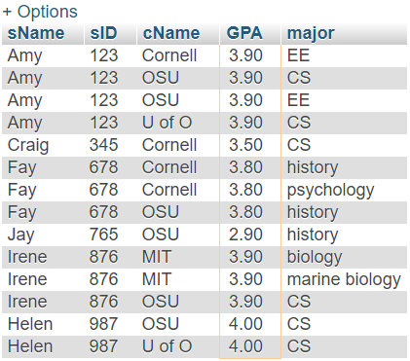

-- 6)   List the name and id of the students that applied

-- to all schools. Do not use the names of the schools in your query.

SELECT S.sName, A.sID

FROM Student S, (

SELECT A.sID, Count(DISTINCT A.cName) AS count1, Count(DISTINCT C.cName) AS count2

FROM Apply A, College C

GROUP BY A.sID

)AS A

WHERE S.sID = A.sID and A.count1 = A.count2

