实习三 Python编程（正则表达式）

- 实习目的
- 熟悉构建正则表达式。
- 熟悉利用正则表达式提取文本。

- 实习内容
以下文档是利用scikit-learn包中的决策树模块生成的决策规则（保存在dot文本文件中），文档包括节点和节点关系两方面内容，节点包括名称（节点编号）和标注（节点信息），节点关系包括->符号（表示节点的父子关系）及可选的其它信息。
节点分表达式节点和输出结果节点，都有gini系数、样本数、值等信息，此外，表达式节点还包括表达式信息。
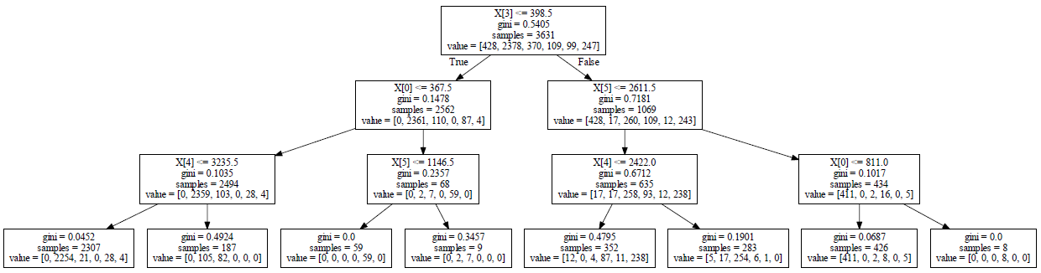
决策树示意图

digraph Tree {
node [shape=box] ;
0 [label="X[3] <= 398.5\ngini = 0.5405\nsamples = 3631\nvalue = [428, 2378, 370, 109, 99, 247]"] ;
1 [label="X[0] <= 367.5\ngini = 0.1478\nsamples = 2562\nvalue = [0, 2361, 110, 0, 87, 4]"] ;
0 -> 1 [labeldistance=2.5, labelangle=45, headlabel="True"] ;
2 [label="X[4] <= 3235.5\ngini = 0.1035\nsamples = 2494\nvalue = [0, 2359, 103, 0, 28, 4]"] ;
1 -> 2 ;
3 [label="gini = 0.0452\nsamples = 2307\nvalue = [0, 2254, 21, 0, 28, 4]"] ;
2 -> 3 ;
4 [label="gini = 0.4924\nsamples = 187\nvalue = [0, 105, 82, 0, 0, 0]"] ;
2 -> 4 ;
5 [label="X[5] <= 1146.5\ngini = 0.2357\nsamples = 68\nvalue = [0, 2, 7, 0, 59, 0]"] ;
1 -> 5 ;
6 [label="gini = 0.0\nsamples = 59\nvalue = [0, 0, 0, 0, 59, 0]"] ;
5 -> 6 ;
7 [label="gini = 0.3457\nsamples = 9\nvalue = [0, 2, 7, 0, 0, 0]"] ;
5 -> 7 ;
8 [label="X[5] <= 2611.5\ngini = 0.7181\nsamples = 1069\nvalue = [428, 17, 260, 109, 12, 243]"] ;
0 -> 8 [labeldistance=2.5, labelangle=-45, headlabel="False"] ;
9 [label="X[4] <= 2422.0\ngini = 0.6712\nsamples = 635\nvalue = [17, 17, 258, 93, 12, 238]"] ;
8 -> 9 ;
10 [label="gini = 0.4795\nsamples = 352\nvalue = [12, 0, 4, 87, 11, 238]"] ;
9 -> 10 ;
11 [label="gini = 0.1901\nsamples = 283\nvalue = [5, 17, 254, 6, 1, 0]"] ;
9 -> 11 ;
12 [label="X[0] <= 811.0\ngini = 0.1017\nsamples = 434\nvalue = [411, 0, 2, 16, 0, 5]"] ;
8 -> 12 ;
13 [label="gini = 0.0687\nsamples = 426\nvalue = [411, 0, 2, 8, 0, 5]"] ;
12 -> 13 ;
14 [label="gini = 0.0\nsamples = 8\nvalue = [0, 0, 0, 8, 0, 0]"] ;
12 -> 14 ;
}
现要求从文件中读取文档，利用正则表达式方法和其它方法提取每个表达式节点的名称和表达式，并以以下的形式进行输出。
begin node
name = 0
expression = X[3] <= 398.5
end node

begin node
name = 1
expression = X[0] <= 367.5
end node

begin node
name = 2
expression = X[4] <= 3235.5
end node

begin node
name = 5
expression = X[5] <= 1146.5
end node

begin node
name = 8
expression = X[5] <= 2611.5
end node

begin node
name = 9
expression = X[4] <= 2422.0
end node

begin node
name = 12
expression = X[0] <= 811.0
end node

3、提示
可以从简单到复杂分步骤调试。
第一步先调试建立正则表达式提取节点所在的行，如下所示：
>>>
0 [label="X[3] <= 398.5\ngini = 0.5405\nsamples = 3631\nvalue = [428, 2378, 370, 109, 99, 247]"] ;
1 [label="X[0] <= 367.5\ngini = 0.1478\nsamples = 2562\nvalue = [0, 2361, 110, 0, 87, 4]"] ;
2 [label="X[4] <= 3235.5\ngini = 0.1035\nsamples = 2494\nvalue = [0, 2359, 103, 0, 28, 4]"] ;
3 [label="gini = 0.0452\nsamples = 2307\nvalue = [0, 2254, 21, 0, 28, 4]"] ;
4 [label="gini = 0.4924\nsamples = 187\nvalue = [0, 105, 82, 0, 0, 0]"] ;
5 [label="X[5] <= 1146.5\ngini = 0.2357\nsamples = 68\nvalue = [0, 2, 7, 0, 59, 0]"] ;
6 [label="gini = 0.0\nsamples = 59\nvalue = [0, 0, 0, 0, 59, 0]"] ;
7 [label="gini = 0.3457\nsamples = 9\nvalue = [0, 2, 7, 0, 0, 0]"] ;
8 [label="X[5] <= 2611.5\ngini = 0.7181\nsamples = 1069\nvalue = [428, 17, 260, 109, 12, 243]"] ;
9 [label="X[4] <= 2422.0\ngini = 0.6712\nsamples = 635\nvalue = [17, 17, 258, 93, 12, 238]"] ;
10 [label="gini = 0.4795\nsamples = 352\nvalue = [12, 0, 4, 87, 11, 238]"] ;
11 [label="gini = 0.1901\nsamples = 283\nvalue = [5, 17, 254, 6, 1, 0]"] ;
12 [label="X[0] <= 811.0\ngini = 0.1017\nsamples = 434\nvalue = [411, 0, 2, 16, 0, 5]"] ;
13 [label="gini = 0.0687\nsamples = 426\nvalue = [411, 0, 2, 8, 0, 5]"] ;
14 [label="gini = 0.0\nsamples = 8\nvalue = [0, 0, 0, 8, 0, 0]"] ;

第二步对第一步构建的正则表达式再增加限制，只提取表达式节点，如下所示：
>>>
0 [label="X[3] <= 398.5\ngini = 0.5405\nsamples = 3631\nvalue = [428, 2378, 370, 109, 99, 247]"] ;
1 [label="X[0] <= 367.5\ngini = 0.1478\nsamples = 2562\nvalue = [0, 2361, 110, 0, 87, 4]"] ;
2 [label="X[4] <= 3235.5\ngini = 0.1035\nsamples = 2494\nvalue = [0, 2359, 103, 0, 28, 4]"] ;
5 [label="X[5] <= 1146.5\ngini = 0.2357\nsamples = 68\nvalue = [0, 2, 7, 0, 59, 0]"] ;
8 [label="X[5] <= 2611.5\ngini = 0.7181\nsamples = 1069\nvalue = [428, 17, 260, 109, 12, 243]"] ;
9 [label="X[4] <= 2422.0\ngini = 0.6712\nsamples = 635\nvalue = [17, 17, 258, 93, 12, 238]"] ;
12 [label="X[0] <= 811.0\ngini = 0.1017\nsamples = 434\nvalue = [411, 0, 2, 16, 0, 5]"] ;

第三步对每个表达式节点提取名称（编号）和表达式，如下所示：
>>>
0 X[3] <= 398.5
1 X[0] <= 367.5
2 X[4] <= 3235.5
5 X[5] <= 1146.5
8 X[5] <= 2611.5
9 X[4] <= 2422.0
12 X[0] <= 811.0
第四步根据提取出的值构建字符串进行输出。

