Suspicious Transaction Alert

Dear AML Compliance Officer,  
  
The transaction between sender_account 2109640283 and receiver_account 9370756208 has been flagged as **suspicious.** Details will be listed in PART A (Transaction Information), PART B (Transaction Features), PART C (Counterparties Screenshot), and PART D (Model Justification).

# PART A (Transaction Information)

Transaction Information Table

|  |  |
| --- | --- |
| Column_Name | Column_Value |
| Transaction_id | T9040512 |
| Hour | 15 |
| Minute | 45 |
| Date | 2023-08-07 |
| Year | 2023 |
| Month | 8 |
| Day | 7 |
| Sender_account | 2109640283 |
| Receiver_account | 9370756208 |
| Amount | 5304.79 |
| Amount_USD | 6703.132644 |
| Payment_currency | UK pounds |
| Received_currency | UK pounds |
| Sender_bank_location | UK |
| Receiver_bank_location | UK |
| Payment_type | ACH |

# PART B (Transaction Features)

Transaction Features Table

|  |  |
| --- | --- |
| Column_Name | Column_Value |
| Last_transaction_time_elapsed_minutes | 162517.23333333334 |
| Amount_USD | 6703.132644 |
| Sender_bank_location_risk | 4.0 |
| Receiver_bank_location_risk | 4.0 |
| Payment_type_risk | 4.0 |
| Different_Currency | 0.0 |
| sender_f_degree_out | 3.0 |
| receiver_f_degree_out | 4.0 |
| receiver_f_degree_in | 12.0 |
| sender_f_egored_nr_trans_in | 0.0 |
| receiver_f_egored_degree_in_rel | 0.16666666666666666 |
| sender_f_degree_in | 8.0 |
| sender_f_nr_trans_in | 86.0 |
| sender_f_amount_out | 113058.66478400001 |
| receiver_f_egored_degree_out_rel | 0.5 |
| sender_f_egored_average_amount_out_rel | 0.0 |
| sender_f_egored_nr_trans_out | 0.0 |
| sender_f_average_amount_in | 14437.002984686049 |
| receiver_f_egored_nr_trans_in | 11.0 |
| sender_f_egored_degree_out_rel | 0.0 |
| sender_f_egored_amount_out_rel | 0.0 |

# PART C (Counterparties Screenshot)

Counterparties Screenshot of Sender account 2109640283

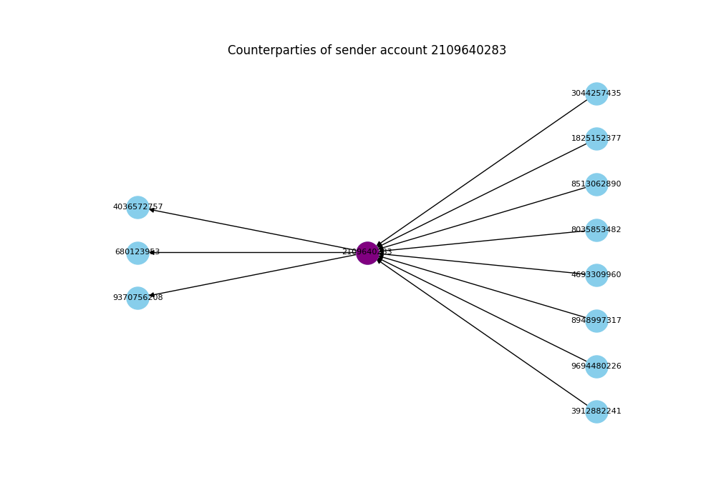

Counterparties Screenshot of receiver account 9370756208

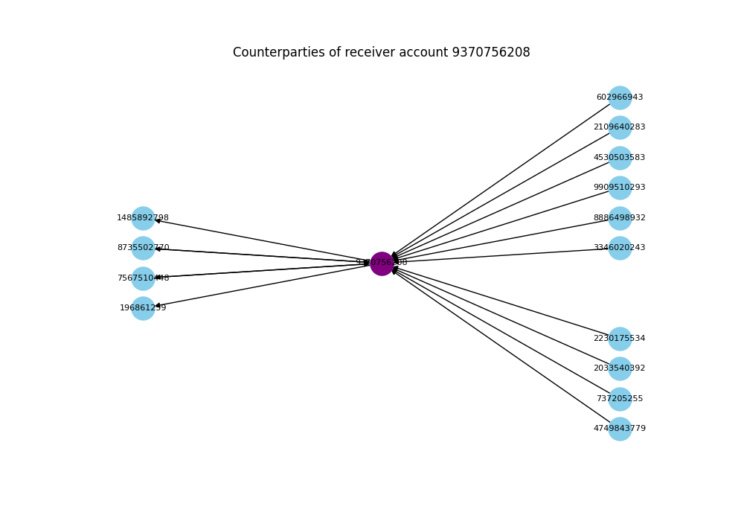

# PART C (Model Justification)

Feature Contribution Score Table

|  |  |  |
| --- | --- | --- |
| feature_name | feature_value | feature_contribution_score |
| receiver_f_degree_out | 4.0 | 30.0 |
| sender_f_degree_out | 3.0 | 16.0 |
| receiver_f_degree_in | 12.0 | 16.0 |

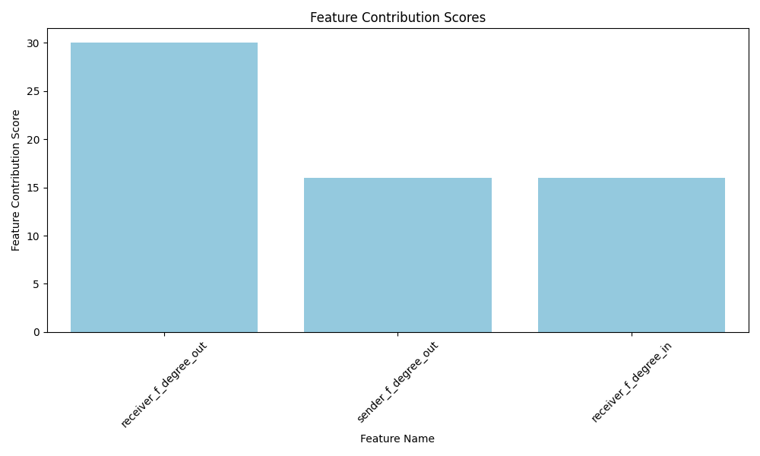

Explanation:  
The A.I. identified the above features as significant for predicting suspicious transactions, based on their contribution scores. Higher scores indicate greater influence on the prediction outcome.

The combinination of these conditions raises concerns about the transaction's nature. Further investigation is warranted to ensure compliance with anti-money laundering regulations.  
  
Please let me know if you require any further information or assistance regarding this matter.  
  
Sincerely,  
[Python Developer]