View the original doc at: https://desktop.github.com/

[GitHub Desktop](https://desktop.github.com/)

* [Overview](https://desktop.github.com/)

* [Release Notes](https://desktop.github.com/release-notes/windows/)

* |

* [Help](https://help.github.com/desktop)

Simple collaboration from your desktop

GitHub Desktop is a seamless way to contribute to projects on [GitHub](https://github.com/) and [GitHub Enterprise](https://enterprise.github.com/).

Available for [Mac](https://desktop.github.com/) and [Windows](https://desktop.github.com/)

[Download GitHub DesktopWindows 7 or later](https://github-windows.s3.amazonaws.com/GitHubSetup.exe)

By clicking the Download button you agree to the[End-User License Agreement](https://desktop.github.com/eula/)

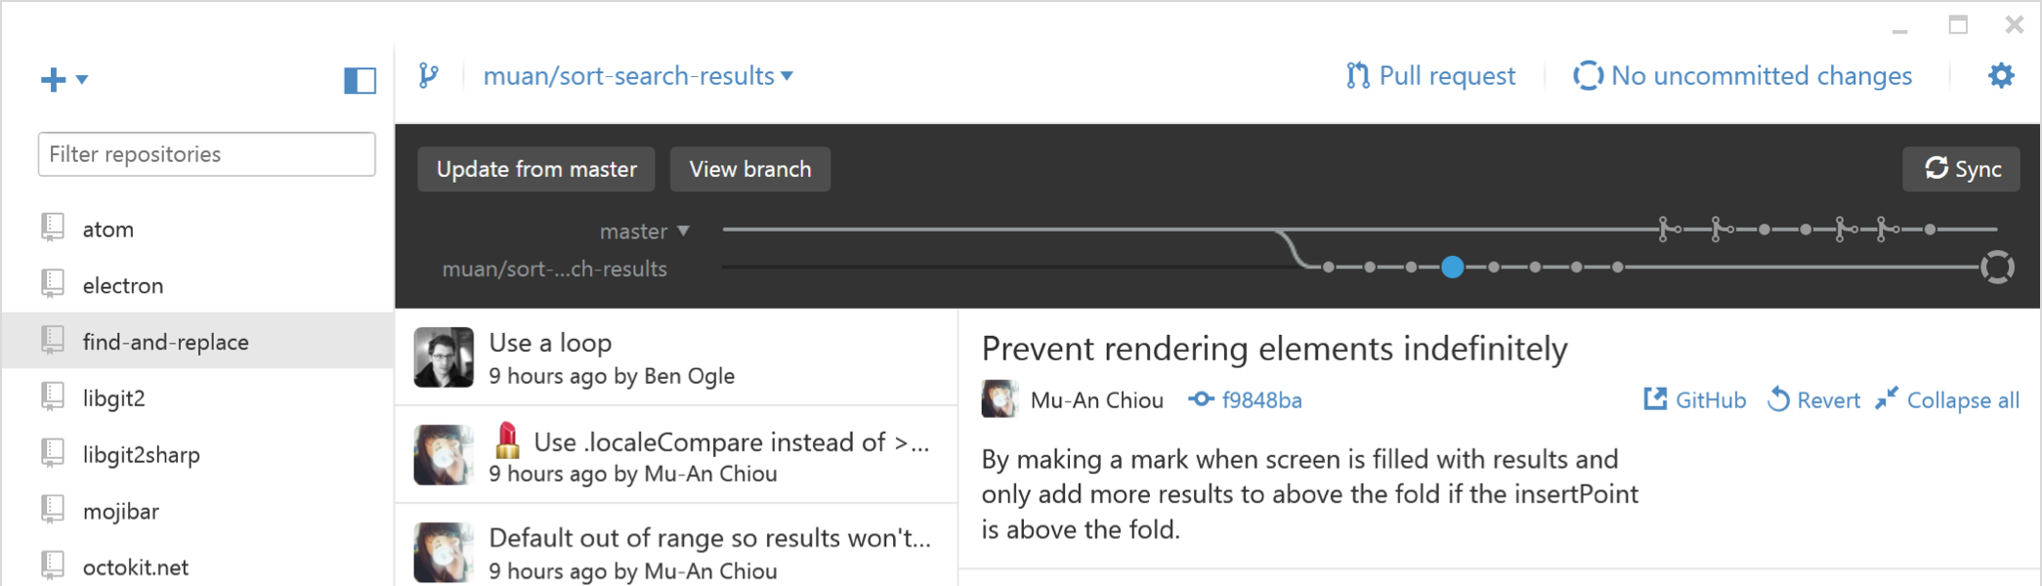

Your GitHub workflow in one native app

Clone repositories

Create branches

Commit changes

Share code

Start a project

You’ll find all the projects you’re working on listed in the sidebar. If you’re starting a new project, use the repository drop down menu to create a new repository or clone an existing one directly from GitHub.com.

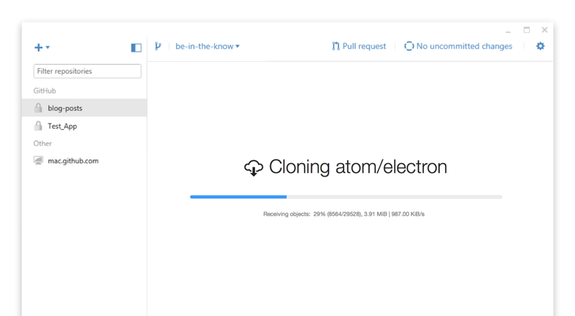

Branch off

Branches are essential to proposing changes and reviewing code on GitHub—and they’re always available in the top left corner of the repository view. Just select the current branch to switch branches or create a new one.

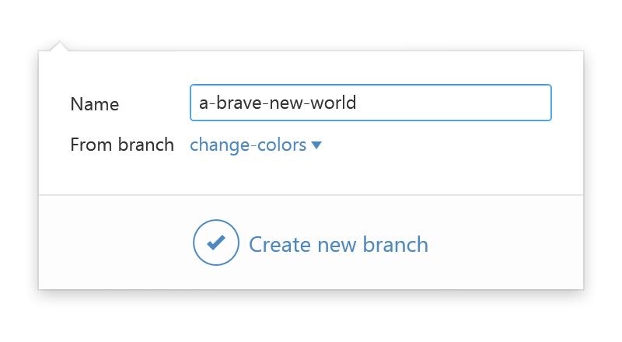

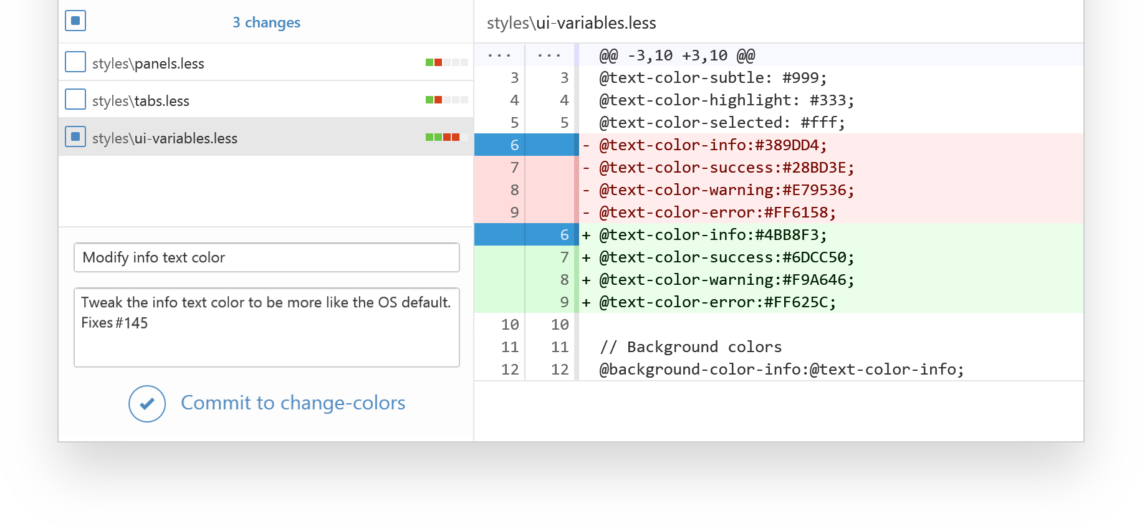

Craft the perfect commit

View a diff of your uncommitted changes, and form the perfect commit by selecting the files—or even the specific lines—that make up a change. Enter the summary and description, then commit.

See your history

Visualize your changes and commits in the comparison graph. You can select commits on the graph to navigate through the history of your local branches.

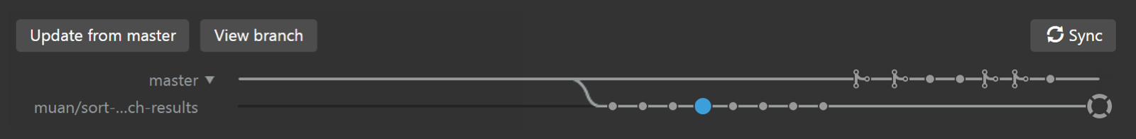

Create a pull request

Once you’re happy with your commits, you can open a pull request for review and discussion without leaving GitHub Desktop or touching the command line.

Merge and deploy

Browse commits on local and remote branches to quickly and clearly see what changes still need to be merged. You can also merge your code to the master branch for deployment right from the app.

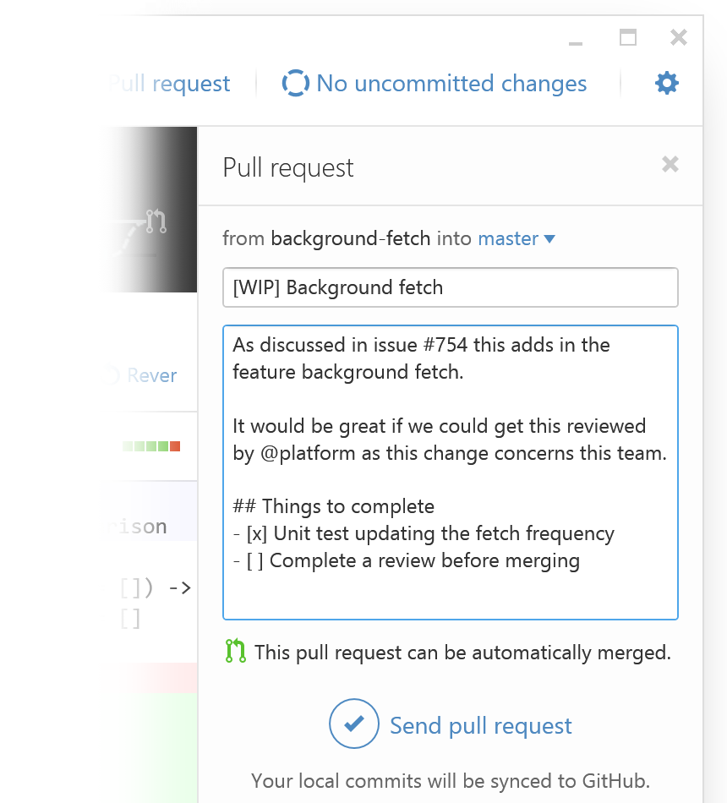

Start contributing, natively

[Download GitHub DesktopWindows 7 or later](https://github-windows.s3.amazonaws.com/GitHubSetup.exe)

Also available for [Mac](https://desktop.github.com/)

* [Overview](https://desktop.github.com/)

* [Release Notes](https://desktop.github.com/release-notes/windows/)

* |

* [Help](https://help.github.com/desktop)

© 2017 GitHub, Inc. All rights reserved.