技术说明文档

一、项目概述

项目背景：
BMS系统是智能化管理及维护各个电池单元，防止电池出现过充电和过放电、延长电池的使用寿命、监控电池状态的系统。在BMS系统中存在大量电池各种信号的规则管理以及监控，良好的是处理信号，并且根据规则，生成相关预警信息，能够极大提升用户体验。为此需要大家完成一套支持规则配置、信号预警的系统，来解决电池各种突发情况和提升用户体验。

二、技术架构

1. 整体架构图：
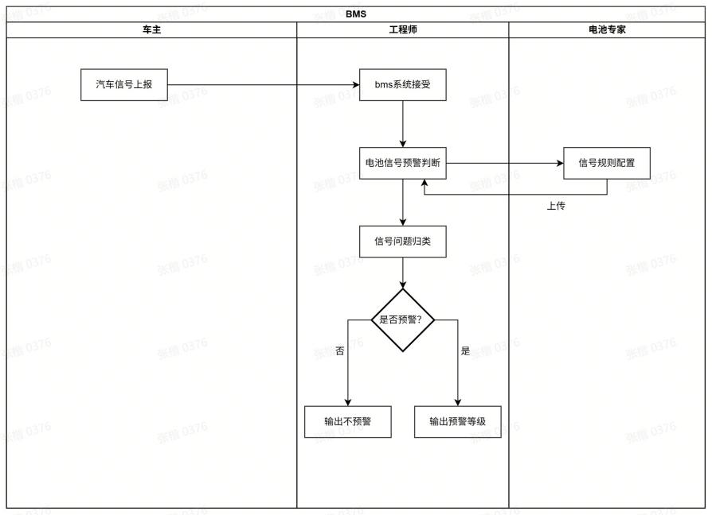
ER图

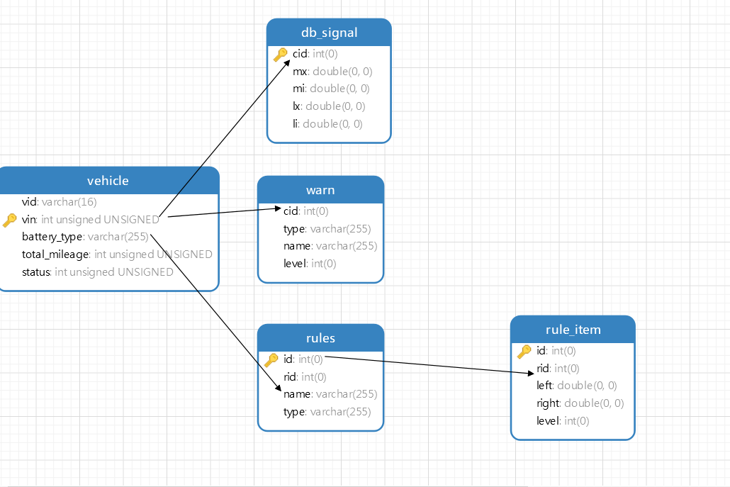

文件结构图：、
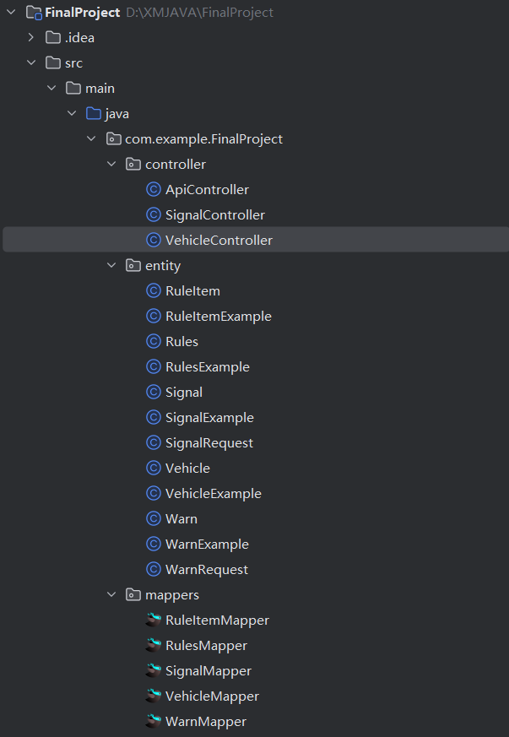 | 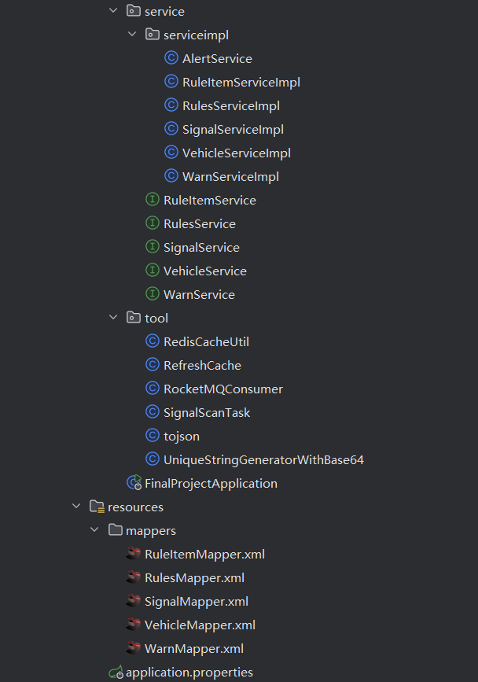

三、功能模块说明

1. 功能模块列表：
模块1; 车辆模块
模块2：信号模块
模块3：警告查询模块
模块4：定时预警模块

四、接口设计

1. 外部接口：
查询汽车和添加汽车
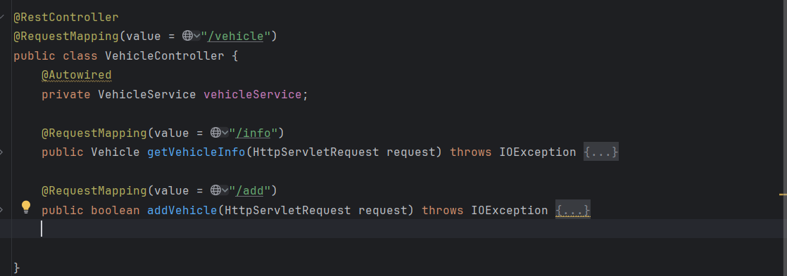
电池信息的增删改查

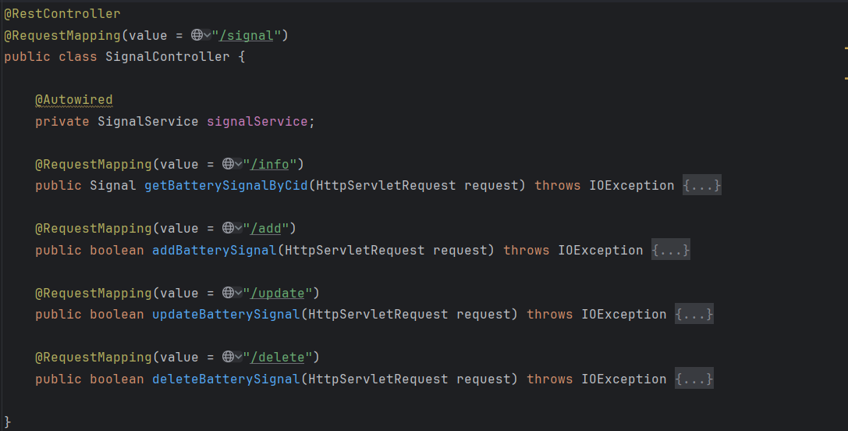
查询电池信号状态
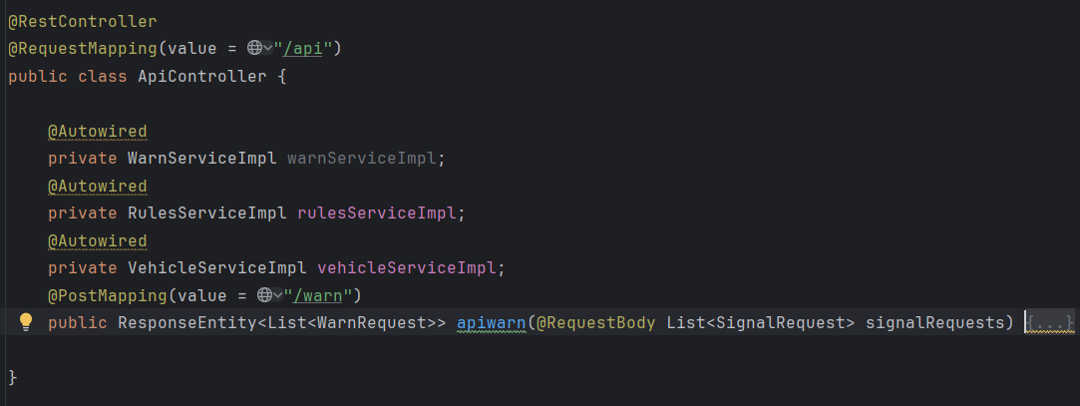

五、详细设计

预警信息
Java
@PostMapping(value = "/warn")
public ResponseEntity<List<WarnRequest>> apiwarn(@RequestBody List<SignalRequest> signalRequests) {
List<WarnRequest> warns = new ArrayList<>();
ObjectMapper objectMapper = new ObjectMapper();
// 从数组中获取单个请求
for (SignalRequest request : signalRequests) {
Signal signal = new Signal();
List<Rules> rules;
// 获取车辆信息
signal.setCid(request.getCarId());
int cid= request.getCarId();
// 电池信息
String btype = vehicleServiceImpl.queryVehicle(cid).getBatteryType();
if (request.getWarnId() != null){
// 根据电池信息和规则编号获取规则
rules = rulesServiceImpl.findRulesByTypeAndRid(btype, request.getWarnId());
}
// 根据电池信息获取规则
else {
rules = rulesServiceImpl.getRulesType(btype);
}
try {
// 解析 signal 字符串为 JSON 对象
Map<String, Object> signalMap = objectMapper.readValue(request.getSignal(), Map.class);
// 设置 mx
if (signalMap.get("Mx") != null) {
signal.setMx((Double) signalMap.get("Mx"));
}
// 设置 mi
if (signalMap.get("Mi") != null) {
signal.setMi((Double) signalMap.get("Mi"));
}
// 设置 lx（将 Ix 映射到 lx）
if (signalMap.get("Ix") != null) {
signal.setLx((Double) signalMap.get("Ix"));
}
// 设置 li（将 Ii 映射到 li）
if (signalMap.get("Ii") != null) {
signal.setLi((Double) signalMap.get("Ii"));
}
// 遍历所有规则
for (Rules rule : rules) {
int rid=rule.getRid();
int temp =-1;
if (rid==1){
temp =rule.judge(signal.getMx()- signal.getMi());}
else if(rid==2){
temp =rule.judge(signal.getLx()- signal.getLi());
}
WarnRequest warn= new WarnRequest();
warn.setCid(request.getCarId());
warn.setName(rule.getName());
warn.setType(rule.getType());
if (temp !=-1) {
warn.setLevel(String.valueOf(temp));
}
else {
warn.setLevel("不报警");
}
warns.add(warn);
}
} catch (IOException e) {
// 处理 JSON 解析异常
return ResponseEntity.badRequest().body(null);
}
}
return ResponseEntity.ok(warns);
}

Java
public List<Rules> findRulesByTypeAndRid(String type, int rid) {
List<Rules> rulesList = new ArrayList<>();
String indexKey = String.format("rules:index:type:%s:rid:%s", type,rid);
// 获取所有匹配的缓存键
Set<String> cacheKeys = stringRedisTemplate.opsForSet().members(indexKey);
if (cacheKeys != null && !cacheKeys.isEmpty()) {
for (String cacheKey : cacheKeys) {
// 从 Redis 获取 Rules 对象
String rulesJson = stringRedisTemplate.opsForValue().get(cacheKey);
if (rulesJson != null) {
Gson gson = new GsonBuilder().serializeSpecialFloatingPointValues().create();
Rules rules = gson .fromJson(rulesJson, Rules.class);
rulesList.add(rules);
}
}
}
else {
RulesExample ruleExample = new RulesExample();
ruleExample.createCriteria().andTypeEqualTo(type).andRidEqualTo(rid);
rulesList=rulesMapper.selectByExample(ruleExample);
if (rulesList != null) {
for (Rules rules : rulesList) {
String cacheKey = CACHE_KEY_PREFIX + rules.getId();
RuleItemExample ruleItemExample = new RuleItemExample();
ruleItemExample.createCriteria().andRidEqualTo(rules.getId());
// 将查询结果存入 Redis 缓存，设置过期时间
rules.setRuleItems(ruleItemMapper.selectByExample(ruleItemExample));
Gson gson = new GsonBuilder().serializeSpecialFloatingPointValues().create();
stringRedisTemplate.opsForValue().set(cacheKey, gson.toJson( rules));
// 更新索引结构
indexKey = String.format("rules:index:type:%s:rid:%s", rules.getType(), rules.getRid());
stringRedisTemplate.opsForSet().add(indexKey, cacheKey);
}
} else {
// 未查询到电池信号状态
return null;
}
}
return rulesList;
}

Java
public List<Rules> getRulesType(String type) {
// 从 Redis 缓存中获取电池信号状态对象
RulesExample ruleExample = new RulesExample();
ruleExample.createCriteria().andTypeEqualTo(type);
List<Rules> rulesList=rulesMapper.selectByExample(ruleExample);
if (rulesList != null) {
for (Rules rules : rulesList) {
String cacheKey = CACHE_KEY_PREFIX + rules.getId();
RuleItemExample ruleItemExample = new RuleItemExample();
ruleItemExample.createCriteria().andRidEqualTo(rules.getId());
// 将查询结果存入 Redis 缓存，设置过期时间（例如 60 秒）
rules.setRuleItems(ruleItemMapper.selectByExample(ruleItemExample));
Gson gson = new GsonBuilder().serializeSpecialFloatingPointValues().create();
stringRedisTemplate.opsForValue().set(cacheKey, gson.toJson( rules));
// 更新索引结构
String indexKey = String.format("rules:index:type:%s:rid:%s", rules.getType(), rules.getRid());
stringRedisTemplate.opsForSet().add(indexKey, cacheKey);
}
} else {
// 未查询到电池信号状态
return null;
}
return rulesList;
}

定时任务
Java
//生产者
@Component
public class SignalScanTask {
@Autowired
private RocketMQTemplate rocketMQTemplate;
@Autowired
private VehicleMapper vehicleMapper;
@Autowired
private SignalServiceImpl signalService;
// 每隔60秒执行一次定时任务
@Scheduled(fixedRate = 60000)
public void scanSignals() {
// 查询电池信号数据
VehicleExample example = new VehicleExample();
List<Vehicle> vehicles = vehicleMapper.selectByExample(example);
for (Vehicle vehicle : vehicles) {
// 构建 Signal 对象
Signal signal = signalService.getBatterySignalByCid(vehicle.getVin());
// 发送信号数据到 RocketMQ
rocketMQTemplate.convertAndSend("signal-topic", signal);
// rocketMQTemplate.sendOneWay("signal-topic", signal);
}
}
}
//消费者
@Component
@RocketMQMessageListener(topic = "signal-topic", consumerGroup = "default-consumer-group")
public class RocketMQConsumer implements RocketMQListener<Signal> {
@Autowired
private AlertService alertService;
@Override
public void onMessage(Signal signal) {
// 生成预警信息
alertService.generateAlert(signal);
}
}

六、运行结果
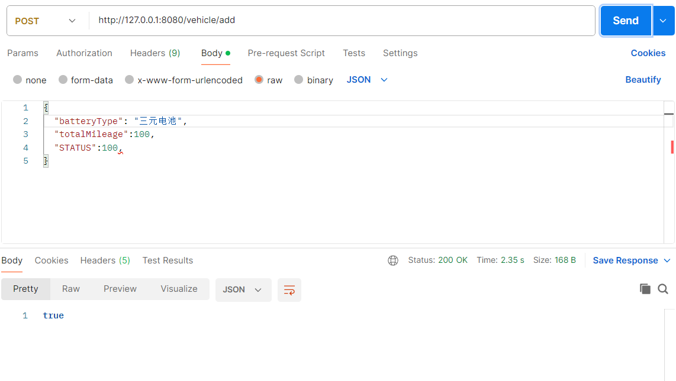

规则表和条目表

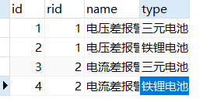
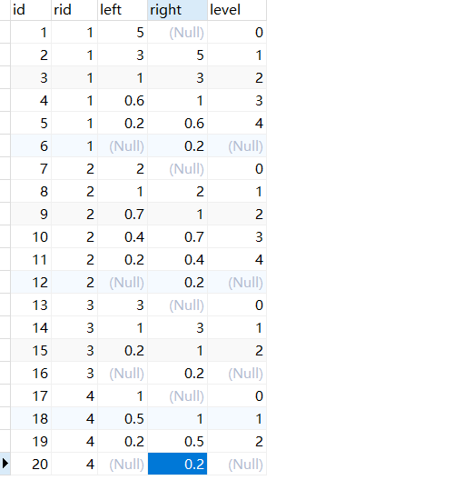

预警接口
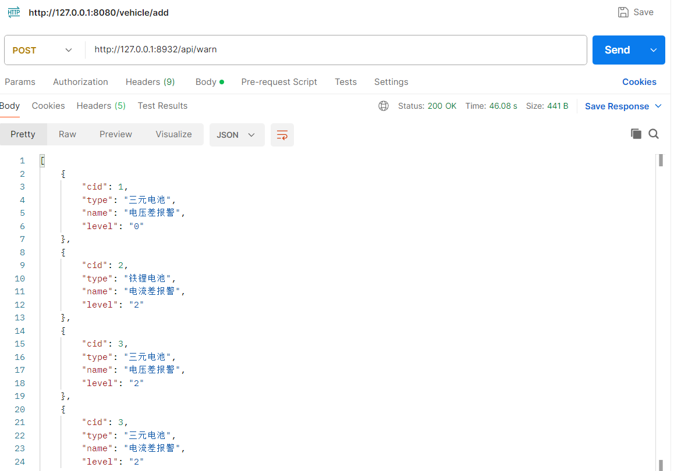

增删改查
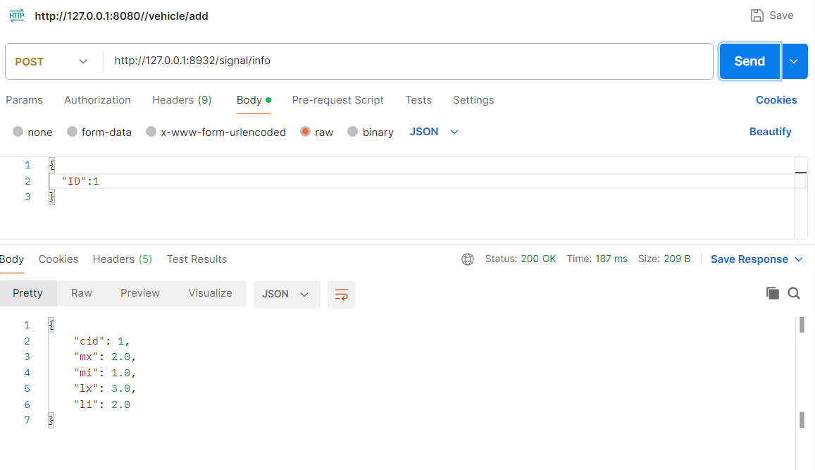
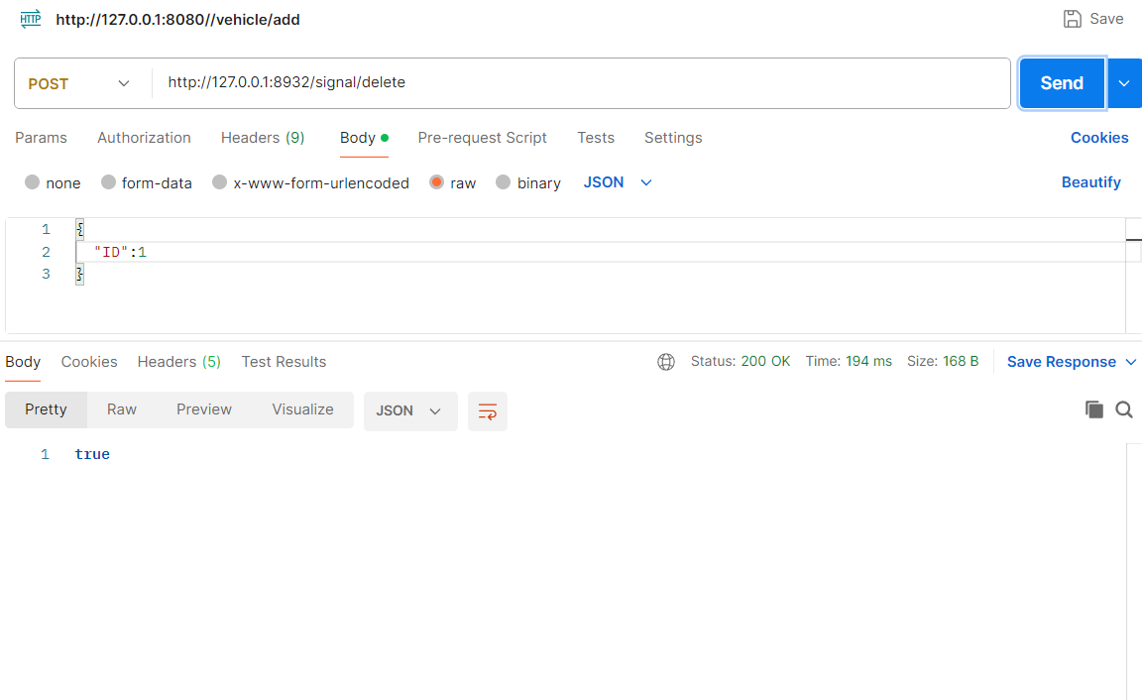
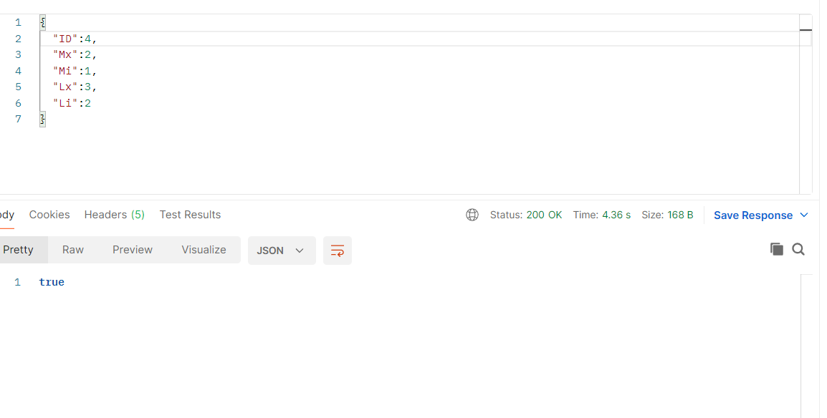
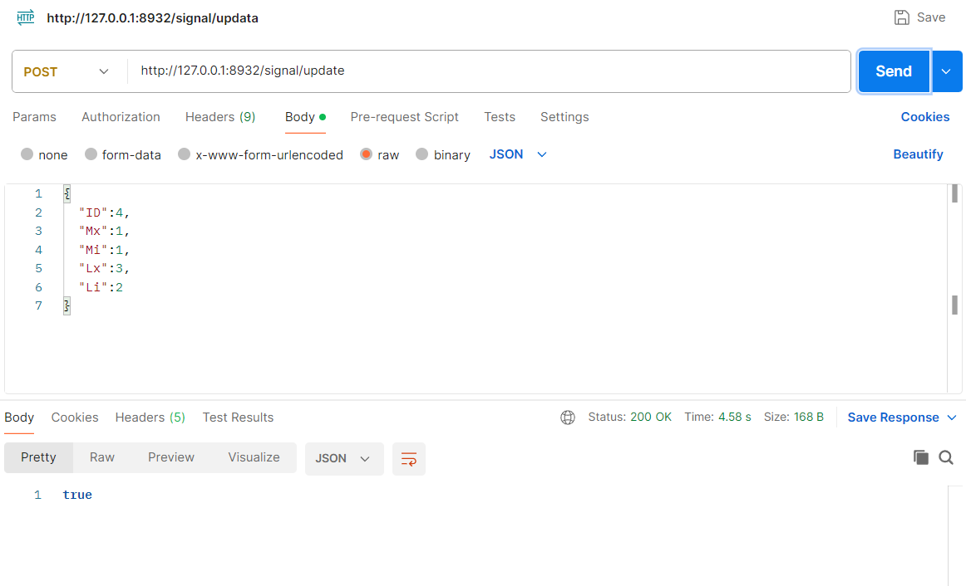

定时任务
