## 数据库表结构

系统一共包含了11张数据表，如下所示。

表 1.1 BookInfos(图书信息表)

|  |  |  |  |  |  |  |
| --- | --- | --- | --- | --- | --- | --- |
| **字段** | **类型** | **空** | **默认** | **链接到** | **注释** | **MIME** |
| CallNo(主键) | varchar(20) | 否 |  |  | 索书号 |  |
| Name | varchar(100) | 否 |  |  | 书籍名称 |  |
| TypeNumber | VARCHAR(10) | 否 |  | BookType -> Number | 类型编号 |  |
| Author | VARCHAR(100) | 是 | NULL |  | 作者 |  |
| Translator | VARCHAR(100) | 是 | NULL |  | 译者 |  |
| Press | VARCHAR(100) | 是 | NULL |  | 出版社 |  |
| DatePublication | YEAR(4) | 是 | NULL |  | 出版年份 |  |
| Price | DOUBLE | 是 | NULL |  | 价格 |  |
| Page | INT(11) | 是 | NULL |  | 页码 |  |

表 1.2 Books（图书表）

|  |  |  |  |  |  |  |
| --- | --- | --- | --- | --- | --- | --- |
| **字段** | **类型** | **空** | **默认** | **链接到** | **注释** | **MIME** |
| Barcode(主键) | VARCHAR(40) | 否 |  |  | 图书条形码 |  |
| BookCallNo | VARCHAR(20) | 否 |  | BookInfos -> CallNo | 图书索书号 |  |
| Operator | VARCHAR | 否 |  | Operator -> Number | 操作员 |  |
| State | BIT(1) | 否 | False |  | 是否外借(False为在库，True为外借) |  |
| Disbled | BIT(1) | 否 | False |  | 是否禁用(False为启用，True为禁用) |  |

表 1.3 BookStatistics（图书统计表）

|  |  |  |  |  |  |  |
| --- | --- | --- | --- | --- | --- | --- |
| **字段** | **类型** | **空** | **默认** | **链接到** | **注释** | **MIME** |
| BookCallNo(主键) | VARCHAR(20) | 否 |  | BookInfos -> CallNo | 图书索书号 |  |
| NumOfLoans | INT(11) | 否 | 0 |  | 借出次数 |  |
| Surplus | INT(11) | 否 | 0 |  | 库存剩余量 |  |
| Total | INT(11) | 否 | 0 |  | 库存总量 |  |

表1.4 BookType（图书类型表表）

|  |  |  |  |  |  |  |
| --- | --- | --- | --- | --- | --- | --- |
| **字段** | **类型** | **空** | **默认** | **链接到** | **注释** | **MIME** |
| Number(主键) | VARCHAR(10) | 否 |  |  | 编号 |  |
| Name | VARCHAR(45) | 否 |  |  | 名称 |  |

表1.5 Borrowing（图书借阅表）

|  |  |  |  |  |  |  |
| --- | --- | --- | --- | --- | --- | --- |
| **字段** | **类型** | **空** | **默认** | **链接到** | **注释** | **MIME** |
| Id (主键) | INT(11) | 否 |  |  | 主键 |  |
| BookBarcode | VARCHAR(40) | 否 |  | Books -> Barcode | 图书条形码 |  |
| RBarcode | VARCHAR(40) | 否 |  | Readers -> Barcode | 读者条形码 |  |
| StartTime | DATETIME | 否 |  |  | 开始时间 |  |
| ExpiryTime | DATETIME | 否 |  |  | 到期时间 |  |
| DisabledRenew | BIT(1) | 否 |  |  | 是否允许续借 |  |
| Operator | VARCHAR(20) | 否 |  | Operator -> Number | 操作员 |  |

表1.6 BorrowingRecords（图书记录表(存放图书归还后借阅数据)）

|  |  |  |  |  |  |  |
| --- | --- | --- | --- | --- | --- | --- |
| **字段** | **类型** | **空** | **默认** | **链接到** | **注释** | **MIME** |
| Id (主键) | INT(11) | 否 |  |  | 主键 |  |
| BookBarcode | VARCHAR(40) | 否 |  | Books -> Barcode | 图书条形码 |  |
| RBarcode | VARCHAR(40) | 否 |  | Readers -> Barcode | 读者条形码 |  |
| StartTime | DATETIME | 否 |  |  | 开始时间 |  |
| ExpiryTime | DATETIME | 否 |  |  | 到期时间 |  |
| DisabledRenew | BIT(1) | 否 |  |  | 是否允许续借 |  |
| Operator | VARCHAR(20) | 否 |  | Operator -> Number | 操作员 |  |

表1.7 Fine（图书罚款表）

|  |  |  |  |  |  |  |
| --- | --- | --- | --- | --- | --- | --- |
| **字段** | **类型** | **空** | **默认** | **链接到** | **注释** | **MIME** |
| Id (主键) | INT(11) | 否 |  |  | 主键 |  |
| BookBarcode | VARCHAR(40) | 否 |  | Books -> Barcode | 图书条形码 |  |
| RBarcode | VARCHAR(40) | 否 |  | Readers -> Barcode | 读者条形码 |  |
| SBId | INT(11) | 否 |  | SendBack->Id | 归还Id |  |
| Price | DOUBLE | 否 |  |  | 欠款金额 |  |
| Payment | BIT(1) | 否 |  |  | 是否交款 |  |
| Operator | VARCHAR(20) | 是 |  | Operator -> Number | 操作员 |  |

表1.8 Operators（操作员表）

|  |  |  |  |  |  |  |
| --- | --- | --- | --- | --- | --- | --- |
| **字段** | **类型** | **空** | **默认** | **链接到** | **注释** | **MIME** |
| Number | VARCHAR(20) | 否 |  |  | 编号(主键) |  |
| Name | VARCHAR(20) | 否 |  |  | 姓名 |  |
| Password | VARCHAR(20) | 否 |  |  | 密码 |  |

表1.9 Readers（读者表）

|  |  |  |  |  |  |  |
| --- | --- | --- | --- | --- | --- | --- |
| **字段** | **类型** | **空** | **默认** | **链接到** | **注释** | **MIME** |
| Number | VARCHAR(20) | 否 |  |  | 编号(主键) |  |
| Name | VARCHAR(20) | 否 |  |  | 姓名 |  |
| Password | VARCHAR(20) | 否 |  |  | 密码 |  |
| TypeId | INT(11) | 否 |  | ReaderType->Id | 读者类型Id |  |
| Barcode | VARCHAR(40) | 否 |  |  | 读者条形码 |  |
| Sex | VARCHAR(4) | 否 |  |  | 性别 |  |
| EnrollmentYear | YEAR(4) | 否 |  |  | 入学年份 |  |
| RegistrationDate | DATE | 否 |  |  | 登记日期 |  |
| Loss | BIT(1) | 否 |  |  | 是否丢失 |  |
| Disabled | BIT(1) | 否 |  |  | 是否禁用 |  |

表1.10 ReaderType（读者类型表）

|  |  |  |  |  |  |  |  |
| --- | --- | --- | --- | --- | --- | --- | --- |
| **字段** | | **类型** | **空** | **默认** | **链接到** | **注释** | **MIME** |
| Id (主键) | INT(11) | | 否 |  |  | 主键 |  |
| Name | | VARCHAR(20) | 否 |  |  | 类型名称 |  |
| LoanPeriod | | INT(11) | 否 |  |  | 可借天数 |  |
| DebitAmount | | DOUBLE | 否 |  |  | 欠款额度 |  |

表1.11 SendBack（图书归还表）

|  |  |  |  |  |  |  |
| --- | --- | --- | --- | --- | --- | --- |
| **字段** | **类型** | **空** | **默认** | **链接到** | **注释** | **MIME** |
| Id (主键) | INT(11) | 否 |  |  | 主键 |  |
| BookBarcode | VARCHAR(40) | 否 |  | Books -> Barcode | 图书条形码 |  |
| RBarcode | VARCHAR(40) | 否 |  | Readers -> Barcode | 读者条形码 |  |
| ReturnTime | DATETIME | 否 |  |  | 归还时间 |  |
| Operator | VARCHAR(20) | 否 |  | Operator -> Number | 操作员 |  |
| BRId | INT(11) | 否 |  | BorrowingRecords->Id | 借阅记录Id |  |

## 数据表关系图

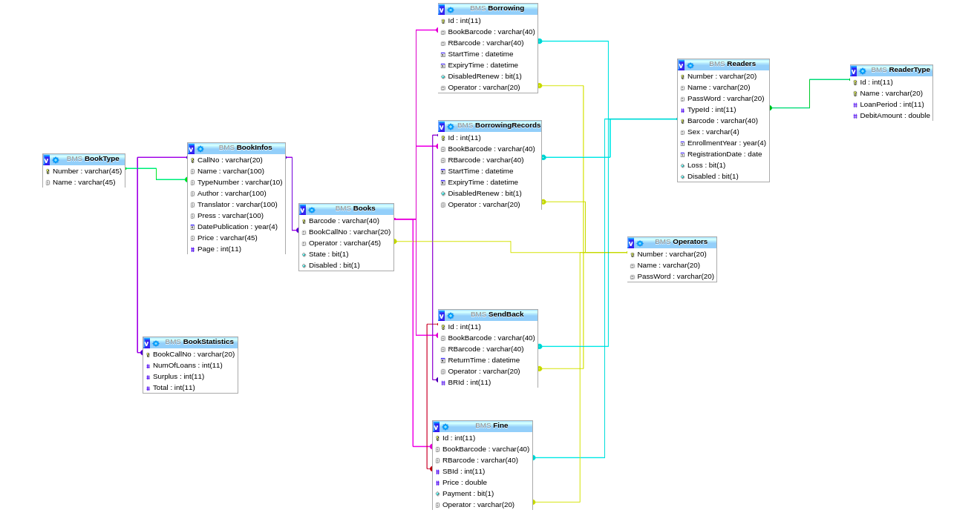

## 三、数据表数据记录

表 3.1 BookInfos(图书信息表)

|  |  |  |  |  |  |  |  |  |
| --- | --- | --- | --- | --- | --- | --- | --- | --- |
| CallNo(主键) | Name | TypeNumber | Author | Translator | Press | DatePublication | Price | Page |
| A18/1 | 马克思箴言 | A | 袁芳 | NULL | 吉林出版集团有限责任公司 | 2014 | 33 | 193 |
| A223/0809 | 唯物主义和经验批判主义 | A | 列宁 | NULL | 人民出版社 | 1960 | 29 | 512 |
| A31/3 | 斯大林文选 | A | 斯大林 | NULL | 人民出版社 | 1962 | 22 | 663 |
| A44/4 | 毛泽东诗词集 | A | 毛泽东 | NULL | 中央文献出版社 | 1996 | 39 | 10265 |
| E072/1 | 指挥与控制战 | E | 宋跃进 | NULL | 国防工业出版社 | 2012 | 55 | 11207 |
| E08/1 | 军种的消亡 | E | 张啸天 | NULL | 新华出版社 | 2013 | NULL | 236 |
| TP312JA/17 | 实战JAVA高并发程序设计 | T | 葛一鸣，郭超 | NULL | 电子工业出版社 | 2015 | NULL | 12339 |

表 3.2 Books(图书表)

|  |  |  |  |  |
| --- | --- | --- | --- | --- |
| Barcode(主键) | BookCallNo | Operator | State | Disbled |
| A180001-01 | A18/1 | Admin | FALSE | FALSE |
| A180001-02 | A18/1 | Admin | FALSE | FALSE |
| A2230809-01 | A223/0809 | Admin | FALSE | FALSE |
| A2230809-02 | A223/0809 | Admin | FALSE | FALSE |
| A310003-01 | A31/3 | Admin | FALSE | FALSE |
| A440004-01 | A44/4 | Admin | FALSE | FALSE |
| A440004-02 | A44/4 | Admin | FALSE | FALSE |
| E0720001-01 | E072/1 | Admin | FALSE | FALSE |
| E0720001-02 | E072/1 | Admin | FALSE | FALSE |
| E0720001-03 | E072/1 | Admin | FALSE | FALSE |
| E080001-01 | E08/1 | Admin | TRUE | FALSE |
| E080001-02 | E08/1 | Admin | FALSE | FALSE |
| E080001-03 | E08/1 | Admin | FALSE | FALSE |
| TP312JA0017-01 | TP312JA/17 | Admin | TRUE | FALSE |
| TP312JA0017-02 | TP312JA/17 | Admin | FALSE | FALSE |

表 3.3 BookStatistics(图书库存 表)

|  |  |  |  |
| --- | --- | --- | --- |
| BookCallNo(主键) | NumOfLoans | Surplus | Total |
| A18/1 | 2 | 2 | 2 |
| A223/0809 | 0 | 2 | 2 |
| A31/3 | 0 | 2 | 2 |
| A44/4 | 0 | 2 | 2 |
| E072/1 | 0 | 3 | 3 |
| E08/1 | 1 | 2 | 3 |
| TP312JA/17 | 1 | 1 | 2 |

表 3.4 BookType(图书类型表)

|  |  |
| --- | --- |
| Number(主键) | Name |
| A | 马克思主义、列宁主义、毛泽东思想、邓小平理论 |
| B | 哲学、宗教 |
| C | 社会科学总论 |
| D | 政治、法律 |
| E | 军事 |
| F | 经济 |
| G | 文化、科学、教育、体育 |
| H | 语言、文字 |
| I | 文学 |
| J | 艺术 |
| K | 历史、地理 |
| N | 自然科学总论 |
| O | 数理科学和化学 |
| P | 天文学、地球科学 |
| Q | 生物科学 |
| R | 医药、卫生 |
| S | 农业科学 |
| T | 工业技术 |
| U | 交通运输 |
| V | 航空、航天 |
| X | 环境科学、劳动保护科学（安全科学） |
| Z | 综合性图书 |

表 3.5 Borrowing(图书借阅表)

|  |  |  |  |  |  |  |
| --- | --- | --- | --- | --- | --- | --- |
| Id (主键) | BookBarcode | RBarcode | StartTime | ExpiryTime | DisabledRenew | Operator |
| 3 | E080001-01 | T07001 | 2019-07-12 | 2019-09-12 | False | 18001 |
| 4 | TP312JA0017-01 | T08002 | 2019-07-15 | 2019-09-15 | False | 18002 |

表 3.6 BorrowingRecords(图书借阅记录表)

|  |  |  |  |  |  |  |
| --- | --- | --- | --- | --- | --- | --- |
| Id (主键) | BookBarcode | RBarcode | StartTime | ExpiryTime | DisabledRenew | Operator |
| 1 | A180001-01 | H20164089101 | 2019-06-11 | 2019-07-11 | False | Admin |
| 2 | A180001-02 | H20164089101 | 2019-07-01 | 2019-07-31 | False | Admin |

表 3.7 Fine(图书罚款表)

|  |  |  |  |  |  |  |
| --- | --- | --- | --- | --- | --- | --- |
| Id (主键) | BookBarcode | RBarcode | SBId | Price | Payment | Operator |
| 1 | A180001-01 | H20164089101 | 1 | 0.6 | False |  |

表 3.8 Operators(操作员表)

|  |  |  |
| --- | --- | --- |
| Number (主键) | Name | Password |
| Admin | Admin | Admin |
| 18001 | 田玲 | 12345 |
| 18002 | 王海 | 88888 |

表 3.9 Readers(读者 表)

|  |  |  |  |  |  |  |  |  |  |
| --- | --- | --- | --- | --- | --- | --- | --- | --- | --- |
| Number | Name | Password | TypeId | Barcode | Sex | EnrollmentYear | RegistrationDate | Loss | Disabled |
| 07001 | 李老师 | tsg123456 | 1 | T07001 | 女 | 2001 | 2001-09 | FALSE | FALSE |
| 08001 | 王老师 | tsg123456 | 1 | T08001 | 男 | 2001 | 2001-09-01 | FALSE | FALSE |
| 08002 | 张老师 | tsg123456 | 1 | T08002 | 男 | 2002 | 2002-09-01 | FALSE | FALSE |
| 20164089101 | 张三 | tsg123456 | 2 | H20164089101 | 男 | 2016 | 2016-09-01 | FALSE | FALSE |
| 20164089102 | 李四 | tsg123456 | 2 | H20164089102 | 女 | 2016 | 2016-09-01 | FALSE | FALSE |

表 3.10 ReaderType(读者类型表)

|  |  |  |  |
| --- | --- | --- | --- |
| Id | Name | LoanPeriod | DebitAmount |
| 1 | 老师 | 60 | 5 |
| 2 | 学生 | 30 | 1 |

表 3.11 SendBack（图书归还表）

|  |  |  |  |  |  |
| --- | --- | --- | --- | --- | --- |
| Id (主键) | BookBarcode | RBarcode | ReturnTime | Operator | BRId |
| 1 | A180001-01 | H20164089101 | 2019-7-17 | Admin | 1 |
| 2 | A180001-02 | H20164089101 | 2019-7-28 | Admin | 2 |