

**Kakuro**

**Information System Development(420-MP6-AS)**

**By**

**Lingjun Liao, Renhao Zhang, Jiaju Li, Zhihui Chen, Jinyang Liu**

**Abstract**

This report outlines the design and development of a Kakuro desktop game based on the popular puzzle game called Kakuro. The program was written in Java to run under the Windows operating system. The design is based on Object Oriented principals and using the Model-View-Controller (MVC) architecture. The report includes a full user manual, as well as the whole of the code that was written."

**Content page**

1. **Introduction**
   1. **Motivation and Context**
   2. **Description of the Project (User Requirements)**
   3. **Main Task**
   4. **Description of the used technologies and tools**
2. **Software Development**
   1. **Problem Statement**
   2. **Proposed Solution – System Analysis and Design**
3. **Conclusion**
4. **Appendix: Graphical User Interface (GUI) of transaction**
5. **Introduction**

This is a Kakuro game application for the College LaSalle Winter 2021 Information Sys Final project.

Kakuro is like a crossword puzzle with numbers. Each "word" must be added to the number provided in the clue above or to the left of it. Words can only use numbers from 1 to 9, and a given number can only be used once in a word. Each Kakuro puzzle has one and only one solution, which can be solved by logic alone.

**1.a) Motivation and Context**

The reason for developing this project is to understand and apply software process and the inter-relatedness of the activities in a project.

**1.b) Description of the Project (User Requirements)**

This is a prototype application for the client. This project allows users to play Kakuro from a computer, where they will be able to view information about how to play the game and the rules, as well as create and save their own user name and, most importantly, view the correct answers.

**1.c) Main Task (Your Transaction)**

Create UML diagrams and implement application by following the conceptual.

**1.d) Description of the used technologies and tools**

We use draw.io as our drawing tools, IntelliJ IDEA to develop Java code and Java Swing to develop GUI.

1. **Software Development**

**2.a) Problem Statement**

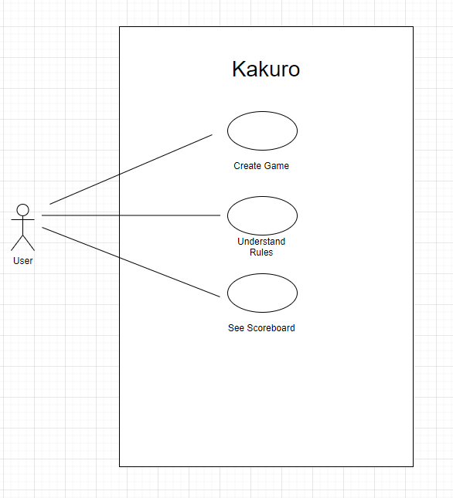

As a logic game, it's logical that users would want to start the game, but they probably don't know the rules, and as a game, it's competitive, so users would want to be able to record their time spent and show it.

**2.b) Proposed Solution – System Analysis and Design**

* **Use case diagram of our transaction**



As a logic game, it's logical that users would want to start the game, but they probably don't know the rules, and as a game, it's competitive, so users would want to be able to record their time spent and show it.

* **Use case template for our transaction**

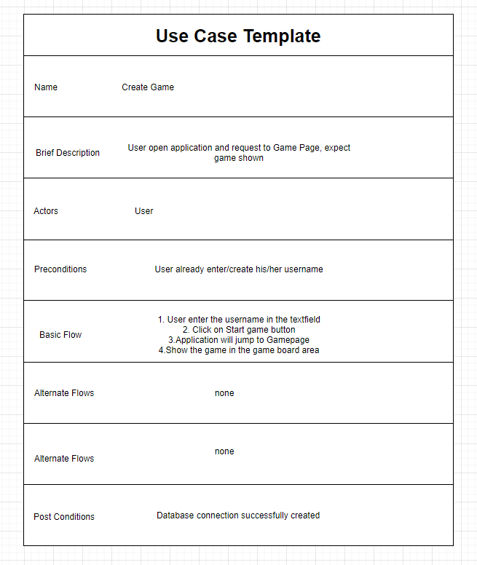

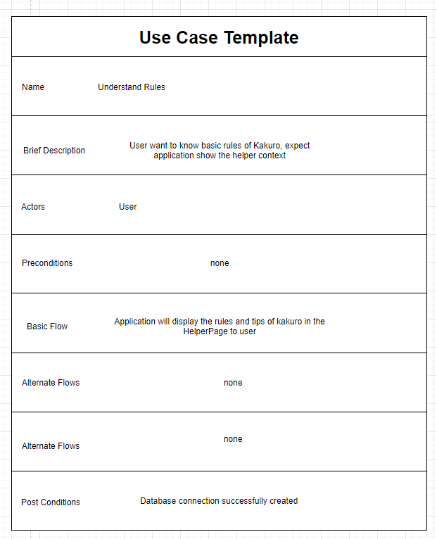

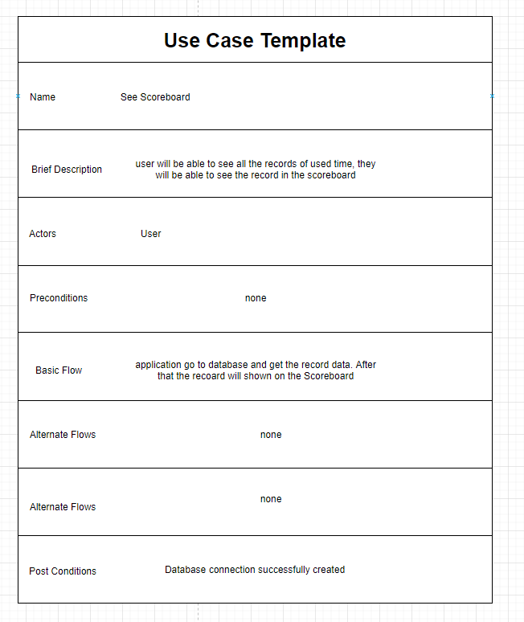

* **Class diagram for our transaction**

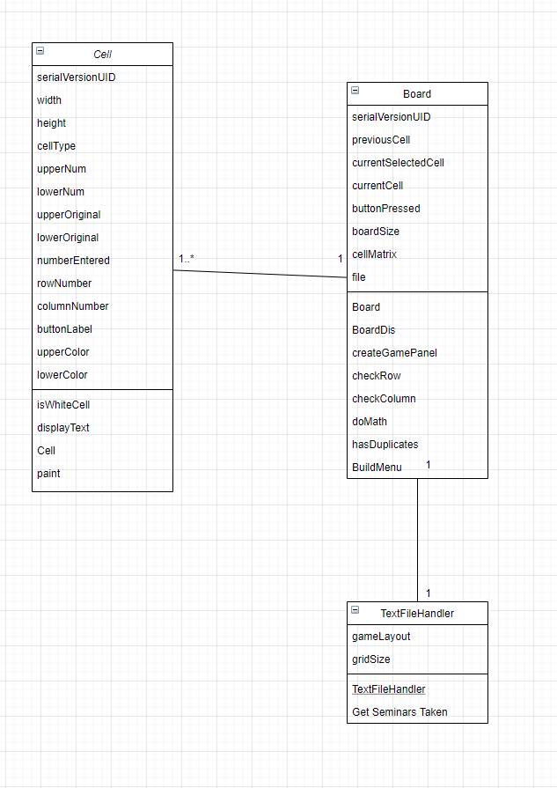

The main class including GUI is GameBoard Diagram. One GameBoard contains many Cells and One GameBoard using one TextFileHandler class to read question data from corresponding txt file.

* **Sequence diagram for our transaction**

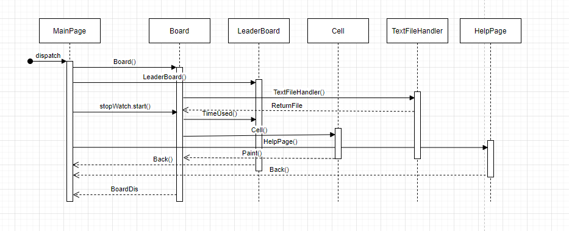

MainPage will create and start timer in Board class, after that, board class will call Cell constructor and TextFileHandler. Also, MainPage can go to LeaderBoard and HelpPage.

1. **Conclusion**

We used java and sqlite and txt files to complete this project and we realized the importance of teamwork and the whole process of programming and practicing it.

1. **Appendix: Graphical User Interface (GUI) of transaction**

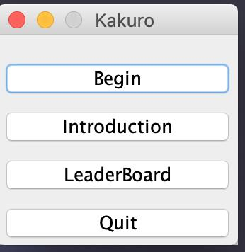

**This is main page, you can click on 4 buttons according to info on the button.**

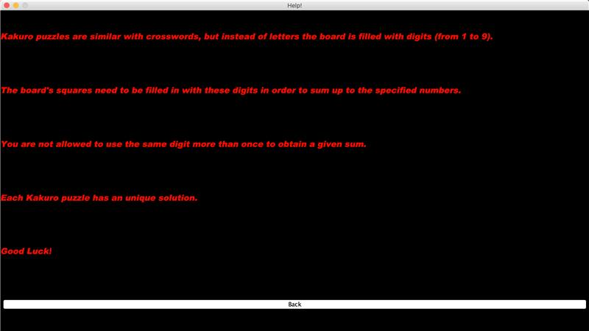

**This is the help page**

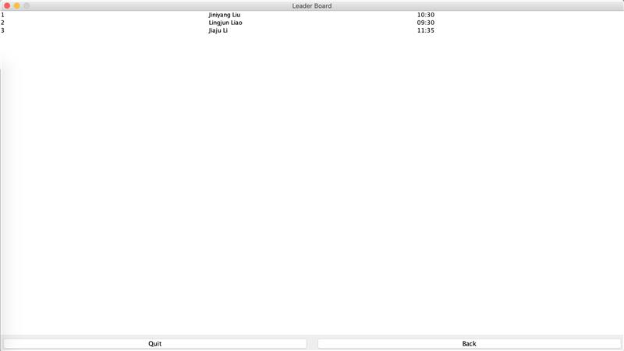

**This is LeaderBoard Page.**

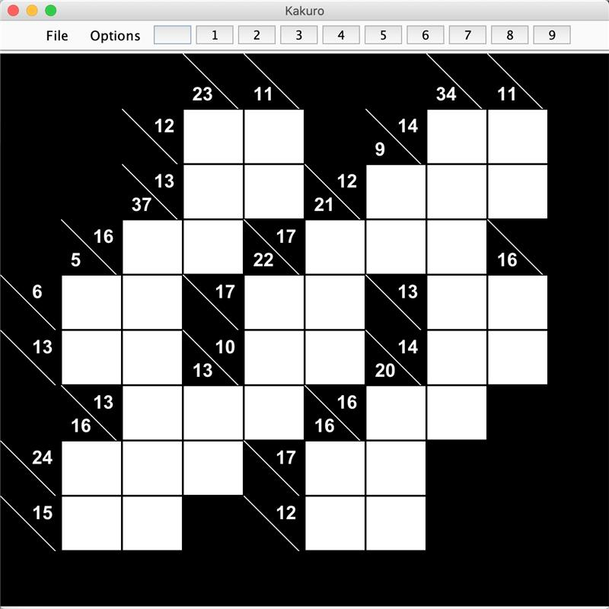

**After you clicked Begin button, the you can see the chess board, and start playing, first you need to select one blank block by clicking mouse twice (please be patient and wait for 1to 3 second) and then select the number on the top to enter it in the block. The number of the hint number will indicate whether the rule is met based on the answer you enter. After you finish, or whenever you want to exit, just click file and choose back button to return to main page.**